Supplementary Materials

Design, Synthesis, and Evaluation of Oleyl-WRH Peptides for siRNA Delivery

Mrigank Shekhar Rai ¹, Muhammad Imran Sajid ^{1,2}, Jonathan Moreno ¹, and Keykavous Parang ^{1,*}, Rakesh Kumar Tiwari ^{3*}

¹ Center for Targeted Drug Delivery, Department of Biomedical and Pharmaceutical Sciences, Chapman University School of Pharmacy, Harry and Diane Rinker Health Science Campus, Irvine, CA 92618, USA; mrrai@chapman.edu (MSR)
² Faculty of Pharmacy, University of Central Punjab, Lahore 54000, Pakistan; msajid@chapman.edu (MIS)
³ Department of Basic Medical Sciences, College of Osteopathic Medicine of the Pacific–Northwest, Western University of Health Sciences, Lebanon, Oregon 97355, USA

* Correspondence: rtiwari@westernu.edu (R.K.T.); Tel.: +1-(541)-259-0318; parang@chapman.edu (K.P.), Tel.: +1-714-516-5489; Fax: +1-(714)-516-5481

Contents
- MALDI-TOF mass spectrum of conjugated peptides Pages 2–9
- Analytical HPLC chromatogram of conjugated peptides Pages 10-14
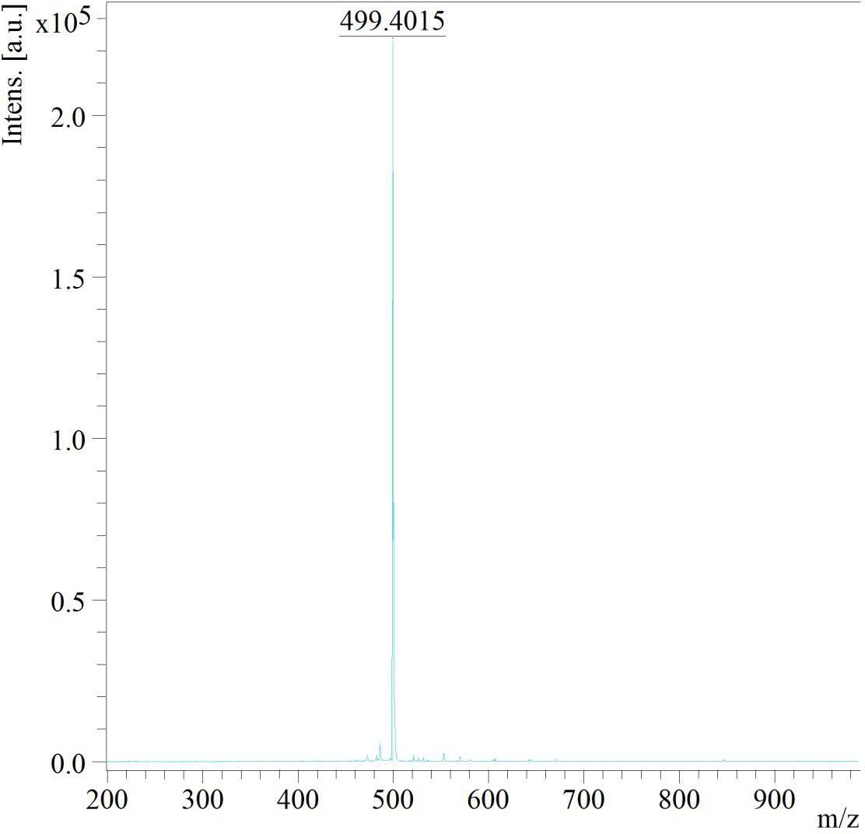
Figure S1. (WRH)₁: MALDI-TOF (m/z) C₂₃H₃₃N₉O₄ Calculated: 499.2645, Found: 499.4015 [M+2H]⁺.

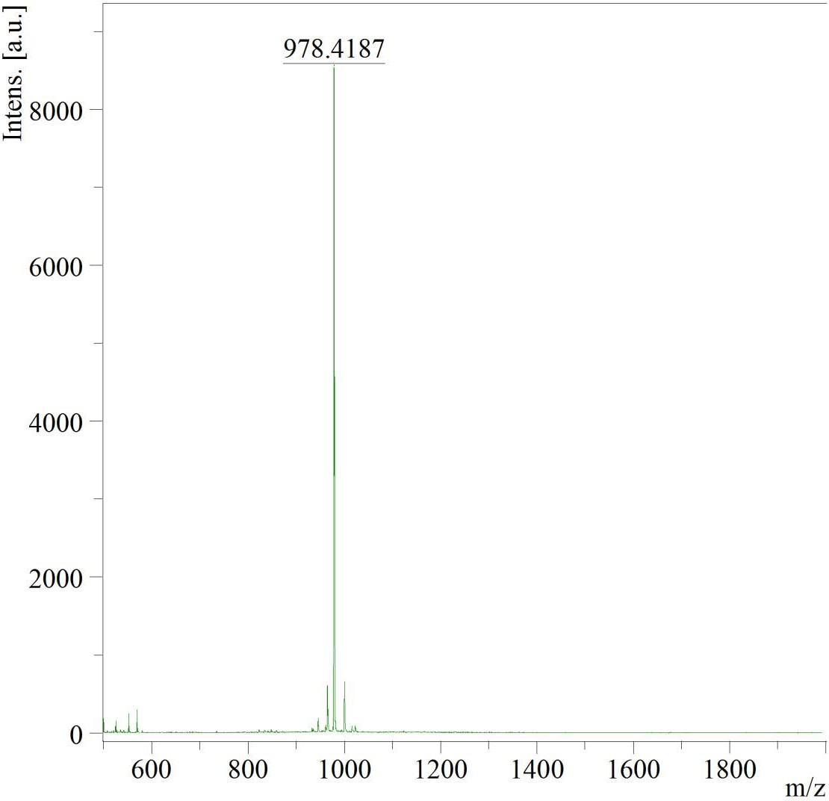

Figure S2. (WRH)2: MALDI-TOF (m/z) C₄₆H₆₂N₁₈O₇ Calculated: 978.5038, Found: 978.4187 [M+2H]⁺.

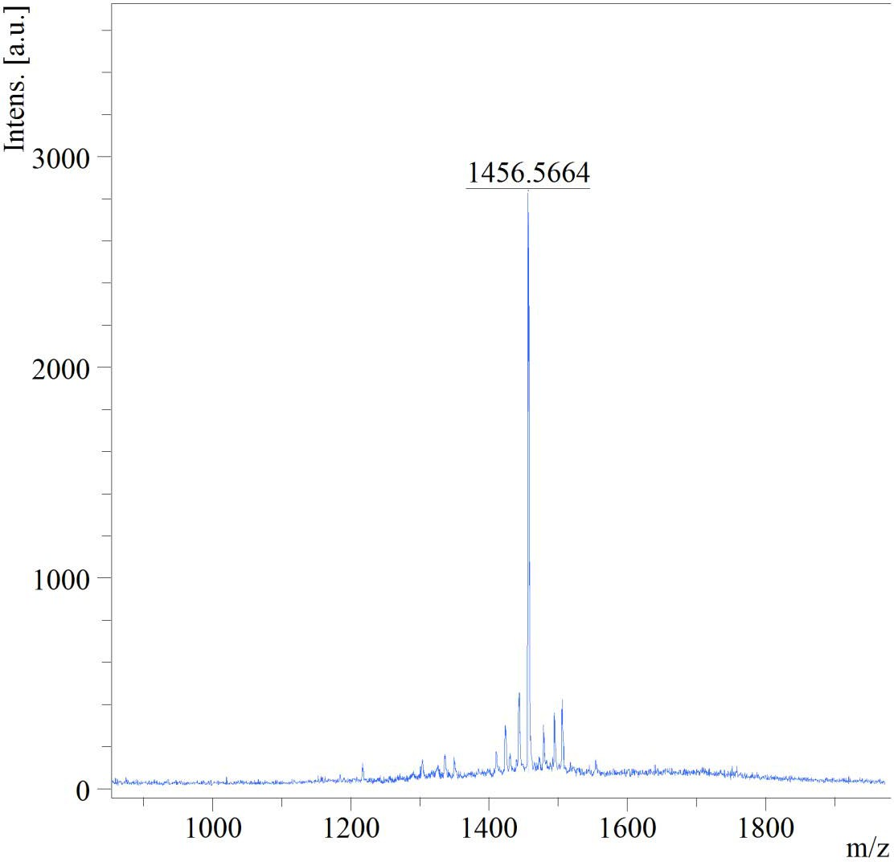

Figure S3. (WRH)₃: MALDI-TOF (m/z) C₆₉H₉₀N₂₇O₁₀ Calculated: 1456.7358, Found: 1456.5664 [M+H]⁺.

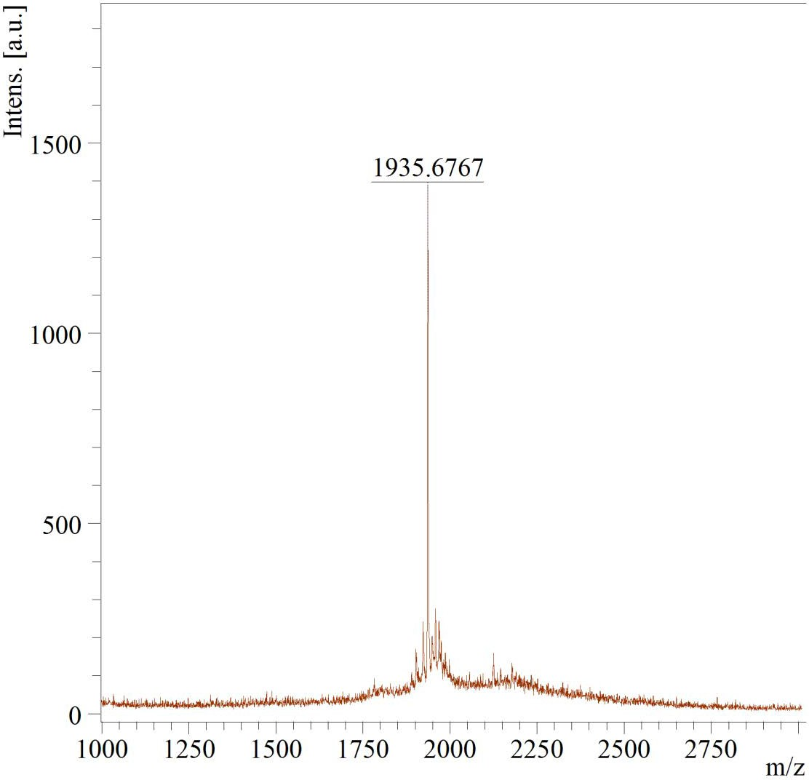

Figure S4. (WRH)₄: MALDI-TOF (m/z) C₉₂H₁₁₉N₃₆O₁₃ Calculated: 1935.9752, Found: 1935.6767 [M+H]⁺.

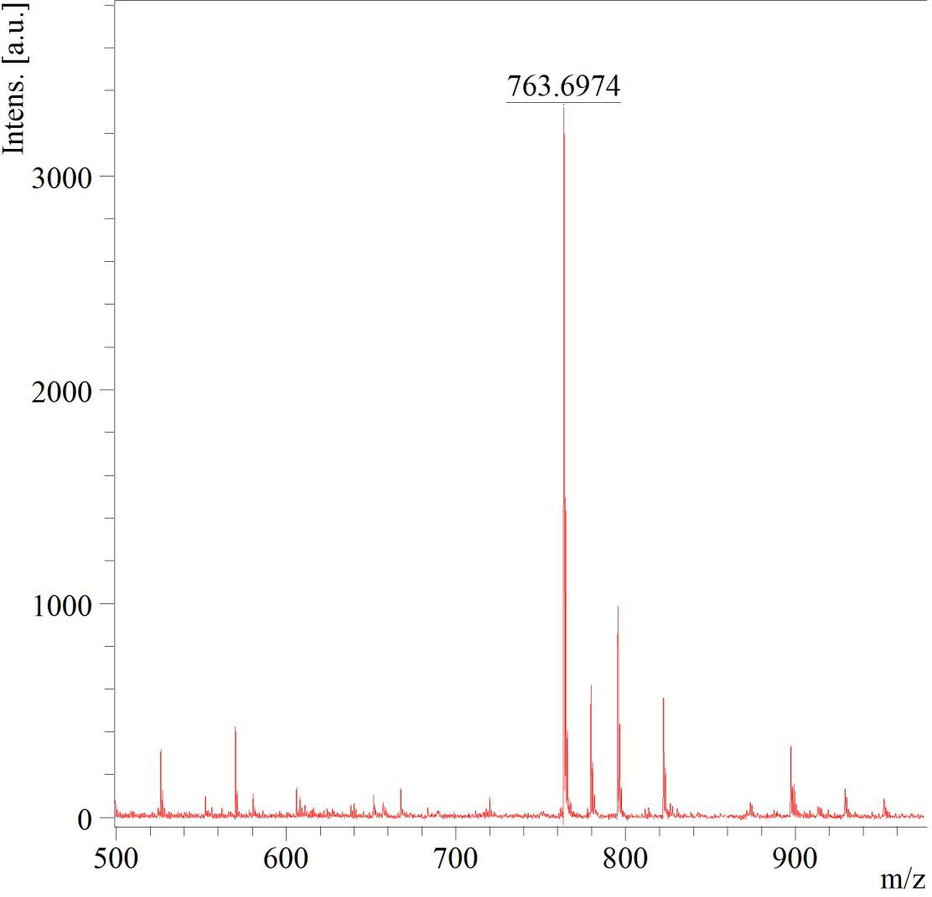

Figure S5. Oleyl-(WRH)₁: MALDI-TOF (m/z) C₄₁H₆₅N₉O₅ Calculated: 763.5098, Found: 763.6974 [M+2H]⁺.

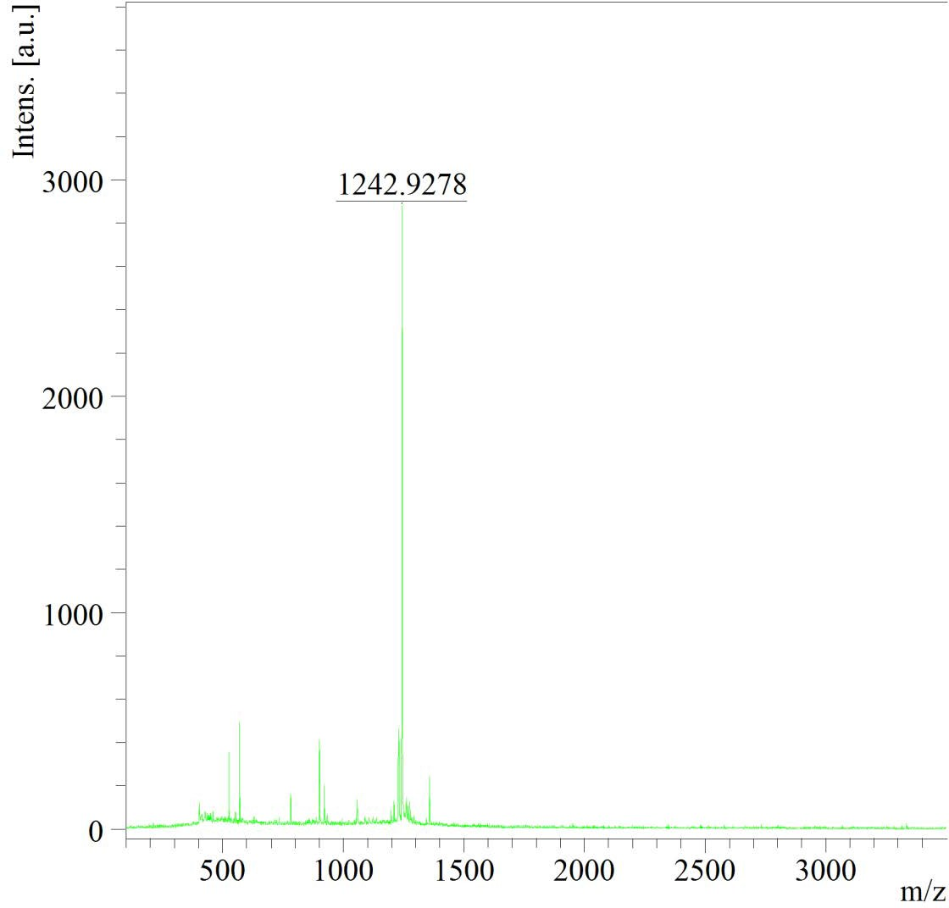

Figure S6. Oleyl-(WRH)₂: MALDI-TOF (m/z) C₆₄H₉₄N₁₈O₈ Calculated: 1242.7491, Found: 1242.9278 [M+2H]⁺.

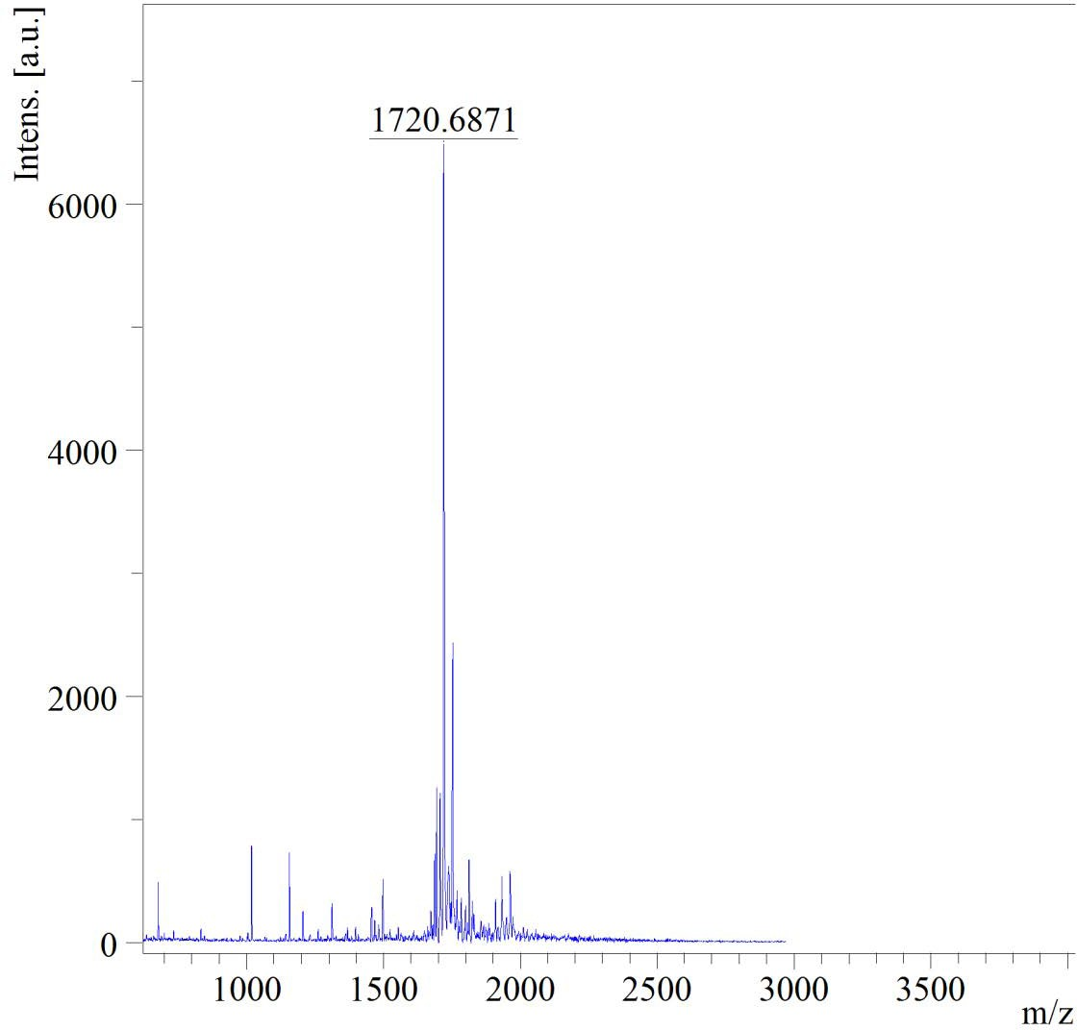

Figure S7. Oleyl-(WRH)₃: MALDI-TOF (m/z) C₈₇H₁₂₂N₂₇O₁₁ Calculated: 1720.9812, Found: 1720.6871 [M+H]⁺.

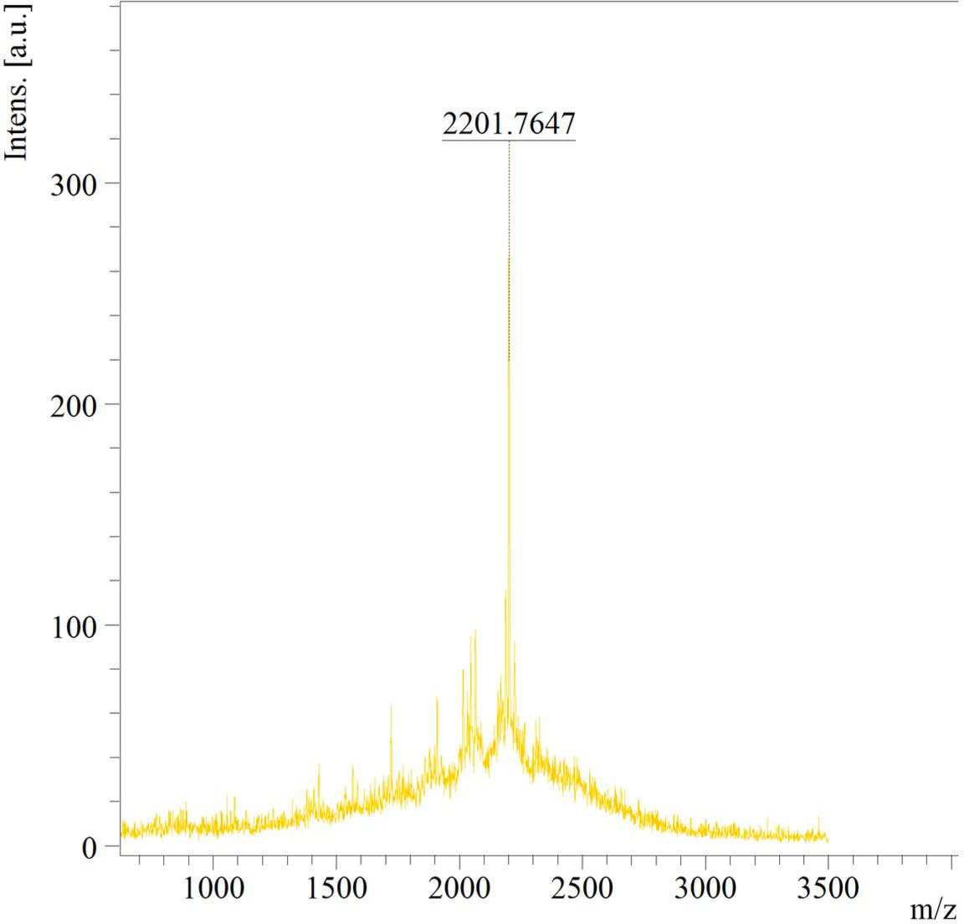

Figure S8. Oleyl-(WRH)4: MALDI-TOF (m/z) C₁₁₂H₁₅₂N₃₆O₁₄ Calculated: 2201.2278, Found: 2201.7647 [M+2H]⁺.

Analytical HPLC Purification Analysis

The purity of the most efficient peptides (WRH)3, (WRH)4, oleyl-(WRH)3, and oleyl- (WRH)4 was determined using the reverse phase analytical HPLC method at a flow rate of 0.4 mL/min on Shimadzu (LC-20ADXR) with a gradient system of water with 0.1% Formic Acid (solvent A) and acetonitrile with 0.1% Formic Acid (solvent B), using (Phenomenex Luna, 4 um C18 150 × 4.6 mm HPLC Column).

Time | 0.01 | 5.0 | 15.0 | 25.0 | 28.0 | 33.0 | 33.0 | 38.0
% Solvent B | 5 | 5 | 20 | 70 | 95 | 95 | 5 | 5

HPLC Chromatograms

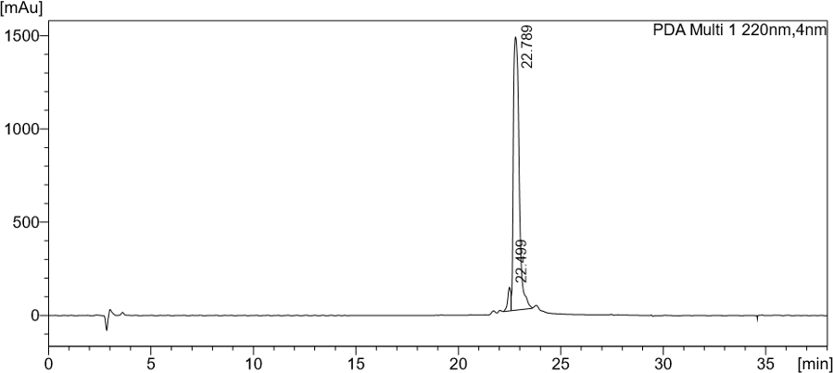

Figure S9. Analytical HPLC chromatogram of (WRH)3

Peptide | (WRH)3
Pump A | 0.1% Formic Acid in 100% Water
Pump B | 0.1% Formic Acid in 100% Acetonitrile
Total Flow | 0.4 ml/min
Retention Time | 22.789 min
% Purity | 95.741

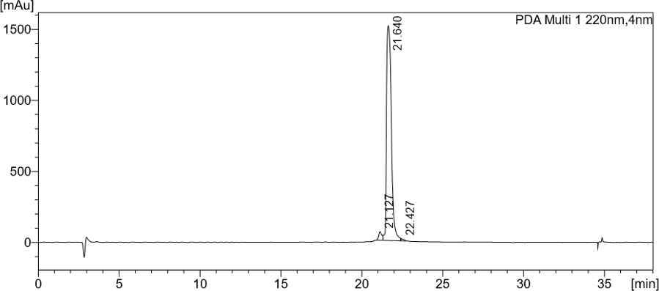

Figure S10. Analytical HPLC chromatogram of (WRH)4.

Peptide | (WRH)4
Pump A | 0.1% Formic Acid in 100% Water
Pump B | 0.1% Formic Acid in 100% Acetonitrile
Total Flow | 0.4 ml/min
Retention Time | 21.640 min
% Purity | 96.495

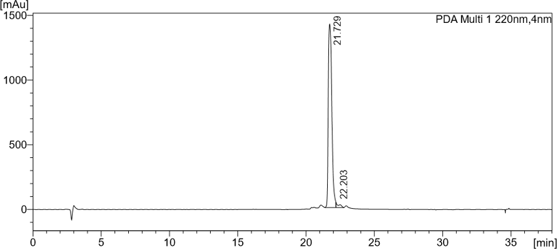

Figure S11. Analytical HPLC chromatogram of Oleyl-(WRH)3.

Peptide | Oleyl-(WRH)3
Pump A | 0.1% Formic Acid in 100% Water
Pump B | 0.1% Formic Acid in 100% Acetonitrile
Total Flow | 0.4 ml/min
Retention Time | 21.729 min
% Purity | 97.318

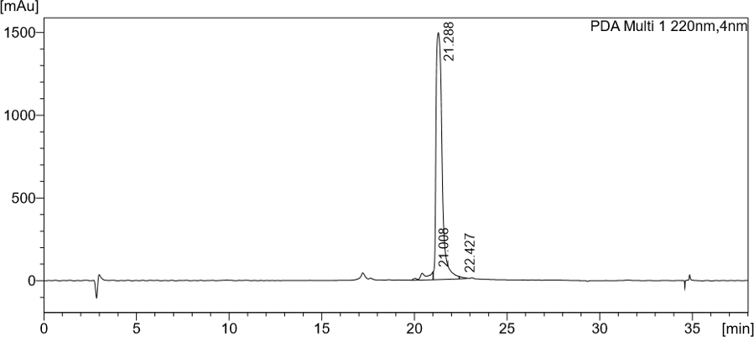

Figure S12. Analytical HPLC chromatogram of Oleyl-(WRH)4.

Peptide | Oleyl-(WRH)4
Pump A | 0.1% Formic Acid in 100% Water
Pump B | 0.1% Formic Acid in 100% Acetonitrile
Total Flow | 0.4 ml/min
Retention Time | 21.288 min
% Purity | 95.359

