Supplementary Information

Phage Anti-Pycsar Proteins Efficiently Degrade β-Lactam Antibiotics
Pallav Joshi^{1,2†}, Stefan Krco^{1,2†}, Samuel J. Davis^{,1,2}, Lachlan Asser¹, Thomas Brück⁴, Rochelle M. Soo^{1,2}, Mikael Boden¹, Philip Hugenholtz^{1,2}, Liam A. Wilson³, Gerhard Schenk^{1,5}* and Marc T. Morris^{1,2}*
¹ School of Chemistry and Molecular Biosciences, The University of Queensland, Brisbane, Australia.
² Australian Centre for Ecogenomics, The University of Queensland, Brisbane, Australia.
³ Chemistry Research Laboratory, Department of Chemistry and the Ineos Oxford Institute for Antimicrobial Research, Oxford University, Oxford, OX1 3TA United Kingdom.
⁴ Werner Siemens-Chair of Synthetic Biotechnology, Technical University of Munich (TUM), TUM School of Natural Sciences, Lichtenbergstr. 4, 85748 Garching, Germany.
⁵ Australian Institute of Bioengineering and Nanotechnology, The University of Queensland, Brisbane, Australia.
* Correspondence: MTM – marc.morris@uq.edu.au; GS schenk@uq.edu.au
† These authors contributed equally to this work and share first authorship

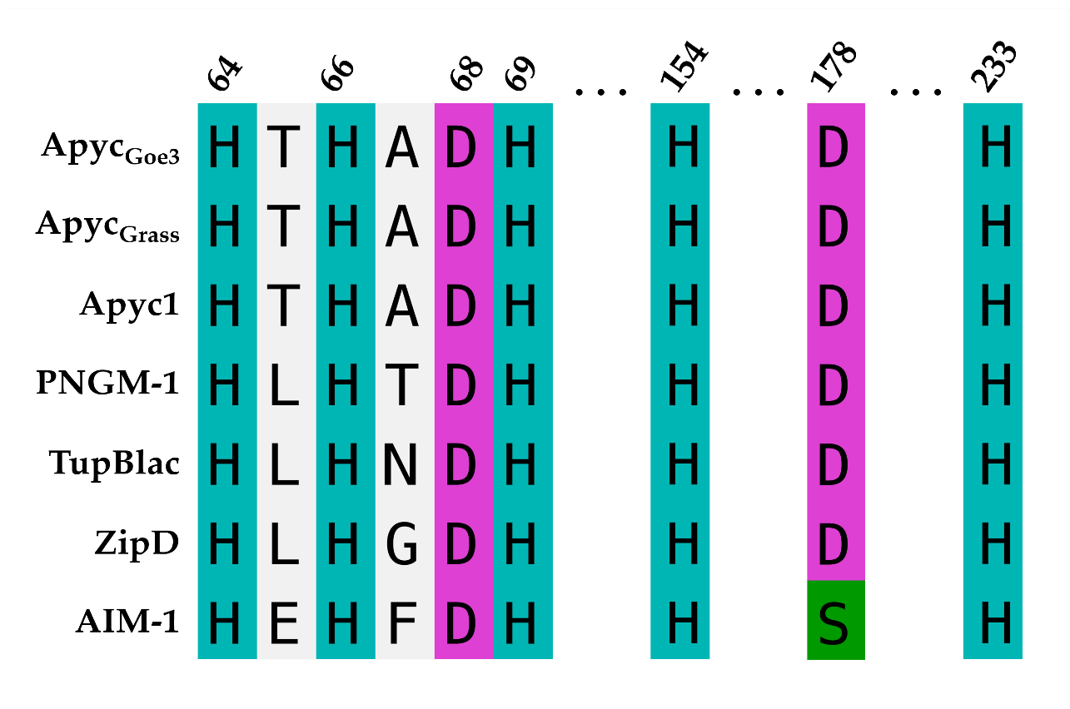
Figure S1. Aligned metal-binding residues of Apyc orthologs and representatives of the MBL-fold superfamily. Amino acid sequences from various functional subgroups of the MBL-fold superfamily were aligned using structure-guided sequence alignment with MAFFT-DASH (L-INS-i) [55,56]. Columns corresponding to residues comprising the α (H64, H66, H154) and β (D68, H69, H233) metal-binding sites, and the metal-bridging position (178) were extracted for representative sequences. Apyc_{Goe3} and Apyc_{Grass} display the same metal binding motifs as Apyc1 and much of the broader superfamily, and possess the bridging aspartate residue absent in true metallo-β-lactamases (i.e., the B1, B2, and B3 MBLs).

Table S1: Catalytic parameters of representative members of each Ambler class of β-lactamases. Classes A, C, and D are SBLs, while Class B (inclusive of the B1, B2, and B3 subgroups) are MBLs. Units of k_{cat}, K_{M}, and k_{cat}/K_{M} are s⁻¹, μM, and s⁻¹ mM⁻¹. ªYong et al. [37], ^{b}Bottoni et al. [57], ^{c}Horsfall et al. [58], ^{d}Segatore et al. [59], ^{e} Bebrone et al. [60], ^{f} Venkatachalam et al. [61], ^{g}De Wals et al. [62], ^{h}Poirel et al. [63], ^{i}Robin et al. [64], ^{j}Marcoccia et al. [65], ^{h} Chiou et al. [66], ^{i} Mammeri et al. [67], ^{j} Mazzariol et al. [68], ^{k} Lenfant et al. [69]. N.H. - no hydrolytic activity detected. | N.D. – not determined.

 | TEM-1  (Class A) |  |  | NDM-1ª  (Class B1) |  |  | CphA  (Class B2) |  |  | AIM-1^{c}  (Class B3) |  |  | AmpC (E. coli K12)  (Class C) |  |  | OXA-48  (Class D)
Substrate | k_{cat} | K_{M} | k_{cat}/K_{M} | k_{cat} | K_{M} | k_{cat}/K_{M} | k_{cat} | K_{M} | k_{cat}/K_{M} | k_{cat} | K_{M} | k_{cat}/K_{M} | k_{cat} | K_{M} | k_{cat}/K_{M} | k_{cat} | K_{M} | k_{cat}/K_{M}
Penicillins
Penicillin G | 1660^{g} | 62^{g} | 26,774^{g} | 11 | 16 | 680 | 3^{d}/  0.03e | 630^{d}/  870e | 4.8^{d}/  0.034e | 778 | 31 | 25,000 | 45 | 4.4 | 10,227 | 245^{h} | 40^{h} | 6’100^{h}
Ampicillin | 1450^{f} | 71^{f} | 20,422^{f} | 15 | 22 | 660 | <0.01e | 2’500e | <0.004 | 594 | 41 | 14,000 | 4.2 | 3.5 | 1,200 | 340^{h} | 5’200^{h} | 65^{h}
Carbenicillin | 120^{k} | 14^{k} | 8,571^{k} | 108^{j} | 285^{j} | 379^{j} | 10^{d} | 500^{d} | 20^{d} | - | - | - | 0.002^{j} | 0.1^{j} | 20^{j} | 311^{k} | 57^{k} | 5’456^{k}
Carbapenems
Meropenem | N.H. | N.H. | N.H. | 12 | 49 | 250 | 3,100^{b}/  53^{d} | 1,600^{b}/  250^{d} | 1,940^{b}/  212^{d} | 1’000 | 163 | 6,100 | - | - | - | 0.1^{h} | 200^{h} | 0.5^{h}
Imipenem | N.H. | N.H. | N.H. | 20 | 95 | 210 | 460^{b}/  140^{d}/  1,200e | 110^{b}/  86^{d}/  340e | 4,180^{b}/  1,627^{d}/  3,529e | 1’700 | 97 | 18,000 | 0.09^{i} | 32’000^{i} | 0.0028^{i} | 2^{h} | 14^{h} | 145^{h}
Cephalosporins
Cephalothin | 77^{g} | 180^{g} | 427^{g} | 4 | 10 | 400 | - | - | - | 529 | 38 | 14,000 | 300 | 42 | 7,142 | 3^{h} | 120^{h} | 150^{h}
Cefuroxime | <0.1^{i} | N.D^{i} | N.D^{i} | 5 | 8 | 610 | - | - | - | 292 | 29 | 10,000 | 0.15^{j} | 0.15^{j} | 1,000^{j} | - | - | -

