Supplementary file
Petya Marinova^{1,}*, Dimitar Stoitsov², Nikola Burdzhiev³, Slava Tsoneva², Denica Blazheva⁴, Aleksandar Slavchev⁴, Evelina Varbanova² and Plamen Penchev²
¹ Department of General and Inorganic Chemistry with Methodology of Chemistry Education, Faculty of Chemistry, “Tzar Assen” str. 24, Plovdiv 4000, Bulgaria, E-mail: marinova@uni-plovdiv.bg (P.M.)
² Department of Analytical Chemistry and Computer Chemistry, Faculty of Chemistry, University of Plovdiv, “Tzar Asen” str., 24 Plovdiv 4000, Bulgaria, E-mail: stoitsov@uni-plovdiv.bg (D.S.); slava.tsoneva@uni-plovdiv.bg; (S.T.); evarbanova@uni-plovdiv.bg (E.V.); plamennpenchev@gmail.com (P.P.)
³ Department of Organic Chemistry and Pharmacognosy, Faculty of Chemistry and Pharmacy, University of Sofia, 1, J. Bourchier Av., 1164 Sofia, Bulgaria, E-mail: nburdzhiev@chem.uni-sofia.bg (N.B.)
⁴ Department of Microbiology, University of Food Technologies, 26 Maritza Blvd., 4002 Plovdiv, Bulgaria, E-mail: d_blazheva@uft-plovdiv.bg (D.B.); a_slavchev@uft-plovdiv.bg (A.S.)
*Correspondence: marinova@uni-plovdiv.bg; petia_marinova@abv.bg (P.M.)

- NMR solution spectra of 2,4-dithiouracil
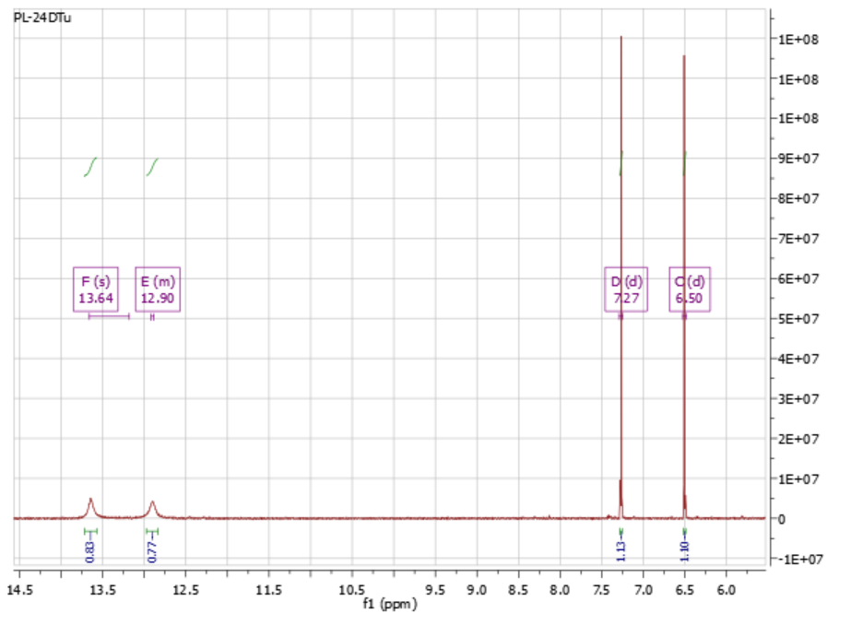
Fig. S1 ¹H NMR
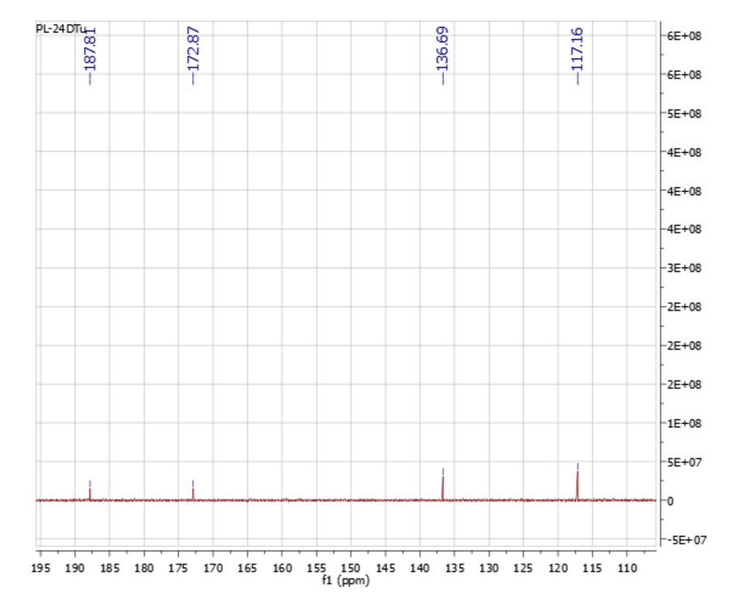
Fig.S2 ¹³C NMR
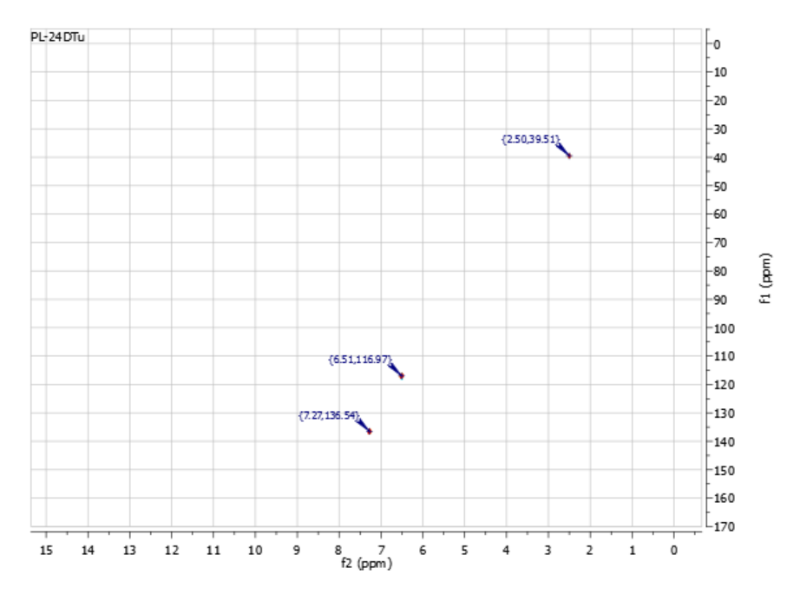
Fig. S3 HSQC
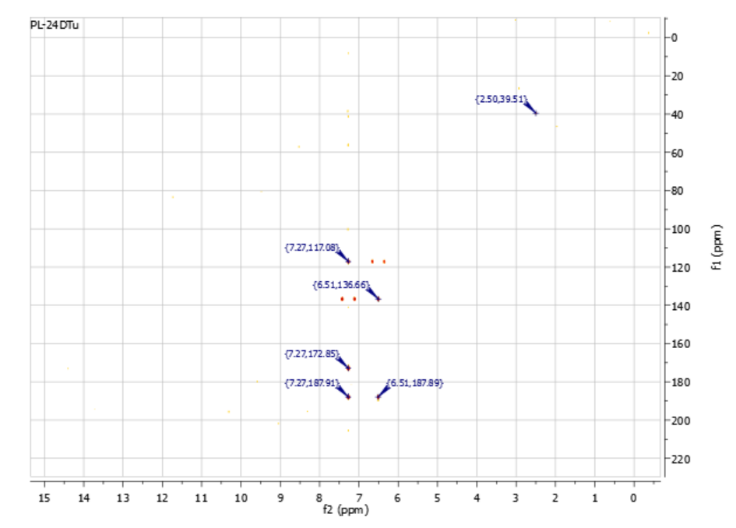
Fig. S4 HMBC
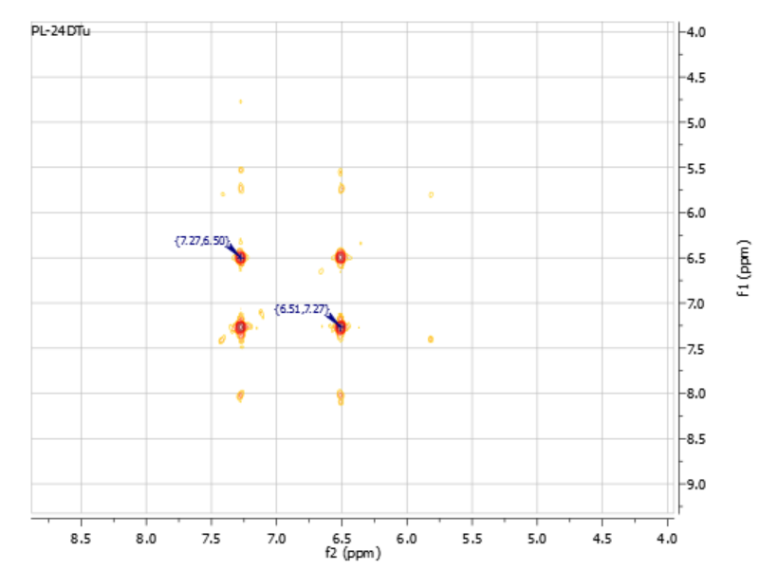
Fig. S5 ¹H-¹H COSY

- NMR solution spectra of the Au and Cu complexes
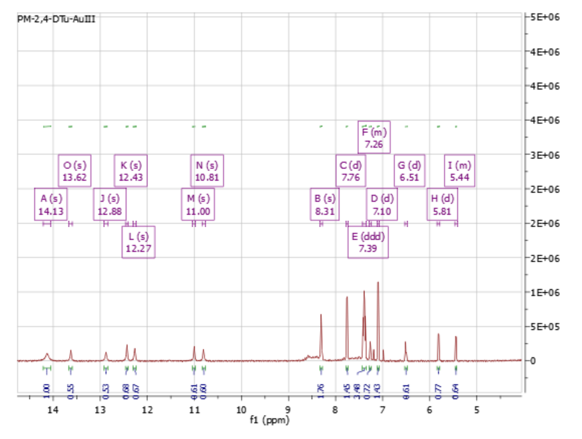
Fig.S6 ¹H NMR of the Au complex
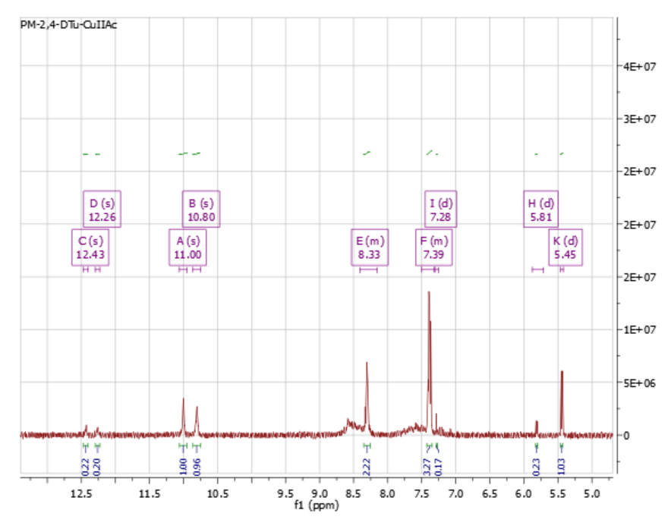
Fig. S7 ¹H NMR of the Cu complex

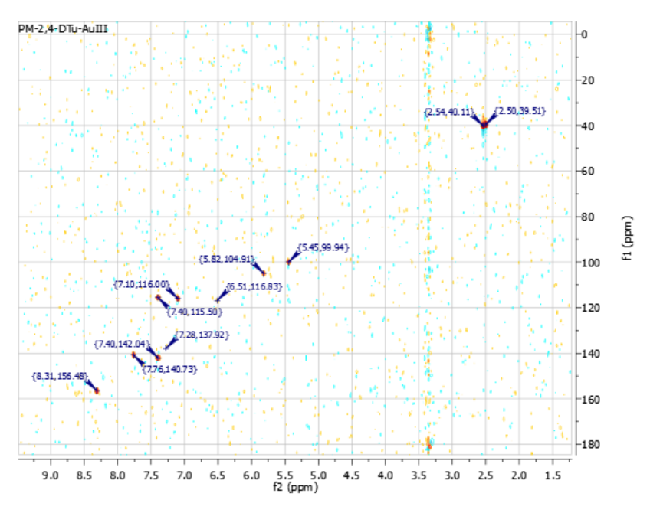
Fig.S8 HSQC of the Au complex

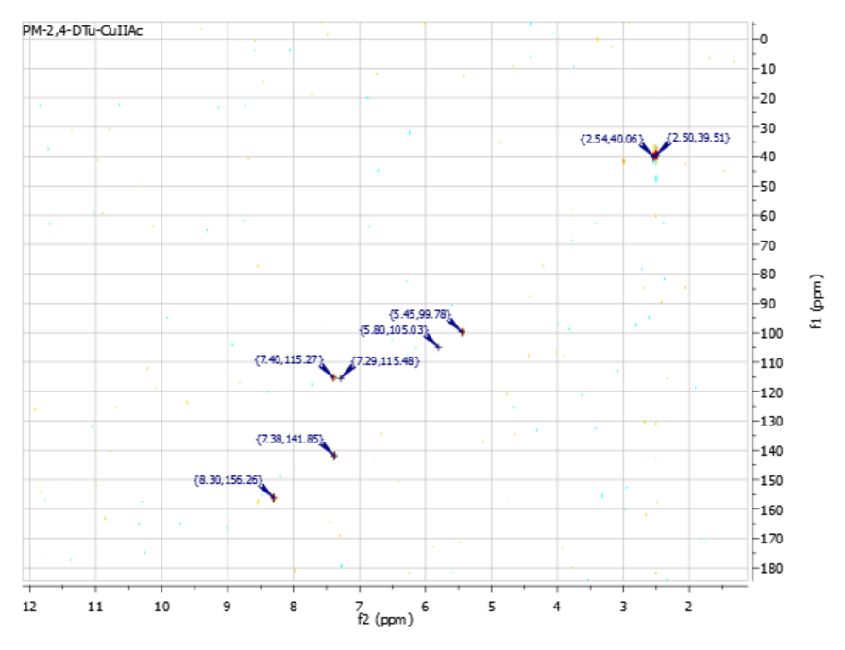
Fig.S9 HSQC of the Cu complex

- ATR and Raman spectra

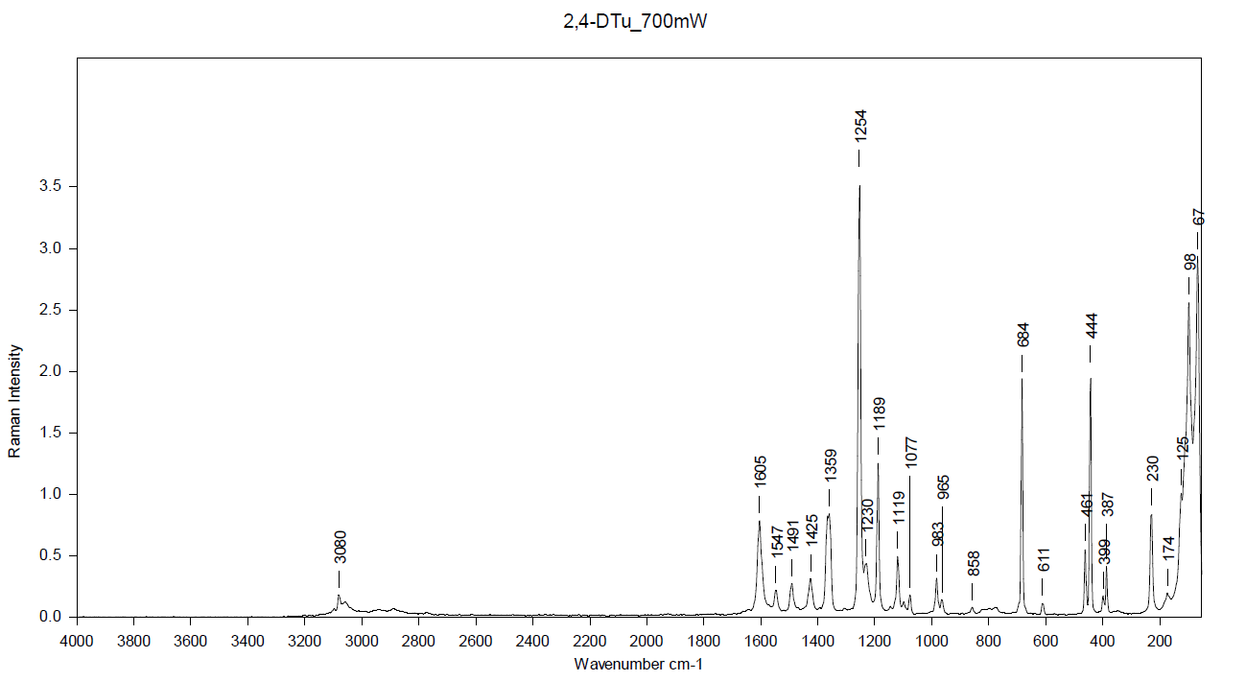
Fig.S10 Raman of 2,4-dithiouracil

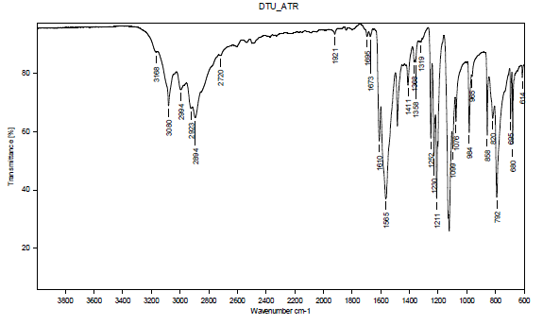
Fig.S11 ATR of 2,4-dithiouracil

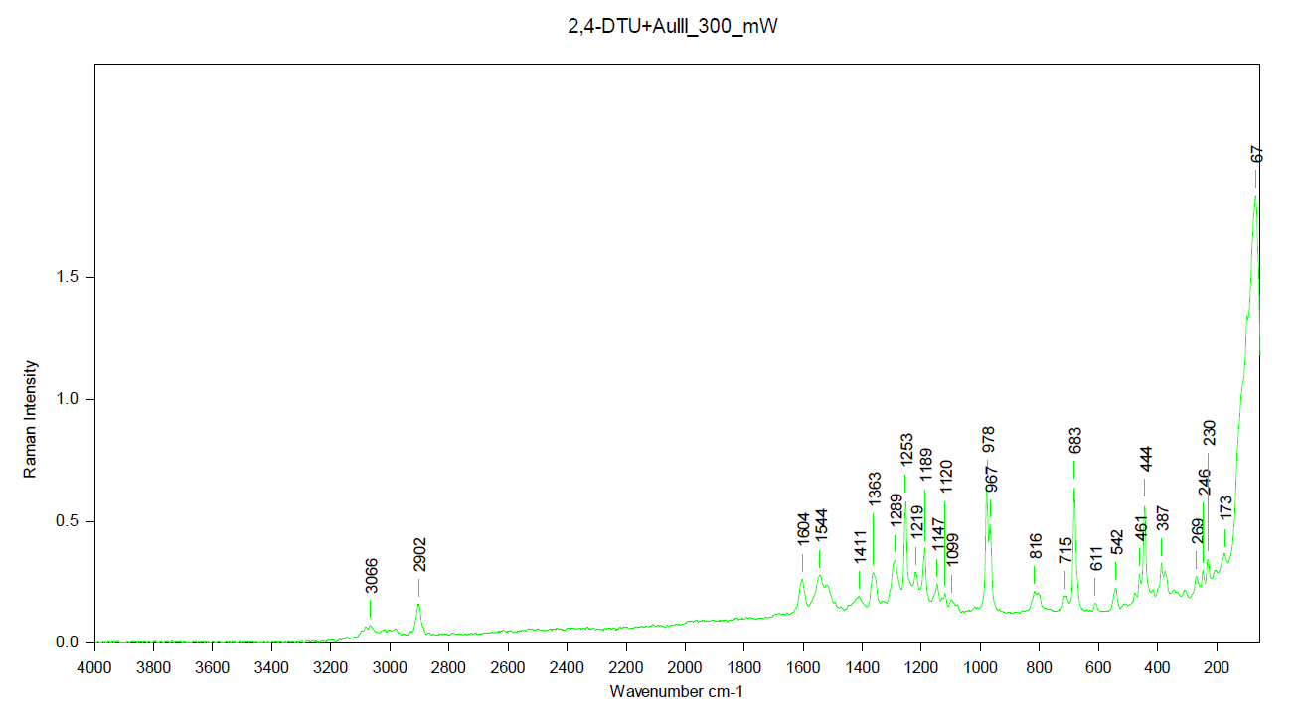
Fig. S12 Raman of the Au complex
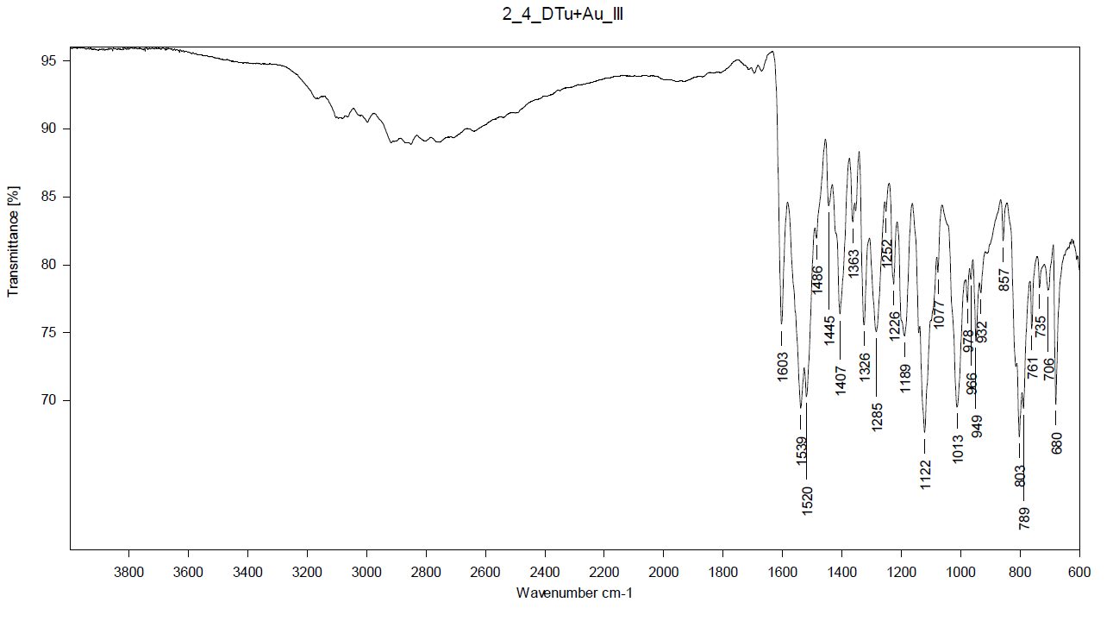
Fig. S13 ATR of the Au complex

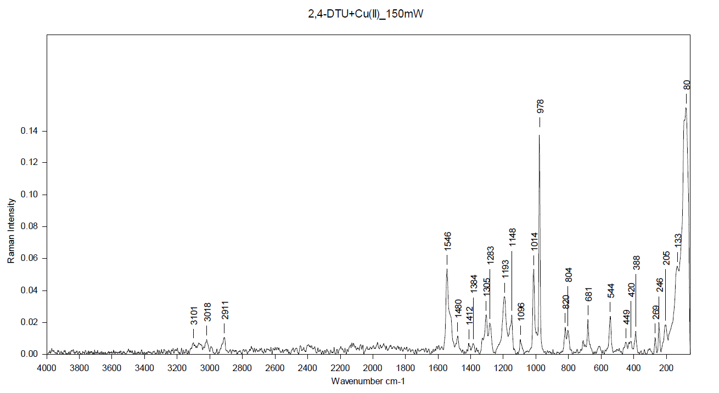
Fig. S14 Raman of the Cu complex

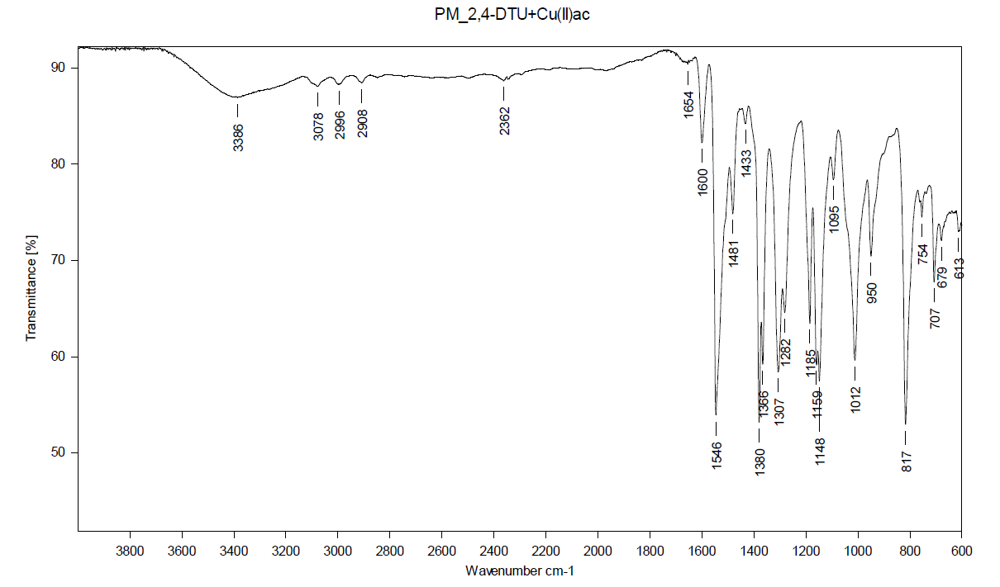
Fig. S15 ATR of the Cu complex

- NMR solid state spectra of the complexes
Fig.S16 ¹H solid state NMR of Au complex

Fig.S17 ¹³C CP MAS NMR of Au complex

Fig.S18¹³C CPPI MAS NMR of Au complex

Fig.S19 ¹H solid state NMR of Cu complex

Fig.S20 ¹³C CP MAS NMR of Cu complex

Fig.S21¹³C CPPI MAS NMR of Cu complex

