Quantum Chemical (QC) Calculations and Linear Solvation Energy Relationships (LSER). Hydrogen-Bonding Calculations with New QC-LSER Molecular Descriptors

Costas Panayiotou
Department of Chemical Engineering, Aristotle University of Thessaloniki, 54624 Thessaloniki, Greece

SUPPLEMENTARY INFORMATION FILE
This file provides with additional information on the new QC-LSER molecular descriptors in terms of graphs and tables. The COSMO-RS calculations are done at the DFT/ TZVPB-Fine level [1, 2].
Distribution curves of σ_{i}²A_{I} are not always as symmetric as in in figure 2 of the main text for water. Corresponding curves for carbon tetrachloride and propanal, which are significantly more asymmetric, are shown in figures S1 and S2, respectively. As shown, CCl₄ has only polarizability non-zero QC-LSER descriptors while propanal, in addition to polarizability descriptors it has a hydrogen-bonding basicity (HBA) descriptor.

Figure s1: The distribution function of the product σ_{i}²A_{i} of charge densities σ_{i} with the molecular charges σ_{i}A_{i} of carbon tetrachloride and the definition areas of the QC-LSER molecular descriptors. CCl₄ has only polarizability non-zero QC-LSER descriptors.

Figure S2: The distribution function of the product σ_{i}²A_{i} of propanal and the definition areas of the QC-LSER molecular descriptors. Propanal has one basic (hydrogen-bonding acceptor) and two polarizability non-zero QC-LSER descriptors.

It should be stressed that all new QC-LSER descriptors are positive, as is the case with Abraham’s LSER descriptors. One could use, alternatively, the distribution of the charge σ_{i}A_{i} for an analogous definition leading to positive and negative descriptors.

Figure S3: The distribution function of the molecular charges σ_{i}A_{i} of water and the areas) for alternative definition of analogous to QC-LSER molecular descriptors. A_{h} and B_{h} would correspond, approximately, to the regions of definition of Dohnal’s [3] α_{cosm} and β_{cosm} descriptors, respectively.

Klamt cosmoments [1,2] were based on distributions analogous to figure 1 of the main text. Dohnal cosmoments are based on distributions analogous to figure S3. Klamt’s regions of definitions of acidity and basicity cosmoments HB_doni and HB_acci correspond to regions A_{h} and B_{h}, respectively, of figure 2 of the main text. In Table S1 are compared the hydrogen-bonding descriptors, A_{h} and B_{h}, with the corresponding Dohnal [3] descriptors. As seen, the two sets of descriptors are, in general, close although there are cases with significant differences.

TABLE S1: Comparison of hydrogen-bonding QC-LSER molecular descriptors, A_{h} and B_{h}, with the corresponding α_{cosmo} and β_{cosmo} Dohnal’s [3] descriptors for some common solutes.
 | This Work |  | Dohnal [5]
SOLUTE | A_{h} | B_{h} | α_{cosmo} | β_{cosmo}
1-OCTENE | 0.00 | 0.05 | 0.0 | 0.2
DICHLOROMETHANE | 0.94 | 0.00 | 1.3 | 0.0
CHLOROFORM | 1.14 | 0.00 | 1.2 | 0.0
DIETHYL ETHER | 0.00 | 1.81 | 0.0 | 1.8
TETRAHYDROFURAN | 0.00 | 2.15 | 0.0 | 2.2
1,4-DIOXANE | 0.00 | 3.12 | 0.0 | 3.3
TETRAHYDROPYRAN | 0.00 | 1.97 | 0.0 | 1.7
ETHYL ACETATE | 0.00 | 2.81 | 0.0 | 2.8
n-PROPYL ACETATE | 0.00 | 2.80 | 0.0 | 2.8
n-BUTYL ACETATE | 0.00 | 2.81 | 0.0 | 2.8
ETHYL PROPIONATE | 0.00 | 2.66 | 0.0 | 2.7
ETHYL n-BUTYRATE | 0.00 | 2.65 | 0.0 | 2.8
ACETONE | 0.02 | 2.95 | 0.0 | 2.8
METHYL ETHYL KETONE | 0.00 | 2.78 | 0.0 | 2.7
2-PENTANONE | 0.00 | 2.81 | 0.0 | 2.7
3-PENTANONE | 0.00 | 2.58 | 0.0 | 2.5
METHANOL | 1.39 | 2.39 | 1.4 | 2.4
ETHANOL | 1.23 | 2.46 | 1.3 | 2.5
1-PROPANOL | 1.23 | 2.44 | 1.2 | 2.5
1-BUTANOL | 1.22 | 2.47 | 1.3 | 2.5
1-PENTANOL | 1.22 | 2.46 | 1.3 | 2.5
ISOPROPANOL | 1.18 | 2.52 | 1.2 | 2.5
2-BUTANOL | 0.91 | 2.46 | 1.2 | 2.2
2-PENTANOL | 1.14 | 2.22 | 1.0 | 2.5
GLYCEROL | 2.98 | 5.26 | 3.0 | 5.3
ETHYLENE GLYCOL, c0 | 2.13 | 3.87 | 2.9 | 4.2
2-METHOXYETHANOL c0 | 0.77 | 3.13 | 1.5 | 3.6
2-ETHOXYETHANOL c0 | 0.63 | 3.13 | 1.5 | 3.7
PHENOL | 2.03 | 0.88 | 2.1 | 1.0
n-BUTYLAMINE | 0.43 | 2.73 | 0.7 | 2.5
ANILINE | 1.62 | 0.78 | 1.7 | 1.0
PYRIDINE | 0.00 | 2.11 | 0.0 | 2.1
FORMAMIDE | 3.03 | 4.23 | 3.1 | 3.7
DIMETHYL SULFOXIDE | 0.10 | 5.24 | 0.6 | 4.6
ACETONITRILE | 0.31 | 2.00 | 1.0 | 2.3
ACRYLONITRILE | 0.43 | 1.52 | 1.0 | 1.7
PROPIONITRILE | 0.08 | 2.02 | 0.3 | 2.4
N,N-DIMETHYLFORMAMIDE | 0.00 | 4.17 | 0.1 | 3.7
N-METHYL FORMAMIDE | 1.58 | 4.20 | 1.5 | 3.7
WATER | 2.89 | 2.99 | 3.0 | 2.9

Below are shown the σ-profiles and the sigma surfaces of various conformers of glycols and alkoxyethanols. Conformers c0 are the most stable facilitating intramolecular hydrogen-bonding. Deep blue in sigma-surfaces indicate donor sites and deep red acceptor sites.

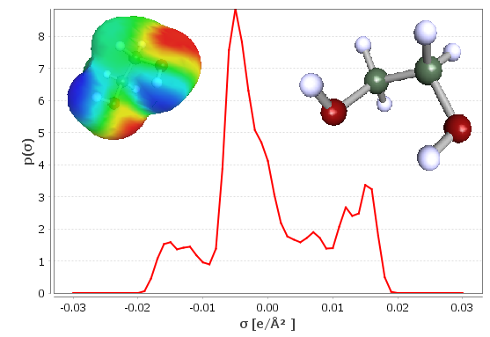

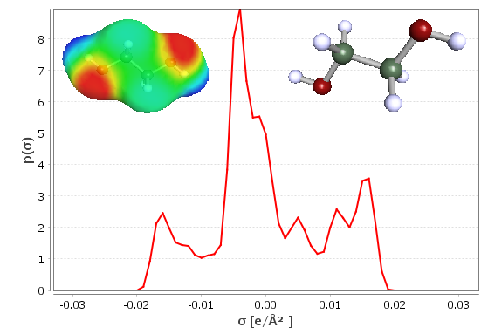

Figure S4: The σ-profiles and σ-surfaces of conformer c0 (upper) and c6 (lower) of ethylene glycol. Data from [1].

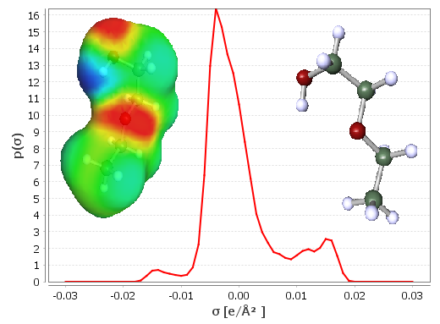
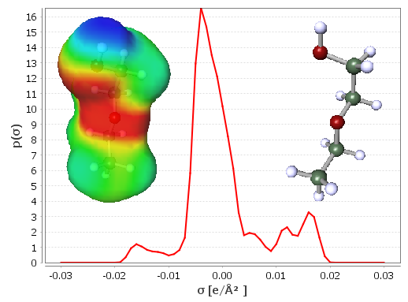

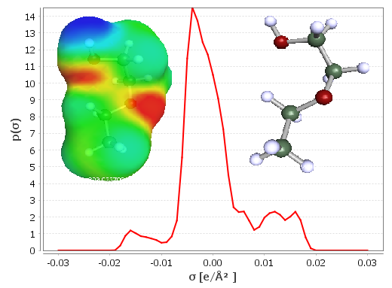
Figure S5: The σ-profiles and σ-surfaces of conformer c0 (upper), c1 (middle) and c9 (lower) of 2-ethoxyethanol Data from [1].
References
- Klamt, A. 2005. COSMO-RS from Quantum Chemistry to Fluid Phase Thermodynamics and Drug Design; Amsterdam: Elsevier.
- COSMObase, ver. 2019, COSMOlogic GmbH &CoKG (now, BIOVIA Dassault Systemes)
- Dohnal, V. 2024, New QSPR molecular descriptors based on low-cost quantum chemistry computations using DFT/COSMO approach, J. Mol. Liq. 125256, https://doi.org/10.1016/ j.molliq.2024.125256.

