Supplementary Materials

*Aquibium pacificus* sp. nov., a novel mixotrophic bacterium from bathypelagic seawater in the western Pacific Ocean

Fan Jiang 1,2, Xun Hao 1, Ding Li 1,2, Xuying Zhu 1, Jiamei Huang 1, Qiliang Lai 1, Jianning Wang 1, Liping Wang 1,*, and Zongze Shao 1,*

1 Key Laboratory of Marine Genetic Resources, Third Institute of Oceanography, Ministry of Natural Resources of PR China, State Key Laboratory Breeding Base of Marine Genetic Resources; Fujian Key Laboratory of Marine Genetic Resources, Xiamen, 361102, China

2 College of Ocean and Earth Sciences, Xiamen University, Xiamen, 361102, China

**\*** Correspondence: [liping84@tio.org.cn](mailto:liping84@tio.org.cn) (W.L); [shaozongze@tio.org.cn (S.Z.);](mailto:shaozz@163.com;)

**Keywords:** *Aquibium pacificus* LZ166T; taxonomy; mixotrophy; carbon fixation; sulfur oxidation

**Supplementary Materials**

**Figure S1.** Transmission electron micrograph in exponential growth phase showing the cell morphology of strain LZ166T.

**Figure S2.** Polar lipids of strain LZ166T following separation by two-dimensional TLC.

**Figure S3.** Minimum evolution phylogenetic tree based on 16S rRNA gene sequences showing the position between strain LZ166T and other closely related phylogenetic neighbors.

**Figure S4.** Neighbor joining phylogenetic tree based on 16S rRNA gene sequences showing the position between strain LZ166T and other closely related phylogenetic neighbors.

**Figure S5**. Genes classification of strain LZ166T against the RAST, COG and CAZy databases.

**Figure S6.** Phylogenetic analysis of form I and form II putative CoxL partial amino acid sequences based on alignments using ClustalW and analysis using MEGA7 with a neighbour joining algorithm.

**Table S1.** The Biolog GNⅢ test of strain LZ166T.

**Table S2.** Cellular fatty acid compositions of strain LZ166T and its reference strains.

**Table S3.** The average nucleotide identity(ANI), average amino identity(AAI) and digital DNA-DNA hybridization (dDDH) value (%) between strain LZ166T and its close-related strains in *Aquibium*.

LZ166-0011

**Figure S1.** Transmission electron micrograph in exponential growth phase showing the cell morphology of strain LZ166T. Bar, 2.0µm.

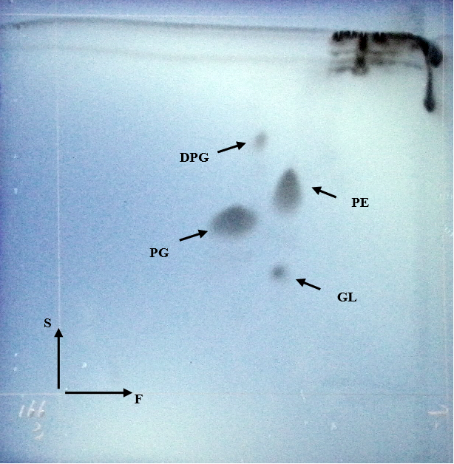

**Figure S2.** Polar lipids of strain LZ166T following separation by two-dimensional TLC. DPG, diphosphatidylglycerol. PE, phosphatidylethanolamine. GL, glycolipid. PG, phosphatidylglycerol.

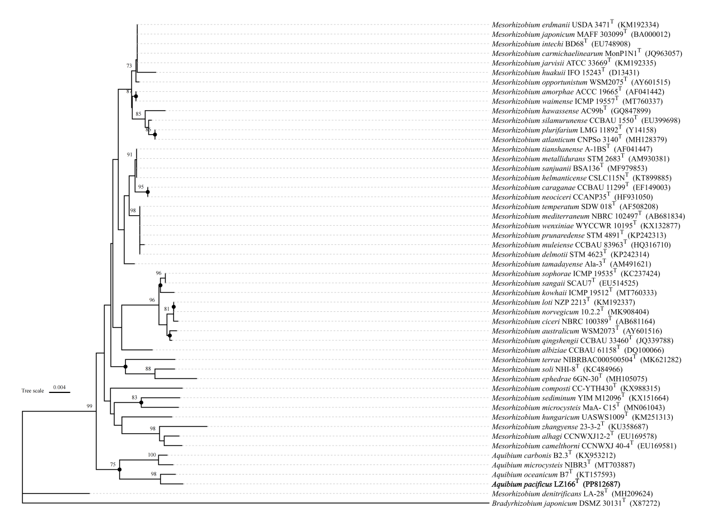

**Figure S3**. Minimum evolution phylogenetic tree based on 16S rRNA gene sequences showing the position between strain LZ166T and other closely related phylogenetic neighbors. Bootstrap numbers (>70%) are shown with 1000 calculations. Solid circle represented that branches are also recovered in the maximum likelihood and neighbor joining trees. *Bradyrhizobium japonicum* DSMZ_30131T (X87272) is used as the out group. Bar, 0.004 substitutions per nucleotide position.

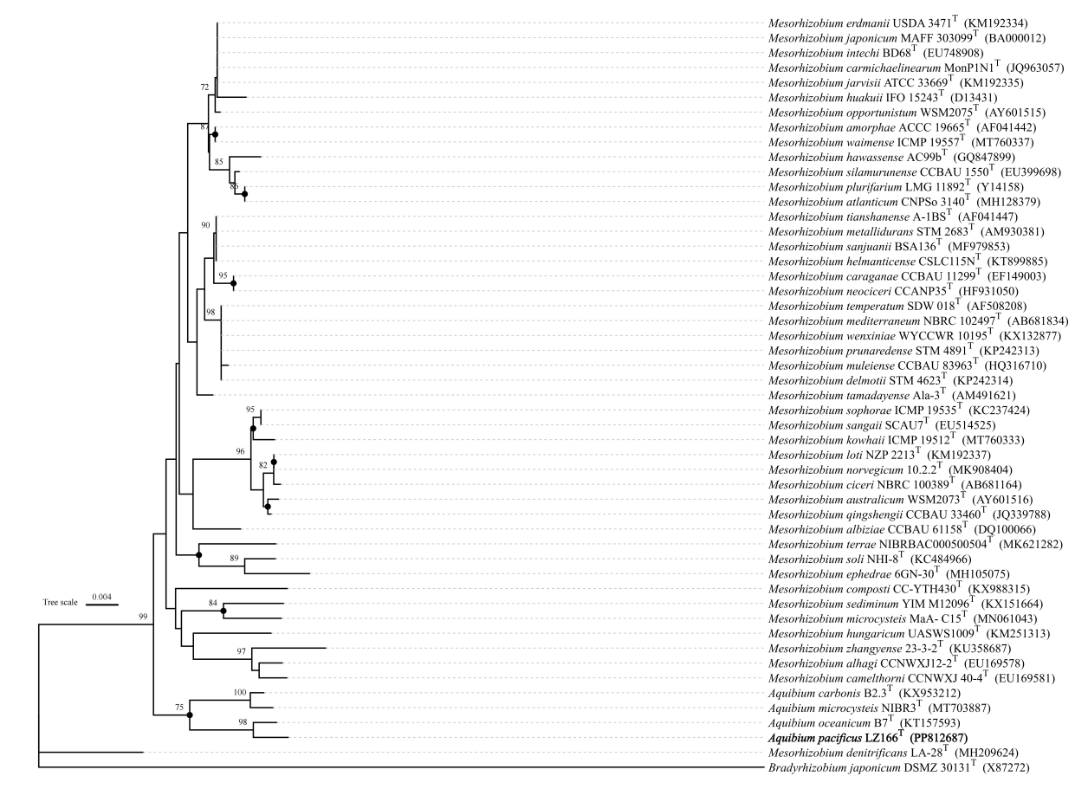

**Figure S4.** Neighbor joining phylogenetic tree based on 16S rRNA gene sequences showing the position between strain LZ166T and other closely related phylogenetic neighbours. Bootstrap numbers (>70%) are shown with 1000 calculations. Solid circle represented that branches are also recovered in the maximum likelihood and minimum evolution trees. *Bradyrhizobium japonicum* DSMZ_30131T (X87272) is used as the out group. Bar, 0.004 substitutions per nucleotide position.

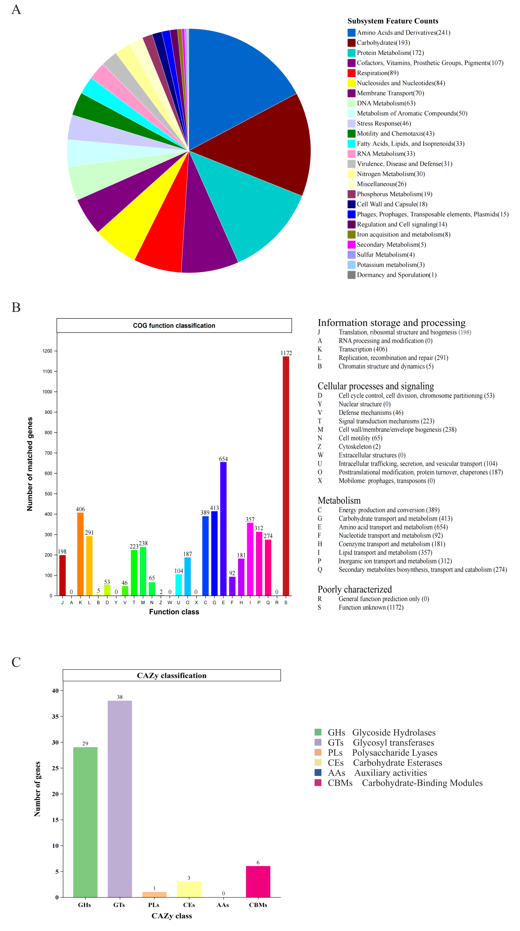

**Figure S5.** Genes classification of strain LZ166T against the RAST, COG and CAZy databases. (A) the subsystem category number of genes by RAST annotation server. (B) number of genes associated with the 26 general COG functional categories. (C) Number of genes associated with the CAZy categories.

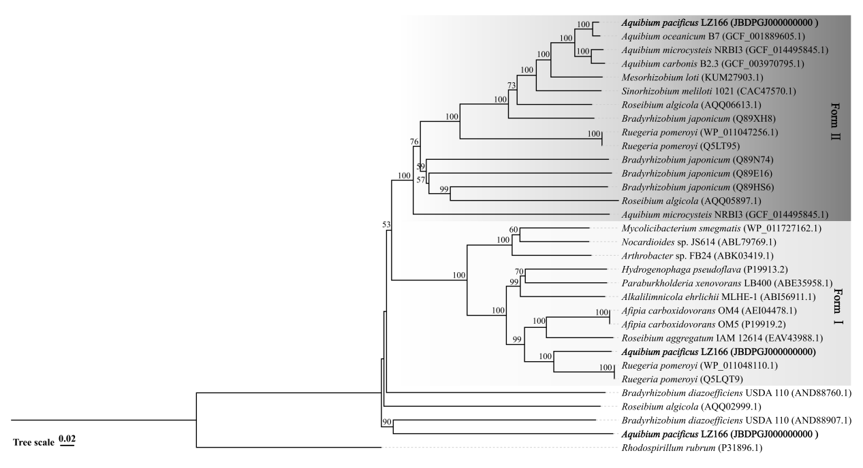

**Figure S6.** Phylogenetic analysis of form I and form II putative CoxL partial amino acid sequences based on alignments using ClustalW and analysis using MEGA7 with a neighbour-joining algorithm. Bootstrap values (%) are indicated at the branch nodes and were calculated from 1000-resample datasets. Threshold higher than 50% is displayed in the tree. Amino acid of Ni, Fe-CODH large subunit in *Rhodospirillum rubrum* (P31896.1) is used as the out group. Bar, 0.02 substitutions per amino position.

**Table S1.** The Biolog GNⅢ test of strain LZ166T.

|  |  |  |
| --- | --- | --- |
| **Biolog GNⅢ test** | | |
| Negative contract | inosine | **D-glucuronic acid** |
| **Dextrin** | 1% sodium lactate | **Glucuronamide** |
| D-maltose | fusidic acid | Mucic acid |
| D-trehalose | D-serine | **Quinic acid** |
| **D-cellobiose** | **D-sorbitol** | D-saccharic acid |
| **Gentiobiose** | **D-mannitol** | Vancomycin |
| Sucrose | **D-arabitol** | **Tetrazolium violet** |
| **D-turanose** | Myo-inositol | Tetrazolium blue |
| Stachyose | Glycerol | p-hydroxyphenylacetic acid |
| **Positive contract** | D-glucose-6-PO4 | Methyl pyruvate |
| **pH6** | **D-fructose-6-PO4** | D-lactic acid methyl ester |
| pH5 | D-aspartic acid | L-lactic acid |
| D-raffinose | D-serine | Citric acid |
| α-D-lactose | Troleandomycin | **α-ketoglutaric acid** |
| D-melibiose | Rofamycin SV | D-malic acid |
| β-methyl-D-glucoside | Minocycline | L-malic acid |
| D-salicin | Gelatin | Bromosuccinic acid |
| N-acetyl-D-glucosamine | Glycyl-L-proline | **Nalidixic acid** |
| N-acetyl-β-D-mannosamine | L-alanine | Lithium chloride |
| N-acetyl-D-galactosamine | L-arginate | Potassium tellurite |
| N-acetyl-neuraminic acid | L-aspartic acid | Tween 40 |
| **1%NaCl** | **L-glutamic acid** | γ-aminobutyric acid |
| 4%NaCl | L-histidine | **α-hydroxybutyric acid** |
| 8%NaCl | L-pyroglutamic acid | **β-hydroxy-D,L-butyric acid** |
| **α-D-glucose** | L-serine | α-ketobutyric acid |
| D-mannose | Lincomycin | **Acetoacetic acid** |
| **D-fructose** | Guanidine HCl | **Propionic acid** |
| D-galactose | Niaproof 4 | **Acetic acid** |
| 3-methyl glucose | Pectin | Formic acid |
| **D-fucose** | **D-galacturonic acid** | Aztreonam |
| L-fucose | **L-galactonic acid lactone** | **Sodium butyrate** |
| L-rhamnose | D-gluconic acid | Sodium bromate |

Bold means positive.

**Table S2.** Cellular fatty acid compositions of strain LZ166T and its reference strains.

|  |  |  |  |  |
| --- | --- | --- | --- | --- |
| **Fatty acid （%）** | | **LZ166T** | ***A. microcysteis***  **NIBR3T** | 1. ***oceanicum***   **B7T** |
| Saturated | C9:0 | ND | 0.2 | ND |
| C11:0 | 0.2 | 0.1 | ND |
| C16:0 | **5.5** | 3.6 | **5.3** |
| C17:0 | 3.5 | 2.2 | 2.9 |
| C18:0 | 4.1 | **5.8** | **6.9** |
| C19:0 | 0.8 | 1.0 | 1.1 |
| C20:0 | 1.6 | 2.4 | 1.4 |
| Hydroxy | C8:0 3-OH | ND | 0.1 | ND |
| C10:0 2-OH | ND | ND | 0.7 |
| C10:0 3-OH | ND | ND | 0.9 |
| C11:0 3-OH | ND | ND | 0.3 |
| C12:0 3-OH | 0.1 | 0.3 | ND |
| C15:0 2-OH | 0.3 | ND | ND |
| C16:0 3-OH | 0.4 | ND | ND |
| C16:1 2-OH | 0.3 | ND | ND |
| C18:0 3-OH | 0.5 | 0.1 | 0.4 |
| Branched | iso-C10:0 | ND | ND | 1.8 |
| iso-C11:0 | 0.9 | 0.3 | 0.9 |
| iso-C11:0 3-OH | 0.7 | 0.3 | 0.6 |
| iso-C12:0 3-OH | ND | ND | 0.1 |
| iso-C13:0 3-OH | 0.5 | 0.9 | 1.5 |
| iso-C15:0 | 1.4 | 0.7 | 0.7 |
| iso-C15:1 F | ND | 0.4 | 1.1 |
| anteiso-C15:1 A | ND | ND | 0.4 |
| iso-C16:0 | ND | ND | 0.2 |
| iso-C17:0 | **13.3** | 4.3 | **5.5** |
| iso-C17:0 3-OH | 0.2 | ND | ND |
| iso-C19:0 | 0.8 | 0.7 | 0.4 |
| anteiso-C19:0 | ND | 0.1 | 0.2 |
| C19:0 cyclo *ω*8*c* | **9.3** | ND | **5.4** |
| Unsaturated | C16:1 *ω*11*c* | ND | 0.3 | ND |
| C17:1 *ω*6*c* | 0.7 | 0.5 | 0.5 |
| C17:1 *ω*8*c* | 1.0 | 1.7 | 0.9 |
| C18:1 *ω*9*c* | 1.1 | 1.4 | 2.4 |
| 11-methyl C18:1 *ω*7*c* | **12.0** | **11.6** | **9.6** |
| C20:1 *ω*7*c* | 0.5 | 0.4 | 1.3 |
| C20:2 *ω*6,9*c* | ND | ND | 0.3 |
| Summed feature | 1* | ND | 0.3 | 0.8 |
| 2* | 0.5 | ND | ND |
| 3* | 0.8 | 1.0 | 0.8 |
| 4* | ND | 0.2 | 0.4 |
| 7* | ND | 0.3 | ND |
| 8* | **39.3** | **58.4** | **44.3** |
| 9* | 0.36 | 0.3 | ND |

1* contains iso-C15:1 H,C13:0 3-OH and/or i-C15:1 H. 2* contains aldehyde -C12:0 and/or unknown 10.928. 3* contains C16:1 *ω*7*c* and/or C16:1 *ω*6*c*. 4* contains iso-C17:1 I and/or anteiso-C17:1 B. 7* contains unknown 18.846 and/or C19:1 *ω*6*c*. 8* contains C18:1 *ω*7*c* and/or C18:1 *ω*6*c*. 9* contains iso-C17:1 *ω*9*c* and/or 10-methyl C16:0. Major fatty acid components (>5.0%) are showed in bold. ND, no detected. All data was obtained in this study.

**Table S3.** The average nucleotide identity(ANI), average amino identity(AAI) and digital DNA-DNA hybridization (dDDH) value (%) between strain LZ166T and its close-related strains in *Aquibium*.

|  |  |  |  |
| --- | --- | --- | --- |
|  | *A. oceanicum* B7T | *A. microcysteis* NIBR3T | *A. carbonis* B2.3T |
| ANI (%) | 90.73 | 77.23 | 76.79 |
| AAI(%) | 88.50 | 79.71 | 79.03 |
| dDDH(%) | 36.1 | 22.8 | 22.2 |