Appendix A
Figure S1. Pictures of selected thrips species (by co-author Marcin Cierpisz).
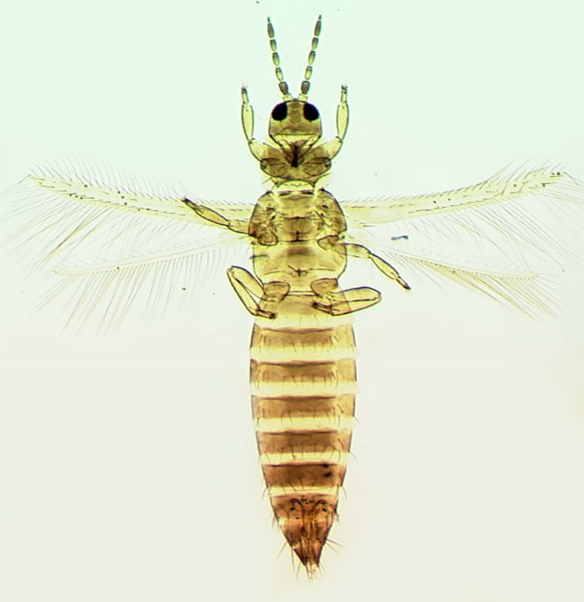 | 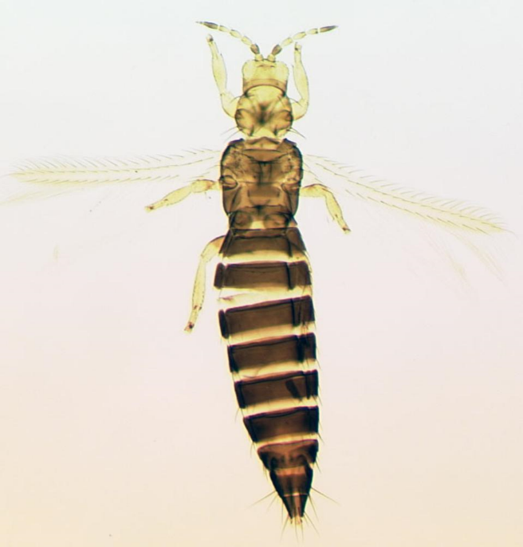
A – Thrips tabaci – female | B - Frankliniella intonsa – female
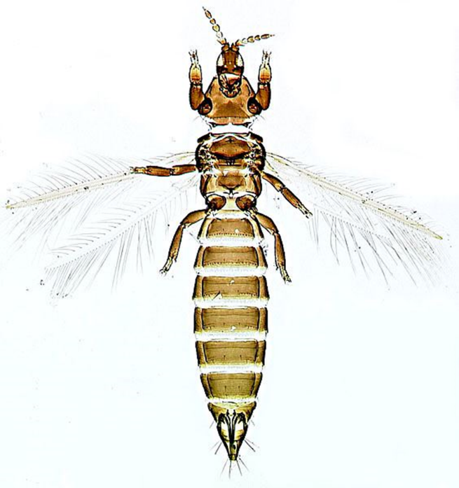 | 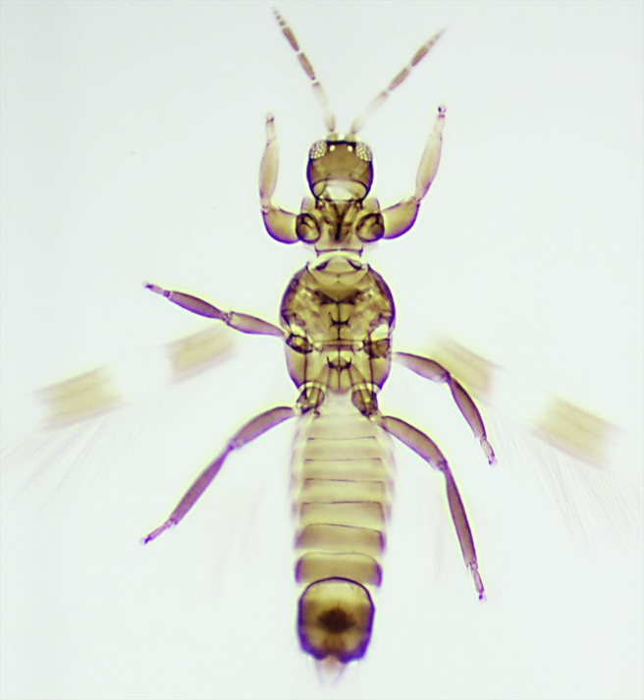
C - Chirothrips manicatus – female | D - Aeolothrips intermedius - male

