Supplementary Materials
Methyl/^{t}butyl salicylate bearing zirconium compounds and their catalytic activity on ε-caprolactone
Gamze Uzun and Asgar Kayan*
Kocaeli University, Department of Chemistry, Kocaeli, 41380, Turkey

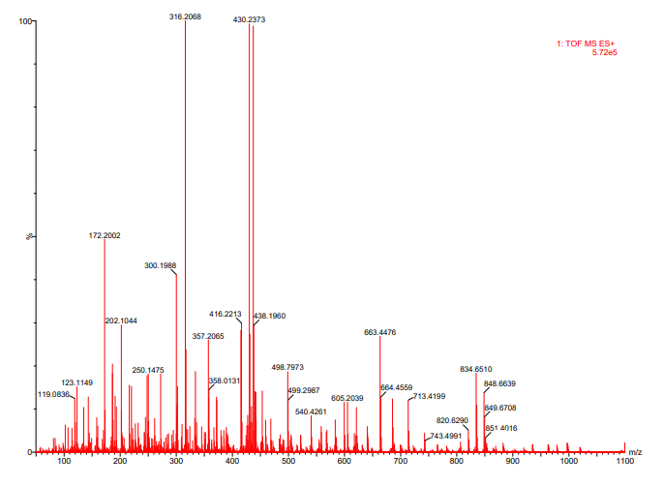

Figure S1. MS spectrum of C7

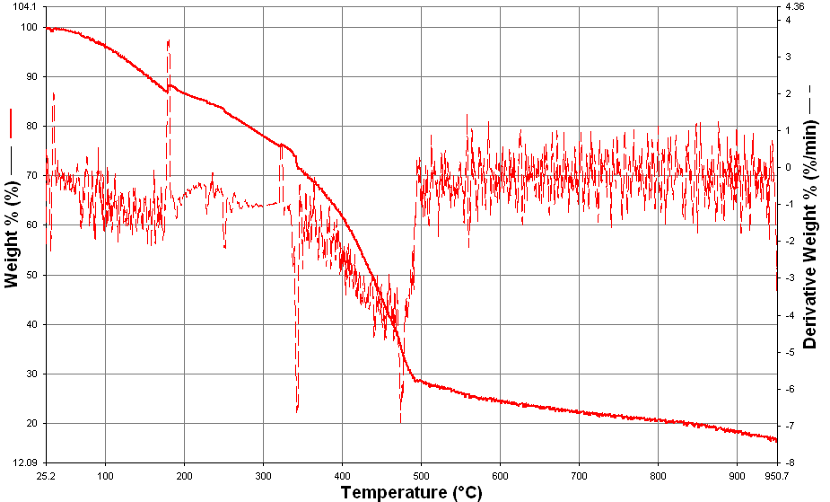
%mass loss= 83.366%

Figure S2. TGA spectrum of C8

