Supplemental Table 1. Antibodies used for confocal imaging.
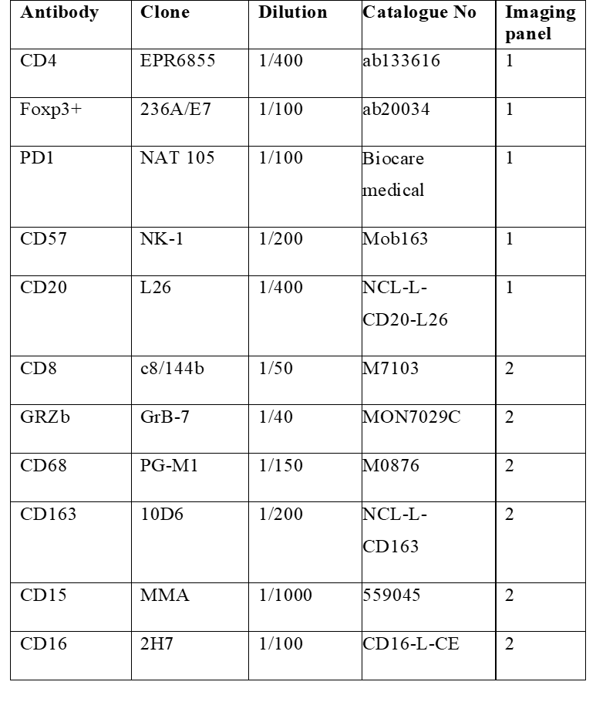

Supplemental Table 2. Mann-Whitney test generated p values were corrected using FDR correction with q=0.05.
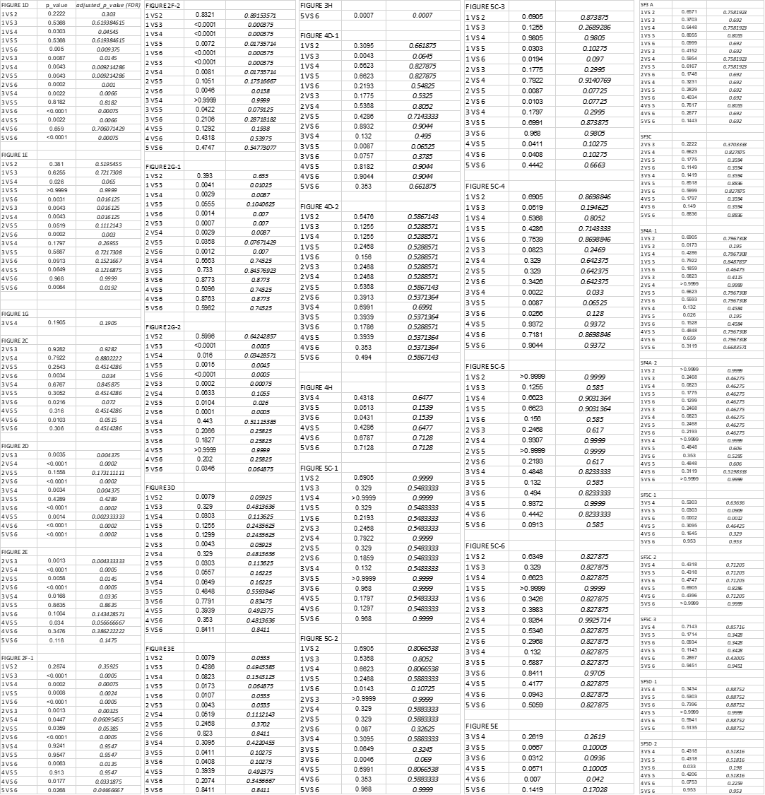

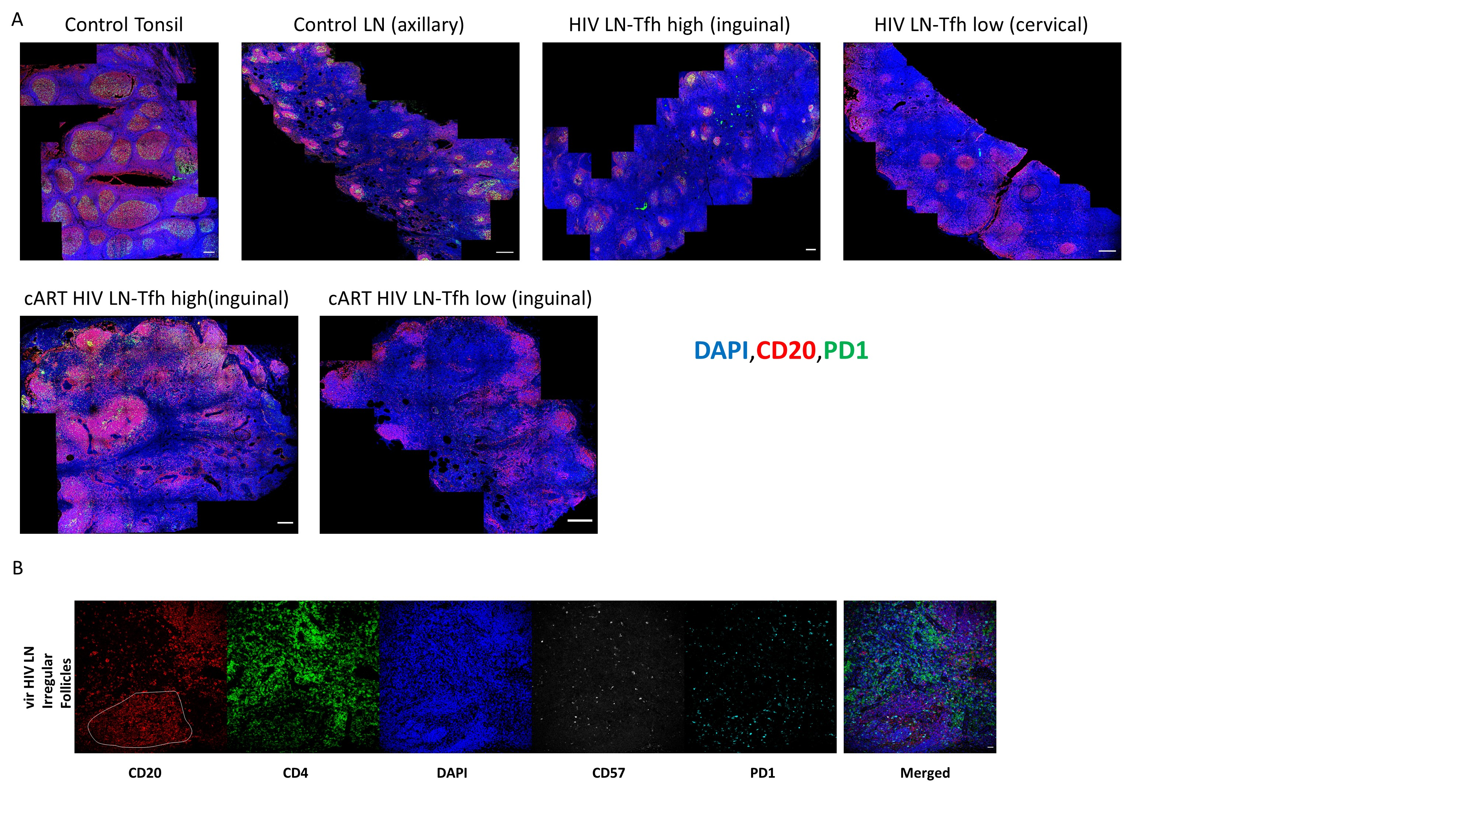
Supplemental Figure 1. (A) Representative whole-tissue examples of CD20 (red), PD1 (green) and DAPI (blue) staining pattern from control tonsils, control LNs, vir HIV LNs and cART HIV LNs (scale bar: 300 μm). (B) Representative examples of CD20 (red), CD4 (green), DAPI (blue), CD57 (grey) and PD1 (cyan) staining pattern from a cART HIV LN (scale bar: 30 μm). The white line denotes the follicular area.
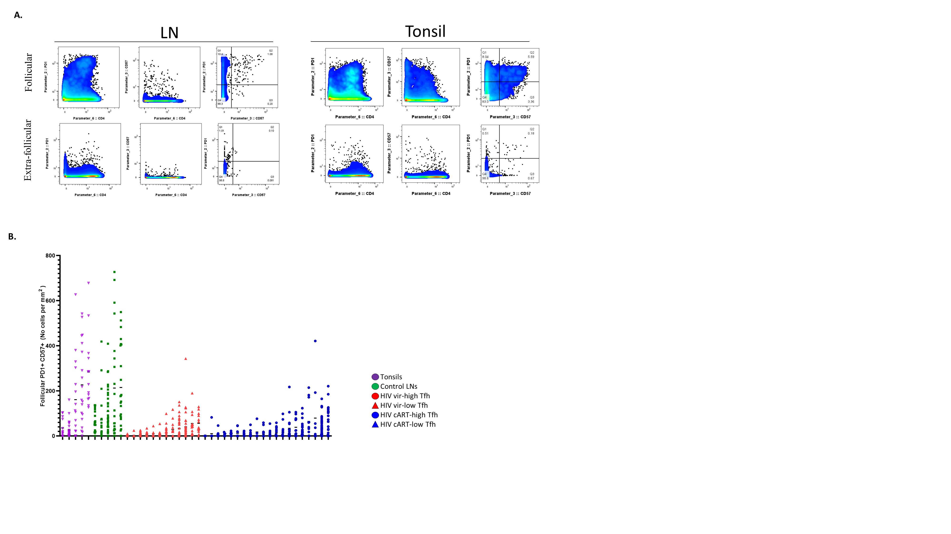
Supplemental Figure 2. (A) Immunophenotyping gating strategy used for the identification of T_{FH} cells in lymphoid and tonsillar tissues of interest based on the expression of PD1 and CD57, by Histocytometry. The extrafollicular expression level was used for setting the gates identifying PD1 and CD57 subsets. An example from one LN and one tonsil are shown. (B) Dot plot graph showing the normalized numbers of PD1^{hi}CD57^{hi} T_{FH} cells in all groups. Each symbol represents a follicular area.

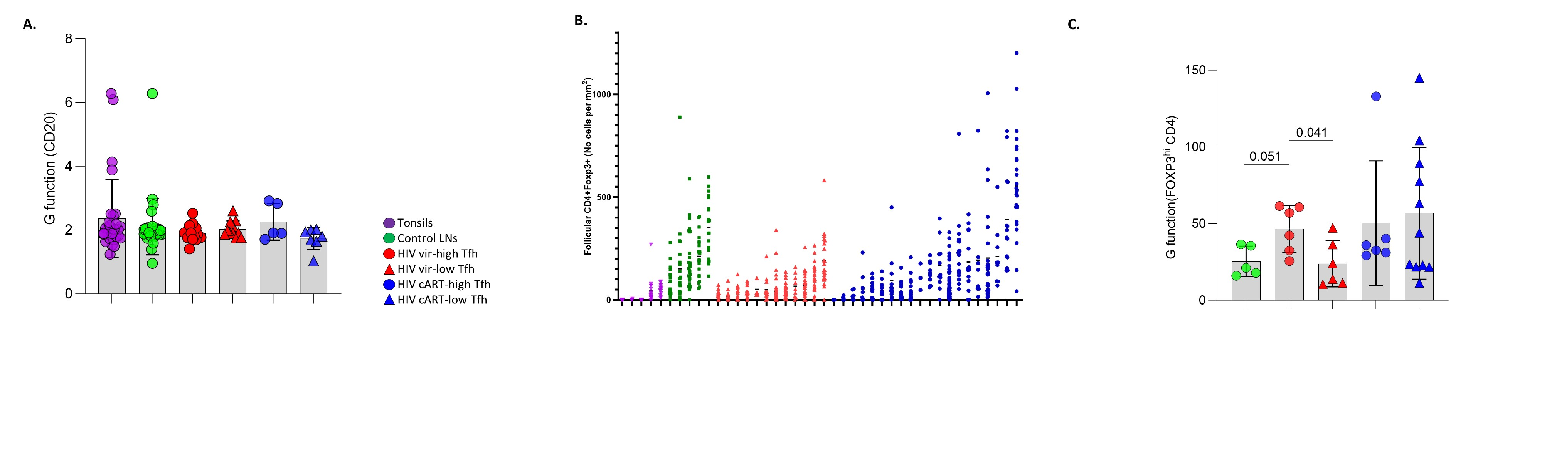
Supplemental Figure 3. (A)Bar graph showing the G function values for CD20^{hi} B cells, in all groups of tissues control tonsils (N=29), control LNs (N=29), HIV vir-high T_{FH} (N=13), HIV vir-low T_{FH} (N=5), HIV cART-high T_{FH} (N=11) and HIV cART-low T_{FH} (N=7)). (B) Dot graph showing the distribution of normalized FOXP3^{hi} CD4+ cell counts in tonsils, control LNs, vir HIV LNs and cART HIV LNs. Each symbol represents a follicle. (C) Bar graph showing the G function values for total FOXP3^{hi} CD4+ T cells in control and HIV infected LNs (control LNs (N=5), HIV vir-high T_{FH} (N=6), HIV vir-low T_{FH} (N=6), HIV cART-high T_{FH} (N=6) and HIV cART-low T_{FH} (N=11)). Each symbol represents a donor.
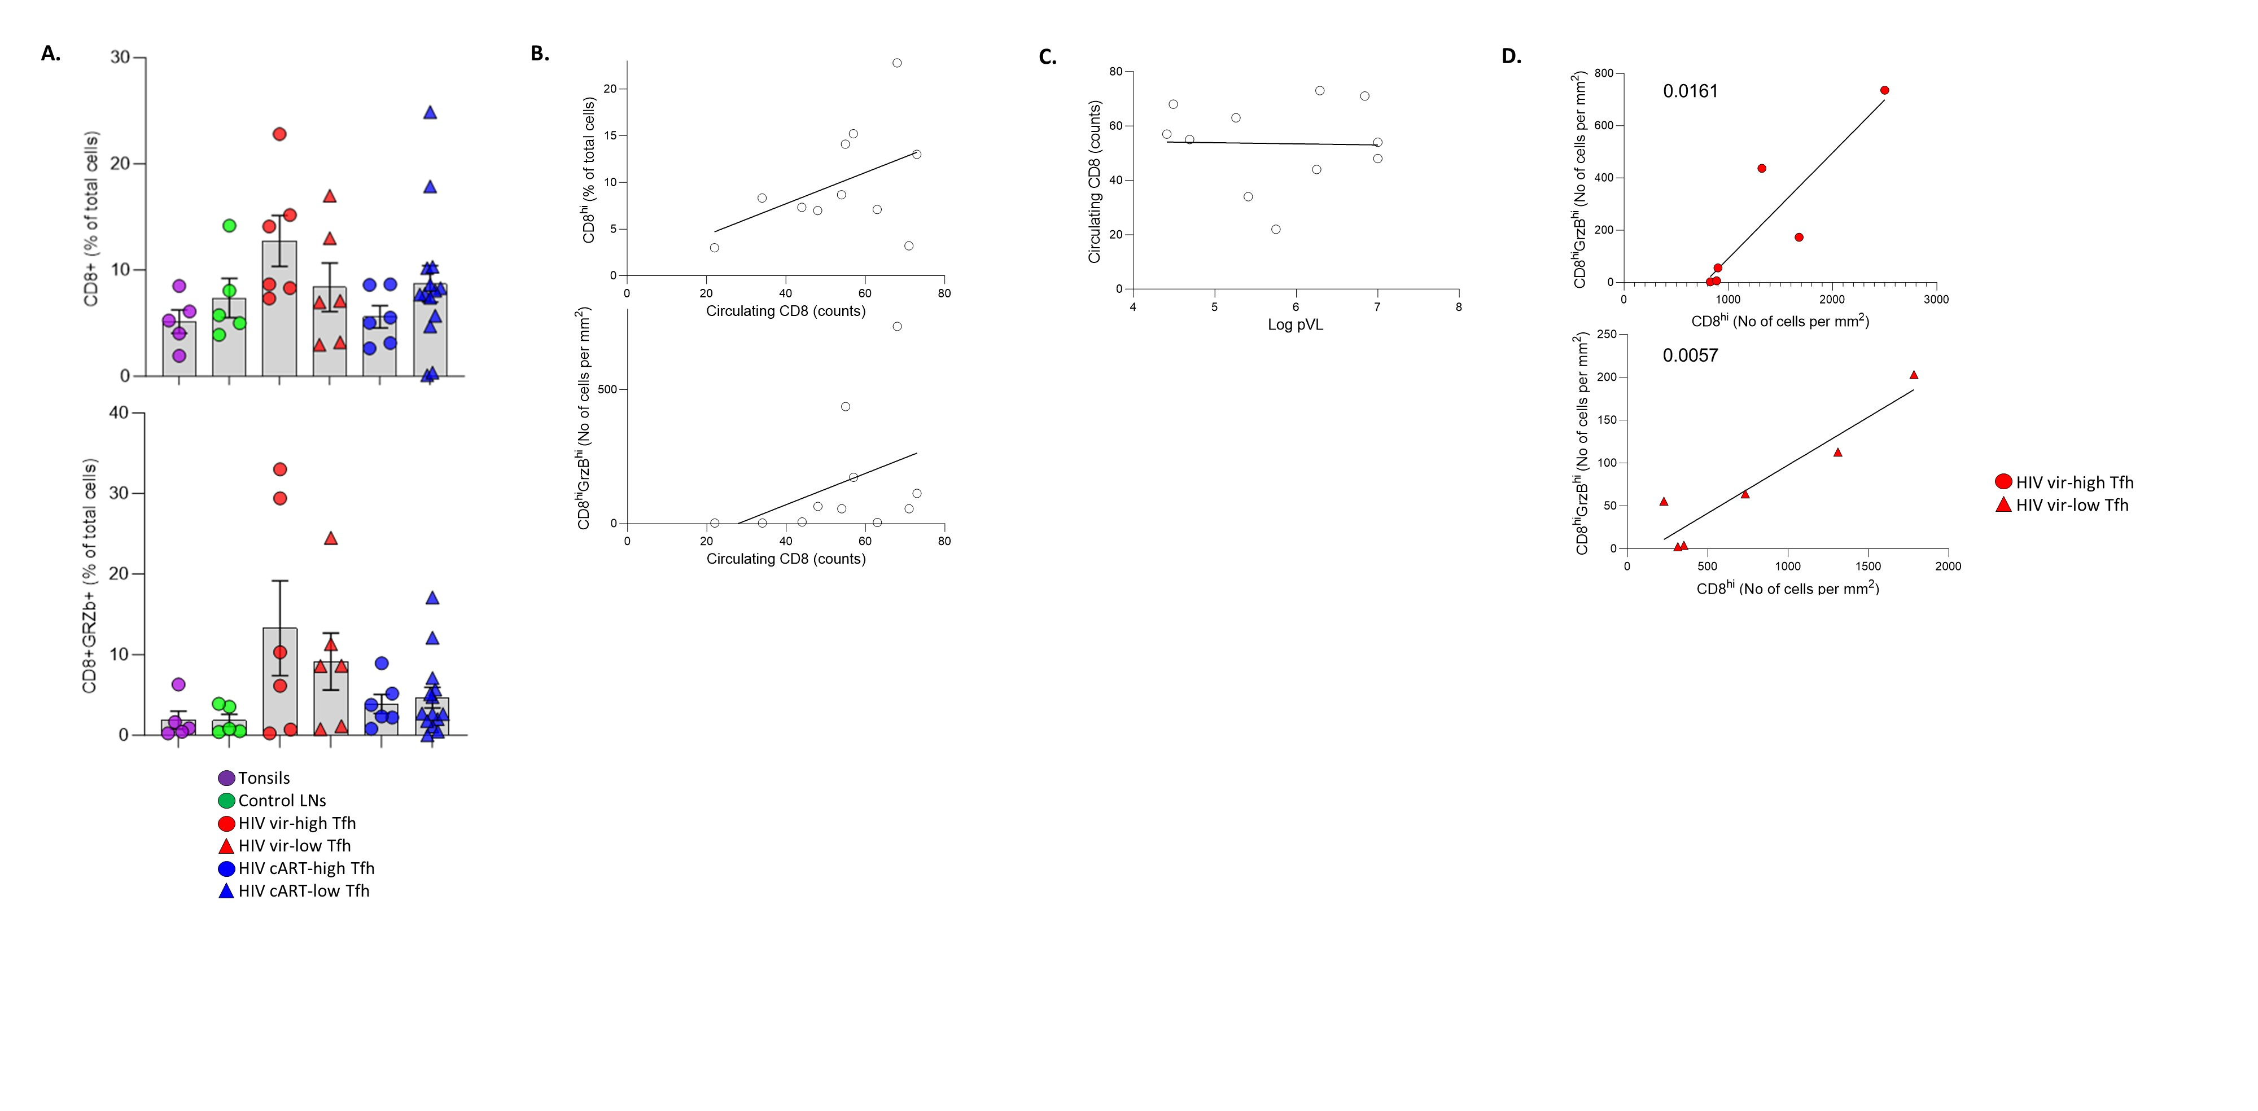
Supplemental Figure 4. (A) Bar graphs demonstrating the frequency of bulk CD8+ (upper panel) and GrzB^{hi} CD8+ (lower panel) cells in control tonsils (N=5), control LNs (N=5), HIV vir-high T_{FH} (N=6), HIV vir-low T_{FH} (N=6), HIV cART-high T_{FH} (N=6) and HIV cART-low T_{FH} (N=14).Each symbol represents a different donor.(B) Linear regression analysis between circulating CD8+ T cells and LN bulk or GrzB^{hi} CD8+ T cells in viremic PLWH. (C) Linear regression analysis between blood viral loads and counts of circulating CD8+ T cells in viremic PLWH. (D) Linear regression analysis between LN bulk and GrzB^{hi} CD8+ T cells in HIV viremic high- and low-T_{FH} subgroups.
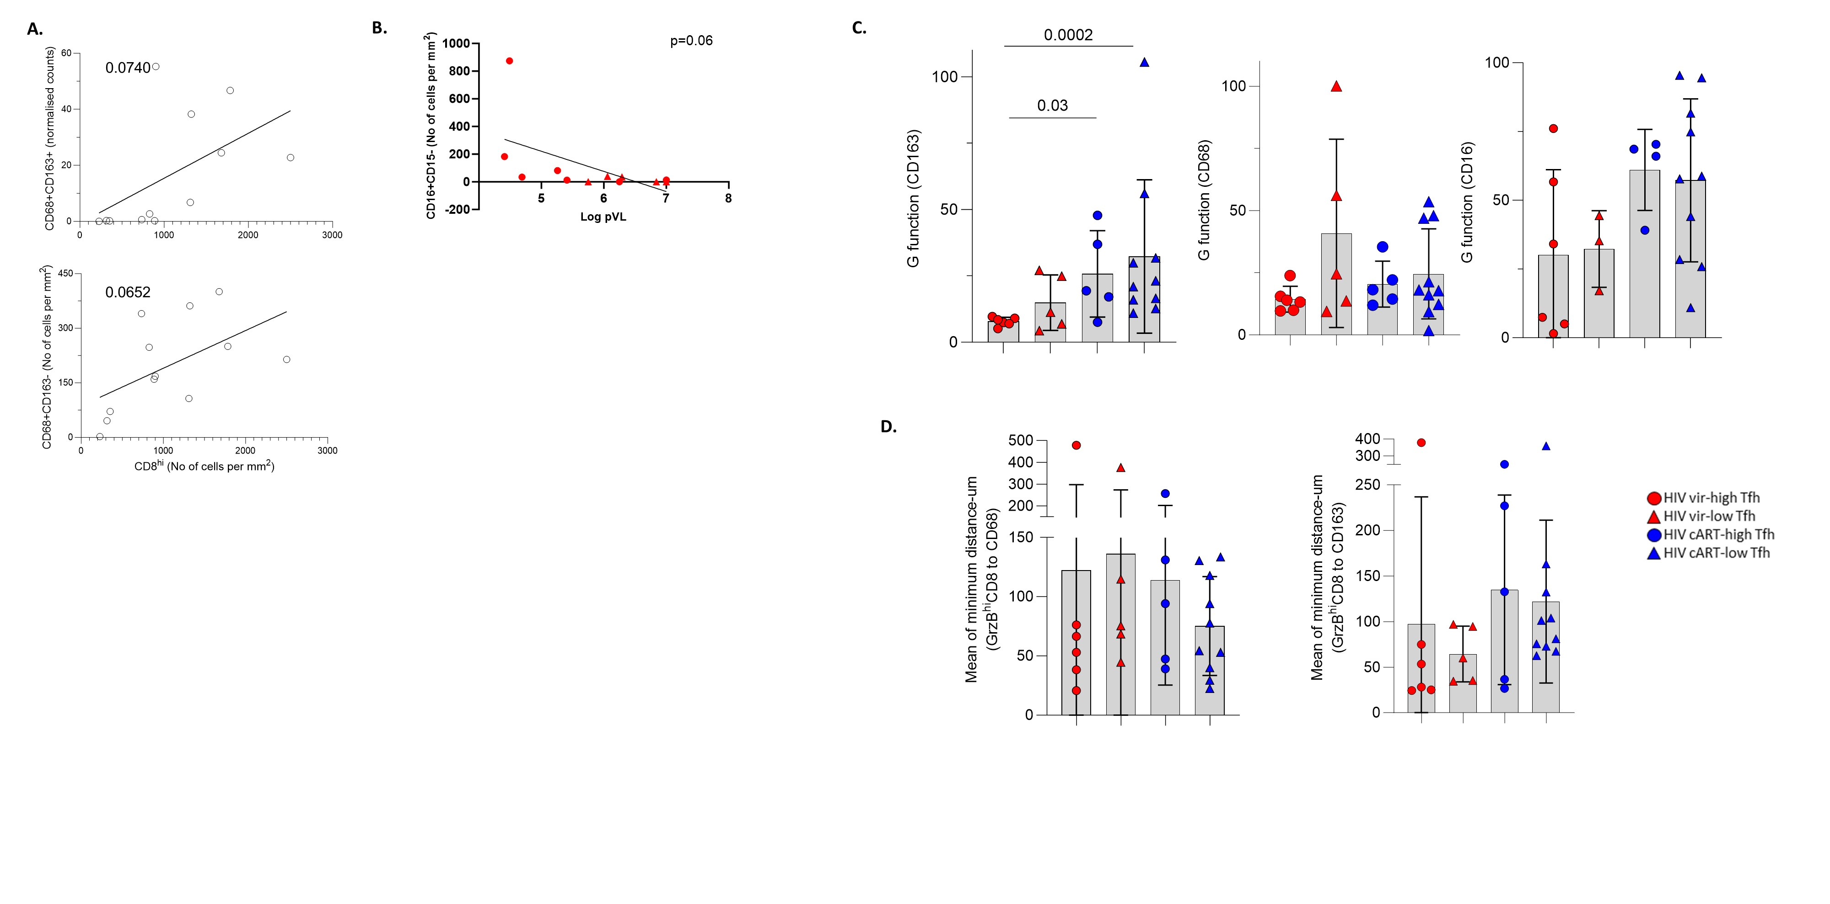
Supplemental Figure 5. (A) Linear regression analysis to show the correlation between LN CD68^{hi}CD163^{hi} (upper panel) or CD68^{hi}CD163^{lo} (lower panel) cells and LN CD8+ cells in HIV vir LNs. (B) Linear regression analysis to show the correlation between LN CD16^{hi}CD15^{lo} and blood viral load in viremic PLWH. (C) Bar graphs showing the calculated G function values for CD163^{hi} (HIV vir-high T_{FH} (N=6), HIV vir-low T_{FH} (N=5), HIV cART-high T_{FH} (N=5) and HIV cART-low T_{FH} (N=10)), CD68^{hi} (HIV vir-high T_{FH} (N=6), HIV vir-low T_{FH} (N=5), HIV cART-high T_{FH} (N=5) and HIV cART-low T_{FH} (N=10)) and CD16^{hi} (HIV vir-high T_{FH} (N=6), HIV vir-low T_{FH} (N=3), HIV cART-high T_{FH} (N=4) and HIV cART-low T_{FH} (N=10)) LN cells in HIV subgroups. (D) Bar graphs showing the mean values of the minimum distances between GrzB^{hi}CD8+ T cells and CD68^{hi} (left panel) or CD163^{hi} (right panel) cells in the HIV subgroups (HIV vir-high T_{FH} (N=6), HIV vir-low T_{FH} (N=5), HIV cART-high T_{FH} (N=5) and HIV cART-low T_{FH} (N=10)). Each symbol represents a different donor.

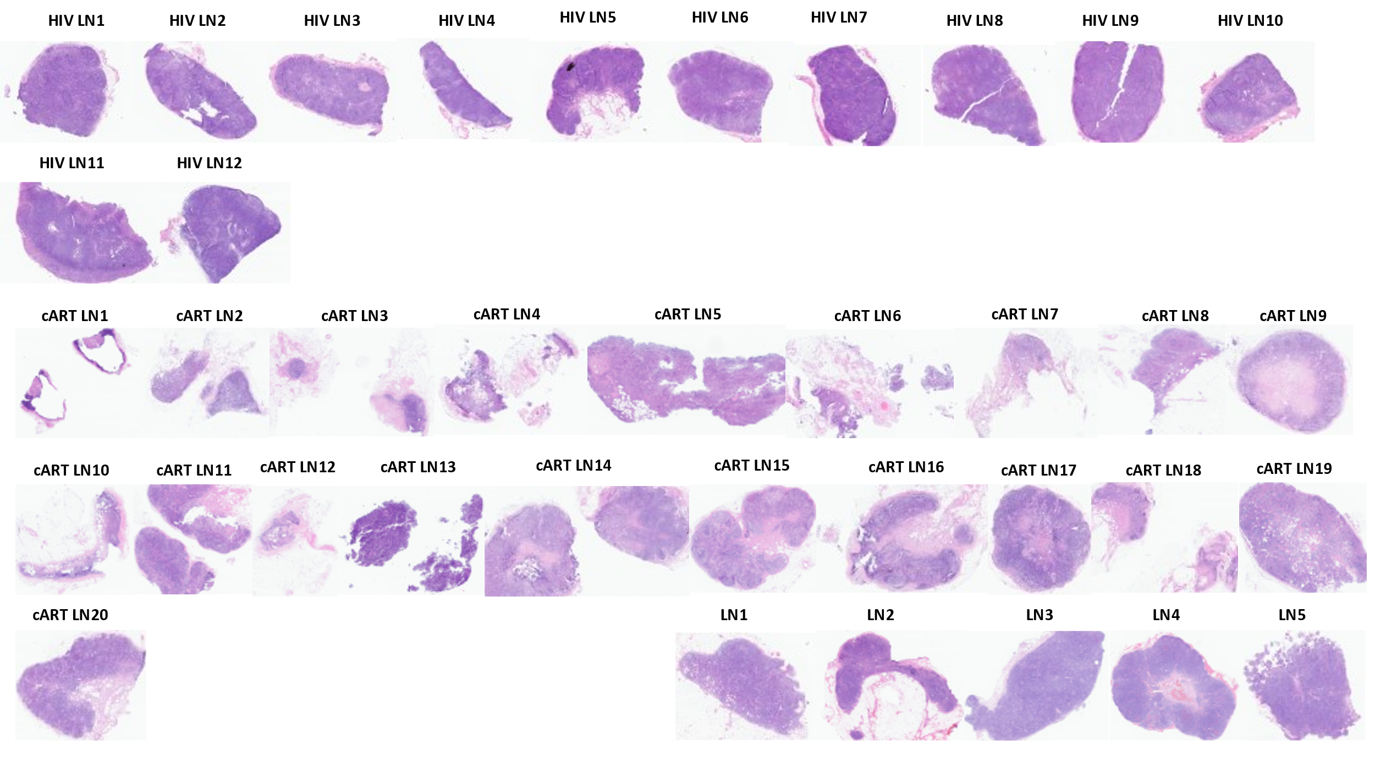
Supplemental Figure 6. Hematoxylin and eosin (H&E) staining for all the LN tissues used in this study (scale bar: 1,5mm).

