Supplementary Materials
Chiral trapped headspace GC-QMS-IMS: boosting untargeted benchtop volatilomics to the next level
Lukas Bodenbender ^{1,2}, Sascha Rohn ², Simeon Sauer ³, Markus Jungen ⁴ and Philipp Weller ^{1,} *
¹ Institute for Instrumental Analytics and Bioanalytics, Mannheim University of Applied Sciences, Paul-Wittsack-Str. 10,68163 Mannheim, l.bodenbender@hs-mannheim.de (L.B.); p.weller@hs-mannheim.de (P.W.)
² Department of Food Chemistry and Analysis, Institute of Food Technology and Food Chemistry, Technische Universität Berlin, Gustav-Meyer-Allee 25, 13355 Berlin; rohn@tu-berlin.de (S.R.)
³ Faculty of Biotechnology, Mannheim University of Applied Sciences, Paul-Wittsack-Str. 10, 68163 Mannheim; s.sauer@hs-mannheim.de (S.S.)
⁴ SGF International e.V., Marie-Curie-Ring 10a, 55291 Saulheim, Germany; markus@sgf.org (M.J.)
* Correspondence: p.weller@hs-mannheim.de; Tel.: +49-(0)621-292-6484

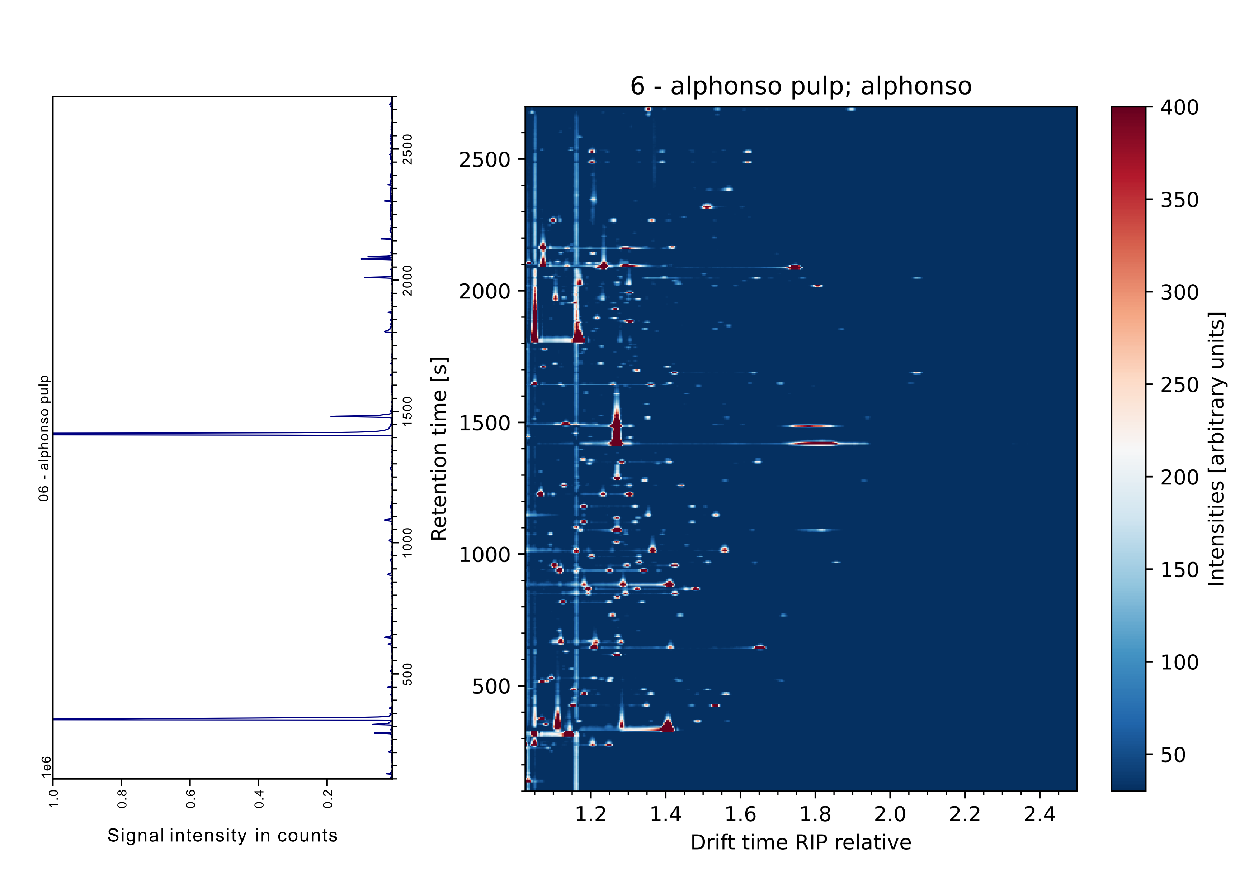
(a) (b)

Figure S1. Exemplary visualization of a ‘Alphonso´ mango sample and the simultaneous sample data of MS (a) and IMS (
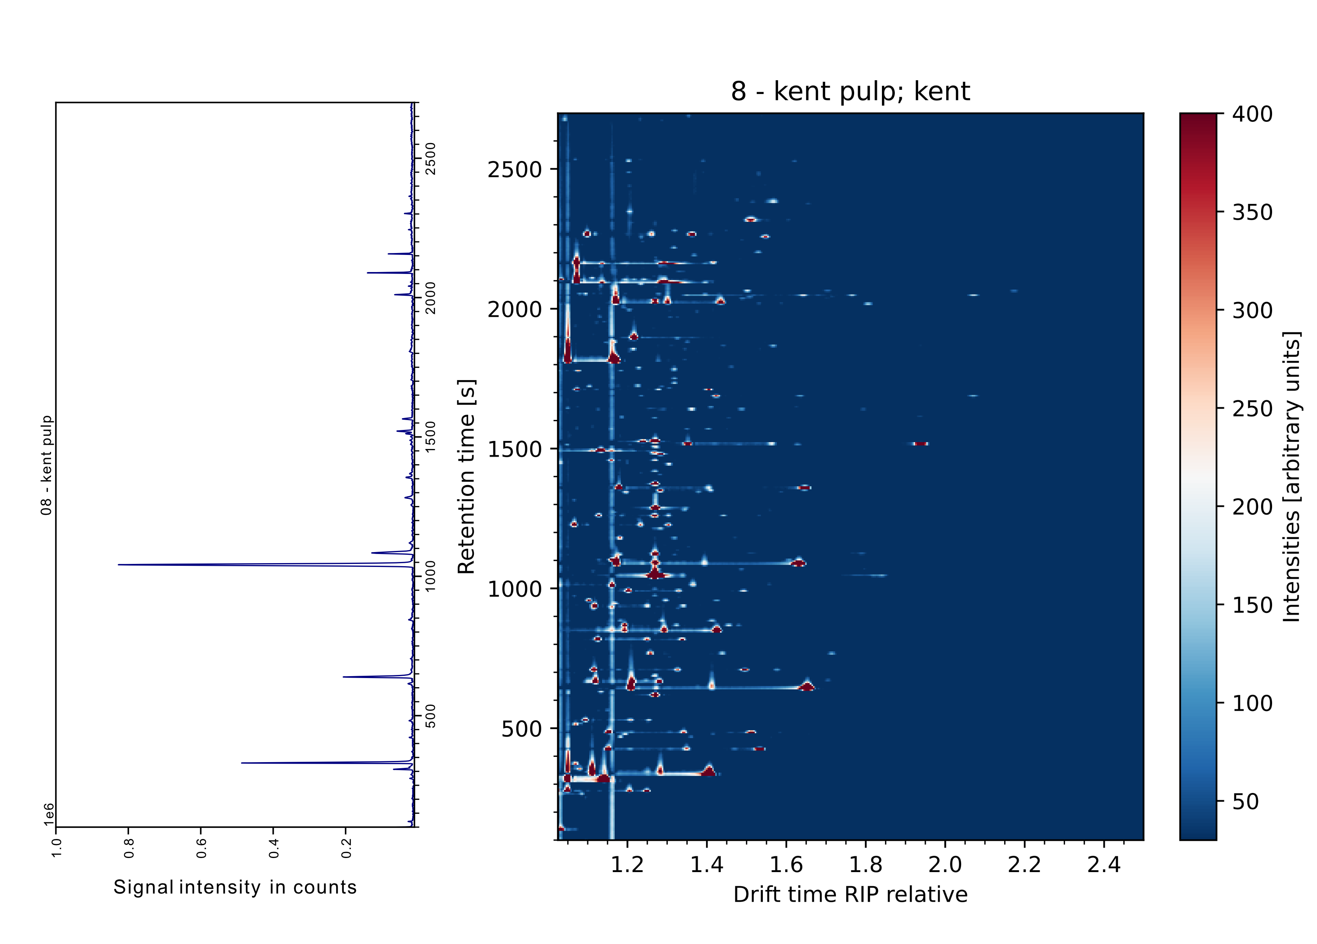
(a) (b)

Figure S2. Exemplary visualization of a ‘Kent’ mango sample and the simultaneous sample data of MS (a) and IMS (b).
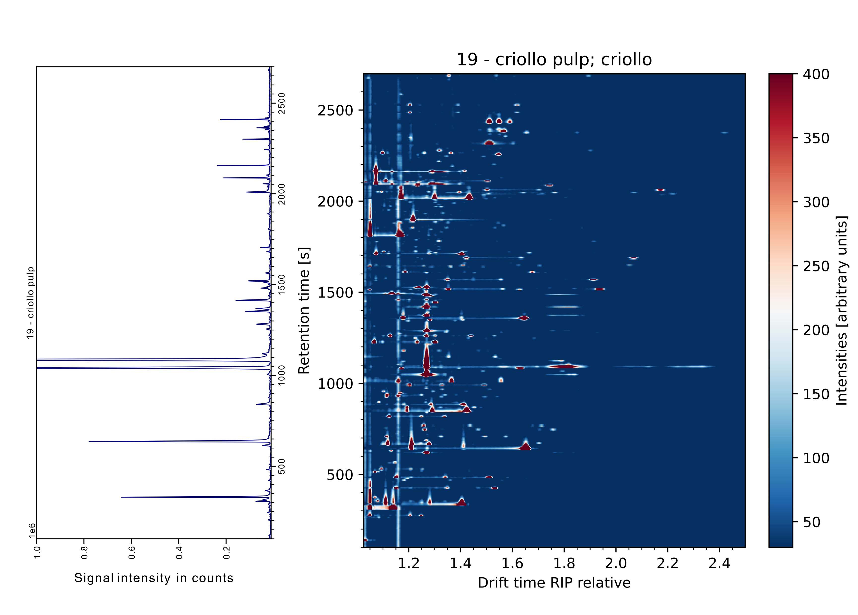
(a) (b)

Figure S3. Exemplary visualization of a ‘Criollo’ mango sample and the simultaneous sample data of MS (a) and IMS (b).
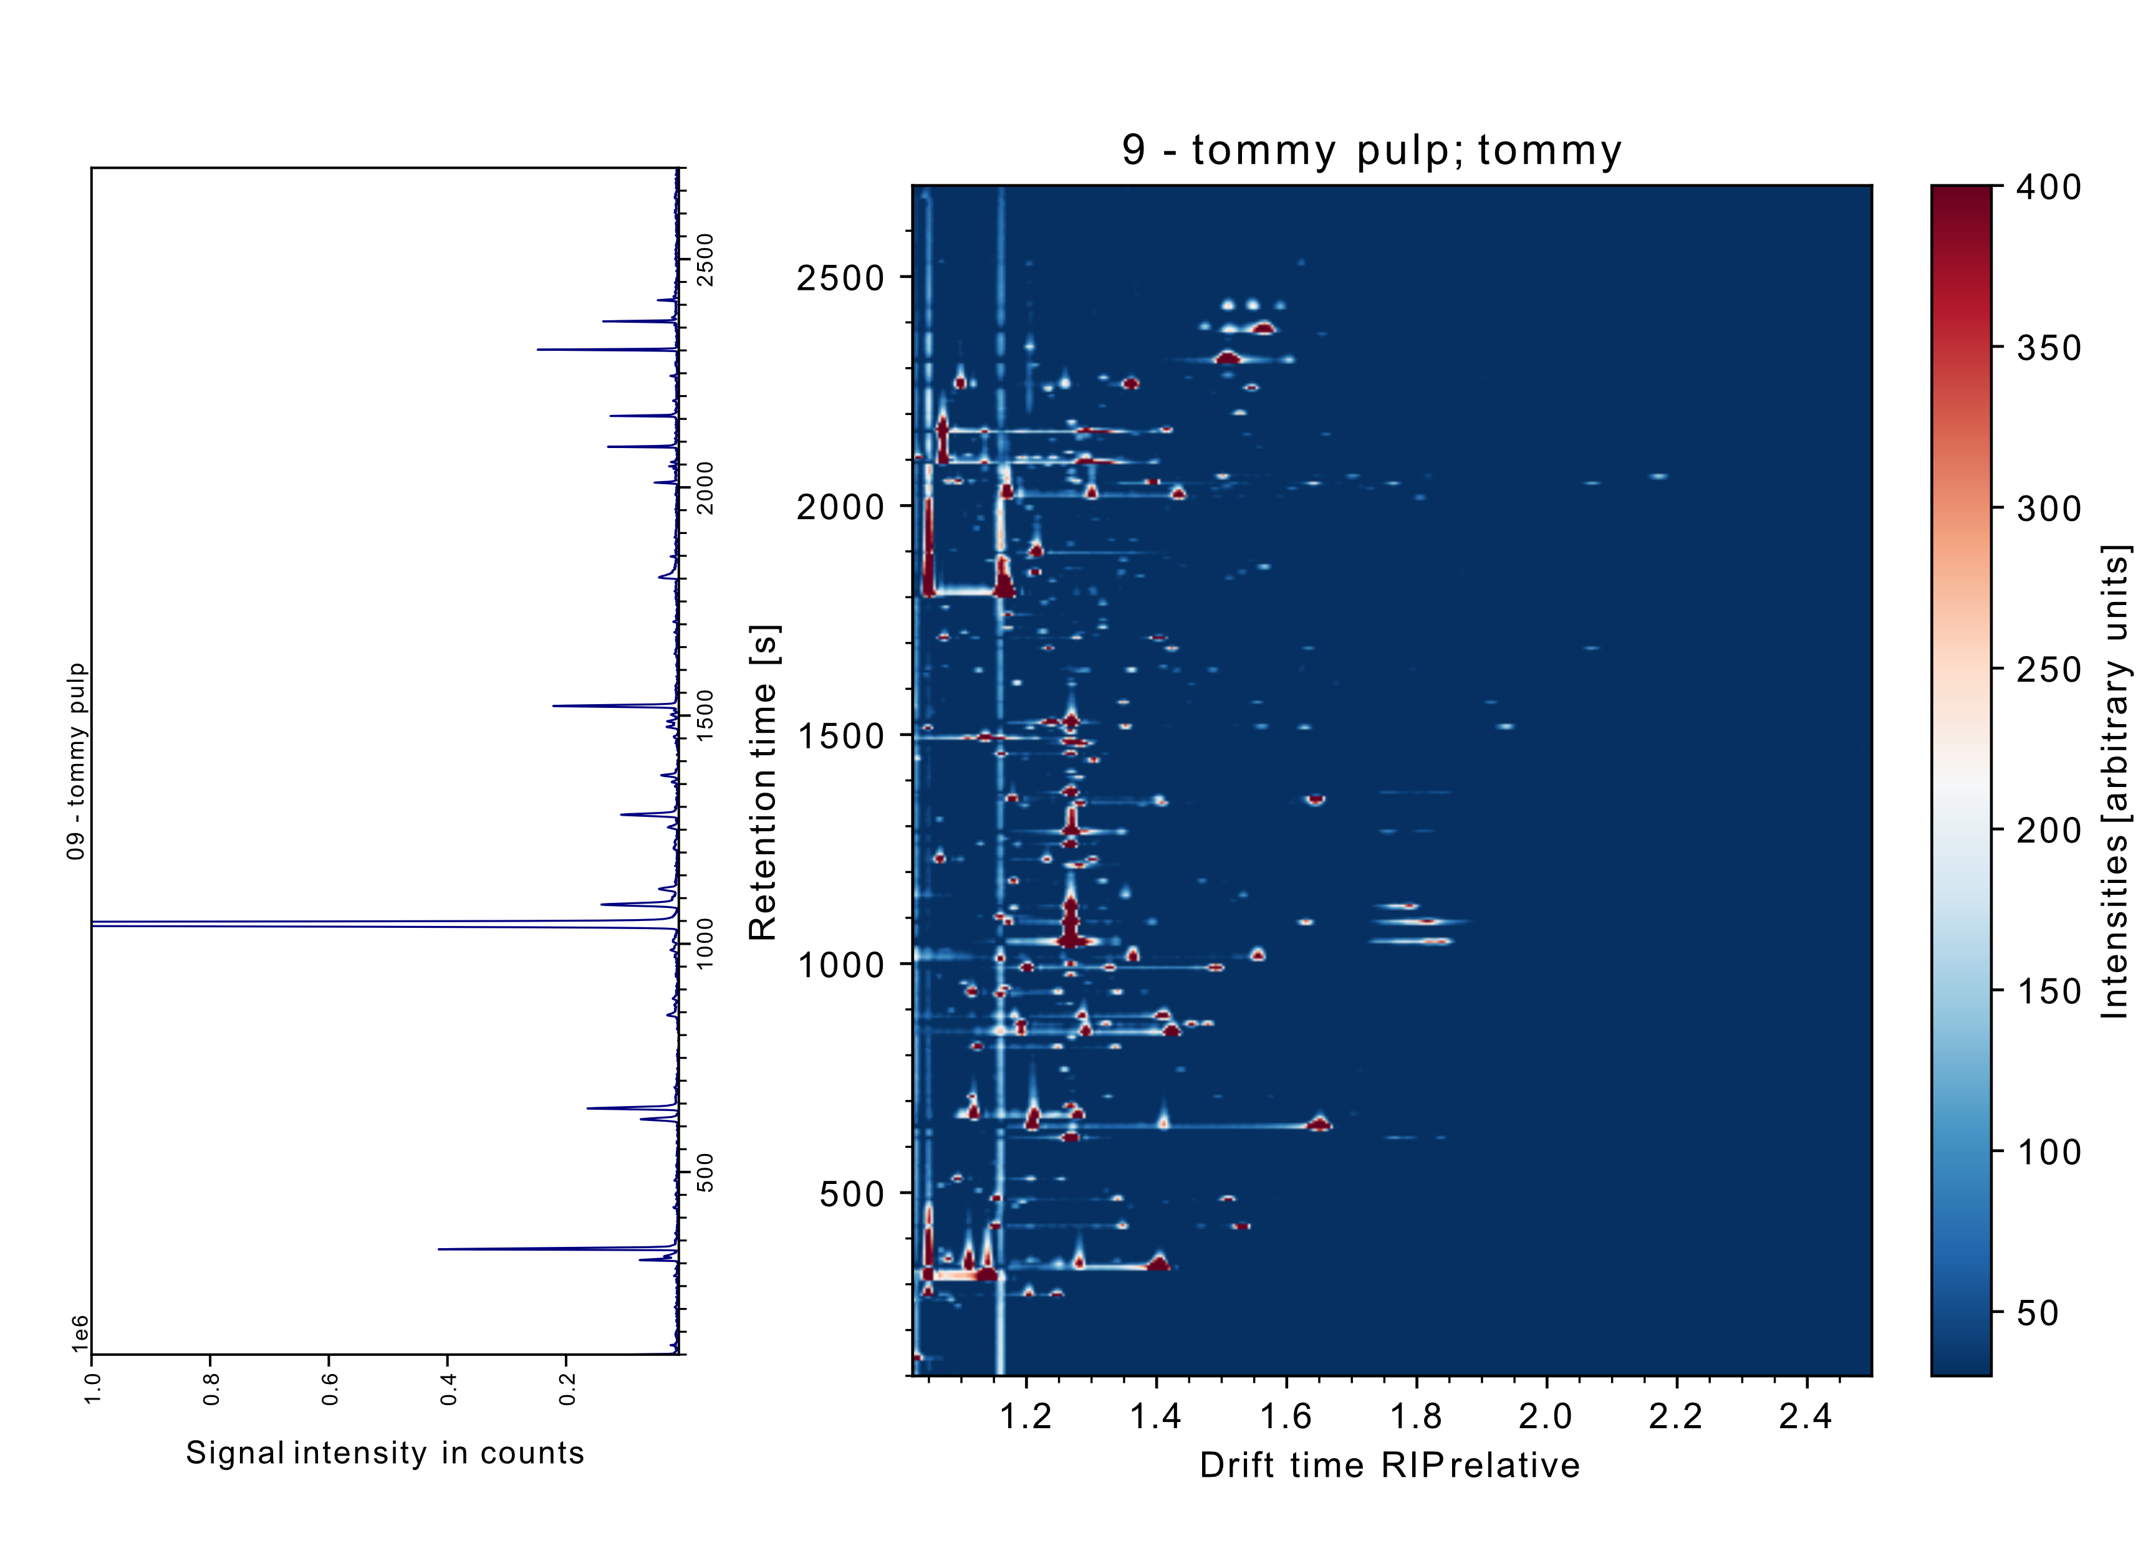

Figure S4. Exemplary visualization of a ‘Tommy’ mango sample and the simultaneous sample data of MS (a) and IMS (b)
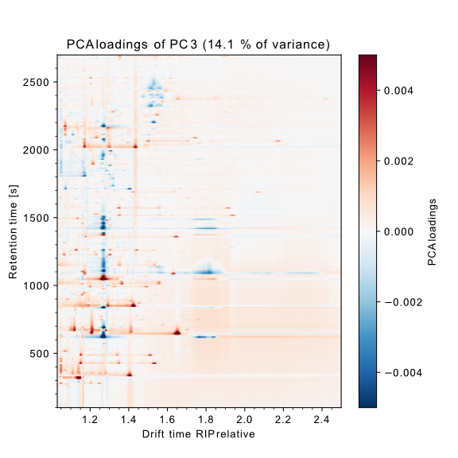
Figure S5. PCA loadings of PC3

