SUPPLEMENTAL MATERIAL
Figure S1

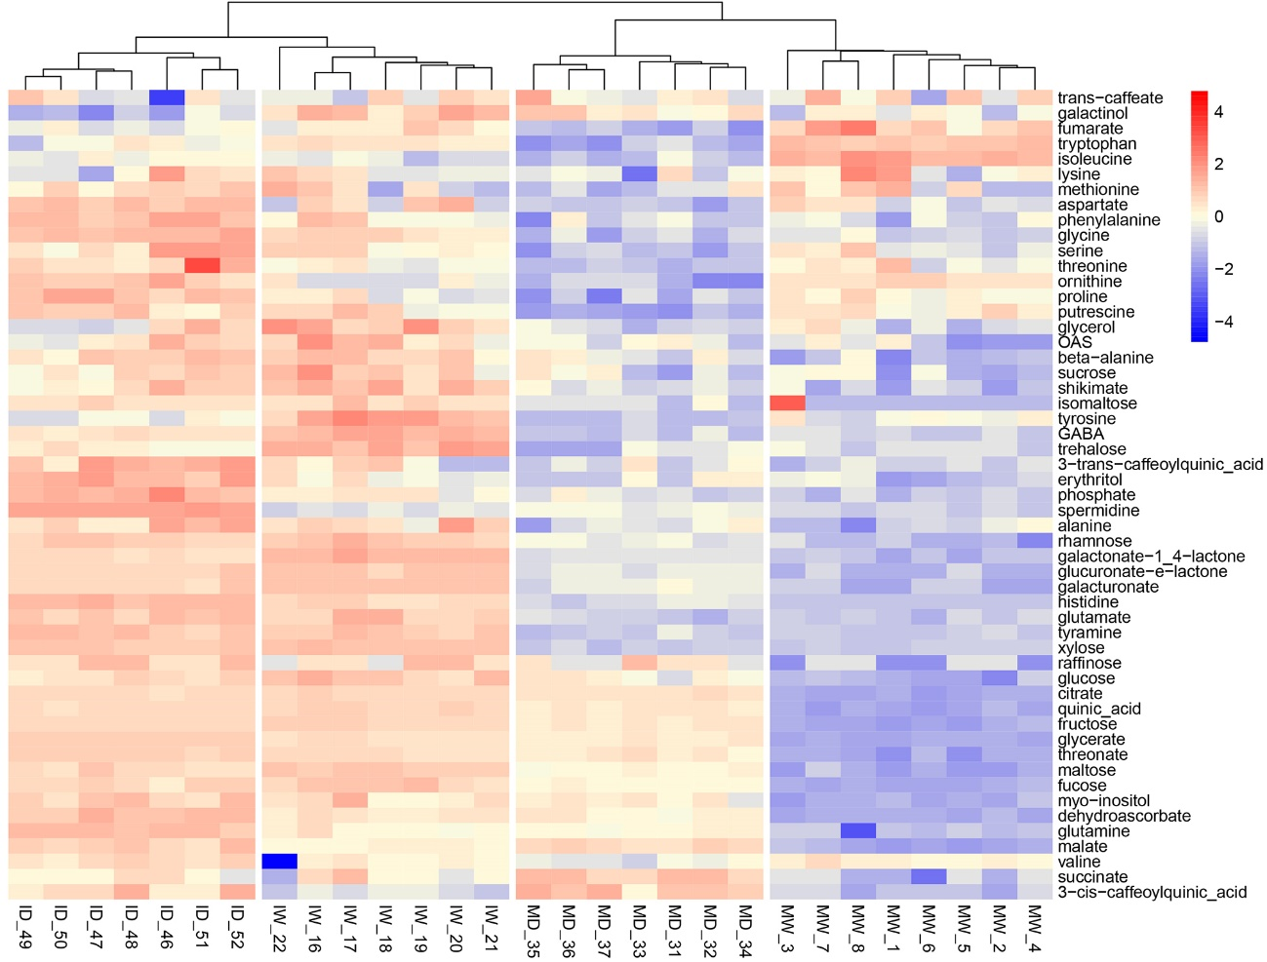

Figure S1. The effects of PVY infection, of drought, or of both combined, on the metabolome of Nicotiana benthamiana plants grown at 30 °C and 790 ppm ambient CO₂. Hierarchical heat map on the metabolomic analysis of 53 compounds present in fresh leaf tissues obtained from plants kept under the four separate treatments (mock/watered, MW; infected/watered, IW; mock/drought, MD; infected/drought, ID).

