Fig.1 Alignment of the amino acid sequences of the QRDR region for the gyrA gene of C.jejuni isolates. The position of the Thr-86-Ile mutation was compared and analyzed with the sequence in the database accession number L04566 for C.jejuni.
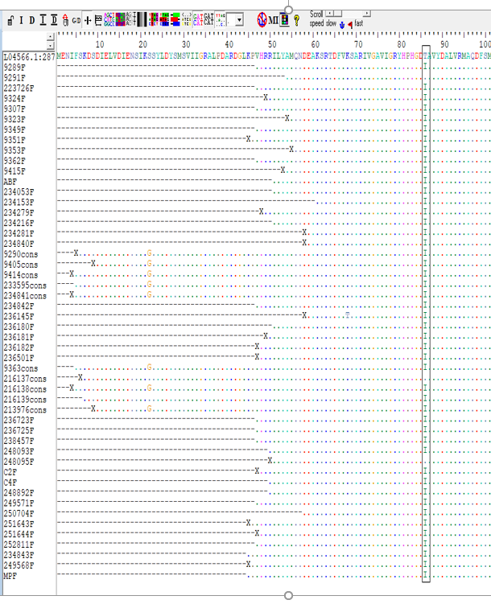

Fig.2 Alignment of the nucleotide sequences of the QRDR region for the gyrA gene. The presence of mutation in position 257 of the ACA to ATA codon and silent mutations in position 243, associated with fluroquinolone resistance of C.jejuni isolates.
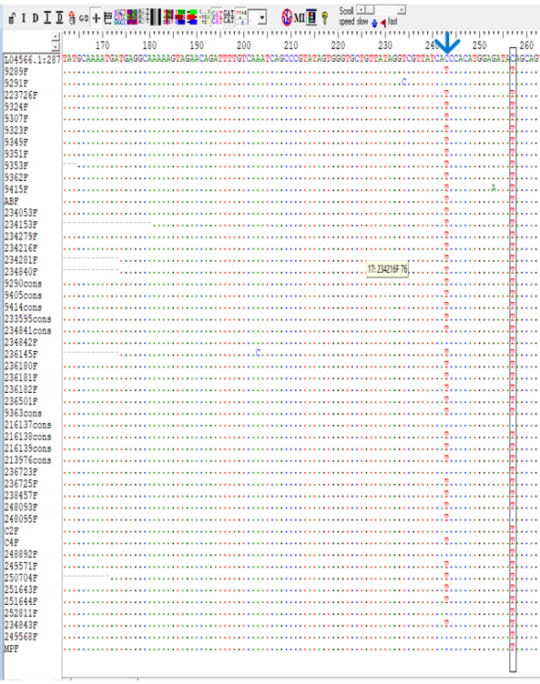

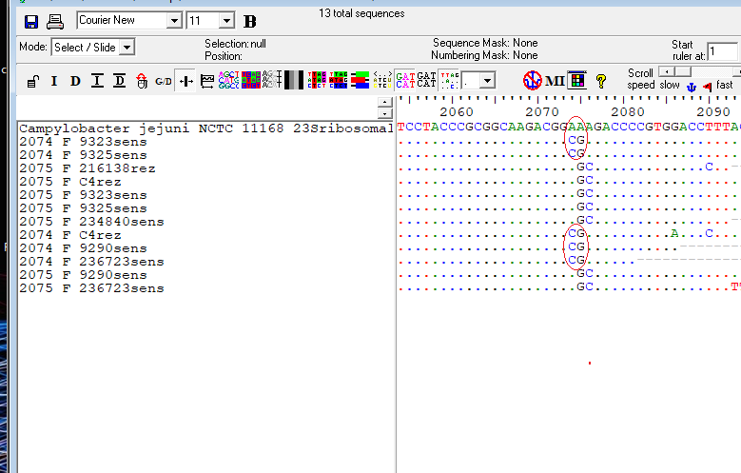
Fig.3 The presence of mutations in position 2074 and 2075 in C.jejuni strains with increased resistance to erythromycin:-the presence of the double mutation both in position 2074 (A-C) and in position 2075 (A-G); - presence of mutation in position 2075 (A-G).
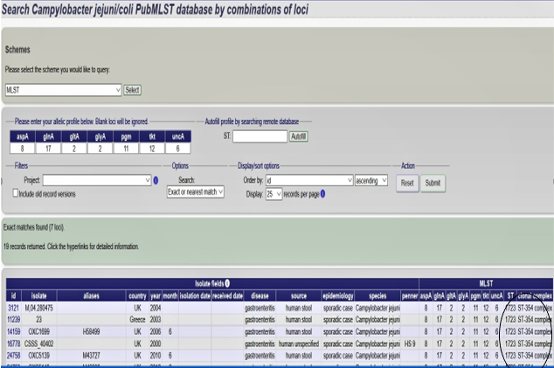
Fig. 4. ST type and clonal complex identified from the MLST database.
Table S1. Campylobacter jejuni strains analyzed by the MLST (multilocus sequence typing).
