SUPPLEMENTARY MATERIALS
of
Structural investigation of the interaction between a GC-376 based peptidomimetic PROTAC and the viral main protease of Coxsackievirus B3 to explore the applicability of a broad-spectrum antiviral PROTAC

Alessia De Santis^{a,b}, Deborah Grifagni^{a,b}, Andrea Orsetti^{a,b}, Elena Lenci^{b}, Antonio Rosato^{a,b}, Mariapina D’ Onofrio^{c}, Andrea Trabocchi^{b}, Simone Ciofi-Baffoni^{a,b}, Francesca Cantini^{a,b,*} and Vito Calderone^{a,b,*}
ªMagnetic Resonance Center CERM, University of Florence, Via Luigi Sacconi 6, 50019, Sesto Fiorentino, Florence, Italy.
^{b}Department of Chemistry, University of Florence, Via della Lastruccia 3, 50019, Sesto Fiorentino, Florence, Italy.
^{c}Department of Biotechnology, University of Verona, Strada le Grazie 15, 37134 Verona, Italy

*Francesca Cantini, Magnetic Resonance Center CERM and Department of Chemistry, University of Florence, Sesto Fiorentino (Florence) – Italy.
E-mail: cantini@cerm.unifi.it

*Vito Calderone, Magnetic Resonance Center CERM and Department of Chemistry, University of Florence, Sesto Fiorentino (Florence) – Italy.
E-mail: calderone@cerm.unifi.it

Table S1. Data collection and refinement statistics of the crystal structure of CVB3 3C^{Pro} in complex with GC-376 PROTAC precursor.
 | 8S6F
Wavelength | 1.541
Resolution range | 35.13 - 1.932 (2.13 - 1.93)*
Space group | C 1 2 1
Unit cell | 76.92 64.35 38.99 90 115.72 90
Total reflections | 48285 (10396)
Unique reflections | 23725 (5260)
Multiplicity | 2.0 (2.0)
Completeness (%) | 94.73 (86.18)
Mean I/sigma(I) | 3.56 (0.95)
Wilson B-factor | 28.98
R-merge | 0.1379 (0.7405)
R-meas | 0.1834 (0.9709)
R-pim | 0.12 (0.6225)
CC1/2 | 0.981 (0.494)
CC* | 0.995 (0.813)
Reflections used in refinement | 12206 (2726)
Reflections used for R-free | 611 (136)
R-work | 0.2384 (0.3192)
R-free | 0.2634 (0.3220)
Number of non-hydrogen atoms | 1496
macromolecules | 1398
ligands | 33
solvent | 65
Protein residues | 180
RMS(bonds) | 0.003
RMS(angles) | 0.69
Ramachandran favored (%) | 94.94
Ramachandran allowed (%) | 4.49
Ramachandran outliers (%) | 0.56
Rotamer outliers (%) | 2.03
Clashscore | 5.99
Average B-factor | 37.25
macromolecules | 37.21
ligands | 39.20
solvent | 37.29
*Statistics for the highest-resolution shell are shown in parentheses.

Figure S1. Chemical formula of GC-376 PROTAC precursor and GC-376 PROTAC previously synthesized by us [1].
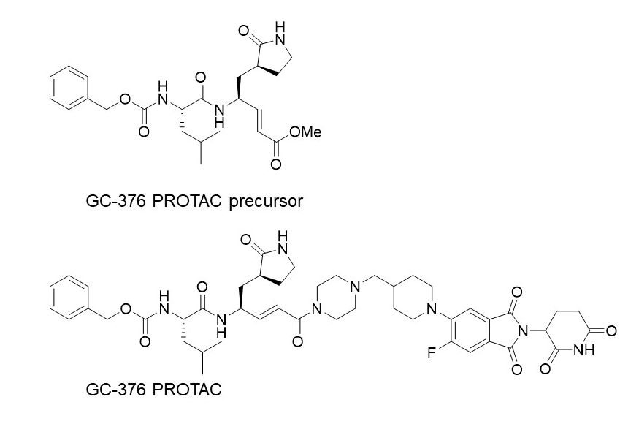

Figure S2. Purification and protein size of CVB3 3C^{Pro}. (A) Analytical gel filtration of CVB3 3C^{Pro} compared with protein standard markers at 30 kDa (in light blue Carbonic anhydrase (CA) and 8.5 kDa (in orange Ubiquitin UB). The theoretical molecular weight of monomeric CVB3 3C^{Pro} is 21 kDa. The protein eluted at a volume corresponding to a molecular mass of 22.9 kDa. (B) Analysis of CVB3 3C^{Pro} expression and purification on a Coomassie Blue-stained SDS-PAGE gel. Lanes from the left: Molecular Marker (labelled in kDa), insoluble and supernatant CVB3 3C^{Pro} samples after overnight expression, Immobilized Metal Affinity Chromatography (IMAC) elution and flow-through, Size-Exclusion Chromatography (SEC) elution of the fractions containing the protein.
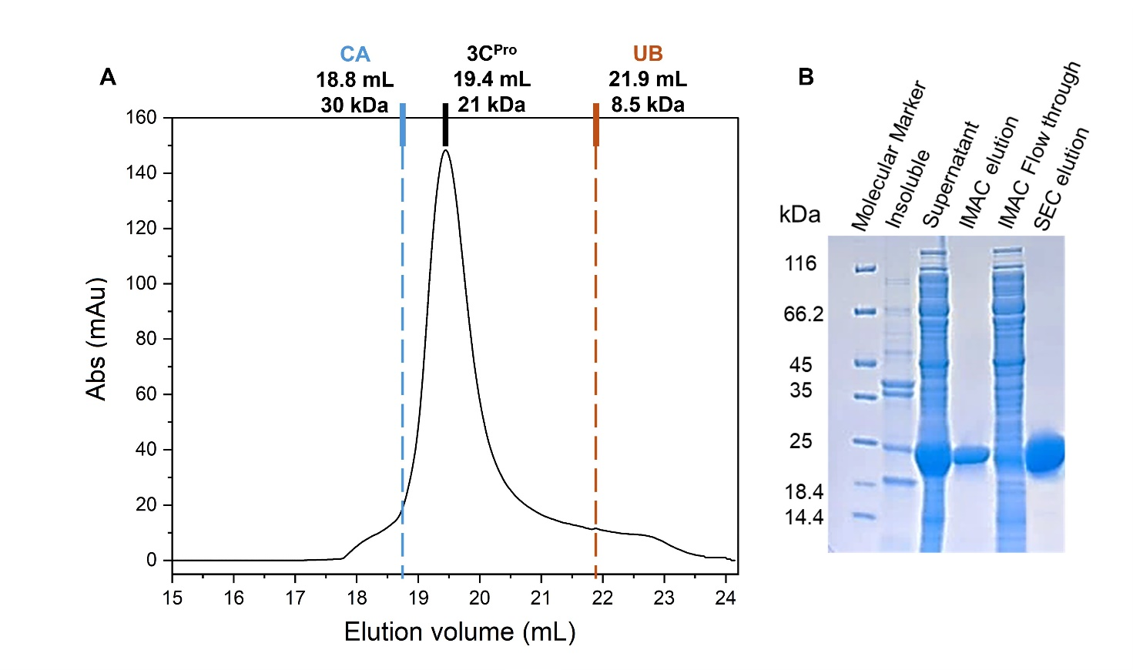
22.9 kDa

Figure S3. Solution NMR spectra of CVB3 3C^{Pro} at 298K. ¹H-¹⁵N HSQC (A) and 3D CBCA(CO)NH (B) NMR spectra of CVB3 3C^{Pro} acquired at 500 MHz and 298 K in 50 mM phosphate buffer with 100 mM NaCl at pH 6.0.

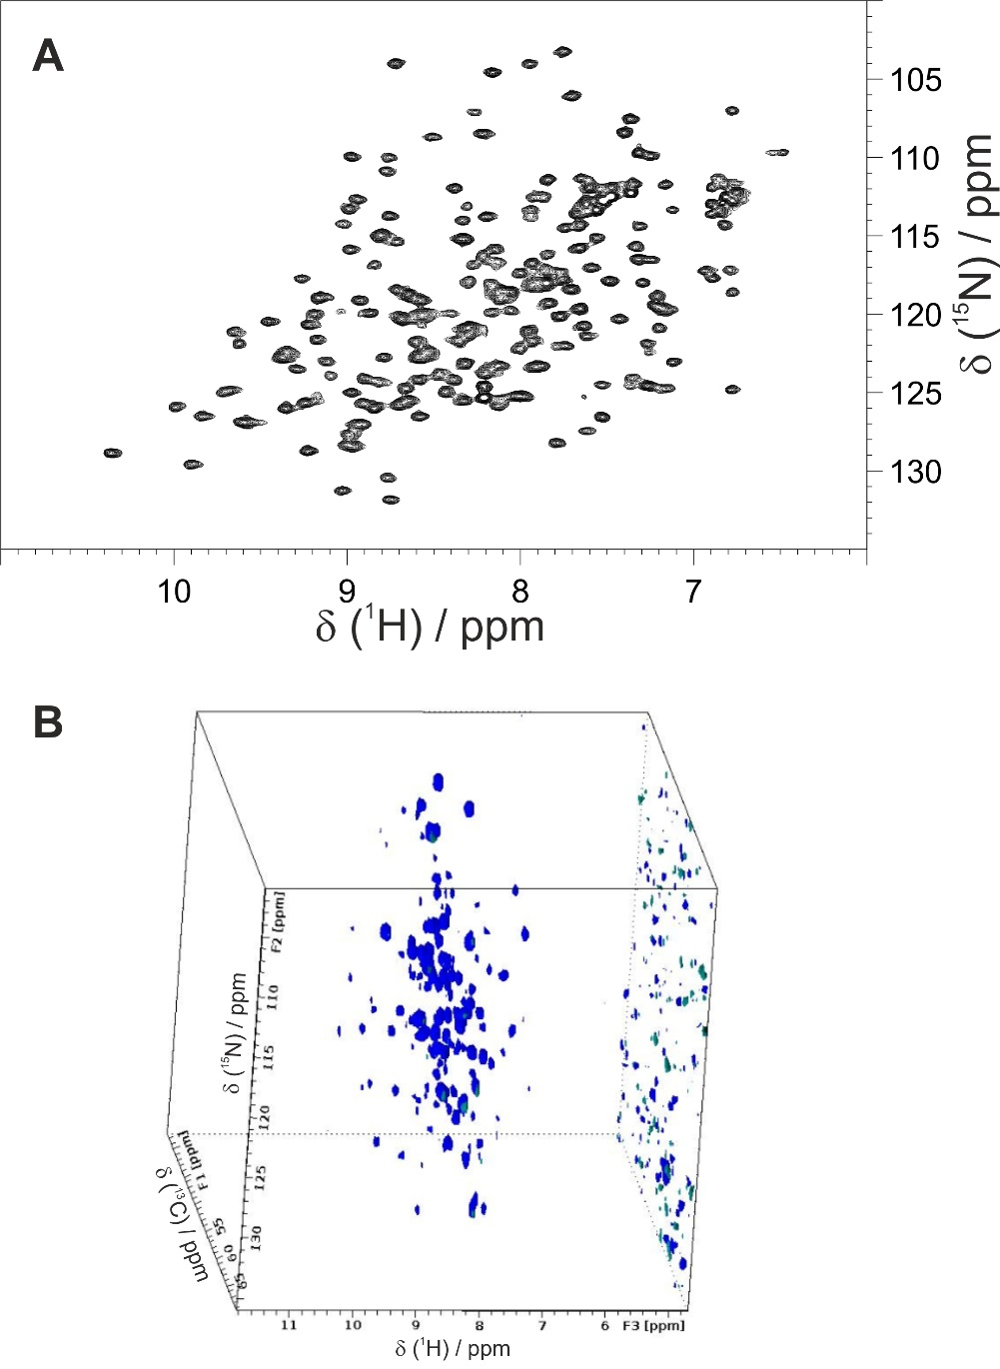

Figure S4. ¹⁵N relaxation data of CVB3 3C^{Pro}. ¹⁵N longitudinal (R₁) and transverse (R₂) relaxation rates and [¹H]¹⁵N heteronuclear NOE values determined at 500 MHz and 298 K in a 50 mM phosphate buffer at pH 6.0 containing 100 mM NaCl, 50 mM arginine, 50 mM glutamate, 1 mM DTT and 1 mM EDTA.

Figure S5. Mapping the interaction between GC-376 PROTAC precursor and CVB3 3C^{Pro} by solution NMR. Backbone weighted average chemical shift differences (Δδ_{avg}(HN)) between ¹⁵N-labelled CVB3 3C^{Pro} and its 1:1 mixture with GC-376 PROTAC precursor. Orange bars with Δδ_{avg}(HN) = 1 indicate residues whose backbone NH signals are not assigned in the CVB3 3C^{Pro} and appear with increasing intensities along the stepwise additions of the GC-376 PROTAC precursor with their chemical shifts corresponding to those of the GC-376 PROTAC precursor-bound species (whose backbone NHs are also identified as orange spheres in Figure 3B). Gray and white bars with Δδ_{avg}(HN) = 1 indicate unassigned backbone NHs in GC-376 PROTAC precursor-bound CVB3 3C^{Pro} and Pro residues, respectively. A chemical shift threshold value of 0.14 ppm, indicated as a dashed line in both panels, was estimated to define the most significant chemical shift differences (see the Materials and Methods section for details). The green bars identify the residues having Δδ_{avg}(HN) larger than the threshold value (whose backbone NHs are also identified as green spheres in Figure 3B).

Figure S6. Inhibition curves of GC-376 PROTAC and of the corresponding precursor.

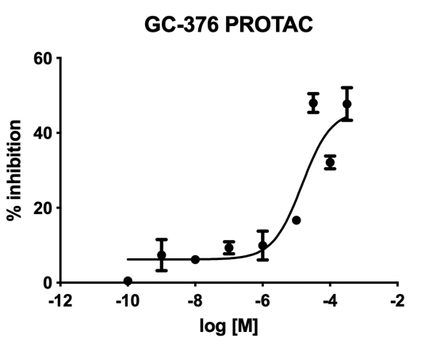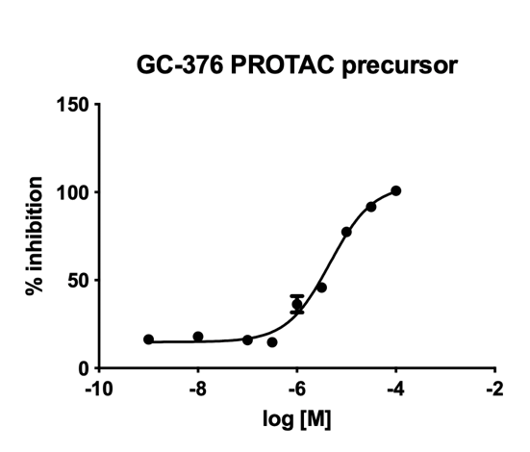

• Graphical Abstract:
A graphical abstract (GA) is an image that appears alongside the text abstract in the Table of Contents. In addition to summarizing the content, it should represent the topic of the article in an attention-grabbing way. Moreover, it should not be exactly the same as the Figure in the paper or just a simple superposition of several subfigures. Note that the GA must be original and unpublished artwork. Any postage stamps, currency from any country, or trademarked items should not be included in it.
The GA should be a high-quality illustration or diagram in any of the following formats: PNG, JPEG, or TIFF. Written text in a GA should be clear and easy to read, using one of the following fonts: Times, Arial, Courier, Helvetica, Ubuntu or Calibri.
The minimum required size for the GA is 560 × 1100 pixels (height × width). The size should be of high quality in order to reproduce well.

1. Grifagni, D.; Lenci, E.; De Santis, A.; Orsetti, A.; Barracchia, C.G.; Tedesco, F.; Bellini Puglielli, R.; Lucarelli, F.; Lauriola, A.; Assfalg, M., et al. Development of a GC-376 Based Peptidomimetic PROTAC as a Degrader of 3-Chymotrypsin-like Protease of SARS-CoV-2. ACS Med Chem Lett 2024, 15, 250-257.

