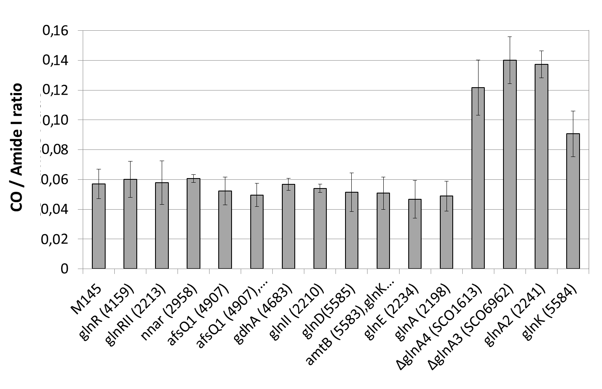
Figure S1: Total lipid content, determined with FTIRS, of S. coelicolor M145 and derivatives of this strain deleted for the genes glnR/sco4159, glnRII/sco2213, glnA/sco2198, glnII/sco2210, glnE/sco2234, nnar/sco2958,gdhA/sco4683, glnD/sco5585, glnK/sco5585, glnA2/sco2241, glnA3/sco6962, glnA4/sco1613 as well as the double mutants afsQ1/sco4907&afsQ2/sco4906 and amtB/sco5583&glnK/sco5584). The strains were grown, in triplicates, on modified solid R2YE proficient in phosphate (5mM) at 28 °C for 72 h. Mean values of the three replicates are shown as histograms with error bars representing standard error (p > 0.05; Tukey-adjusted comparisons).

Figure S2: Total lipid content of S. coelicolor M145 (grey histograms), determined with FTIRS, and of a derivative of this strain deleted for the gene pup/sco1646 (white histograms) and this mutant strain complemented by the gene pup/sco1646 cloned into the vector pSET152 (white histograms) (1). The three strains were grown, in triplicates, in solid R2YE medium limited in phosphate (1mM), for 48 h, 72h and 96h. Mean values of the three replicates are shown as histograms with error bars representing standard error (p > 0.05; Tukey-adjusted comparisons).
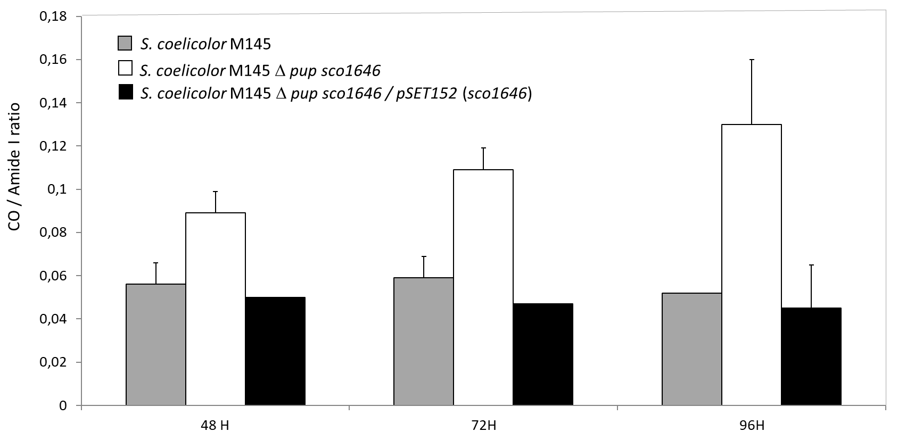

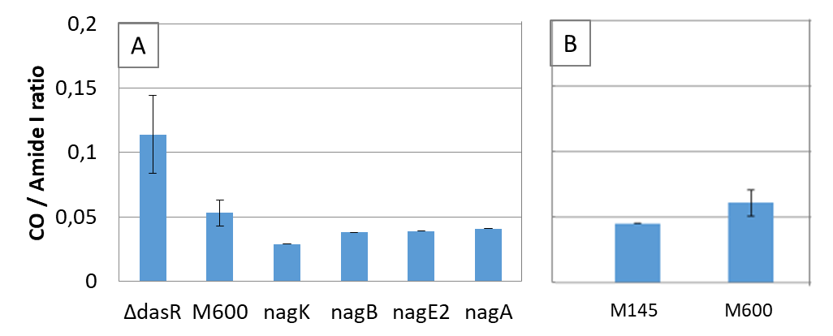
Figure S3: Total lipid content, determined with FTIRS of S. coelicolor M600 and derivatives of this strain deleted for dasR/sco5231 and for genes of the DasR regulon involved in N-acetylglucosamine (NAG) degradation and up-take, including the genes nagA/sco2758 (NAG-6-phosphate deacetylase), nagB/sco5236 (glucosamine-6-phosphate deaminase/isomerase), nagK/sco4285 (NAG kinase) and nagE2/sco2907 (high-affinity NAG permease) (A) as well as of S. coelicolor M145 and S. coelicolor M600 (B). These strains were grown, in triplicates, on modified solid R2YE medium limited in phosphate (1mM) at 28°C for 72h. Mean values of the three replicates are shown as histograms with error bars representing standard error (p > 0.05; Tukey-adjusted comparisons).

