1. **Appendix**

## **Appendix 1: Drought Risk Map of Afghanistan**

Maps portraying the spatial variability of drought risk, hazard, exposure and vulnerability.

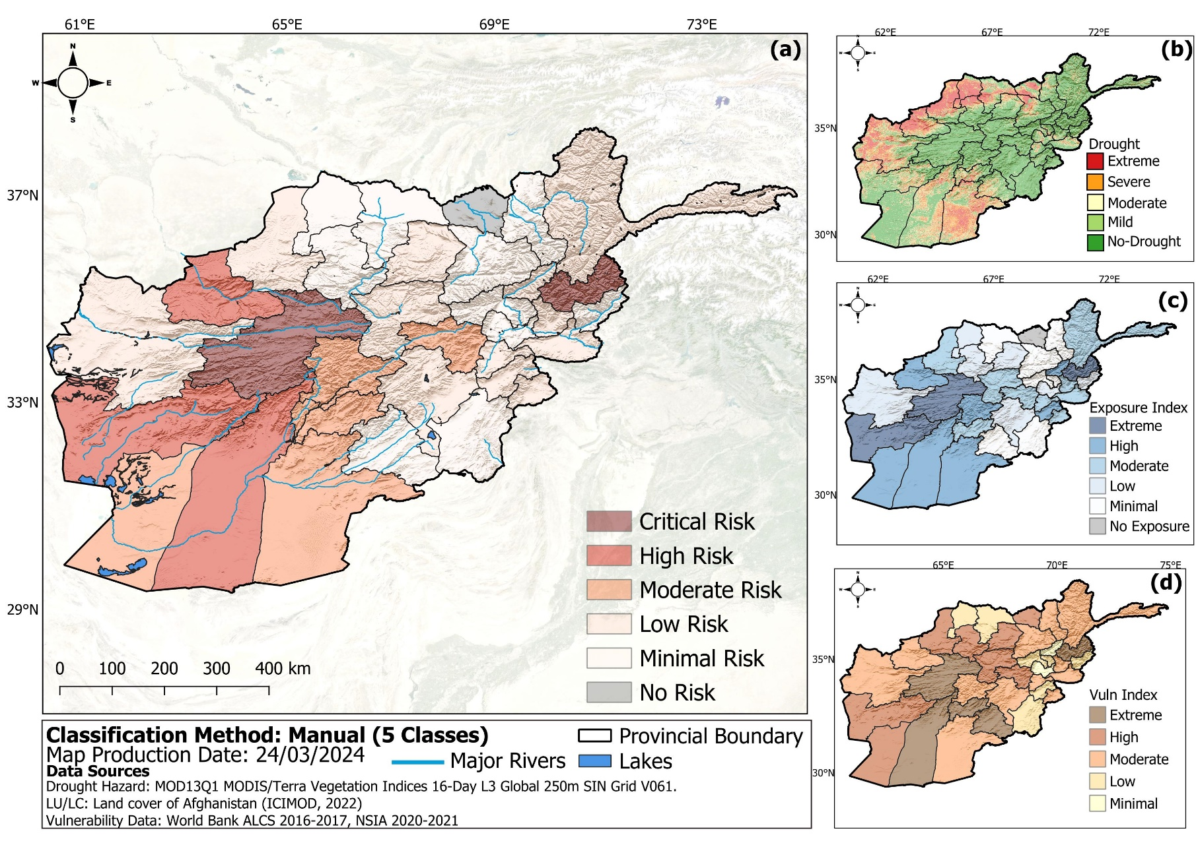

## **Appendix 2: Exposure, Vulnerability and Risk Profile of Afghanistan.**

*This chart shows drought risk, exposure and vulnerability profiles of each province.*

## **Appendix 4: Data for Exposure and Vulnerability Indicators Used in Risk Index Computation.**



**Figure 8.1:** Pearson multicollinearity test.

## **Appendix 5: Workflow**

## **Appendix 7: Drought Hazard per Province**

## **FAO GIEWS Country Brief on Afghanistan -Appendix 8: Crop Calendar of Afghanistan**

## **Appendix 9: Drought zonation based on VCI values**

|  |  |
| --- | --- |
| Drought | Value |
| Extreme | <10 |
| Severe | <20 |
| Moderate | <30 |
| Mild | <40 |
| No | ≥40 |

Source: UN-SPIDER