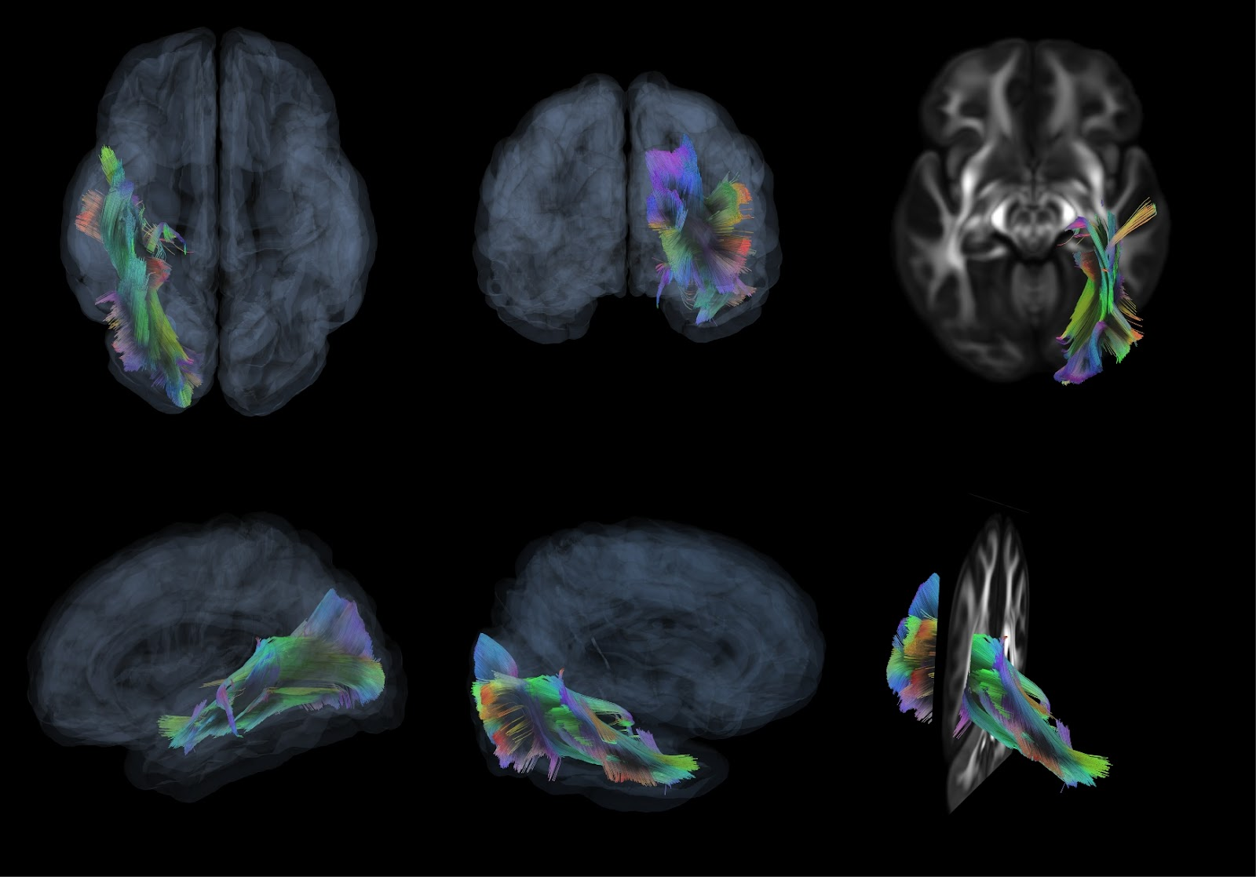
Figure S1 - Diffusion tensor imaging (DTI)-based on the Right Inferior Longitudinal Fasciculus.
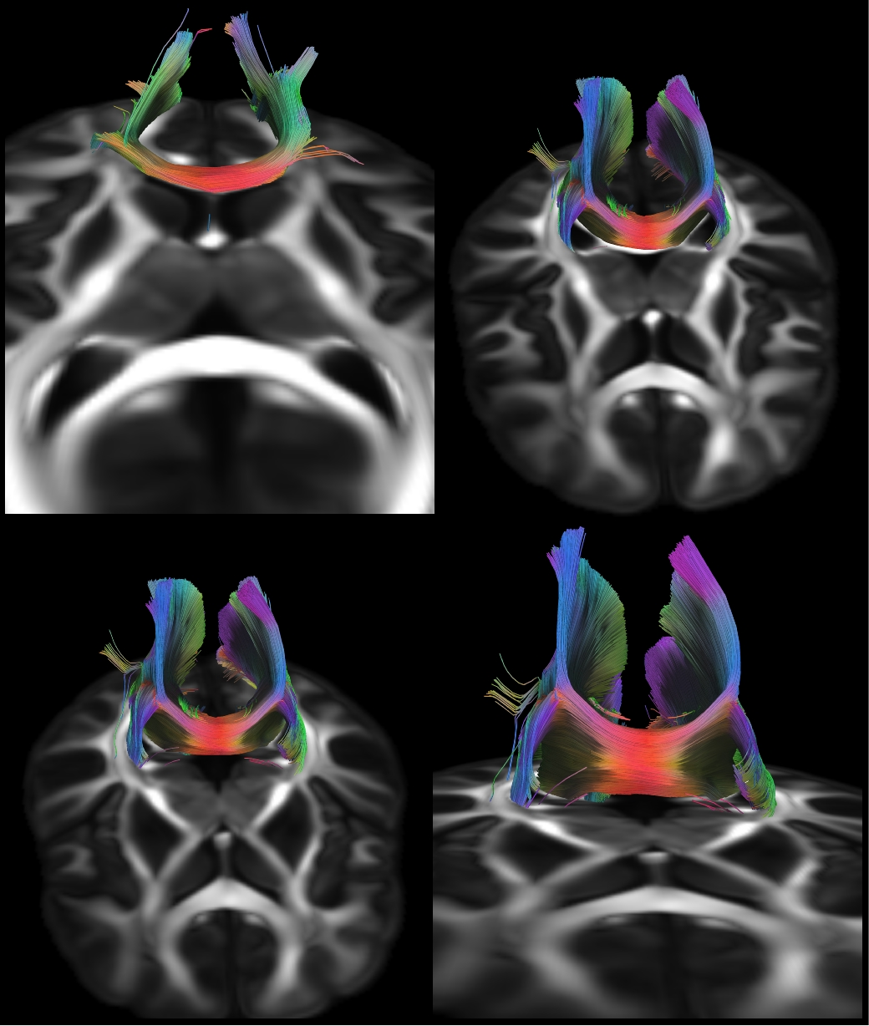
Figure S2 - Diffusion tensor imaging (DTI)-based on the Corpus Callosum Forceps Major.

