Supplementary material

Journal: Pharmaceuticals
Special Issue “Drug Discovery of Antiprotozoal Agents 2024”

Exploratory Study of Guanidine Derivatives as Novel Anti Trypanosoma cruzi Scaffolds
Eduardo Henrique Zampieri ¹, Policarpo Ademar Sales Junior ², Silvane Maria Fonseca Murta ^{2,}*, Predrag Kalaba ³, Alexandre Prado-Roller ⁴, Natalie Gajic ⁴, Martin Zehl ⁵, Anna Fabisikova ⁵, Luana Ribeiro dos Anjos ¹, Luana Passiano-to Gushiken ¹, Gert Lubec ⁶, and Eduardo R. Perez Gonzalez ^{1,}*

- Fine Organic Chemistry Lab. Department of Chemistry and Biochemistry. Faculty of Science and Tech-nology. University of Sao Paulo State (Unesp). Roberto Simonsen, 305 – 19060080. Presidente Prudente, SP – Brazil. E-mails: eduardo.gonzalez@unesp.br; eduardo.h.zampieri@unesp.br; luana.anjos@unesp.br; luana.lqof@gmail.com
- Grupo Genômica Funcional de Parasitos, Instituto René Rachou, Fundação Oswaldo Cruz -Fiocruz Minas Avenida Augusto de Lima, 1715 – 30190-002, Belo Horizonte, MG, Brazil. E-mails: policar-po.junior@fiocruz.br; silvane.murta@fiocruz.br
- Department of Pharmaceutical Chemistry, Faculty of Life Sciences, University of Vienna UZ2, Al-thanstrasse 14,1090 Vienna, Austria. E-mails: predrag.kalaba@univie.ac.at
- Centre for X-ray Structure Analysis, Faculty of Chemistry, University of Vienna, Währinger Straße 40-42, 1090 Vienna, Austria. E-mails: natalie.gajic@univie.ac.at (N.G.); alexander.roller@univie.ac.at (A.P.-R.)
- Department of Analytical Chemistry and Mass Spectrometry Centre, Faculty of Chemistry, University of Vienna, Währinger Straße 38, A-1090 Vienna, Austria. E-mails: anna.fabisikova@univie.ac.at (A.F.); martin.zehl@univie.ac.at (M.Z.)
- Department of Neuroproteomics, Paracelsus Medical University, 5020 Salzburg, Austria. E-mails: gert.lubec@lubeclab.com

* Corresponding authors: eduardo.gonzalez@unesp.br (E.R.P.G.); silvane.murta@fiocruz.br (S.M.F.M.)

Table of contents
1. Analysis for LQOF-G29 3
1.1 NMR measurements 3
1.2 EI-MS analysis 4
1.3. LC/MS with UV/Vis detection analysis for LQOF-G29. 4
2. Structural data of LQOF-G29 6

Analysis of LQOF-G29

NMR measurements

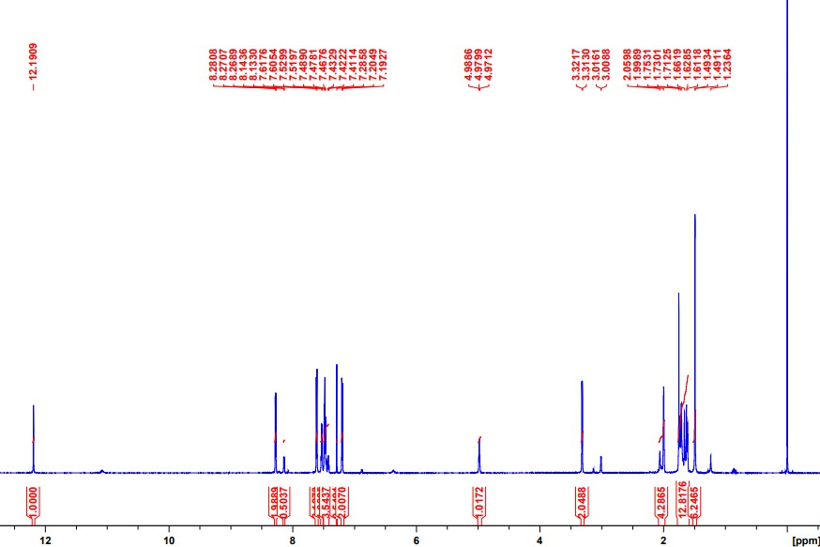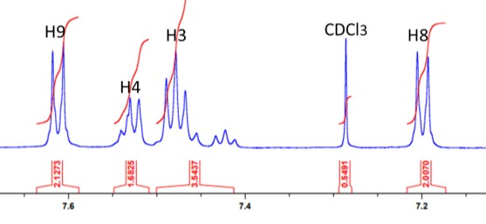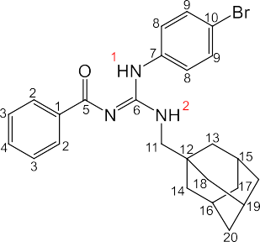
H13, H14, H18
21
H17, H20, H21
H15, H16, H19
NH1
H2
H11
NH2

Figure S1. ¹H NMR spectrum of LQOF-G29.

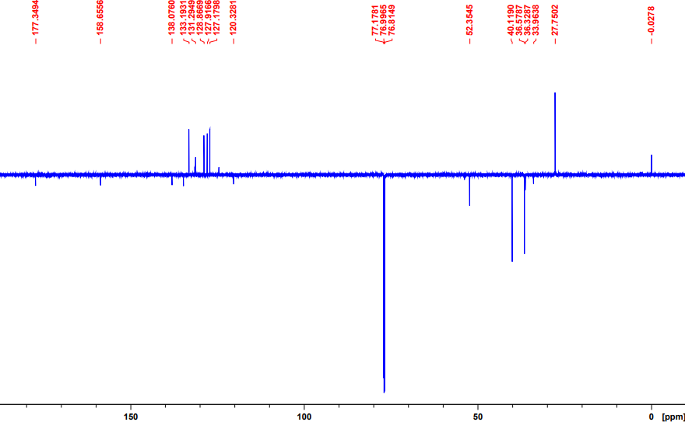
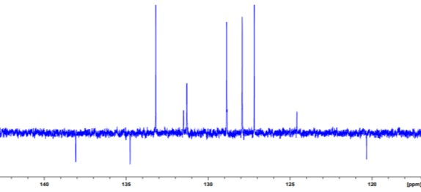
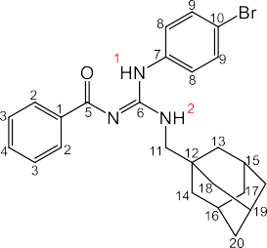
21
C15, C16, C19
C5
C6
C12
C9
C8
C2C3
C11
C17, C20,
C4 C13, C14, C21
C18
C1 C10
C7

Figure S2. ¹³C NMR spectrum of LQOF-G29.

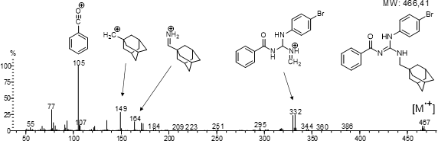
EI-MS analysis

Figure. S3. EI-MS (70 eV) spectrum of compound LQOF-G29.

1.3. HRESIMS and HPLC-UV analysis of LQOF-G29.

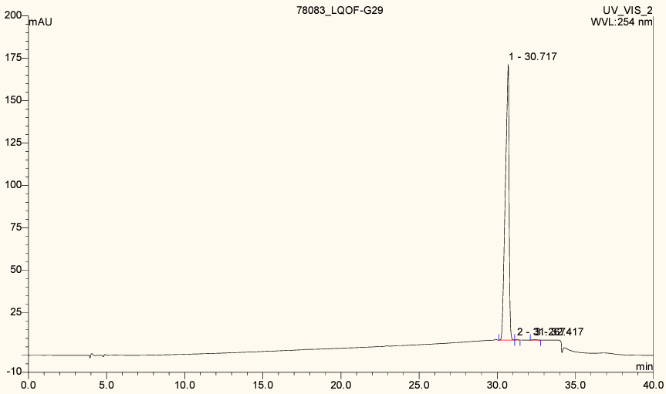
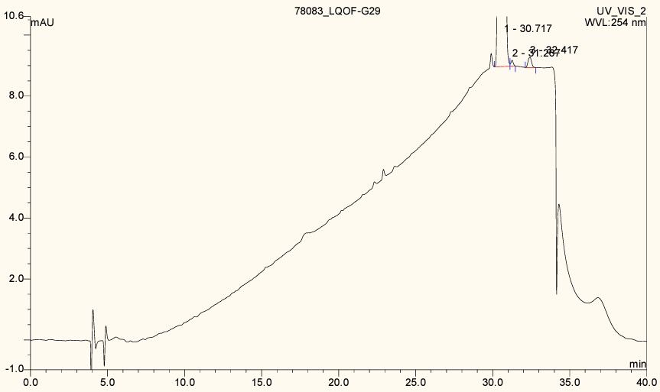

Figure. S4. HPLC-UV (254 nm) analysis of LQOF-G29.

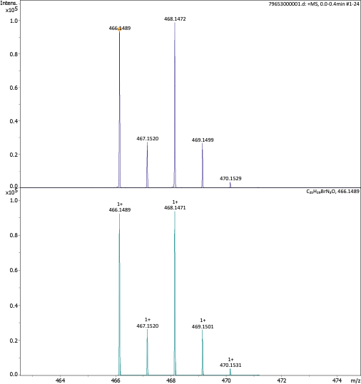

Figure. S5. HRESI-(+) MS analysis of LQOF-G29.

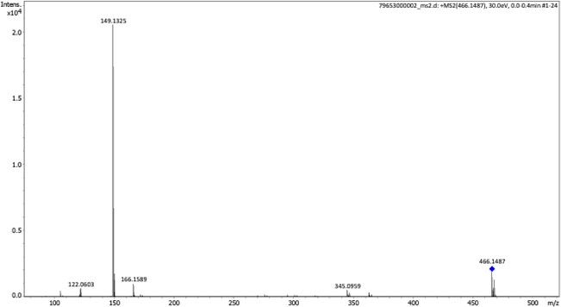
Figure. S6. HRESI-(+) MS/MS analysis of LQOF-G29.

Structural data of LQOF-G29

N-((adamantanemethylamine))((4-bromophenyl)amino)methylene)benzamide (LQOF-G29). White solid. Yield 62%. Recrystallized with hexane. LC-UV/MS: 99.73%; ESI(+)-MS m/z found 466.1489, m/z calculated for [C25H27BrN3O + H]⁺: 466.1489; ESI(+)-MS/MS: [M + H – C7H5ONH2]⁺ m/z 345.0959, [M + H – C14H10BrN2O]⁺ m/z 166.1589, [M + H – C14H11BrN3O]⁺ m/z 149.1325. ¹H NMR (400.13 MHz, CDCl3) δ = 12.19 (s, 1H), 8.28 (d, J = 4.0 Hz, 2H), 7.61 (d, J = 4.8 Hz, 2H), 7.52 (t, J = 4.0 Hz, 1H), 7.47 (t, 4.2 Hz, 2H), 7.20 (d, 4.8 Hz, 2H), 4.97 (t, J = 3.5 Hz, 1H), 3.32 (d, J = 3.5 Hz, 2H), 1.99 (m, 3H), 1.75 (m, 6H), 1.49 (m, 6H); ¹³C NMR (100.61 MHz, CDCl3) δ = 177.3 (C=O), 158.6 (C=N), 138.7 (C), 134.7 (C-Br), 133.1 (CH), 131.2 (CH), 128.8 (2CH), 127.9 (2CH), 127.1 (2CH), 120.3 (C), 52.3 (CH2), 40.1 (3CH2), 36.5 (3CH2), 33.9 (C), 27.7 (3CH).

