**Supporting Information**

**CNN-Optimized Electrospun TPE/PVDF Nanofiber Membranes for Enhanced Temperature and Pressure Sensing**

Ming Ma 1, 4, Ce Jin 2, 4, Shufang Yao 2, 4, Nan Li 3, 4*, Huchen Zhou 2, 4, Zhao Dai 2, 4 *

1 School of Life Sciences, Tiangong University, Tianjin 300387, China

2 School of Chemical Engineering and Technology, Tiangong University, Tianjin, 300387, China

3 School of Chemistry, Tiangong University, Tianjin, 300387, China

4 State Key Laboratory of Separation Membranes and Membrane Processes, Tianjin, 300387, China

**Table S1** Comparison of R² and RMSE values for different neural networks.

|  |  |  |
| --- | --- | --- |
| Neural Network Type | R2 | RMSE |
| Artificial Neural Network | 0.9776 | 45.4107 |
| PSO-BP Neural Network | 0.9751 | 17.3598 |
| Radial Basis Function Network | 0.9757 | 15.9746 |
| ELM Neural Network | 0.9886 | 31.3541 |
| GA-ELM Neural Network | 0.9959 | 7.446 |

**Table S2** Electrospinning parameters of PVDF and measured fiber diameter

| Exp.  No. | | Concentration  (wt%) | | Voltage  (kV) | | Receiving distance  (cm) | | Injection speed (mL/h) | | Nanofiber  diameter (nm) |
| --- | --- | --- | --- | --- | --- | --- | --- | --- | --- | --- |
| 1 | | 15.5 | | 9 | | 14 | | 0.4 | | 425.22 |
| 2 | | 15.5 | | 10 | | 14 | | 0.4 | | 418.36 |
| 3 | | 15.5 | | 11 | | 14 | | 0.4 | | 428.53 |
| 4 | 15.5 | | 12 | | 14 | | 0.4 | | 410.23 | |
| 5 | 15.5 | | 13 | | 11 | | 0.4 | | 443.81 | |
| 6 | 15.5 | | 13 | | 12 | | 0.4 | | 438.81 | |
| 7 | 15.5 | | 13 | | 13 | | 0.4 | | 424.41 | |
| 8 | 15.5 | | 13 | | 14 | | 0.4 | | 456.78 | |
| 9 | 15.5 | | 13 | | 14 | | 0.1 | | 418.18 | |
| 10 | 15.5 | | 13 | | 14 | | 0.2 | | 418.05 | |
| 11 | 15.5 | | 13 | | 14 | | 0.3 | | 419.67 | |
| 12 | 15.5 | | 13 | | 14 | | 0.5 | | 416.25 | |
| 13 | 15.5 | | 13 | | 15 | | 0.4 | | 423.65 | |
| 14 | 15.5 | | 13 | | 16 | | 0.4 | | 422.28 | |
| 15 | 15.5 | | 14 | | 14 | | 0.4 | | 433.64 | |
| 16 | 15.5 | | 15 | | 14 | | 0.4 | | 408.47 | |
| 17 | 15.5 | | 15 | | 15 | | 0.5 | | 395.72 | |
| 18 | 16.5 | | 9 | | 14 | | 0.4 | | 431.13 | |
| 19 | 16.5 | | 9 | | 15 | | 0.4 | | 462.56 | |
| 20 | 16.5 | | 10 | | 14 | | 0.4 | | 438.8 | |
| 21 | 16.5 | | 10 | | 15 | | 0.4 | | 468.37 | |
| 22 | 16.5 | | 11 | | 14 | | 0.4 | | 440.81 | |
| 23 | 16.5 | | 11 | | 15 | | 0.4 | | 453.01 | |
| 24 | 16.5 | | 12 | | 14 | | 0.4 | | 455.35 | |
| 25 | 16.5 | | 12 | | 15 | | 0.4 | | 478.42 | |
| 26 | 16.5 | | 13 | | 14 | | 0.4 | | 448.36 | |
| 27 | 16.5 | | 13 | | 15 | | 0.4 | | 471.55 | |
| 28 | 16.5 | | 13 | | 15 | | 0.2 | | 405.16 | |
| 29 | 16.5 | | 14 | | 11 | | 0.4 | | 456.83 | |
| 30 | 16.5 | | 14 | | 11 | | 0.5 | | 405.77 | |
| 31 | 16.5 | | 14 | | 12 | | 0.4 | | 481.28 | |
| 32 | 16.5 | | 14 | | 13 | | 0.4 | | 447.11 | |
| 33 | 16.5 | | 14 | | 14 | | 0.4 | | 444.55 | |
| 34 | 16.5 | | 14 | | 14 | | 0.1 | | 444.81 | |
| 35 | 16.5 | | 14 | | 14 | | 0.2 | | 497.66 | |
| 36 | 16.5 | | 14 | | 14 | | 0.3 | | 489.63 | |
| 37 | 16.5 | | 14 | | 14 | | 0.5 | | 444.52 | |
| 38 | 16.5 | | 14 | | 15 | | 0.4 | | 488.43 | |
| 39 | 16.5 | | 14 | | 16 | | 0.4 | | 458.91 | |
| 40 | 16.5 | | 15 | | 14 | | 0.4 | | 481.41 | |
| 41 | 16.5 | | 15 | | 14 | | 0.5 | | 474.32 | |
| 42 | 16.5 | | 15 | | 15 | | 0.4 | | 468.94 | |
| 43 | 16.5 | | 15 | | 16 | | 0.4 | | 466.67 | |
| 44 | 17.5 | | 9 | | 14 | | 0.4 | | 448.37 | |
| 45 | 17.5 | | 10 | | 14 | | 0.4 | | 477.68 | |
| 46 | 17.5 | | 11 | | 14 | | 0.4 | | 480.47 | |
| 47 | 17.5 | | 12 | | 14 | | 0.4 | | 523.4 | |
| 48 | 17.5 | | 13 | | 11 | | 0.1 | | 595.43 | |
| 49 | 17.5 | | 13 | | 11 | | 0.2 | | 598.8 | |
| 50 | 17.5 | | 13 | | 11 | | 0.3 | | 601.05 | |
| 51 | 17.5 | | 13 | | 11 | | 0.4 | | 579.47 | |
| 52 | 17.5 | | 13 | | 11 | | 0.5 | | 536.47 | |
| 53 | 17.5 | | 13 | | 12 | | 0.1 | | 560.33 | |
| 54 | 17.5 | | 13 | | 12 | | 0.2 | | 558.89 | |
| 55 | 17.5 | | 13 | | 12 | | 0.3 | | 444.96 | |
| 56 | 17.5 | | 13 | | 12 | | 0.4 | | 519.29 | |
| 57 | 17.5 | | 13 | | 12 | | 0.5 | | 490.31 | |
| 58 | 17.5 | | 13 | | 13 | | 0.1 | | 507.28 | |
| 59 | 17.5 | | 13 | | 13 | | 0.2 | | 499.65 | |
| 60 | 17.5 | | 13 | | 13 | | 0.3 | | 488.23 | |
| 61 | 17.5 | | 13 | | 13 | | 0.4 | | 585.6 | |
| 62 | 17.5 | | 13 | | 13 | | 0.5 | | 574.52 | |
| 63 | 17.5 | | 13 | | 14 | | 0.1 | | 607.32 | |
| 64 | 17.5 | | 13 | | 14 | | 0.2 | | 627.8 | |
| 65 | 17.5 | | 13 | | 14 | | 0.3 | | 613.56 | |
| 66 | 17.5 | | 13 | | 14 | | 0.4 | | 612.6 | |
| 67 | 17.5 | | 13 | | 14 | | 0.5 | | 499.07 | |
| 68 | 17.5 | | 13 | | 15 | | 0.1 | | 587.65 | |
| 69 | 17.5 | | 13 | | 15 | | 0.2 | | 592.12 | |
| 70 | 17.5 | | 13 | | 15 | | 0.3 | | 523.13 | |
| 71 | 17.5 | | 13 | | 15 | | 0.4 | | 608.75 | |
| 72 | 17.5 | | 13 | | 15 | | 0.5 | | 565.06 | |
| 73 | 17.5 | | 13 | | 16 | | 0.1 | | 539.65 | |
| 74 | 17.5 | | 13 | | 16 | | 0.2 | | 517.2 | |
| 75 | 17.5 | | 13 | | 16 | | 0.3 | | 543.3 | |
| 76 | 17.5 | | 13 | | 16 | | 0.4 | | 520.68 | |
| 77 | 17.5 | | 13 | | 16 | | 0.5 | | 487.53 | |
| 78 | 17.5 | | 14 | | 14 | | 0.1 | | 537.51 | |
| 79 | 17.5 | | 14 | | 14 | | 0.2 | | 562.33 | |
| 80 | 17.5 | | 14 | | 14 | | 0.3 | | 556.43 | |
| 81 | 17.5 | | 14 | | 14 | | 0.4 | | 503.87 | |
| 82 | 17.5 | | 15 | | 11 | | 0.3 | | 503.88 | |
| 83 | 17.5 | | 15 | | 14 | | 0.4 | | 507.67 | |
| 84 | 17.5 | | 15 | | 14 | | 0.5 | | 521.02 | |
| 85 | 18.5 | | 9 | | 15 | | 0.4 | | 598.26 | |
| 86 | 18.5 | | 10 | | 15 | | 0.4 | | 600.87 | |
| 87 | 18.5 | | 11 | | 15 | | 0.4 | | 580.56 | |
| 88 | 18.5 | | 12 | | 15 | | 0.4 | | 571.59 | |
| 89 | 18.5 | | 13 | | 11 | | 0.4 | | 537.01 | |
| 90 | 18.5 | | 13 | | 12 | | 0.4 | | 648.77 | |
| 91 | 18.5 | | 13 | | 13 | | 0.4 | | 642.8 | |
| 92 | 18.5 | | 13 | | 14 | | 0.1 | | 606.36 | |
| 93 | 18.5 | | 13 | | 14 | | 0.2 | | 567.6 | |
| 94 | 18.5 | | 13 | | 14 | | 0.3 | | 576.43 | |
| 95 | 18.5 | | 13 | | 14 | | 0.4 | | 591.46 | |
| 96 | 18.5 | | 13 | | 14 | | 0.5 | | 612.47 | |
| 97 | 18.5 | | 13 | | 15 | | 0.4 | | 594.61 | |
| 98 | 18.5 | | 13 | | 16 | | 0.4 | | 590.63 | |
| 99 | 18.5 | | 14 | | 15 | | 0.4 | | 508.12 | |
| 100 | 18.5 | | 14 | | 14 | | 0.3 | | 546.53 | |
| 101 | 18.5 | | 15 | | 14 | | 0.2 | | 556.58 | |
| 102 | 18.5 | | 15 | | 15 | | 0.4 | | 625.36 | |
| 103 | 19.5 | | 9 | | 14 | | 0.4 | | 609.72 | |
| 104 | 19.5 | | 10 | | 14 | | 0.4 | | 753.94 | |
| 105 | 19.5 | | 11 | | 14 | | 0.4 | | 671.60 | |
| 106 | 19.5 | | 12 | | 14 | | 0.4 | | 662.43 | |
| 107 | 19.5 | | 13 | | 11 | | 0.4 | | 689.78 | |
| 108 | 19.5 | | 13 | | 12 | | 0.4 | | 657.36 | |
| 109 | 19.5 | | 13 | | 13 | | 0.4 | | 638.89 | |
| 110 | 19.5 | | 13 | | 14 | | 0.4 | | 665.83 | |
| 111 | 19.5 | | 13 | | 14 | | 0.1 | | 685.96 | |
| 112 | 19.5 | | 13 | | 14 | | 0.2 | | 662.90 | |
| 113 | 19.5 | | 13 | | 14 | | 0.3 | | 696.14 | |
| 114 | 19.5 | | 13 | | 14 | | 0.5 | | 704.89 | |
| 115 | 19.5 | | 13 | | 15 | | 0.4 | | 660.89 | |
| 116 | 19.5 | | 13 | | 16 | | 0.4 | | 649.76 | |
| 117 | 19.5 | | 14 | | 14 | | 0.4 | | 667.47 | |
| 118 | 19.5 | | 15 | | 14 | | 0.4 | | 682.02 | |
| 119 | 19.5 | | 15 | | 15 | | 0.4 | | 702.28 | |
| 120 | 20.5 | | 9 | | 15 | | 0.4 | | 984.4 | |
| 121 | 20.5 | | 10 | | 15 | | 0.4 | | 1161 | |
| 122 | 20.5 | | 11 | | 15 | | 0.4 | | 822.23 | |
| 123 | 20.5 | | 12 | | 15 | | 0.4 | | 785.70 | |
| 124 | 20.5 | | 13 | | 11 | | 0.4 | | 764.71 | |
| 125 | 20.5 | | 13 | | 12 | | 0.4 | | 789.45 | |
| 126 | 20.5 | | 13 | | 13 | | 0.4 | | 771.87 | |
| 127 | 20.5 | | 13 | | 14 | | 0.5 | | 736.33 | |
| 128 | 20.5 | | 13 | | 14 | | 0.4 | | 755.19 | |
| 129 | 20.5 | | 13 | | 14 | | 0.3 | | 758.57 | |
| 130 | 20.5 | | 13 | | 14 | | 0.2 | | 839.4 | |
| 131 | 20.5 | | 13 | | 14 | | 0.1 | | 927.55 | |
| 132 | 20.5 | | 13 | | 15 | | 0.4 | | 773.34 | |
| 133 | 20.5 | | 13 | | 16 | | 0.4 | | 822.58 | |
| 134 | 20.5 | | 14 | | 15 | | 0.4 | | 756.58 | |
| 135 | 20.5 | | 15 | | 15 | | 0.5 | | 737.4 | |
| 136 | 20.5 | | 15 | | 15 | | 0.4 | | 821.9 | |
| 137 | 20.5 | | 15 | | 16 | | 0.5 | | 803.66 | |

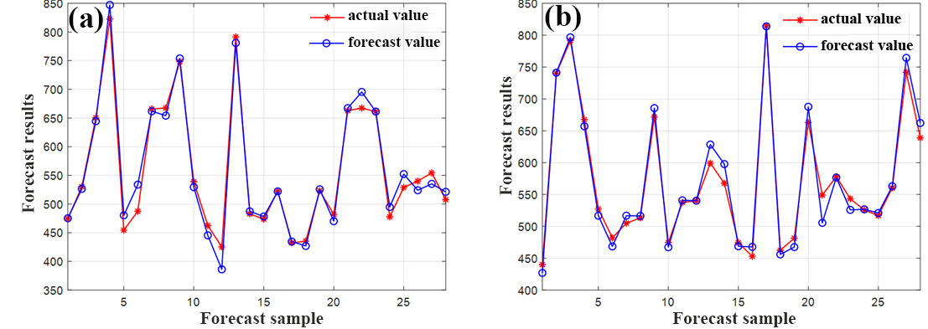

**Figure. S1** Comparison of actual values versus predicted values for: (a) Particle Swarm Optimization BP Neural Network (PSO-BPNN); (b) Radial Basis Function Neural Network (RBFNN).

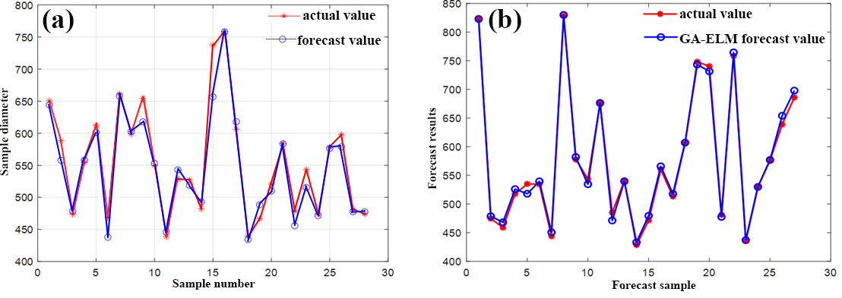

**Figure. S2** Comparison of actual values versus predicted values for: (a) Extreme Learning Machine (ELM) Neural Network; (b) Genetic Algorithm-Extreme Learning Machine (GA-ELM) Neural Network.

Figure S3 shows photographs of TPE powder under daylight and UV light. Under daylight, TPE appears beige, while under UV light at 365 nm, TPE emits bright blue fluorescence.

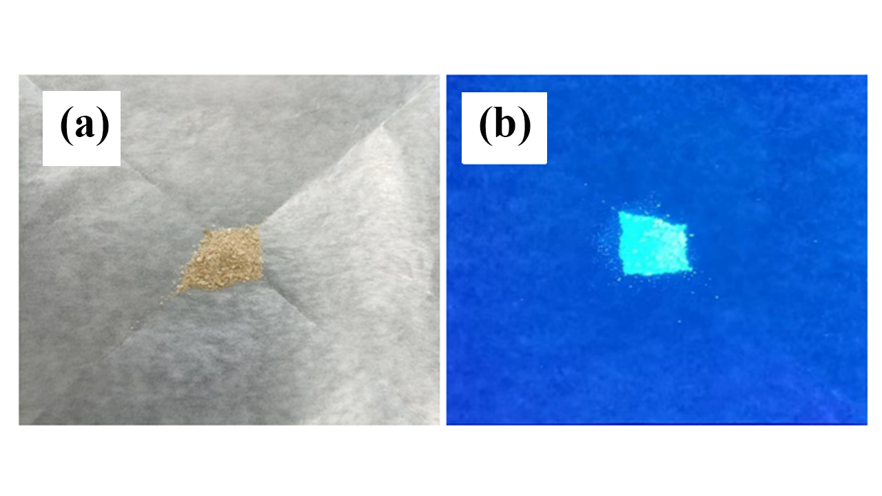

**Figure. S3** TPE Solid Powder: (a) Under daylight; (b) Under UV light.

Figure S4 (a) presents the solubility of TPE at mass fractions of 1%, 2%, 3%, 4%, and 5% in a 17.5% spinning solution from left to right. The (b) and (c) shows enlarged images of the bottom of the 4% and 5% spinning solutions. When the TPE mass fraction is 4% and 5%, solid precipitates at the bottom after the spinning solution is left to stand for a while. Under 365 nm UV light, the solid at the bottom emits blue fluorescence, indicating that the maximum solubility of TPE in the 17.5% spinning solution is 3%.

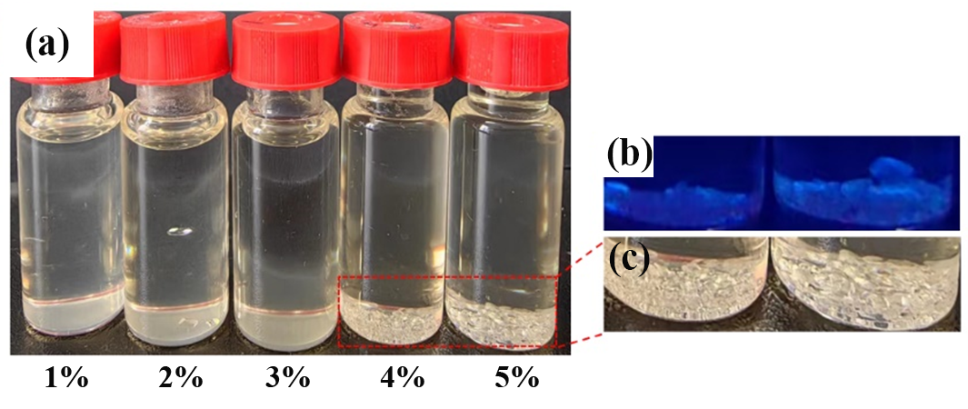

**Figure. S4** Solubility of Different Mass Fractions of TPE in 17.5% Spinning Solution.

Figure S5 illustrates the fluorescence intensity of TPE in solutions with varying water and DMF ratios. The fluorescence intensity initially increases with the water content, as water is a poor solvent for TPE. The TPE precipitates out, enhancing fluorescence intensity. However, excessive precipitation leads to aggregation and rapid sedimentation, reducing the TPE content in the solution and thereby decreasing the fluorescence intensity.



**Figure. S5** Fluorescence intensity of TPE in different water-DMF ratios: (a) Excitation spectra of the solution; (b) Fluorescence intensity at 460 nm.

**Table S3** Spinning parameters of fluorescent nanofibers at different voltages.

|  |  |  |  |  |  |  |  |  |  |
| --- | --- | --- | --- | --- | --- | --- | --- | --- | --- |
| |  | | --- | | TPE Content (%) | | |  | | --- | | PVDF Concentration (wt.%) | | |  | | --- | | Voltage (kV) | | |  | | --- | | Receiving distance (cm) | | |  | | --- | | Flow Rate (mL/h) | |
| 1 | 17.5 | 9 | 13 | 0.2 |
| 1 | 17.5 | 10 | 13 | 0.2 |
| 1 | 17.5 | 11 | 13 | 0.2 |
| 1 | 17.5 | 12 | 13 | 0.2 |
| 1 | 17.5 | 13 | 13 | 0.2 |

**Table S4** Spinning parameters of fluorescent nanofibers at different distances.

|  |  |  |  |  |  |  |  |  |  |
| --- | --- | --- | --- | --- | --- | --- | --- | --- | --- |
| |  | | --- | | TPE Content (%) | | |  | | --- | | PVDF Concentration (wt.%) | | |  | | --- | | Voltage (kV) | | |  | | --- | | Receiving distance (cm) | | |  | | --- | | Flow Rate (mL/h) | |
| 1 | 17.5 | 11 | 11 | 0.2 |
| 1 | 17.5 | 11 | 12 | 0.2 |
| 1 | 17.5 | 11 | 13 | 0.2 |
| 1 | 17.5 | 11 | 14 | 0.2 |
| 1 | 17.5 | 11 | 15 | 0.2 |

**Table S5** Spinning parameters of fluorescent nanofibers at different flow rates.

|  |  |  |  |  |  |  |  |  |  |
| --- | --- | --- | --- | --- | --- | --- | --- | --- | --- |
| |  | | --- | | TPE Content (%) | | |  | | --- | | PVDF Concentration (wt.%) | | |  | | --- | | Voltage (kV) | | |  | | --- | | Receiving distance (cm) | | |  | | --- | | Flow Rate (mL/h) | |
| 1 | 17.5 | 11 | 13 | 0.1 |
| 1 | 17.5 | 11 | 13 | 0.2 |
| 1 | 17.5 | 11 | 13 | 0.3 |
| 1 | 17.5 | 11 | 13 | 0.4 |
| 1 | 17.5 | 11 | 13 | 0.5 |

Figure S6 shows the appearance of fluorescent nanofiber membranes under a daylight lamp and a 365 nm UV lamp. In Figure S6(a), the nanofiber membrane under the daylight lamp appears uniformly distributed and defect-free, with a white color. The individual fibers are not visible due to their small diameter. In Figure S6(b), the fluorescent nanofiber membrane under the 365 nm UV lamp appears blue, which is the characteristic emission of TPE, forming a strong contrast with Figure S6(a).

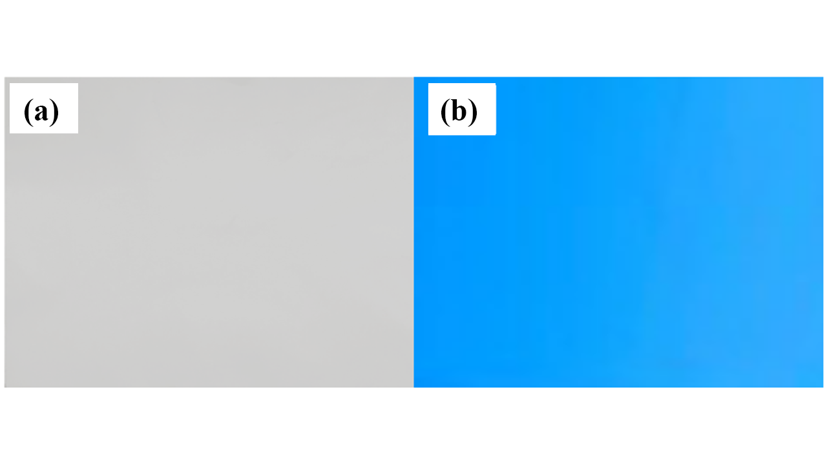

**Figure. S6** Appearance of fluorescent nanofiber membranes: (a) Under daylight lamp; (b) Under 365 nm UV lamp.

Figure S7 presents the excitation and emission spectra of nanofiber membranes electrospun from a spinning solution containing 1% TPE. The black curve in Figure S7 shows the excitation spectrum of the fluorescent nanofiber membrane, indicating an optimal excitation wavelength of 355 nm. The red curve represents the emission spectrum of the fluorescent nanofiber membrane, with an optimal emission wavelength of 460 nm.



**Figure. S7** Excitation and emission spectra of fluorescent nanofiber membranes.

 **Figure.S8** Recovery of fluorescence after heating to 100°C: (a) Emission spectra; (b) Fluorescence intensity at 460 nm over time.

**Figure.S9** Fluorescence photos and converted grayscale photos during heating-cooling cycles.