**Supporting Information**

3D Printed Phenylboronic Acid-bearing Hydrogels for Glucose-Triggered Drug Release

Jérémy Odent*, Nicolas Baleine, Serena Maria Torcasio, Sarah Gautier, Olivier Coulembier, Jean-Marie Raquez

Laboratory of Polymeric and Composite Materials (LPCM), Center of Innovation and Research in Materials and Polymers (CIRMAP), University of Mons (UMONS), Place du Parc 20, 7000 Mons, Belgium

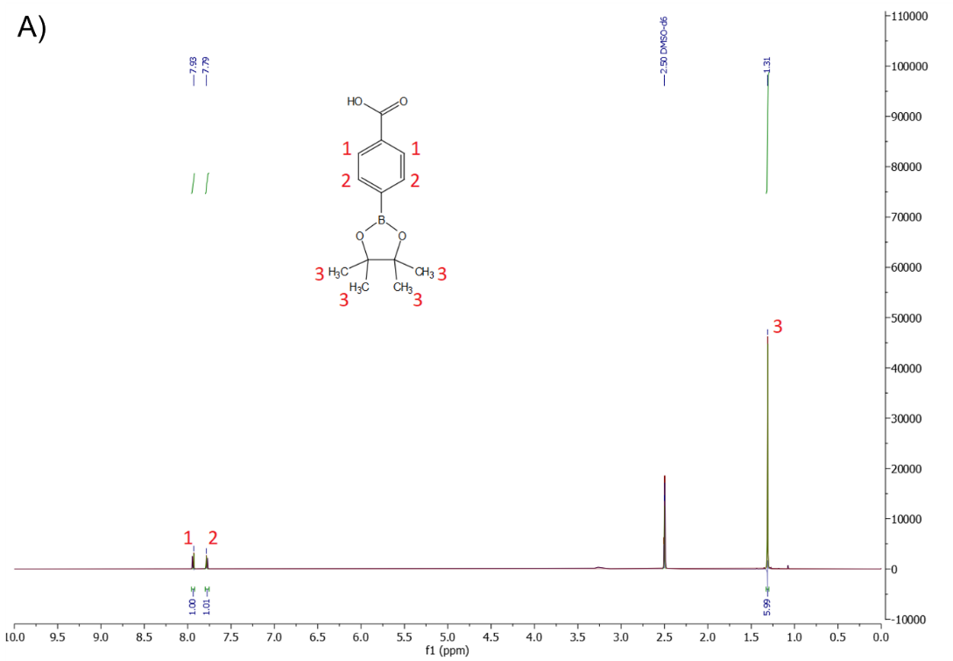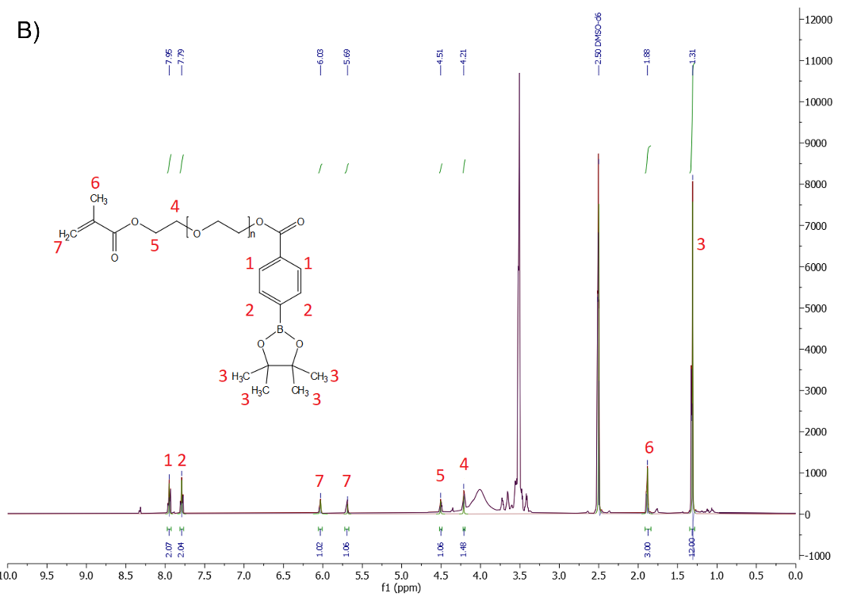

**Figure S1.** 1H-NMR in DMSO-d6 of (A) pinacol-protected phenylboronic acid and (B) PEGMA-PBA-Pinacol. The acid proton resonance around 12 ppm is not shown.

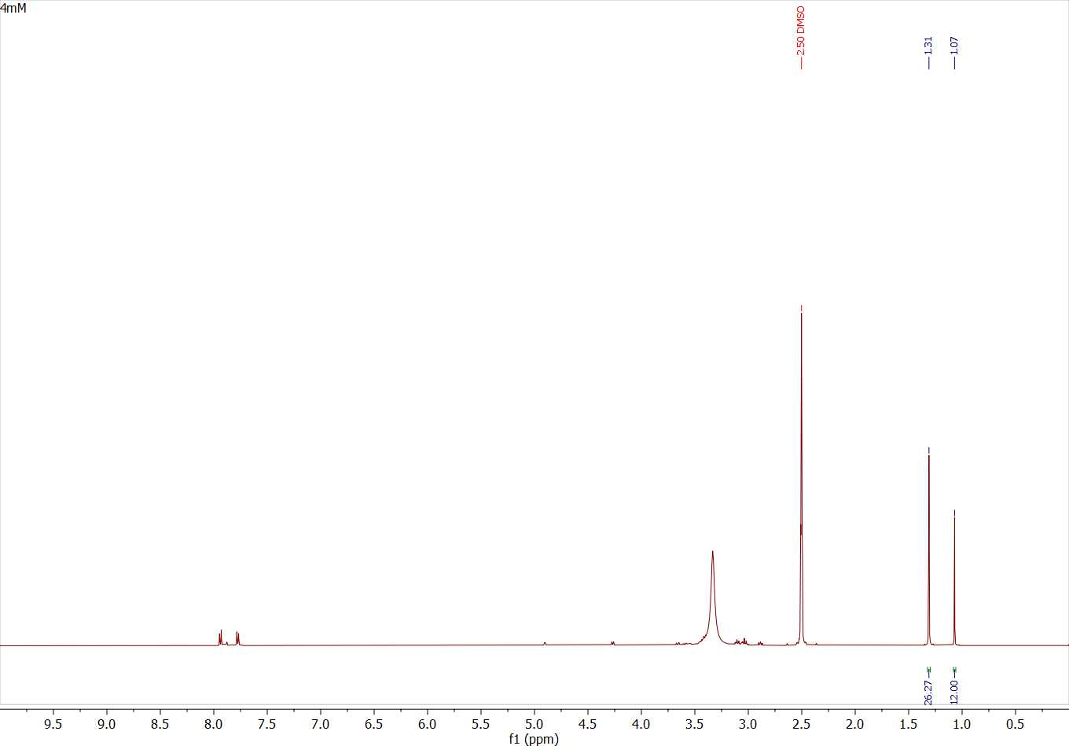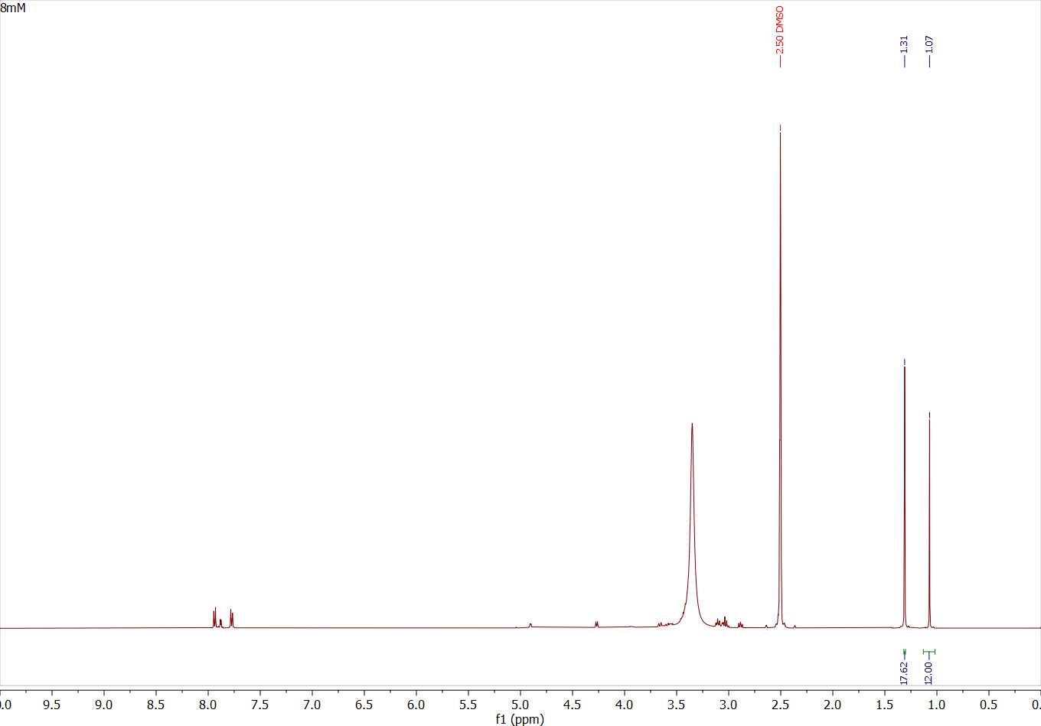

C)

B)

A)

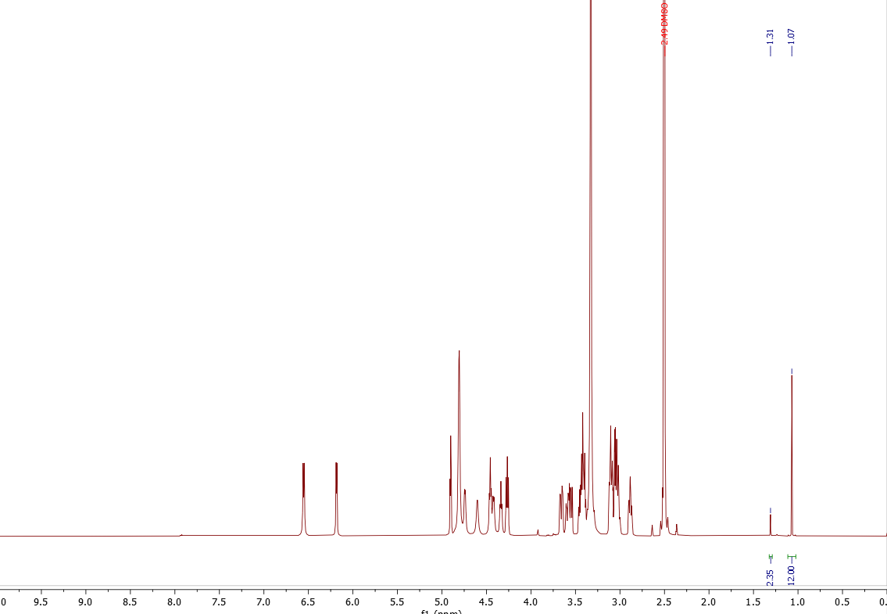

**Figure S2.** 1H-NMR in DMSO-d6 of the crude medium obtained after 3 days of reaction between PEGMA-PBA-Pinacol in a A) 4 mM, B) 8 mM, and C) 12 mM glucose solution (using a 100 mM sodium phosphate buffer).

**Figure S3.** Release of pinacol from PEGMA-PBA-Pinacol after 3 days in a 4 mM, 8 mM, and 12 mM glucose solution (as-determined by 1H-NMR).

**Figure S4.** Storage modulus G' (full) and loss modulus G" (hollow) (A) as well as complex viscosity (B) of HEMA (black circle), PEGMA-PBA-pinacol (red diamond) and HEMA/PEGMA-PBA-pinacol (90/10 mol%) (green triangles) as a function of near-UV exposition time.

**Figure S5.** FTIR spectra of PEGMA-PBA-Pinacol (blue), neat PHEMA (red), PHEMA-PBA2 (green) and PHEMA-PBA10 (zoom in the region of borate asymmetric stretching vibration around 1350 cm-1).

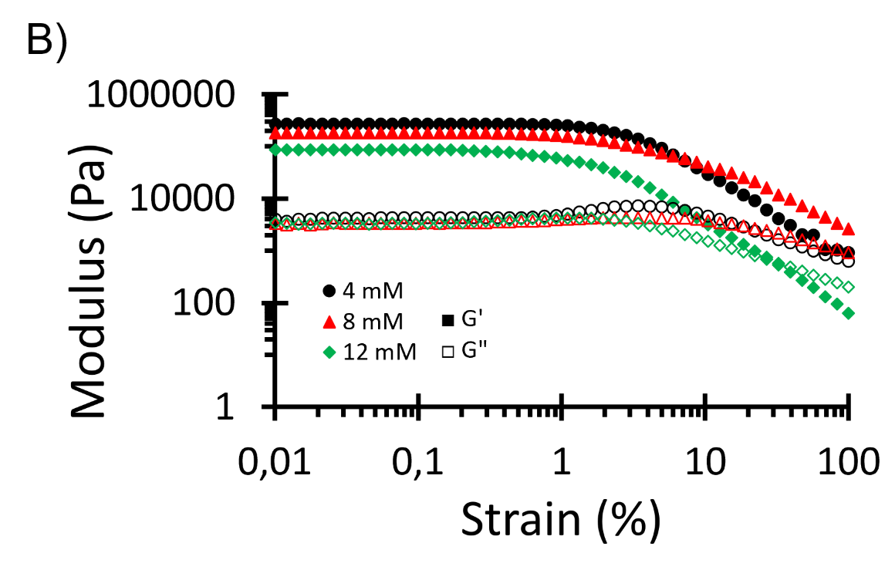

**Figure S6.** Storage modulus G’ (full) and loss modulus G” (hollow) as a function of strain of PHEMA-PBA10 swelled at equilibrium in glucose solutions of 4 mM (black circles), 8 mM (red triangles) and 12 mM (green diamonds).

**Table S1.** Rheological characterization and associated mesh sizes of PHEMA-based hydrogels.

|  |  |  |  |
| --- | --- | --- | --- |
| Hydrogel composition | Glucose concentration (mM) | G’ (kPa) | rmesh (nm)* |
| Neat PHEMA | 0 | 41 | 5.7 |
| 4 | 41 | 5.7 |
| 8 | 41 | 5.7 |
| 12 | 41 | 5.7 |
| PHEMA-PBA2 | 0 | 39 | 5.8 |
| 4 | 272 | 3.1 |
| 8 | 187 | 3.5 |
| 12 | 55 | 5.2 |
| PHEMA-PBA5 | 0 | 38 | 5.8 |
| 4 | 357 | 2.8 |
| 8 | 233 | 3.3 |
| 12 | 59 | 5.1 |
| PHEMA-PBA10 | 0 | 37 | 5.9 |
| 4 | 470 | 2.5 |
| 8 | 285 | 3.0 |
| 12 | 66 | 4.9 |

*

**Figure S7.** Swelling behavior (dashed line) and release kinetic (solid line) of PHEMA-PBA2 (red) and PHEMA-PBA10 (black) in a glucose solution of 12 mM.

**Figure S8.** Relative pinacol released as a function of square root of time for diffusion coefficient determination of (a) PHEMA-PBA2 and (b) PHEMA-PBA10.

**Table S2.** Diffusion coefficient D (cm²/s) of pinacol release from PHEMA-based hydrogels.

|  |  |  |
| --- | --- | --- |
| Composition | Glucose solution  (mM) | Diffusion coefficient D  (cm²/s) |
| PHEMA-PBA2 | 4 | 3.12 10-12 |
| 8 | 6.66 10-12 |
| 12 | 1.61 10-11 |
| PHEMA-PBA10 | 4 | 3.59 10-12 |
| 8 | 4.01 10-12 |
| 12 | 2.02 10-11 |

**Figure S9.** Swelling behavior (dashed line) and release kinetic (solid line) of implant with an infill density of 100% (black) and 50% (red) in a glucose solution of 12 mM.