DRIFTS 5% Re purge-no purge.tif

**Figure S1.** CO DRIFTS of Re5-H at 20°C: (black) after reduction in H2 at 400°C and (red) after reduction and heating in flowing He at 400°C.

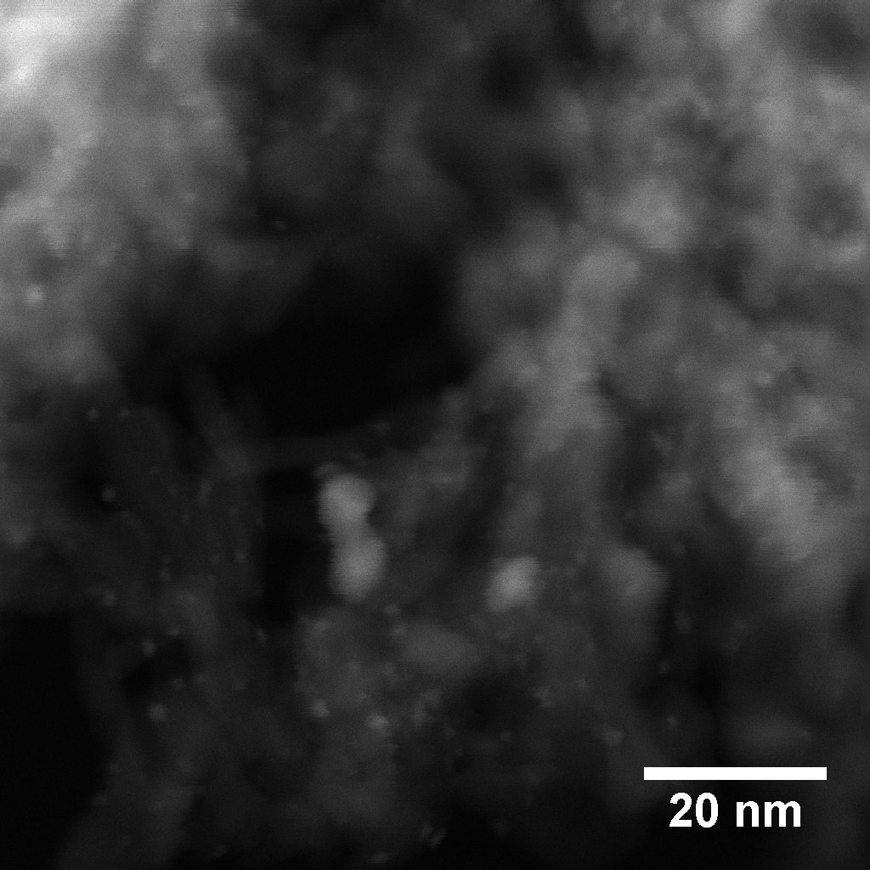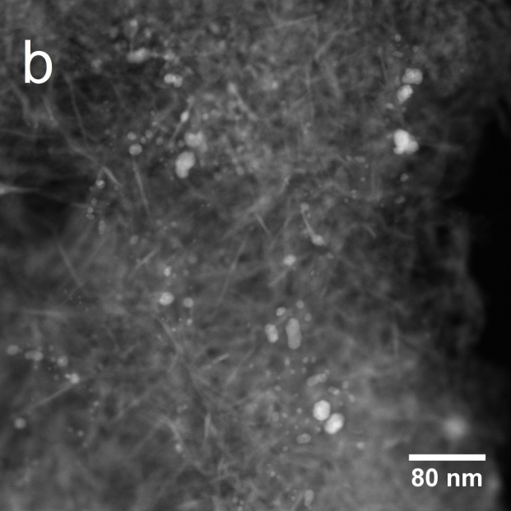

a

**Figure S2.** HAADF-STEM images of Pd3-TA (a) and Pd3-N (b) catalysts.

EXAFS chiR RePd fcc standards.tifEXAFS chiR RePd fcc standards.tif

Figure S3. Fourier transforms of FEFF-simulated EXAFS spectra generated by substitution of one metal into the first (fcc) coordination shell of the other: Re into Pd at the Pd K edge (a) and Pd into Re at the Re LIII-edge (b).



**Figure S4.** Composite HAADF-STEM particle size distribution of Re5-H catalyst.