**Online Supplemental - An Ecoregional Conservation Assessment for the Southern Rocky Mountains Ecoregion, and Santa Fe Subregion, Wyoming to New Mexico, USA**

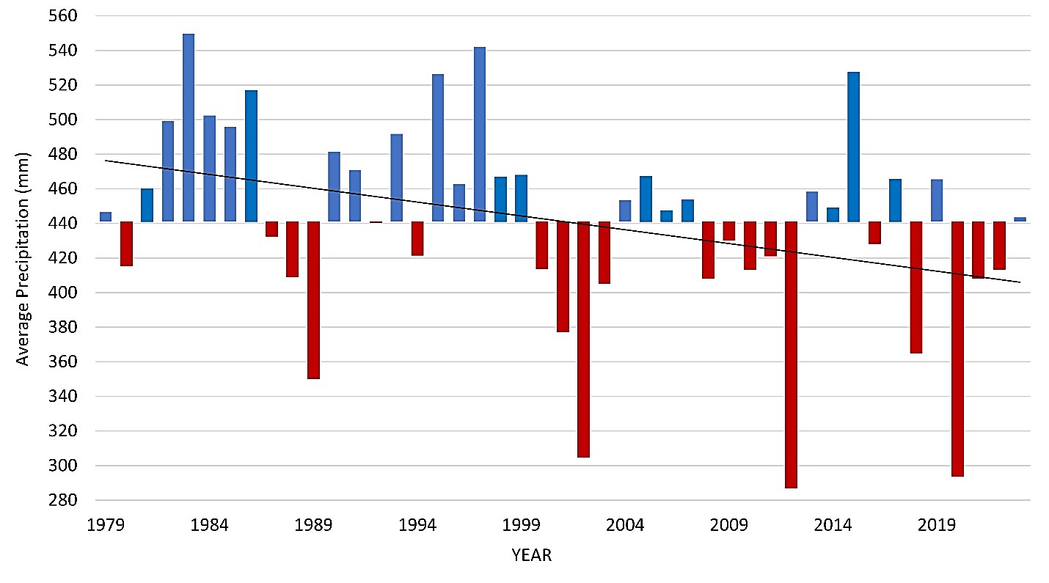

Figure S1. Annual precipitation (mm) across the study area, from 1979-2023, showing precipitation lower than the overall mean (441mm) in red and higher than the mean in blue. The trendline shows an overall decline in precipitation of -16mm/decade (r=-0.36, p=0.02). Graph created with gridMET data from Climate Toolbox Historical Climate Tracker web tool (Hegewisch and Abatzoglou, 2023).

**Table S1.** The 10 southernmost watersheds (8-digit Hydrologic Unit Code) of the Southern Rocky Mountains Ecoregion (SRME), which we used to delineate the Santa Fe Subregion (SFSR).

|  |  |  |
| --- | --- | --- |
|  |  |  |
| **Watershed Name** | **Hydrologic Unit Code** | **Watershed ha** |
| Cimarron | 11080002 | 192,833 |
| Upper Canadian | 11080003 | 45,449 |
| Mora | 11080004 | 148,869 |
| Upper Rio Grande | 13020101 | 424,055 |
| Rio Chama | 13020102 | 706,264 |
| Rio Grande-Santa Fe | 13020201 | 109,683 |
| Jemez | 13020202 | 161,707 |
| Rio Puerco | 13020204 | 48,043 |
| Pecos Headwaters | 13060001 | 213,556 |
| Blanco Canyon | 14080103 | 137,591 |
| **Total ha** | | **2,188,050** |

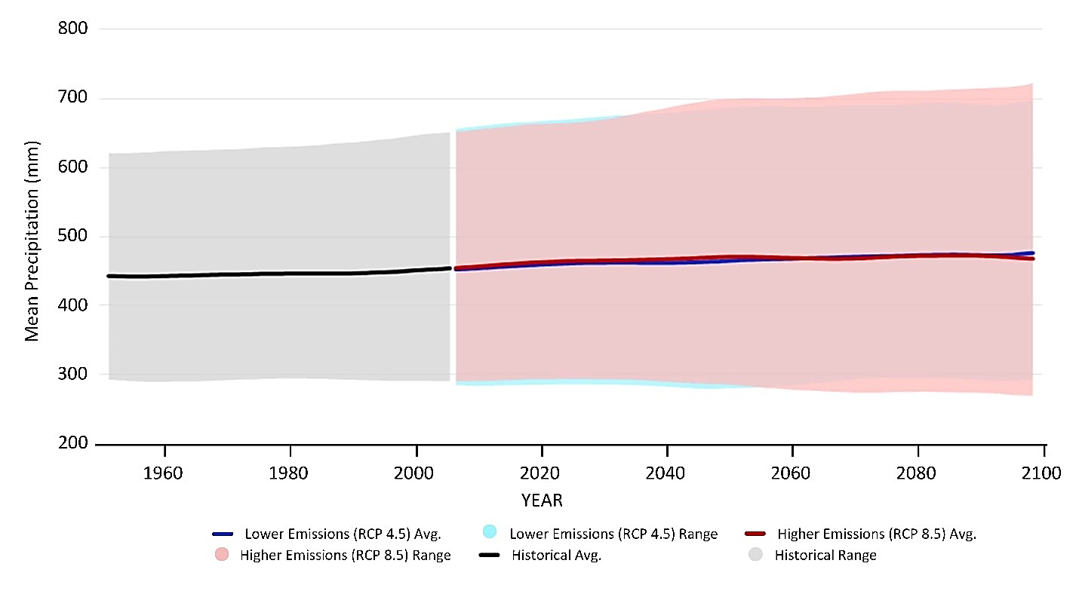

Figure S2. Projected future mean precipitation for the study area varies substantially compared to the historical average (1950-2005). Graph created with Climate Toolbox Future Time Series web tool based on MACAv2-METDATA CMIP5 model ensemble (Hegewisch and Abatzoglou, 2023).

**Table S2.** Existing Vegetation Types (EVT) as defined by LANDFIRE 2022 within the SRME and the broader categories we created from them.

|  |  |  |  |
| --- | --- | --- | --- |
|  |  |  |  |
| **Existing Vegetation Type (EVT)** | **Category** | **Southern Rocky Mountains Ecoregion (ha)** | **Santa Fe Subregion (ha)** |
| Colorado Plateau Mixed Bedrock Canyon and Tableland | Sparse | 5,818 | 1,790 |
| Colorado Plateau Mixed Low Sagebrush Shrubland | Shrubland | 3,405 | 1,843 |
| Colorado Plateau Pinyon-Juniper Woodland | Pinyon-Juniper | 282,357 | 87,595 |
| Developed-High Intensity | Developed | 1,944 | 122 |
| Developed-Low Intensity | Developed | 17,263 | 1,532 |
| Developed-Medium Intensity | Developed | 7,260 | 525 |
| Developed-Roads | Developed | 98,681 | 14,222 |
| Great Basin & Intermountain Introduced Annual and Biennial Forbland | Grassland | 3,362 | 1,018 |
| Great Basin & Intermountain Introduced Annual Grassland | Grassland | 0.2 |  |
| Great Basin & Intermountain Introduced Perennial Grassland and Forbland | Grassland | 36,427 | 5,512 |
| Great Basin & Intermountain Ruderal Shrubland | Shrubland | 9,661 | 7,254 |
| Interior Western North American Temperate Ruderal Grassland | Grassland | 133,321 | 6,501 |
| Interior Western North American Temperate Ruderal Shrubland | Shrubland | 27,868 | 819 |
| Inter-Mountain Basins Active and Stabilized Dune | Sparse | 124 | 2.3 |
| Inter-Mountain Basins Aspen-Mixed Conifer Forest and Woodland | Aspen and Mixed-Conifer Forest | 68,684 | 3,875 |
| Inter-Mountain Basins Big Sagebrush Shrubland | Shrubland | 260,357 | 109,828 |
| Inter-Mountain Basins Big Sagebrush Steppe | Shrubland | 48,689 | 0 |
| Inter-Mountain Basins Curl-leaf Mountain Mahogany Woodland | Shrubland | 0.7 | 0 |
| Inter-Mountain Basins Greasewood Flat | Shrubland | 2,687 | 567 |
| Inter-Mountain Basins Juniper Savanna | Pinyon-Juniper | 88 | 41 |
| Inter-Mountain Basins Mixed Salt Desert Scrub | Shrubland | 4,271 | 2,193 |
| Inter-Mountain Basins Montane Sagebrush Steppe | Shrubland | 1,032,364 | 38,826 |
| Inter-Mountain Basins Semi-Desert Grassland | Grassland | 19,733 | 4,165 |
| Inter-Mountain Basins Semi-Desert Shrub-Steppe | Shrubland | 67,992 | 22,420 |
| North American Arid West Emergent Marsh | Wetland | 1,842 | 88 |
| North American Glacier and Ice Field | Snow-Ice | 61,304 | 21 |
| Northern & Central Plains Ruderal & Planted Shrubland | Shrubland | 0.1 | 0 |
| Northwestern Great Plains Mixedgrass Prairie | Grassland | 127,538 | 0 |
| Open Water | Water | 62,799 | 4,860 |
| Quarries-Strip Mines-Gravel Pits-Well and Wind Pads | Barren | 7,214 | 1,751 |
| Rocky Mountain Alpine Bedrock and Scree | Sparse | 291,082 | 1,603 |
| Rocky Mountain Alpine Dwarf-Shrubland | Shrubland | 26,535 | 321 |
| Rocky Mountain Alpine Fell-Field | Alpine | 5,219 | 315 |
| Rocky Mountain Alpine Turf | Alpine | 176,004 | 1,694 |
| Rocky Mountain Alpine-Montane Wet Meadow | Wetland | 112,464 | 13,274 |
| Rocky Mountain Aspen Forest and Woodland | Aspen Forest and Woodland | 1,280,563 | 77,397 |
| Rocky Mountain Cliff Canyon and Massive Bedrock | Barren | 120,738 | 6,963 |
| Rocky Mountain Foothill Limber Pine-Juniper Woodland | Limber Pine Woodland | 3,921 | 0 |
| Rocky Mountain Gambel Oak-Mixed Montane Shrubland | Shrubland | 663,202 | 50,648 |
| Rocky Mountain Lodgepole Pine Forest | Lodgepole Pine Forest | 831,299 | 2.1 |
| Rocky Mountain Lower Montane-Foothill Riparian Shrubland | Riparian | 39,938 | 3,760 |
| Rocky Mountain Lower Montane-Foothill Riparian Woodland | Riparian | 81,569 | 12,543 |
| Rocky Mountain Lower Montane-Foothill Shrubland | Shrubland | 319,058 | 23,075 |
| Rocky Mountain Subalpine Dry-Mesic Spruce-Fir Forest and Woodland | Subalpine Forest | 2,334,721 | 209,476 |
| Rocky Mountain Subalpine Mesic-Wet Spruce-Fir Forest and Woodland | Subalpine Forest | 10,007 | 640 |
| Rocky Mountain Subalpine-Montane Limber-Bristlecone Pine Woodland | Subalpine Forest | 96,288 | 2,614 |
| Rocky Mountain Subalpine-Montane Mesic Meadow | Grassland | 211,588 | 13,563 |
| Rocky Mountain Subalpine-Montane Riparian Shrubland | Riparian | 43,243 | 969 |
| Rocky Mountain Subalpine-Montane Riparian Woodland | Riparian | 81,138 | 2,522 |
| Southern Rocky Mountain Dry-Mesic Montane Mixed Conifer Forest and Woodland | Mixed-Conifer Forest | 792,309 | 189,038 |
| Southern Rocky Mountain Juniper Woodland and Savanna | Pinyon-Juniper | 1,909 | 1,894 |
| Southern Rocky Mountain Mesic Montane Mixed Conifer Forest and Woodland | Mixed-Conifer Forest | 410,880 | 172,681 |
| Southern Rocky Mountain Montane-Subalpine Grassland | Grassland | 839,965 | 88,339 |
| Southern Rocky Mountain Pinyon-Juniper Woodland | Pinyon-Juniper | 671,359 | 293,548 |
| Southern Rocky Mountain Ponderosa Pine Savanna | Ponderosa Pine | 20,128 | 1,314 |
| Southern Rocky Mountain Ponderosa Pine Woodland | Ponderosa Pine | 2,185,042 | 660,342 |
| Western Cool Temperate Close Grown Crop | Agricultural | 30,206 | 2,236 |
| Western Cool Temperate Developed Deciduous Forest | Developed | 1,273 | 25 |
| Western Cool Temperate Developed Evergreen Forest | Developed | 9,662 | 1,219 |
| Western Cool Temperate Developed Herbaceous | Developed | 2,391 | 323 |
| Western Cool Temperate Developed Mixed Forest | Developed | 965 | 110 |
| Western Cool Temperate Developed Shrubland | Developed | 3,732 | 371 |
| Western Cool Temperate Fallow/Idle Cropland | Agricultural | 14,627 | 6,023 |
| Western Cool Temperate Orchard | Agricultural | 24 | 9.1 |
| Western Cool Temperate Pasture and Hayland | Agricultural | 210,004 | 20,420 |
| Western Cool Temperate Row Crop | Agricultural | 850 | 106 |
| Western Cool Temperate Row Crop - Close Grown Crop | Agricultural | 305 | 7.4 |
| Western Cool Temperate Urban Deciduous Forest | Developed | 10,222 | 379 |
| Western Cool Temperate Urban Evergreen Forest | Developed | 18,917 | 2,232 |
| Western Cool Temperate Urban Herbaceous | Developed | 8,787 | 399 |
| Western Cool Temperate Urban Mixed Forest | Developed | 4,436 | 333 |
| Western Cool Temperate Urban Shrubland | Developed | 29,611 | 3,491 |
| Western Cool Temperate Vineyard | Agricultural | 0.4 | 0.3 |
| Western Cool Temperate Wheat | Agricultural | 294 | 30 |
| Western Great Plains Cliff and Outcrop | Barren | 5,444 | 42 |
| Western Great Plains Foothill and Piedmont Grassland | Grassland | 55,296 | 803 |
| Western Great Plains Riparian Herbaceous | Riparian | 0.1 |  |
| Western Great Plains Shortgrass Prairie | Grassland | 14,876 | 805 |
| Western North American Ruderal Wet Meadow & Marsh | Wetland | 4,619 | 253 |
| Western North American Ruderal Wet Shrubland | Wetland | 426 | 57 |
| Western Warm Temperate Close Grown Crop | Agricultural | 131 | 131 |
| Western Warm Temperate Developed Evergreen Forest | Developed | 401 | 401 |
| Western Warm Temperate Developed Herbaceous | Developed | 16 | 16 |
| Western Warm Temperate Developed Mixed Forest | Developed | 14 | 14 |
| Western Warm Temperate Developed Shrubland | Developed | 171 | 171 |
| Western Warm Temperate Fallow/Idle Cropland | Agricultural | 76 | 76 |
| Western Warm Temperate Orchard | Agricultural | 0.9 | 0.9 |
| Western Warm Temperate Pasture and Hayland | Agricultural | 456 | 456 |
| Western Warm Temperate Row Crop | Agricultural | 4.3 | 4.3 |
| Western Warm Temperate Urban Deciduous Forest | Developed | 40 | 40 |
| Western Warm Temperate Urban Evergreen Forest | Developed | 338 | 338 |
| Western Warm Temperate Urban Herbaceous | Developed | 38 | 38 |
| Western Warm Temperate Urban Mixed Forest | Developed | 7.6 | 7.6 |
| Western Warm Temperate Urban Shrubland | Developed | 768 | 768 |
| Western Warm Temperate Vineyard | Agricultural | 0.1 | 0.1 |
| Western Warm Temperate Wheat | Agricultural | 5.3 | 5.3 |
| Wyoming Basins Dwarf Sagebrush Shrubland and Steppe | Shrubland | 2,864 |  |
| **Total ha** | | **14,475,519** | **2,188,050** |

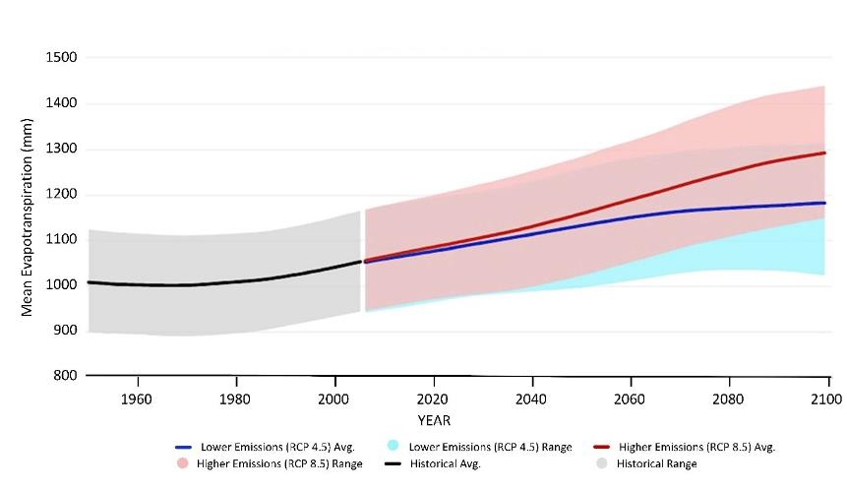

Figure S3. Evapotranspiration is projected to increase by 17-37% with higher emissions (RCP8.5) and by 8-23% with lower emissions (RCP4.5). Graph created with Climate Toolbox Future Time Series web tool based on MACAv2-METDATA CMIP5 model ensemble (Hegewisch and Abatzoglou 2024, 2023).

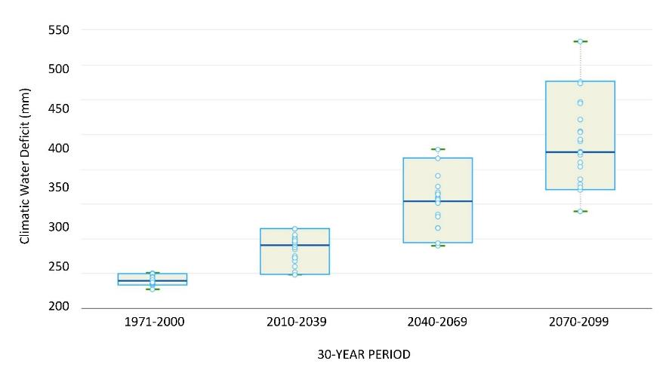

Figure S4. Increasing Climatic Water Deficit (mm), based on continued higher emissions (RCP8.5). Data from 20 GCMs shown, including median (blue line), 5th and 95th percentiles (box), and highest/lowest values (green lines or “whiskers”). Graph downloaded from Climate Toolbox Future Box Plots web tool (Hegewisch and Abatzoglou, 2023).

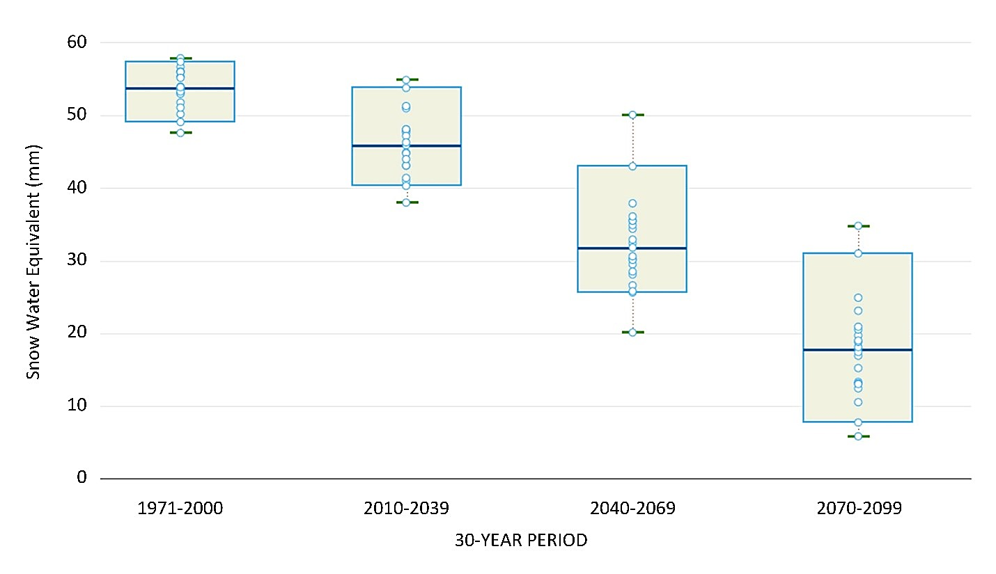

Figure S5. Winter (Dec-Feb) snow water equivalent (mm) across the study area is projected to decline by 40-92%, as compared to the historical period, by the end of the century. Graph downloaded from Climate Toolbox Future Box Plots web tool (Hegewisch and Abatzoglou, 2023).

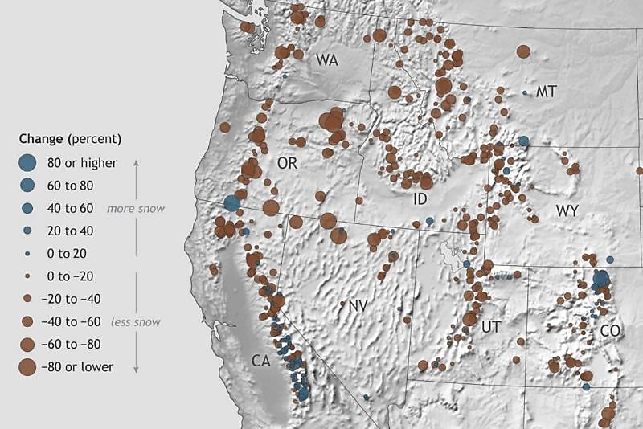

Figure S6. Observed changes in April snowpack across the Western U.S. from 1955-2020. Map by NOAA Climate.gov based on USDA Natural Resources Conservation Snow Data (EPA 2023).

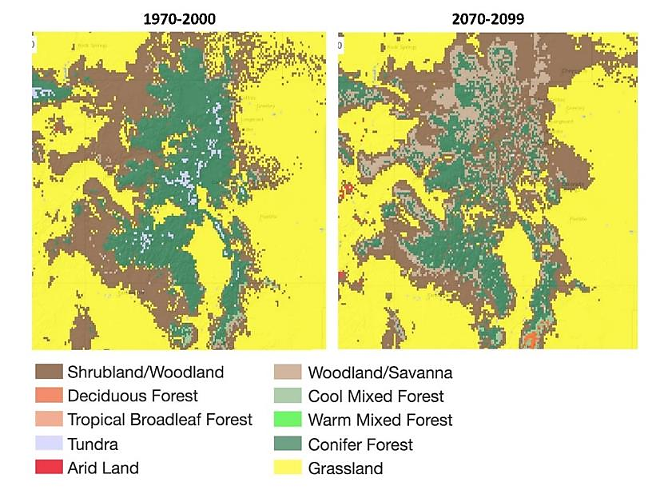

Figure S7. MC2 vegetation model results compare modeled 1971-2000 vegetation types (left) to projected vegetation types in 2070-2099 (right) based on ensemble average across 20 GCMs and continued higher emissions (RCP8.5). Limited shifts in dominant vegetation type are expected across the study area by the end of the century, primarily as a loss of subalpine forest, and expansion of shrublands. Graphic downloaded from Climate Toolbox Future Vegetation web tool using MC2-MACAv2-Prism, without fire suppression.

**Literature Cited**

US EPA. Climate Change Indicators: Snowpack. Available online: <https://www.epa.gov/climate-indicators/climate-change-indicators-snowpack> (accessed on 10 June 2024).

Hegewisch, K.C.; Abatzoglou, J.T. 2023. Future Time Series web tool. Climate Toolbox <https://climatetoolbox.org/> (accessed on March 23, 2024).