Supplementary Materials: Towards air quality protection in an urban area – case study
Zbigniew Nahorski ^{1,2}, Piotr Holnicki ^{1,}* and Andrzej Kałuszko ¹
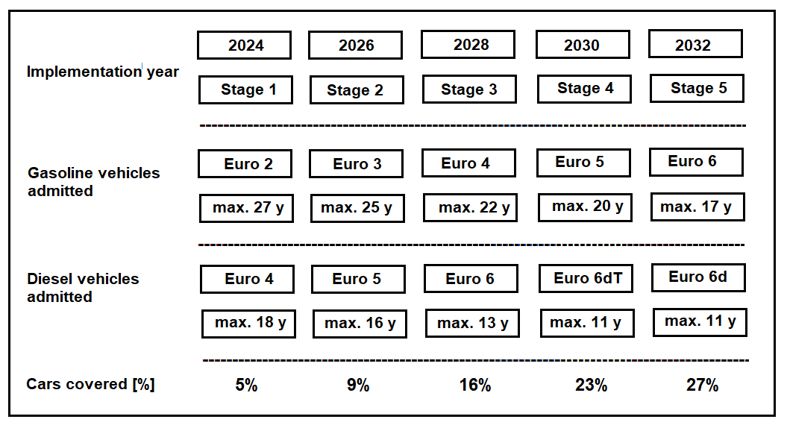
Figure S1. The planned implementation of the Low Emission Zone in Warsaw. The vehicle
ages correspond to the start of the first stage of the zone’s launch (according to [7]).
Table S1. The expected NOx and PM emission reduction in the LEZ resulting from the zone
implementation (according to [7]).
STAGE  EMISSION |  | ST 1 (2024) E2 (G)  E4 (D) | ST 2 (2026) E3 (G)  E5 (D) | ST 3 (2028)  E4 (G)  E6 (D) | ST 4 (2030) E5 (G) E6dT (D) | ST 5 (2032) E6 (G)  E6d( D)
NOx | Gasoline/Diesel share | 41% - G 59% - D | 42% - G 58% - D | 51% - G 49% - D | 52% - G 48% - D | 55% - G 45% - D
 | Total emission reduction | 11% | 23% | 49% | 66% | 75%
PM | Gasoline/Diesel share | 62% - G 38% - D | 56% - G  44% - D | 59% - G 41% - D | 62% - G 38% - D | 60% - G  40% - D
 | Total emission reduction | 32% | 55% | 66% | 70% | 73%

