Name | Sequence | Length [nt]
Detect-Seq | PolyAGTAAAACGACGGCCAGT | 27
Ctrl-Seq | PolyAACTGGCCGTCGTTTTAC | 58
Tgt-Seq1 | CAGCAGCAATTCATGTTTTGAA | 22
MB1 | PolyAGTAAAACGACGGCCA TTCAAAACATGAATTGCTGCT GACTGGCCGTCGTTTTAC | 71
Tgt-Seq2 | TGTGCGTGTGACAGCGGCTGA | 21
MB2 | PolyAGTAAAACGACGGCCA TCAGCCGCTGTCACACGCACA GACTGGCCGTCGTTTTAC | 70
Tgt-Seq3 | AAAGTNNNGCGNNNTTTNNNCGT | 23
MB3 | PolyAGTAAAACGACGGCCAACGNNNNNNNNNNGCNNNNCNNNGACTGGCCGTCGTTTTAC | 72
Tgt-Seq4 | TANNNCACNNNGTGNNNGCC | 20
MB4 | PolyAGTAAAACGACGGCCAGGNNNNCNCNNNGNGNNNNNGACTGGCCGTCGTTTTAC | 69

Table S1. List of Oligonucleotides used in this work. The colour codes of some bases represent parts of the sequences in Figure 3 and 4. PolyA: A10 to A40; N: hidden code of specific bases.

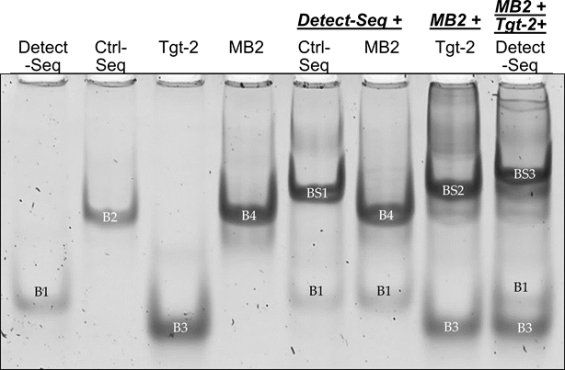
Figure S1. Incubation of oligonucleotides MB2 and Ctrl-Seq to Detect-Seq and Tgt-Seq2 by EMSA. All four DNA oligos showed a distinct band (B1-B4). Ctrl-Seq band B2 band shifted strongly to BS1 with Detect-Seq (B1). MB2 (B4) showed no band shift only with Detect-Seq (B1), but the strong band shift BS2 only with Tgt-Seq2 (B3) or the higher upwards band shift BS3 with Detect-Seq in the presence of Tgt-Seq2. MB2 = Molecular Beacon, Ctrl-Seq = control line oligonucleotide, Tgt-Seq2 = target oligonucleotide, Detect-Seq = detection oligonucleotide. Incubation time 60 min, ratio 1:4 of MB2 to Tgt-Seq2, ratio 1:2 of MB2/Ctrl-Seq to Detect-Seq. Stained with GelStarTM Nucleic Acid Gel Stain, 10,000X.
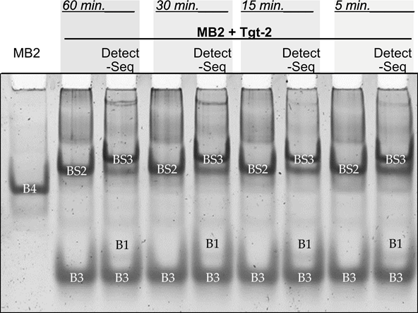
Figure S2. Variation of incubation time (60 to 5 min) of oligonucleotides MB2 to Detect-Seq and Tgt-Seq2 by EMSA. DNA oligo MB2 (B4) showed shifting to BS2 with Tgt-Seq2 (B3), and additionally with Detect-Seq (B1) and Tgt-Seq2 together to BS3. The band shifts have become weaker with shorter incubation time. MB2 = Molecular Beacon, Tgt-Seq2 = target oligonucleotide, Detect-Seq = detection oligonucleotide. Ratio 1:4 of MB2 to Tgt-Seq2, ratio 1:2 of MB2 to Detect-Seq. Stained with GelStarTM Nucleic Acid Gel Stain, 10,000X.
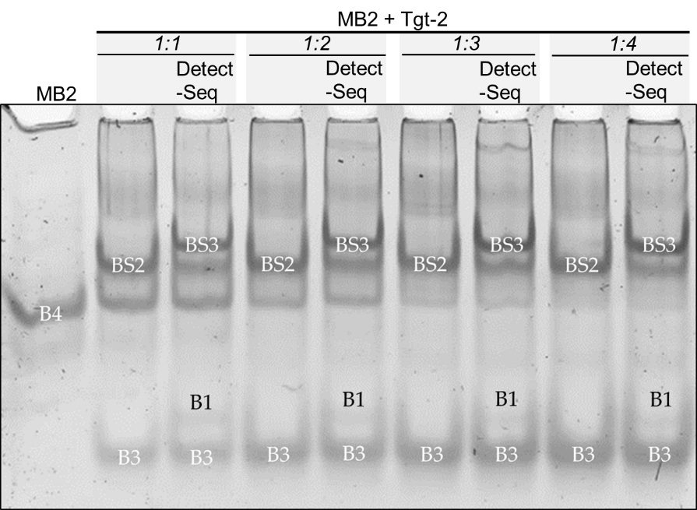
Figure S3. Variation of molar ratio (1:1 to 1:4) of the oligonucleotides MB2 to Tgt-Seq2 without/with Detect-Seq by EMSA. DNA oligo MB2 (B4) showed the band shift BS2 with Tgt-Seq2 (B3), and additionally the band shift BS3 with Detect-Seq (B1) and Tgt-Seq2 (B3) together. The band shift has become more pronounced with increasing surplus of Tgt-Seq2. MB2 = Molecular Beacon, Tgt-Seq2 = target oligonucleotide, Detect-Seq = detection oligonucleotide. Incubation time 15min, ratio 1:2 of MB2 to Detect-Seq. Stained with GelStarTM Nucleic Acid Gel Stain, 10,000X.
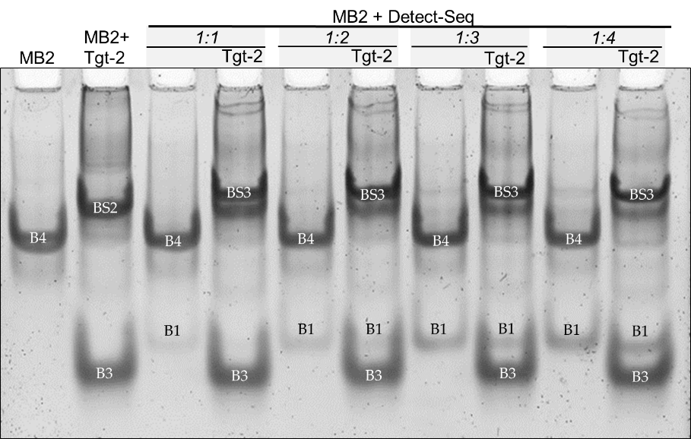
Figure S4. Variation of molar ratio (1:1 to 1:4) of the oligonucleotides MB2 to Detect-Seq without/with Tgt-Seq2 by EMSA. MB2 showed band shift BS2 with Tgt-Seq2, and additionally the band shift BS3 with Detect-Seq (B1) and Tgt-Seq2 (B3) together. The band shift has become more pronounced with increasing surplus of Detect-Seq. MB2 = Molecular Beacon, Tgt-Seq2 = target oligonucleotide, Detect-Seq = detection oligonucleotide. Incubation time 15 min, ratio 1:3 of MB2 to Tgt-Seq2. Stained with GelStarTM Nucleic Acid Gel Stain, 10,000X.

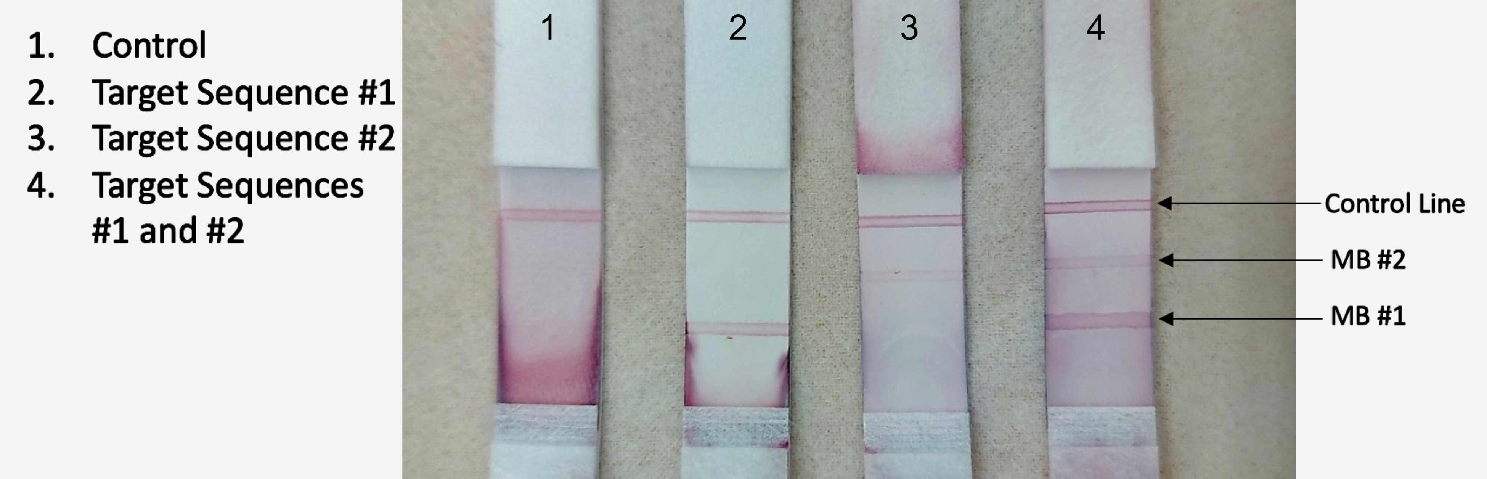
Figure S5. Multiplex NALFA performance in lined LFA format.
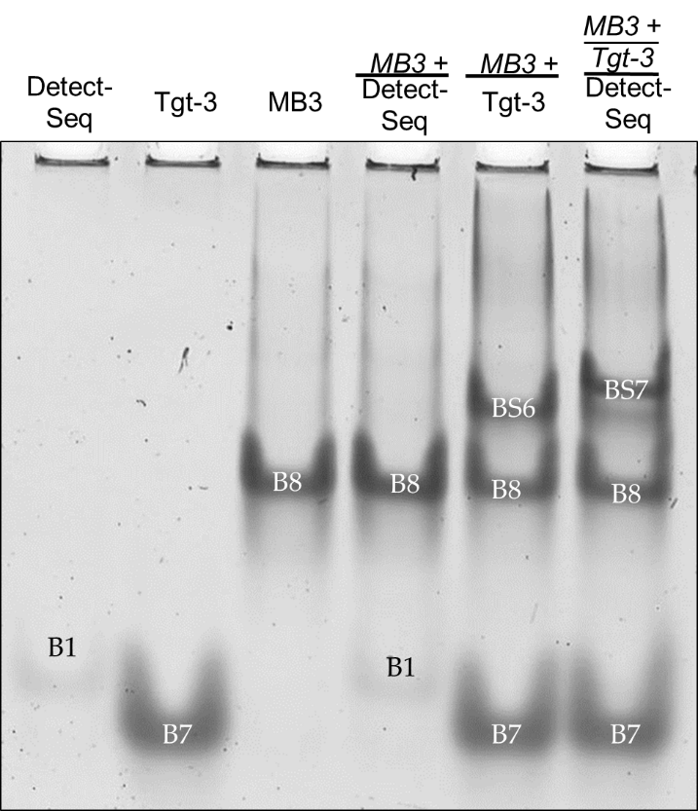 | 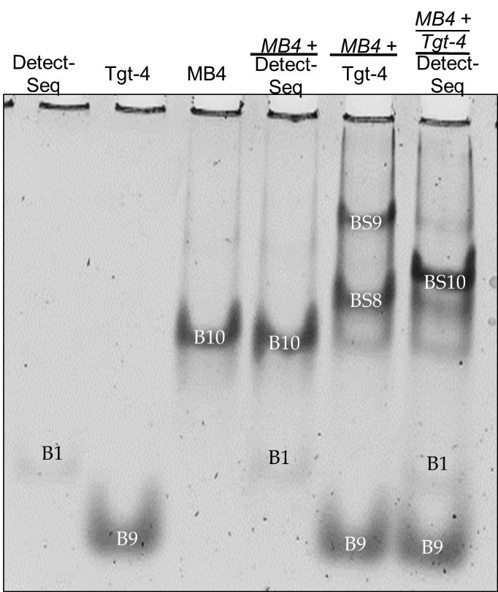
(a) | (b)
Figure S6. Incubation of oligonucleotides MB3 and MB4 with Detect-Seq, Tgt-Seq3 and Tgt-Seq4 respectively by EMSA. (a) MB3 (B8) showed band shift BS6 only with Tgt-Seq3 (B7) and the third band shift BS7 with Tgt-Seq3 and Detect-Seq (B1) together. (b) MB4 (B10) showed two band shifts BS8 and BS9 only with Tgt-Seq4 (B9) and the additional higher upwards band shift BS10 with Tgt-Seq4 and Detect-Seq (B1) together. MB3 and 4 = Molecular Beacons, Tgt-Seq 3 and 4 = target oligonucleotides, Detect-Seq = detection oligonucleotide. Incubation time 15 min, ratio 1:3 of MB3 and 4 to Tgt-Seq 3 and 4, ratio 1:2 of MB3 and 4 to Detect-Seq. EMSA gels stained with GelStarTM Nucleic Acid Gel Stain, 10,000X.

