Supplementary material
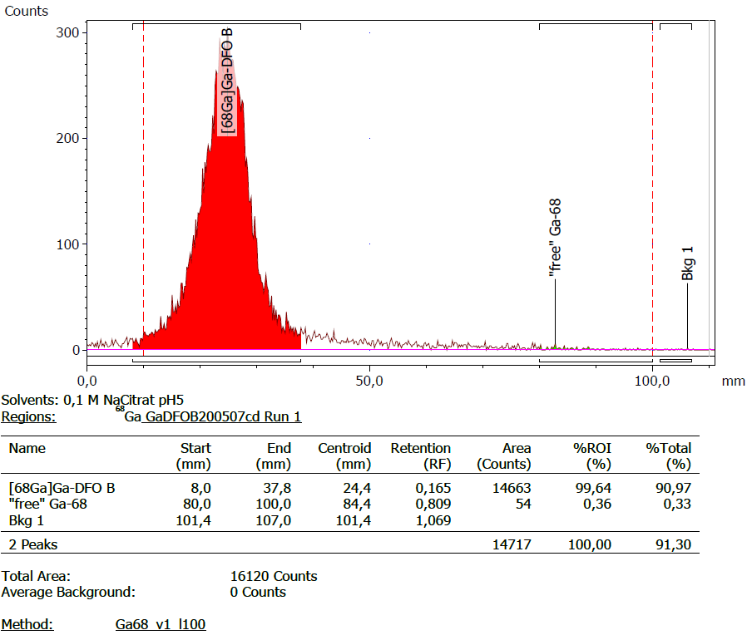
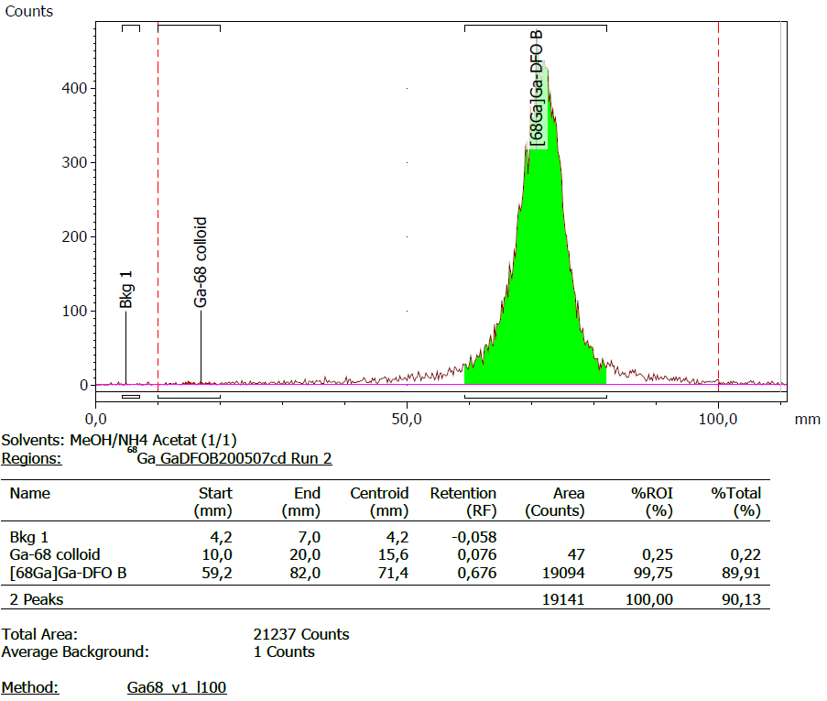
Figure S1 Sample chromatograms from ITLC of [⁶⁸Ga]Ga-desferrioxamine B with silica gel as stationary phase. Chromatograms with mobile phase A (upper panel: sodium citrate 0.1 M with pH 5) and mobile phase B (lower panel: ammonium acetate 1 M + methanol 1:1 ^{v}/_{v}) are shown.
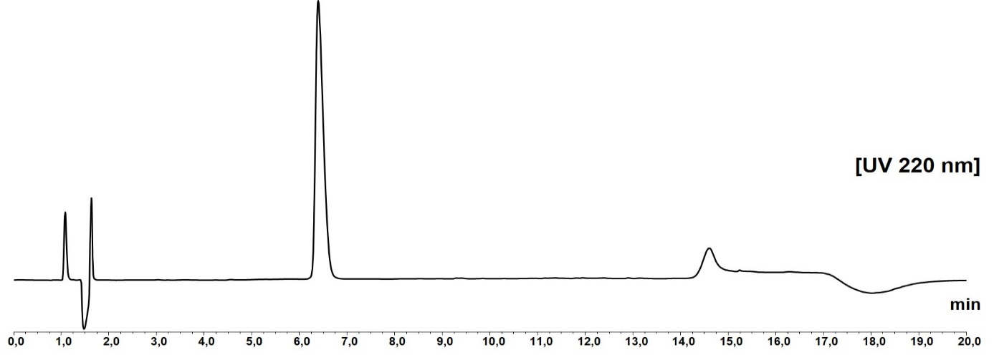
Figure S2 Sample UV chromatogram at 220 nm from RP-HPLC of [^{nat}Ga]Ga-desferrioxamine B. The main peak has a retention time of 6.4 min.
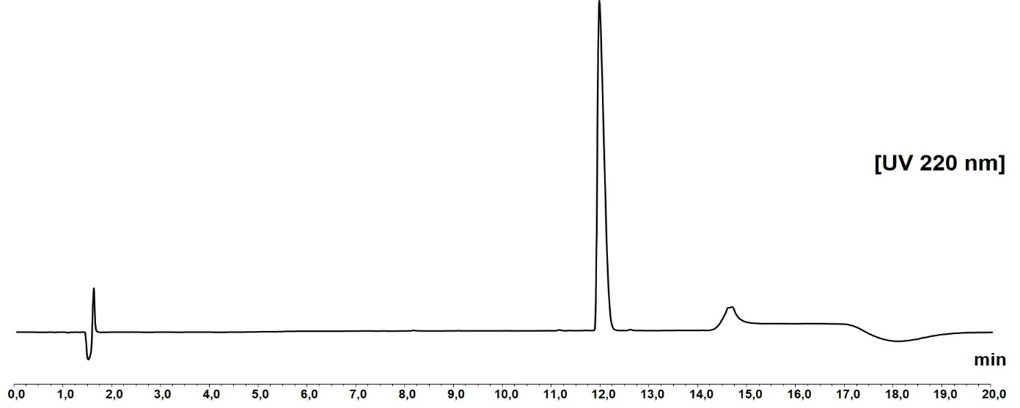
Figure S3 Sample UV chromatogram at 220 nm from RP-HPLC of desferrioxamine B (Desferal®). The main peak has a retention time of 11.9 min.
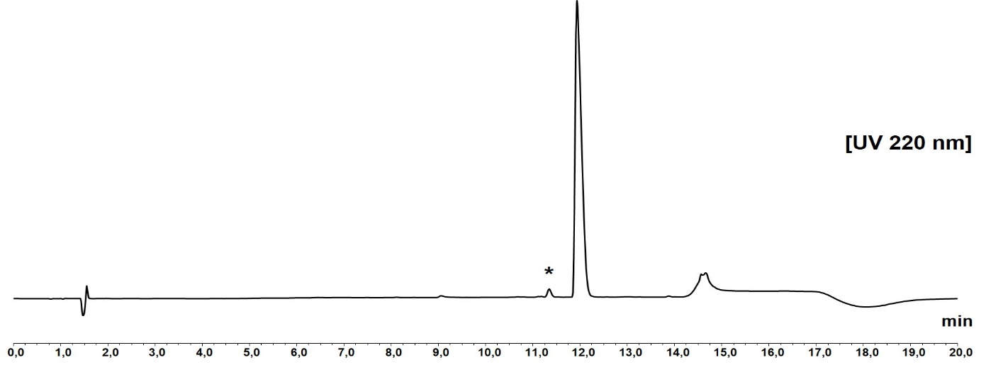
Figure S4 Sample UV chromatogram at 220 nm from RP-HPLC of desferrioxamine B (CRS standard for system suitability). The main peak has a retention time of 11.9 min. An impurity specified as impurity G in the Ph. Eur. is visible at 11.3 min (marked with an asterisk * in the chromatogram).

