Phytoremediation of mercury contamination: bibliometric analysis.
Lina M. Mosquera ¹, Diego Paredes Cuervo ²*, Ana M. López ³, Carlos A. Arias ⁴*, Pedro N. Carvalho ⁵
¹ Faculty of Engineering, Environmental Engineering, Universidad Tecnológica del Chocó, Quibdó 270002, Chocó, Colombia; e-mail: d-lina.mosquera@utch.edu.co.
²Department of Basic Environmental Sciences Faculty, Universidad Tecnológica de Pereira, Pereira 660003, Risaralda, Colombia; e-mail: diparede@utp.edu.co
³Faculty of Agricultural Sciences and Agroindustry, Universidad Tecnológica de Pereira, Pereira 660003, Risaralda, Colombia; e-mail: alopez@utp.edu.co
⁴Aarhus University, Department of Bioscience, Ole Worms Allé 1, Building 1135, 8000 Århus C, Denmark; e-mail: carlos.arias@bio.au.dk
⁵Aarhus University, Department of Environmental Science, Frederiksborgvej 399, 4000 Roskilde, Denmark; e-mail: pedro.carvalho@envs.au.dk
*Correspondence: diparede@utp.edu.co; carlos.arias@bio.au.dk

Citation: Mosquera, L.M.; Paredes, D.; López, A.M.; Arias, C.A.; Carvalho, P.
To be added by editorial staff during production.
Academic Editor: Firstname Lastname
Received: date
Revised: date
Accepted: date
Published: date
Copyright: © 2024 by the authors. Submitted for possible open access publication under the terms and conditions of the Creative Commons Attribution (CC BY) license (https://creativecommons.org/licenses/by/4.0/).

Table S1. Top 10 authors with the highest number of articles in WoS and Scopus on phytoremediation of mercury contamination
Rank | WoS |  |  |  | Scopus
 | Author | Country | Documents | Citations | Author | Country | Documents | Citations
1 | Feng, Xinbin | China | 10 | 251 | Wang, Jianxu | China | 16 | 816
2 | Liu, Zhongchuang | China | 10 | 190 | Feng, Xinbin | China | 14 | 753
3 | Wang, Li-Ao | China | 9 | 140 | Kumar, Amit | Canada | 11 | 544
4 | Wang, Jianxu | China | 8 | 218 | Liu, Zhongchuang | China | 10 | 151
5 | Anderson, Christopher W. N. | Nueva Zelanda | 8 | 205 | Meagher, Richard Brian | United States | 9 | 821
6 | Marrugo Negrete, Jose | Colombia | 7 | 287 | Kiyono, Masako | Japan | 8 | 171
7 | Smolinska, Beata | Poland | 7 | 110 | Wang, Li-Ao | China | 8 | 148
8 | Kiyono, Masako | Japan | 6 | 71 | Chen, Jian | China | 8 | 410
9 | Nakamura, Ryosuke | Japan | 6 | 71 | Anderson, Christopher W. N. | Nueva Zelanda | 8 | 798
10 | Pereira, Eduarda | Portugal | 6 | 95 | Wang, H | China | 8 | 232

Table S2. Journals with the greatest scientific production in WoS
Rank | Source | Documents | Percentage of publications | Citations | H | Q (2022) | Country | Subject area
1 | Environmental Science and Pollution Research | 26 | 5.7 | 564 | 154 | Q2 | Germany | Environmental Science; Medicine
2 | International Journal of Phytoremediation | 26 | 5.7 | 479 | 98 | Q2 | United Kingdom | Environmental Science; Agricultural and Biological Sciences
3 | Chemosphere | 23 | 5.0 | 875 | 98 | Q2 | United Kingdom | Environmental Science; Medicine; Chemistry
4 | Science of the Total Environment | 19 | 4.2 | 1551 | 317 | Q1 | Netherlands | Environmental Science
5 | Journal of Hazardous Materials | 17 | 3.7 | 546 | 329 | Q1 | Germany | Environmental Science
6 | Ecotoxicology and Environmental Safety | 14 | 3.1 | 785 | 161 | Q1 | United States | Environmental Science; Medicine
7 | Water Air and Soil Pollution | 13 | 2.8 | 239 | 127 | Q2 | Netherlands | Environmental Science
8 | Environmental Monitoring and Assessment | 10 | 2.2 | 238 | 132 | Q2 | Netherlands | Environmental Science; Medicine
9 | Ecological Engineering | 7 | 1.5 | 180 | 150 | Q1 | Netherlands | Environmental Science
10 | Environmental Pollution | 7 | 1.5 | 364 | 275 | Q1 | United Kingdom | Environmental Science; Medicine; Pharmacology, Toxicology and Pharmaceutics

Table S3. Journals with the greatest scientific production in Scopus
Rank | Source | Documents | Percentage of publications | Citations | H | Q (2022) | Country | Subject area
1 | Chemosphere | 26 | 3.7 | 2031 | 288 | Q1 | United Kingdom | Environmental Science; Medicine; Chemistry
2 | Environmental Science and Pollution Research | 26 | 3.7 | 704 | 154 | Q2 | Germany | Environmental Science; Medicine
3 | International Journal of Phytoremediation | 26 | 3.7 | 963 | 98 | Q2 | United Kingdom | Environmental Science; Agricultural and Biological Sciences
4 | Ecotoxicology And Environmental Safety | 19 | 2.7 | 1500 | 161 | Q1 | United States | Environmental Science; Medicine
5 | Journal Of Hazardous Materials | 19 | 2.7 | 1235 | 329 | Q1 | Germany | Environmental Science
6 | Water, Air, And Soil Pollution | 19 | 2.7 | 826 | 127 | Q2 | Netherlands | Environmental Science
7 | Science Of the Total Environment | 16 | 2.3 | 1582 | 317 | Q1 | Netherlands | Environmental Science
8 | Environmental Pollution | 14 | 2.0 | 1297 | 275 | Q1 | United Kingdom | Environmental Science; Medicine; Pharmacology, Toxicology and Pharmaceutics
9 | Environmental Monitoring and Assessment | 13 | 1.9 | 1004 | 132 | Q2 | Netherlands | Environmental Science; Medicine
10 | Ecological Engineering | 8 | 1.2 | 222 | 150 | Q1 | Netherlands | Environmental Science

Table S4. Most cited papers on phytoremediation of mercury pollution in WoS
No | First author/ Corresponding author | Institution and Country of origin (based on first author’s affiliation) | Journal | Tittle | Publication Year | Citations | Document type
1 | Liu, L / Guo, M | Delaware State University (USA) | Science of the Total Environment | Remediation techniques for heavy metal-contaminated soils: Principles and applicability | 2018 | 814 | Review
2 | Park, J / Lee, Y, Martinoia, E | University of Zurich (Zurich) and Pohang University of Science and Technology (Korea) | The Plant Journal | The phytochelatin transporters AtABCC1 and AtABCC2 mediate tolerance to cadmium and mercury. | 2012 | 382 | Article
3 | Li, C / Yan, X | Academy of Agricultural Sciences (China) | Soil and Sediment Contamination | A Review on Heavy Metals Contamination in Soil: Effects, Sources, and Remediation Techniques | 2019 | 277 | Review
4 | Marchand, L | Université Bordeaux 1 (France) | Environmental pollution | Metal and metalloid removal in constructed wetlands, with emphasis on the importance of plants and standardized measurements: A review | 2010 | 262 | Review
5 | Xiao, R | Northwest A&F University (China) | Ecotoxicology and environmental safety | Soil heavy metal contamination and health risks associated with artisanal gold mining in Tongguan, Shaanxi, China | 2017 | 246 | Article
6 | Rahman, M | Kanazawa University (Japan) | Chemosphere | Aquatic arsenic: phytoremediation using floating macrophytes | 2011 | 230 | Review
7 | Khanam, R/Nayak, A | ICAR – National Rice Research Institute (India) | Science of the Total Environment | Metal (loid) s (As, Hg, Se, Pb and Cd) in paddy soil: Bioavailability and potential risk to human health | 2019 | 178 | Review
8 | Hernández, L | Universidad Autónoma de Madrid (Spain) | Journal of Experimental Botany | Contribution of glutathione to the control of cellular redox homeostasis under toxic metal and metalloid stress | 2015 | 174 | Review
9 | Wang, L/Hou, D | Tsinghua University (China) | Environment international | Remediation of mercury contaminated soil, water, and air: A review of emerging materials and innovative technologies | 2020 | 164 | Review
10 | Akpor, O | Tshwane University of Technology (South Africa) | International Journal of Physical Sciences | Remediation of heavy metals in drinking water and wastewater treatment systems: processes and applications | 2010 | 158 | Review
11 | Arao, T | National Institute for Agro-Environmental Sciences (Japan) | Paddy and water Environment | Heavy metal contamination of agricultural soil and countermeasures in Japan | 2010 | 158 | Review
12 | Gaur, N | School of Biotechnology, Rajiv Gandhi Proudyogiki Vishwavidyalaya (India) | Environmental Science: Processes & Impacts | A review with recent advancements on bioremediation-based abolition of heavy metals | 2014 | 139 | Review
13 | Singh, J | BB Ambedkar (Central) University (India) | Gene | Genetically engineered bacteria: an emerging tool for environmental remediation and future research perspectives | 2011 | 138 | Review
14 | Bonanno, G | University of Catania (Italy) | Ecotoxicology and Environmental Safety | Comparative performance of trace element bioaccumulation and biomonitoring in the plant species Typha domingensis, Phragmites australis and Arundo donax | 2013 | 125 | Article
15 | Marrugo-Negrete, J/ Díez, S | University of Córdoba (Colombia)/ Institute of Environmental Assessment and Water Research (Spain) | Chemosphere | Phytoremediation of mercury-contaminated soils by Jatropha curcas | 2015 | 122 | Article
16 | Li, K/ Ramakrishna, W | Michigan Technological University (USA) | Journal of hazardous materials | Effect of multiple metal resistant bacteria from contaminated lake sediments on metal accumulation and plant growth. | 2011 | 106 | Article
17 | Monterroso, C | Universidade de Santiago de Compostela (Spain) | Applied Geochemistry | Heavy metal distribution in mine-soils and plants growing in a Pb/Zn-mining area in NW Spain | 2014 | 96 | Article
18 | Mleczek, M/ Rutkowski, P | University of Life Sciences in Poznan (Poland) | Biomass and Bioenergy | Biomass productivity and phytoremediation potential of Salix alba and Salix viminalis | 2010 | 90 | Article
19 | Bonanno, G | University of Catania (Italy) | Ecotoxicology and Environmental Safety | Comparative analysis of element concentrations and translocation in three wetland congener plants: Typha domingensis, Typha latifolia and Typha angustifolia | 2017 | 88 | Article
20 | Li, W | The Hong Kong Institute of Education (Hong Kong) | Environmental Science and Pollution Research | Health risk and significance of mercury in the environment | 2015 | 87 | Review

Table S5. Most cited papers on phytoremediation of mercury pollution in Scopus
No | First author/ Corresponding author | Institution and Country of origin (based on first author’s affiliation) | Journal | Tittle | Publication Year | Citations | Document type
1 | Schützendübel, A | Georg-August-University Göttingen (Germany) | Journal of experimental botany | Plant responses to abiotic stresses: heavy metal‐induced oxidative stress and protection by mycorrhization | 2002 | 1766 | Review
2 | Mulligan, C. | Concordia University (Canadá) | Engineering geology | Remediation technologies for metal-contaminated soils and groundwater: an evaluation | 2001 | 1235 | Review
3 | He, J | Zhejiang University  (China) and University of Florida (USA) | Journal of Trace Elements in Medicine and Biology | Trace elements in agroecosystems and impacts on the environment. | 2005 | 1171 | Review
4 | Tangahu, B | Universiti Kebangsaan (Malaysia) | International Journal of Chemical Engineering | A review on heavy metals (As, Pb, and Hg) uptake by plants through phytoremediation | 2011 | 1099 | Review
5 | Liu, L/ Guo, M | Delaware State University (USA) | Science of The Total Environment | Remediation techniques for heavy metal-contaminated soils: Principles and applicability | 2018 | 954 | Review
6 | McGrath, S | Rothamsted Research (United Kingdom) | Current Opinion in Biotechnology | Phytoextraction of metals and metalloids from contaminated soils | 2003 | 902 | Review
7 | Wong, M | Hong Kong Baptist University (Hong Kong) | Chemosphere | Ecological restoration of mine degraded soils, with emphasis on metal contaminated soils | 2003 | 861 | Review
8 | Weis, J | Rutgers University (USA) | Environment International | Metal uptake, transport and release by wetland plants: Implications for phytoremediation and restoration | 2004 | 776 | Review
9 | Ojuederie, O / Babalola, O | North-West University (South Africa) | International journal of environmental research and public health | Microbial and Plant-Assisted Bioremediation of Heavy Metal Polluted Environments: A Review | 2017 | 587 | Review
10 | Gall, J / Rajakaruna, N | College of the Atlantic (USA) And North-West University (South Africa) | Environmental monitoring and assessment | Transfer of heavy metals through terrestrial food webs: a review | 2015 | 519 | Review
11 | Ashraf, S | University of Agriculture (Pakistan) | Ecotoxicology and Environmental Safety | Phytoremediation: Environmentally sustainable way for reclamation of heavy metal polluted soils | 2019 | 483 | Review
12 | Wang, J / Feng, X | Institute of Geochemistry, Chinese Academy of Sciences (China) | Journal of Hazardous Materials | Remediation of mercury contaminated sites - A review | 2012 | 472 | Review
13 | Park, J / Lee, Y, Martinoia, E | University of Zurich (Zurich) and Pohang University of Science and Technology (Korea) | The Plant Journal | The phytochelatin transporters AtABCC1 and AtABCC2 mediate tolerance to cadmium and mercury | 2012 | 444 | Article
14 | Patra, M. | University of Calcutta (India) | The Botanical Review | Mercury toxicity in plants | 2000 | 442 | Review
15 | McGrath, S | Agriculture and the Environment Division IACR-Rothamsted (United Kingdom) | Advances in Agronomy | Phytoremediation of metals, metalloids, and radionuclides | 2002 | 419 | Review
16 | Krämer, U | Max Planck Institute of Molecular Plant Physiology  (Germany) | Current opinion in Biotechnology | Phytoremediation: novel approaches to cleaning up polluted soils | 2005 | 380 | Review
17 | Doty, S | University of Washington (USA) | New Phytologist | Enhancing phytoremediation through the use of transgenics and endophytes | 2008 | 371 | Review
18 | Eapen, S | Bhabha Atomic Research Centre (India) | Biotechnology Advances | Prospects of genetic engineering of plants for phytoremediation of toxic metals | 2005 | 348 | Review
19 | Li, C / Yan, X | Academy of Agricultural Sciences (China) | Soil and Sediment Contamination | A Review on Heavy Metals Contamination in Soil: Effects, Sources, and Remediation Techniques | 2019 | 340 | Review
20 | Lebeau, T | University of Haute-Alsace (France) | Environmental Pollution | Performance of bioaugmentation-assisted phytoextraction applied to metal contaminated soils: A review | 2008 | 301 | Review

Table S6. Top 31 Keywords with the Strongest Citation Bursts in WoS
Keywords | Frequently | Year_q1 | Year_med | Year_q3
Diversity | 12 | 2020 | 2022 | 2023
Soils | 44 | 2015 | 2020 | 2022
Remediation | 43 | 2018 | 2020 | 2022
Lead | 40 | 2018 | 2020 | 2022
Pb | 19 | 2018 | 2021 | 2022
Plant-Growth | 16 | 2019 | 2021 | 2022
Stress | 16 | 2017 | 2021 | 2022
Cadmium Accumulation | 9 | 2020 | 2022 | 2022
Oryza-Sativa L. | 6 | 2020 | 2022 | 2022
Escherichia-coli | 9 | 2010 | 2013 | 2021
Cadmium | 88 | 2014 | 2018 | 2021
Mercury | 48 | 2015 | 2018 | 2021
Phytoremediation | 184 | 2015 | 2019 | 2021
Heavy-Metals | 155 | 2016 | 2019 | 2021
Accumulation | 152 | 2015 | 2019 | 2021
Aquatic macrophytes | 10 | 2014 | 2016 | 2020
Phytoextraction | 51 | 2014 | 2017 | 2020
Resistance | 16 | 2014 | 2017 | 2020
Plants | 84 | 2015 | 2018 | 2020
Availability | 6 | 2012 | 2014 | 2019
Metal | 5 | 2013 | 2015 | 2019
Zinc | 19 | 2012 | 2016 | 2019
Metals | 17 | 2014 | 2016 | 2019
Organic-Acids | 6 | 2012 | 2014 | 2018
Glutathione | 11 | 2013 | 2017 | 2018
Exposure | 9 | 2014 | 2015 | 2017
Thlaspi-caerulescens | 8 | 2012 | 2015 | 2017
Areas | 7 | 2012 | 2013 | 2016
Volatilization | 7 | 2010 | 2010 | 2014
Nickel | 5 | 2012 | 2013 | 2013

Table S7. Top 24 Keywords with the Strongest Citation Bursts in Scopus
Keywords | Frequently | Year_q1 | Year_med | Year_q3
Article | 207 | 2010 | 2016 | 2019
Plant root | 99 | 2012 | 2016 | 2019
Mercury (Element) | 148 | 2011 | 2016 | 2020
Phytoremediation | 593 | 2012 | 2017 | 2020
Mercury | 504 | 2012 | 2017 | 2020
Bioremediation | 411 | 2014 | 2017 | 2020
Soil pollution | 357 | 2014 | 2018 | 2021
Heavy metal | 260 | 2015 | 2018 | 2021
Arsenic | 137 | 2014 | 2018 | 2021
Soil pollutant | 135 | 2016 | 2019 | 2021
Soil pollutants | 130 | 2015 | 2019 | 2021
Heavy | 94 | 2015 | 2019 | 2022
Soil | 177 | 2017 | 2020 | 2022
China | 60 | 2017 | 2020 | 2022
Phytostabilization | 32 | 2015 | 2020 | 2022
Human | 49 | 2016 | 2021 | 2022
Humans | 37 | 2015 | 2021 | 2022
Ecosystem | 36 | 2017 | 2021 | 2022
Risk Assessment | 38 | 2020 | 2022 | 2022
Siderophore | 13 | 2021 | 2022 | 2022
Inductively coupled plasma mass spectrometry | 13 | 2019 | 2022 | 2023
Agricultural land | 8 | 2022 | 2023 | 2023
Mycorrhizae | 7 | 2016 | 2023 | 2023
Brassicaceae | 5 | 2017 | 2023 | 2023

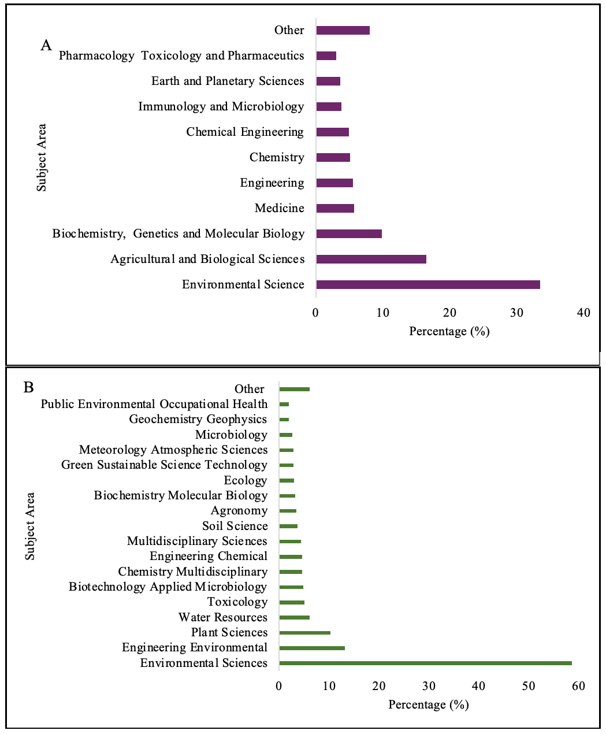
Figure S1. Documents by subject area: A) Scopus and B) WoS

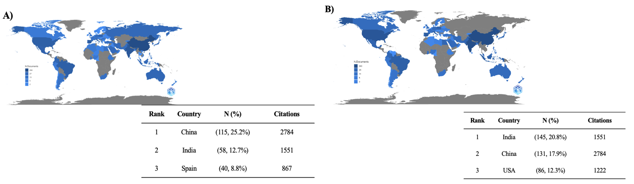
Figure S2. Countries’ Scientific production: A) WoS and B) Scopus
The intensity of the blue color is related to the countries with the highest number of published papers. In contrast, the gray color is related to the countries where no papers related to this topic have been published.

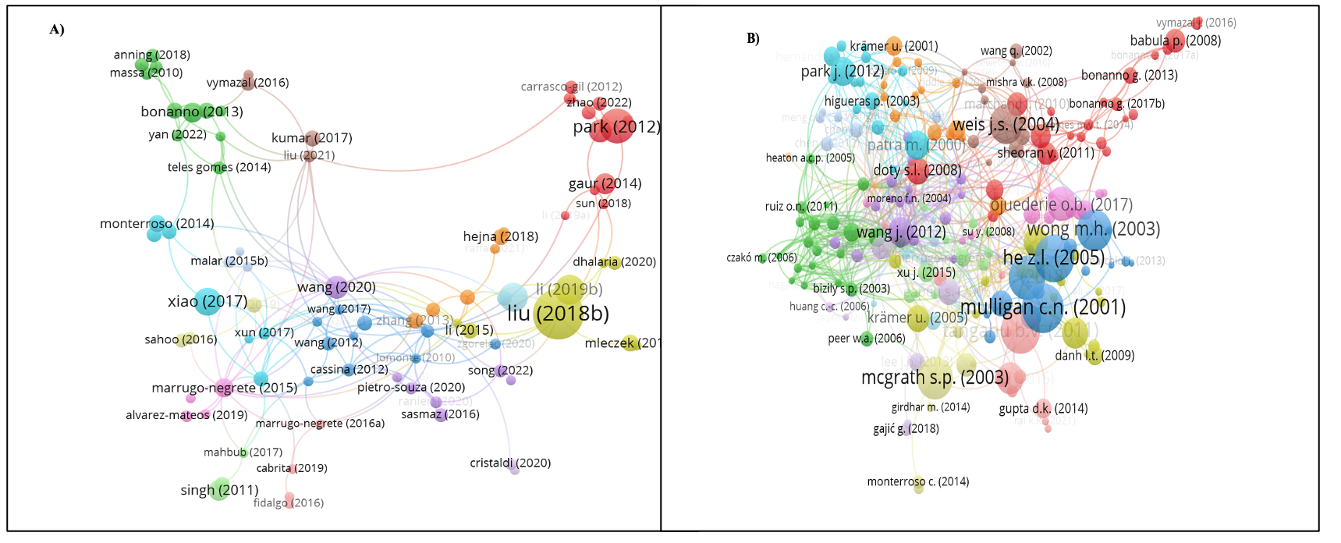
Figure S3. Highly cited articles: A) WoS and B) Scopus

