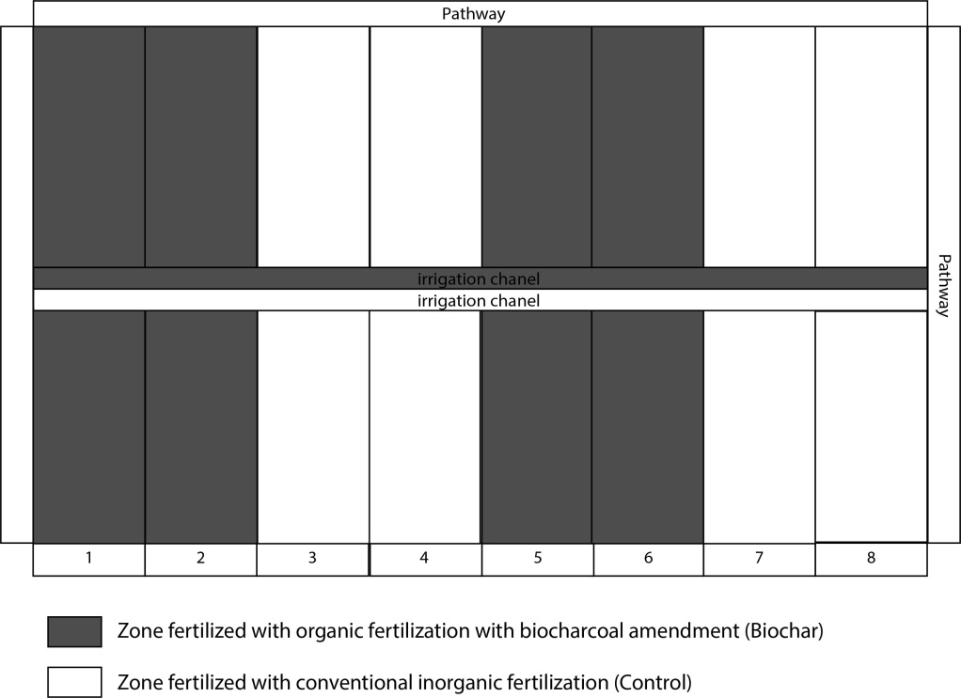
Supp. Figure1. Illustrative scheme of the field trial

Supp. Table 1. Fertilization planning of artichoke plants according to the phonological stage and plant development (unit of the element each 100 units of fertilizer)
Week | N |  | P | K | Ca
31 |  | 6.69 | 0.02 | 7.34 | 0.01
32 |  | 6.69 | 0.02 | 7.34 | 0.01
33 |  | 6.69 | 0.02 | 7.34 | 0.01
34 |  | 6.69 | 0.02 | 7.34 | 0.01
35 |  | 6.69 | 0.02 | 7.34 | 0.01
36 |  | 6.69 | 0.02 | 7.34 | 0.01
37 |  | 8.68 | 0.02 | 11.00 | 0.01
38 |  | 8.68 | 0.02 | 11.00 | 0.01
39 |  | 8.68 | 0.02 | 11.00 | 0.01
40 |  | 8.68 | 0.02 | 11.00 | 0.01
41 |  | 7.35 | 2.44 | 10.99 | 8.00
42 |  | 7.35 | 2.44 | 10.99 | 8.00
43 |  | 7.35 | 2.44 | 10.99 | 8.00
44 |  | 7.35 | 2.44 | 10.99 | 8.00
45 |  | 3.93 | 1.22 | 5.86 | 4.24
46 |  | 3.93 | 1.22 | 5.86 | 4.24
47 |  | 3.93 | 1.22 | 5.86 | 4.24
48 |  | 3.93 | 1.22 | 5.86 | 4.24
49 |  | 5.88 | 2.44 | 8.79 | 6.56
50 |  | 5.88 | 2.44 | 8.79 | 6.56
51 |  | 5.88 | 2.44 | 8.79 | 6.56
52 |  | 5.88 | 2.44 | 8.79 | 6.56
1 |  | 7.35 | 2.44 | 10.99 | 8.00
2 |  | 7.35 | 2.44 | 10.99 | 8.00
3 |  | 7.35 | 2.44 | 10.99 | 8.00
4 |  | 7.35 | 2.44 | 10.99 | 8.00
5 |  | 7.35 | 2.44 | 10.99 | 8.00
6 |  | 7.35 | 2.44 | 10.99 | 8.00
7 |  | 7.35 | 2.44 | 10.99 | 8.00
8 |  | 7.35 | 2.44 | 10.99 | 8.00
9 |  | 2.46 | 1.22 | 3.66 | 2.80
10 |  | 2.46 | 1.22 | 3.66 | 2.80
11 |  | 2.46 | 1.22 | 3.66 | 2.80
12 |  | 2.46 | 1.22 | 3.66 | 2.80
TOTAL 212.10 49.03 293.10 150.49

Supl. Table 2. Conventional fertilization schedule of artichoke plants during the crop cycle.
 |  |  | Week fertilization (Kg/ha)
Week |  | NH₄NO₃ |  | KNO₃ | Ca(NO₃)₂ |  | KH₂PO₄ |  |  | NOVATEC 21
31 |  | 8.00 |  | 15.92 |  |  |  |  |  | 8.82
32 |  | 8.00 |  | 15.92 |  |  |  |  |  | 8.82
33 |  | 8.00 |  | 15.92 |  |  |  |  |  | 8.82
34 |  | 8.00 |  | 15.92 |  |  |  |  |  | 8.82
35 |  | 8.00 |  | 15.92 |  |  |  |  |  | 8.82
36 |  | 8.00 |  | 15.92 |  |  |  |  |  | 8.82
37 |  | 8.00 |  | 23.88 |  |  |  |  |  | 16.66
38 |  | 8.00 |  | 23.88 |  |  |  |  |  | 16.66
39 |  | 8.00 |  | 23.88 |  |  |  |  |  | 16.66
40 |  | 8.00 |  | 23.88 |  |  |  |  |  | 16.66
41 |  |  |  | 20.35 | 30.19 |  | 4.79
42 |  |  |  | 20.35 | 30.19 |  | 4.79
43 |  |  |  | 20.35 | 30.19 |  | 4.79
44 |  |  |  | 20.35 | 30.19 |  | 4.79
45 |  |  |  | 10.97 | 16.00 |  | 2.39
46 |  |  |  | 10.97 | 16.00 |  | 2.39
47 |  |  |  | 10.97 | 16.00 |  | 2.39
48 |  |  |  | 10.97 | 16.00 |  | 2.39
49 |  |  |  | 15.57 | 24.75 |  | 4.79
50 |  |  |  | 15.57 | 24.75 |  | 4.79
51 |  |  |  | 15.57 | 24.75 |  | 4.79
52 |  |  |  | 15.57 | 24.75 |  | 4.79
1 |  |  |  | 20.35 | 30.19 |  | 4.79
2 |  |  |  | 20.35 | 30.19 |  | 4.79
3 |  |  |  | 20.35 | 30.19 |  | 4.79
4 |  |  |  | 20.35 | 30.19 |  | 4.79
5 |  |  |  | 20.35 | 30.19 |  | 4.79
6 |  |  |  | 20.35 | 30.19 |  | 4.79
7 |  |  |  | 20.35 | 30.19 |  | 4.79
8 |  |  |  | 20.35 | 30.19 |  | 4.79
9 |  |  |  | 6.19 | 10.56 |  | 2.39
10 |  |  |  | 6.19 | 10.56 |  | 2.39
11 |  |  |  | 6.19 | 10.56 |  | 2.39
12 |  |  |  | 6.19 | 10.56 |  | 2.39
TOTAL |  | 80.05 |  | 566.12 | 567.49 |  | 95.74 |  |  | 119.57

Supp. Table 4. Organic fertilization schedule of artichoke plants during the crop cycle.
Week | Organic Fertilizer  L/ha
31 | 83.01
32 | 83.01
33 | 83.01
34 | 83.01
35 | 83.01
36 | 83.01
37 | 124.61
38 | 124.61
39 | 124.61
40 | 124.61
41 | 124.61
42 | 124.61
43 | 124.61
44 | 124.61
45 | 66.41
46 | 66.41
47 | 66.41
48 | 66.41
49 | 99.61
50 | 99.61
51 | 99.61
52 | 99.61
1 | 124.61
2 | 124.61
3 | 124.61
4 | 124.61
5 | 124.61
6 | 124.61
7 | 124.61
8 | 124.61
9 | 41.41
10 | 41.41
11 | 41.41
12 | 41.41
TOTAL | 3321.5

Suppl. Table 5. Units of fertilizer (UF) of Nitrogen (N), Phosphorous (P) and Potassium (K) supplied by organic fertilization in artichoke plants.
UF ORGANIC FERTILIZER
WEEK | N | P | K
31 | 3.74 | 0.01 | 1.21
32 | 3.74 | 0.01 | 1.25
33 | 3.74 | 0.01 | 1.29
34 | 3.74 | 0.01 | 1.33
35 | 3.74 | 0.01 | 1.37
36 | 3.74 | 0.01 | 1.40
37 | 5.61 | 0.01 | 1.44
38 | 5.61 | 0.01 | 1.48
39 | 5.61 | 0.01 | 1.52
40 | 5.61 | 0.01 | 1.56
41 | 5.61 | 0.01 | 1.60
42 | 5.61 | 0.01 | 1.64
43 | 5.61 | 0.01 | 1.68
44 | 5.61 | 0.01 | 1.72
45 | 2.99 | 0.01 | 1.76
46 | 2.99 | 0.01 | 1.79
47 | 2.99 | 0.01 | 1.83
48 | 2.99 | 0.01 | 1.87
49 | 4.48 | 0.01 | 1.91
50 | 4.48 | 0.01 | 1.95
51 | 4.48 | 0.01 | 1.99
52 | 4.48 | 0.01 | 2.03
1 | 5.61 | 0.01 | 0.04
2 | 5.61 | 0.01 | 0.08
3 | 5.61 | 0.01 | 0.12
4 | 5.61 | 0.01 | 0.16
5 | 5.61 | 0.01 | 0.20
6 | 5.61 | 0.01 | 0.23
7 | 5.61 | 0.01 | 0.27
8 | 5.61 | 0.01 | 0.31
9 | 1.86 | 0.01 | 0.35
10 | 1.86 | 0.01 | 0.39
11 | 1.86 | 0.01 | 0.43
12 | 1.86 | 0.01 | 0.47
TOTAL | 149.47 | 0.20 | 38.65

Supp. Table 6. Biochar composition and properties
Material | Untreated log charcoal from sustainable forestry (FSC certified), vinasse, sugar cane molasses
Nutrients and secondary components | Total N | 2%
 | Total K2O | 2%
 | Total P2O5 | 0.3%
 | Total S | 0.2%
 | Ca | 0.6%
 | Mg | 0.05%
 | Organic Matter | 73%
 | Immediately available nitrogen content | 20%
 | Available nitrogen content after 3-5 weeks | 80%
Analytical Parameters | Carbon in thedry mass of coal | 80%
 | Pollutants (PAHs, ndl-PCB, sl-PCB, dioxins) | All maximum limits of contaminants allowed in the European Union are respected
Structure | granular
Size | 2-5mm
pH | 6.6
Internal surface | >250m²/g

