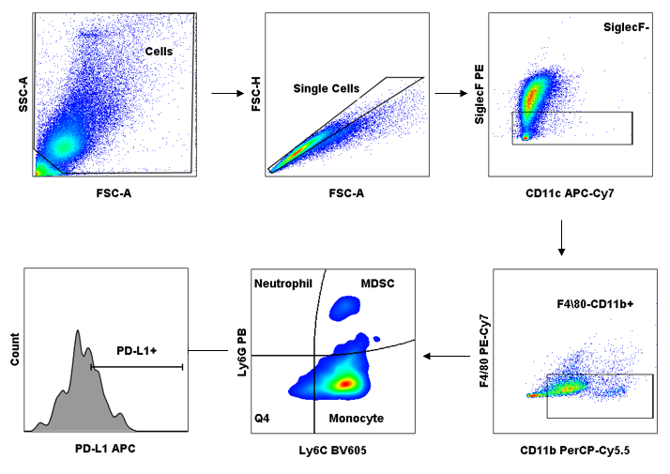

Supplementary figure 1. Gate strategy used for MDSCs cells in intratracheal infection. Bronchoaveolar lavage of mice was performed 48 hours or 21 days after infection with the B3501 or CAP67 strain of C. neoformans. The obtained cells were stained for flow cytometry to determine the frequency of CD11b+Ly6G+Ly6C+PD-L1+ cells within the gate of SiglecF-CD11c+ cells.

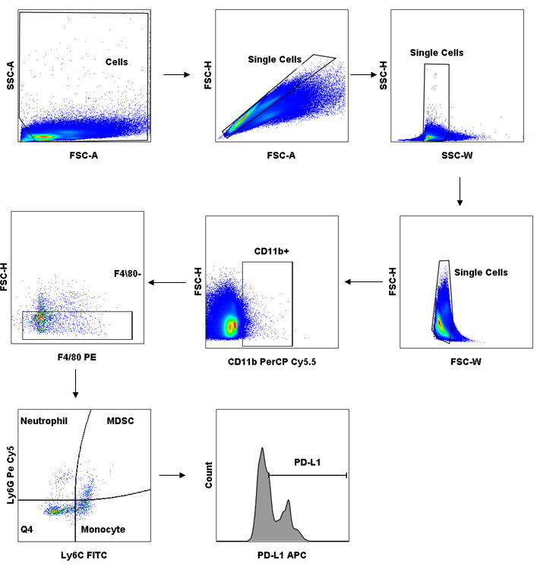
Supplementary figure 2. Gate strategy used for MDSCs cells in peritoneal infection. Peritoneal lavage of mice was performed 4 or 8 hours after infection with the B3501 or CAP67 strain of C. neoformans. The cells obtained were stained for flow cytometry to determine the frequency of CD11b+Ly6G+Ly6C+PD-L1+ cells within the gate of F4/80+ cells.

