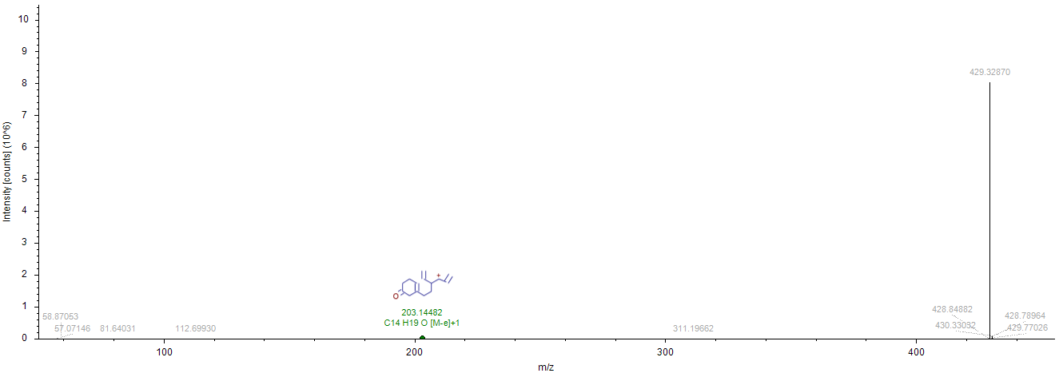
Figure S1: The unique fragment ions spectrum (MS2) of nandrolene.
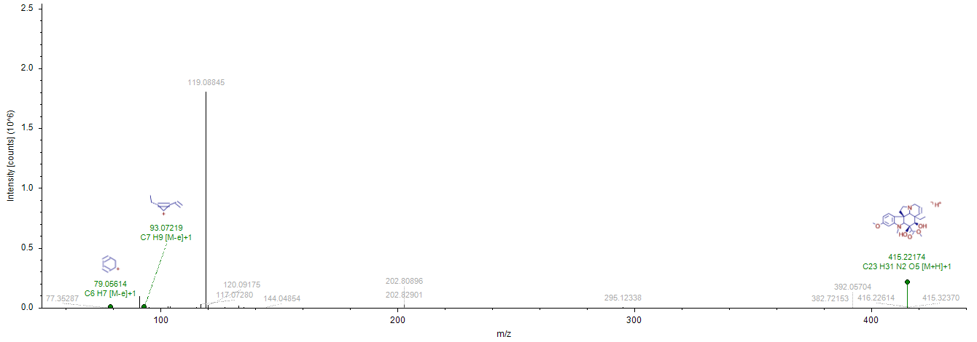
Figure S2: The unique fragment ions spectrum (MS2) of deacetylvindoline.

