Supplemental Material

Supplemental Table 1. Participant Participation Rate and Adherence Rate
 | N (%)
Invited | 60
Enrolled | 41 (68)
Responded ≥3 Symptoms in Week 1 | 39 (95)
Responded ≥3 Symptoms in Week 5 | 37 (90)
Responded ≥3 Symptoms in Week 9 | 38 (93)
Responded ≥3 Symptoms in Weeks 1, 5 and 9 | 34 (83)
Responded HRQOL Week 1 | 41 (100)
Responded HRQOL Week 5 | 39 (95)
Responded HRQOL Week 9 | 39 (95)
Responded HRQOL in Weeks 1, 5 and 9 | 39 (95)
Responded ≥4 reports (≥3 symptoms and 1 HRQOL) in Week 1 | 39 (95)
Responded ≥4 reports (≥3 symptoms and 1 HRQOL) in Week 5 | 36 (88)
Responded ≥4 reports (≥3 symptoms and 1 HRQOL) in Week 9 | 38 (93)
Responded ≥12 reports (≥3 symptoms and 1 HRQOL) in Weeks 1, 5 and 9 | 34 (83)

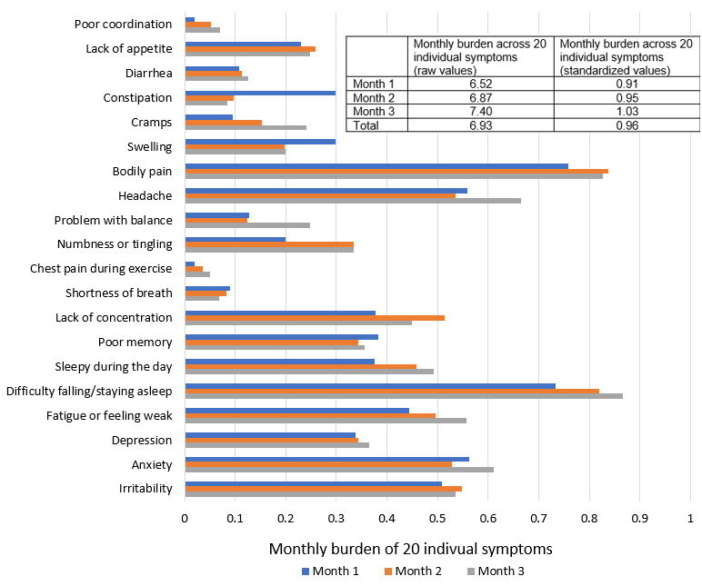

Supplemental Figure 1. Monthly burden of 20 individual symptoms (N=41)

Note: 1) Monthly burden of individual symptoms was defined as the mean of 5 daily symptom burdens for each of the three months (range: 0-3). 2) Monthly burden across 20 individual symptoms is the sum of the individual symptoms for each month (range: 0-60). 3) Total burden across 20 symptoms is the mean of symptom burdens over 3 months. 4) The standardized monthly burden is the sum of the monthly burden divided by the standard deviation of all monthly burdens (7.20).

