Carotenoids from different pumpkin varieties exert a cytotoxic effect on human neuroblastoma SHSY-5Y cells
Nicola Pinna ^{1,†}, Federica Ianni ^{1,†}, Carmela Conte ¹, Michela Codini ¹, Raffaella Di Vito ¹, Stefania Urbani ², Roberto Selvaggini ², Lina Cossignani ^{1,}* and Francesca Blasi ¹
¹ Department of Pharmaceutical Sciences, University of Perugia, 06126 Perugia, Italy; nicola.pinna@dottorandi.unipg.it; federica.ianni@unipg.it; carmela.conte@unipg.it; michela.codini@unipg.it; raffaella.divito@studenti.unipg.it; francesca.blasi@unipg.it
² Department of Agricultural, Food and Environmental Sciences, University of Perugia, 06126 Perugia, Italy; stefania.urbani99@gmail.com; roberto.selvaggini@unipg.it
* Correspondence: lina.cossignani@unipg.it; Tel.: +39-075-585-7959

Table S1 Correlation between color parameters (L, a, b, C, H) of two different species (C. moschata and C. maxima)
 |  | L* | a* | b* | C* | H*
L* | C. moschata | - | 0.9822 | 0.5958 | 0.3544 | 0.9919
 | C. maxima | - | 0.9171 | 0.9561 | 0.9505 | 0.9573
a* | C. moschata | 0.9822 | - | 0.4948 | 0.2597 | 0.9884
 | C. maxima | 0.9171 | - | 0.8213 | 0.8056 | 0.9457
b* | C. moschata | 0.5958 | 0.4948 | - | 0.9403
 | C. maxima | 0.9561 | 0.8213 | - | 0.9993
C* | C. moschata | 0.3544 | 0.2597 | 0.9403 | - | 0.3572
 | C. maxima | 0.9505 | 0.8056 | 0.9993 | - | 0.9147
H* | C. moschata | 0.9919 | 0.9884 | 0.6003 | 0.3572 | 0.6003
 | C. maxima | 0.9573 | 0.9457 | 0.9286 | 0.9147 | 0.9286

Table S2 Correlation between spectrophotometric parameters (TCC, ABTS, ORAC) of two different species (C. moschata and C. maxima)

 |  | TCC | ABTS | ORAC
TCC | C. moschata | - | 0.8618 | 0.5666
 | C. maxima | - | 0.7601 | 0.6122
ABTS | C. moschata | 0.8618 | - | 0.5980
 | C. maxima | 0.7601 | - | 0.8513
ORAC | C. moschata | 0.5666 | 0.5980 | -
 | C. maxima | 0.6122 | 0.8513 | -
TCC, total carotenoid content measured by spectrophotometric assay; ABTS, 2,2’-azino-bis(3-ethylbenzothiazoline-6-sulfonic acid) diammonium salt; ORAC, Oxygen Radical Absorbance Capacity

Table S3 Regression equation, R², linearity range, LOD, and LOQ of lutein and zeaxanthin dipalmitate, analyzed by HPLC-DAD
Standard | Regression Equation | R² | Linearity range (μg/mL) | LOD (ng/mL) | LOQ (ng/mL)
Lutein | y = 182.59 (±5.69)x - 36.15 (±20.72) | 0.996 | 0.24 - 5.90 | 0.37 | 1.13
Zeaxanthin dipalmitate | y = 11.03 (±0.44)x -27.66 (±2.34) | 0.994 | 0.95 – 95.0 | 0.70 | 2.12
Limit of detection (LOD); limit of quantification (LOQ)

Table S4 Method validation for lutein and zeaxanthin dipalmitate: evaluation of precision (RSD %) and accuracy (recovery %) in the short- and log-term period (intra-day and inter-day precision and accuracy values)
Theoretical conc. (µg/mL) | Intra-day mean conc. (µg/mL) | Intra-day Precision  (RSD %) | Intra-day Accuracy  (Recovery %) | Inter-day  mean conc.  (µg/mL) | Inter-day  Precision  (RSD %) | Inter-day Accuracy  (Recovery %)
Lutein  4.72 | 4.56 | 1.55 | 96.57
 | 4.75 | 1.70 | 100.68 | 4.71 | 3.18 | 99.86
 | 4.83 | 2.93 | 102.32
Zeaxanthin dipalmitate  71.25 | 72.17 | 2.18 | 100.84 | 71.31 | 2.85 | 100.09
 | 72.38 | 3.46 | 101.59
 | 69.73 | 1.65 | 97.86
Intra-day and Inter-day evaluation: analysis of 3 replicates of the selected external standard within one day and for three consecutive days

Carotenoids | Molecular formula | Rt (min) | λmax  (nm) | [M+H]⁺  (m/z) | Fragments  (m/z)
neoxanthin | C40H56O4 | 5.05 | 416, 442, 470 | 601 | 583, 565, 221
violaxanthin | C40H56O4 | 5.83 | 420, 444, 472 | 601 | 583, 565, 491
antheraxanthin | C40H56O3 | 8.96 | 445, 473 | 585 | 567, 549, 493
lutein | C40H56O2 | 9.61 | 422sh, 445, 473 | 569 | 551, 553, 463
zeaxanthin | C40H56O2 | 10.53 | 426sh, 450, 477 | 569 | 551, 553
α-carotene | C40H56 | 35.07 | 422sh, 445, 473 | 537 | 537, 444, 177
β-carotene | C40H56 | 37.80 | 426sh, 450, 477 | 537 | 444, 177
Violaxanthin myristate | C55H84O3 | 27.46 | 416,442,470 | 812 | 794, 776, 565
Lutein palmitate | C56H86O3 | 30.63 | 420, 444, 472 | 809 | 551, 533, 495
Antheraxanthin myristate | C55H84O3 | 33.42 | 420, 446, 472 | 797 | 779, 705
Antheraxanthin palmitate | C56H86O5 | 36.17 | 420, 446, 471 | 825 | 807, 733
Violaxanthin di-myristate | C70H112O6 | 40.13 | 413, 435, 464 | 1022 | 1004, 793, 775
Antheraxanthin di-laurate | C70H112O6 | 42.01 | 418, 442, 470 | 949 | 931, 857, 533
Lutein di-laurate | C70H112O4 | 45.61 | 420, 445, 474 | 942 | 734, 533
Lutein myristate-laurate | C68H108O4 | 47.17 | 421, 443, 474 | 960 | 761, 733, 533
Lutein di-myristate | C71H114O4 | 48.74 | 422, 446, 474 | 990 | 761, 669, 533
Lutein myristate-palmitate | C70H112O4 | 50.32 | 421, 443, 467 | 1018 | 790, 762, 533
Lutein di-palmitate | C72H116O4 | 51.79 | 428, 448, 476 | 1046 | 790, 533
Table S5 HPLC retention times, ultraviolet (UV)/visible light (Vis) spectra, and MS spectral data of carotenoids from pumpkin pulp

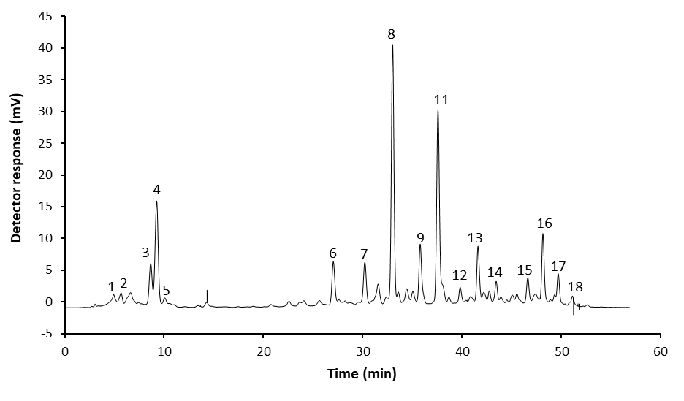
:
A

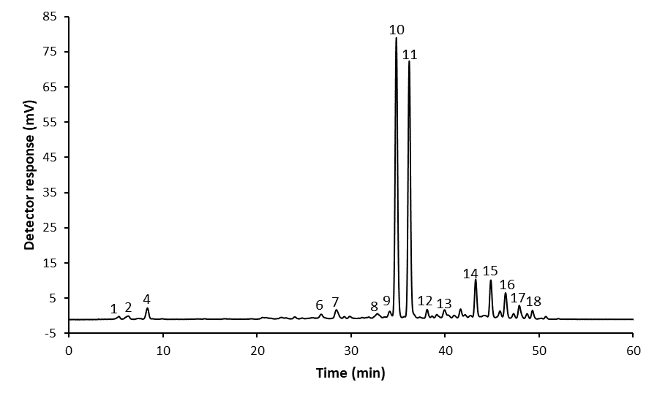
B
Figure S1: A typical HPLC-DAD chromatographic profile of pumpkin pulp. A, Hokkaido variety (C. maxima species); B, Moscata di Provenza variety (C. moschata species). 1, neoxanthin; 2, violaxanthin; 3, antheraxanthin; 4, lutein; 5, zeaxanthin; 6, violaxanthin myristate; 7, lutein palmitate; 8, antheraxanthin myristate; 9, antheraxanthin palmitate; 10, α-carotene; 11, β-carotene; 12 violaxanthin di-myristate; 13, antheraxanthin di-laurate; 14, lutein di-laurate; 15, lutein laurate myristate; 16, lutein di-myristate; 17, lutein palmitate myristate; 18, lutein di-palmitate
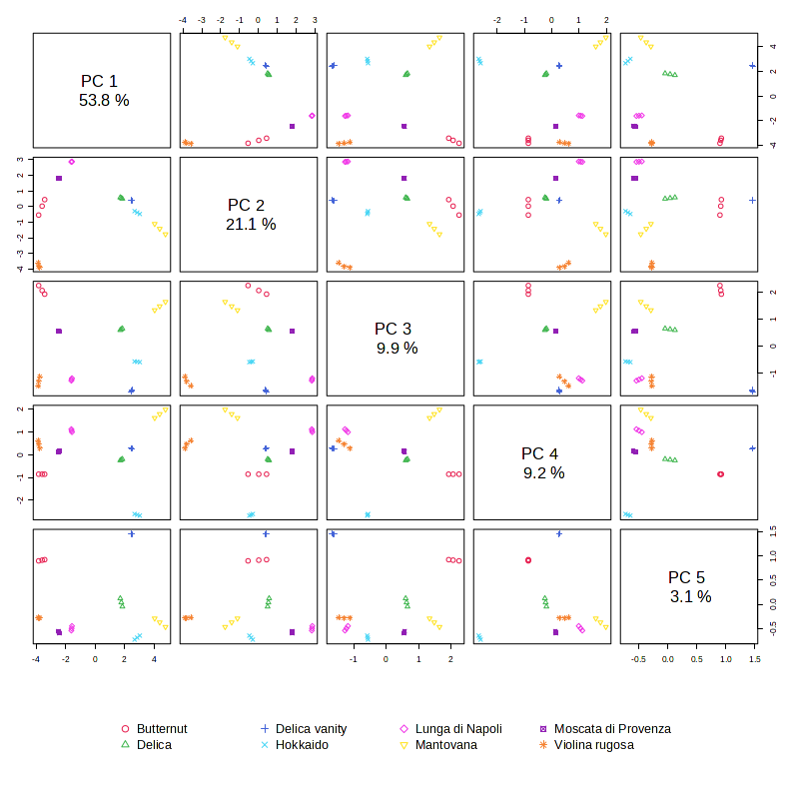
Figure S2: PCA overview. Display pairwise score plot for top 5 PCs.
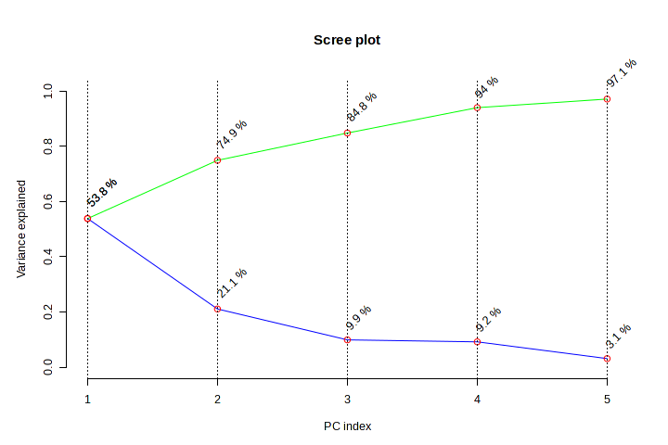
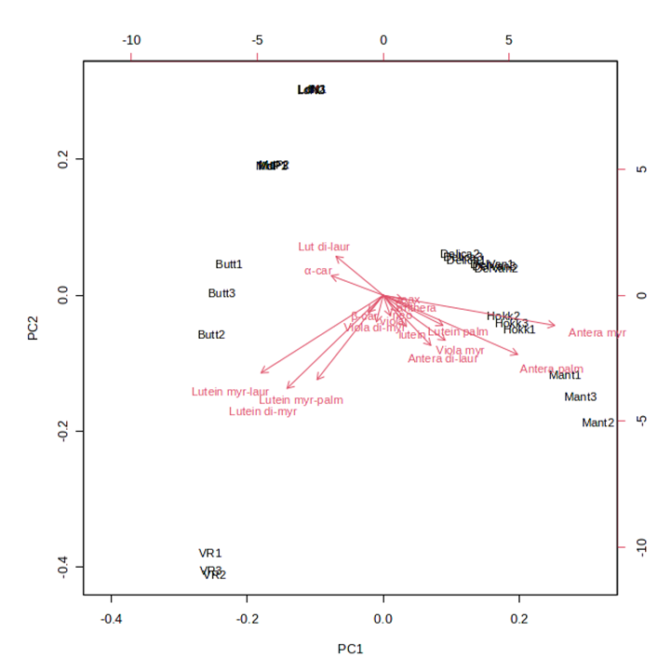
Figure S3: PCA scree plot. The green line on top shows the accumulated variance explained; the blue line underneath shows the variance explained by individual PC.
Figure S4: Biplot for principal components (PC1 and PC2).
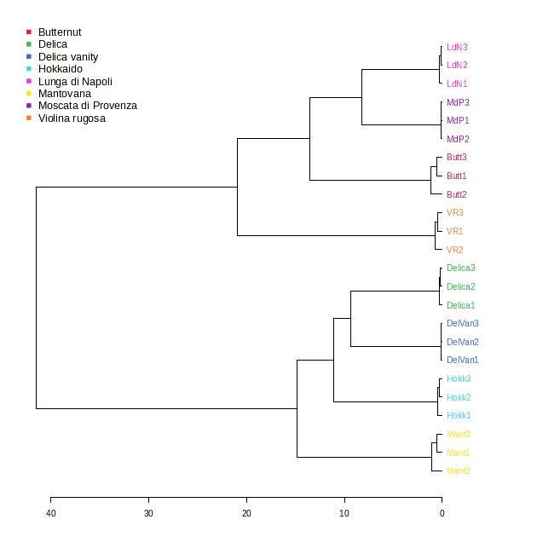
Figure S5: Hierarchical Clustering Dendrogram. Distance Measure: Euclidean; Clustering Algorithm: Ward.

