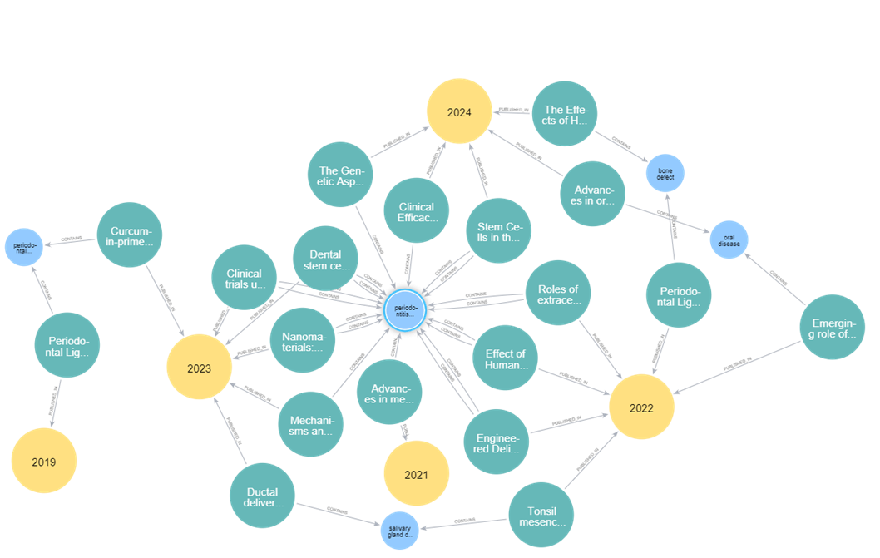
Supplementary Figure S1. Neo4j Knowledge graph of Disease category nodes (light blue) connected to at least two article nodes (dark green. A part of their title is written on the node). Yellow nodes indicate publication year.

