Supplementary Materials for
Impacts of Am aggregation on the bulk properties of mixed oxides (U, Am)O₂ from first-principles

Tao Liu ^{a,} *, Ziyi Yang ª, Xiaoyan Yu ª, Tao Gao ^{b}

ª College of Science, Guiyang University, Guiyang, 550005, China
^{b} Institute of Atomic and Molecular Physics, Sichuan University, Chengdu, 610065, China

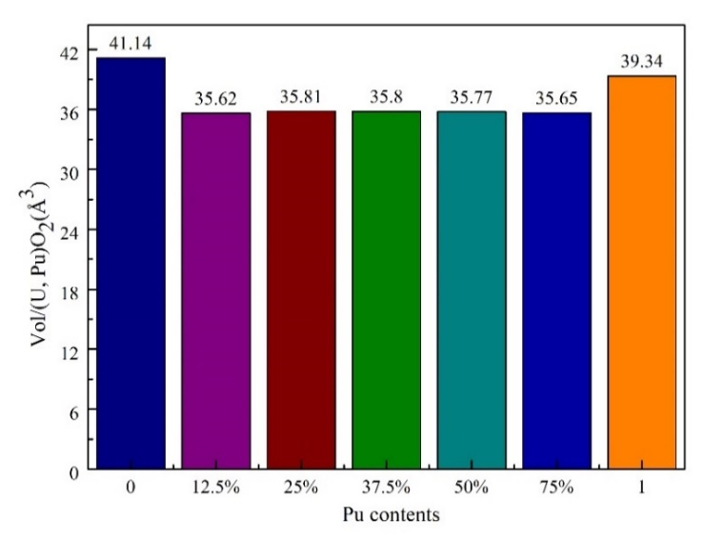
Fig. S1. Variation of the systems volume of mixed oxides (U, Pu)O₂ with different Pu aggregation contents.
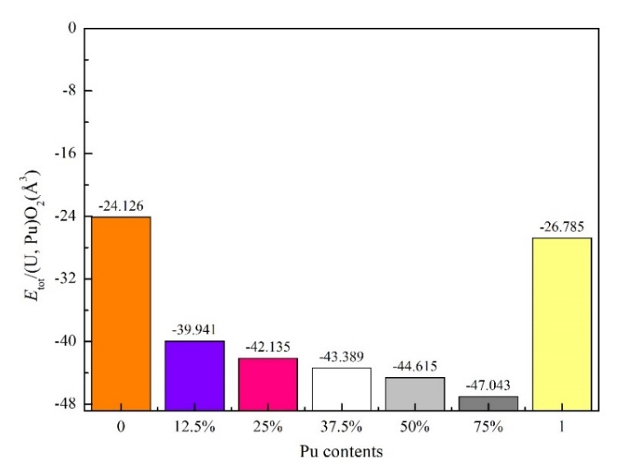
Fig. S2. Variation of the energy E_{tot} of mixed oxides (U, Pu)O₂ with different Pu aggregation contents.

Table S1
Magnetic stability including the lattice parameter and band gap of the (U, Pu)O₂ defect model for various Pu aggregation contents using PBEsol+U.
Pu content | AFM |  |  |  | FM |  |  | E_{FM}-E_{AFM}/atom  (eV)
 | a₀ (Å) | c/a | G (eV) |  | a₀ (Å) | c/a | G (eV)
UO₂ | 5.480 | 1.0 | 2.0 |  | 5.469 | 1.0 | 1.8 | 0.12
12.5% | 5.223 | 1.0 | 1.1 |  | 5.222 | 1.0 | 0.9 | 0.00
25% | 5.233 | 1.0 | 1.1 |  | 5.232 | 1.0 | 0.9 | 0.00
37.5% | 5.232 | 0.999 | 1.1 |  | 5.232 | 0.998 | 0.9 | 0.00
50% | 5.230 | 0.998 | 1.0 |  | 5.231 | 0.998 | 0.8 | 0.02
75% | 5.224 | 0.998 | 0.0 |  | 5.224 | 0.999 | 0.0 | 0.00
PuO₂ | 5.399 | 1.0 | 2.0 |  | 5.409 | 1.0 | 1.9 | 0.39

Table S2
Lattice parameter, band gap, magnetic moment of UO₂, PuO₂ and (U, Pu)O₂ using PBEsol+U.
Pu content | Functional | a₀（Å） |  | G（eV） | μ_{mag}（μ_{B}） | E_{FM}-E_{AFM}/atom  （eV）
 |  | AFM | FM | AFM | AFM
UO₂ | PBEsol+U | 5.480 | 5.469 | 2.0 | 2.0 | +0.12
 | PBE+U [2] | 5.543 | 5.547 | 2.5
 | expt [3] | 5.470 |  | 2.1
(U_{0.75}Pu_{0.25})O₂ | PBEsol+U | 5.223 | 5.222 | 1.1 | 5.4 | 0.00
 | PBE+U [2] | 5.520 | 5.520 | 1.2
(U_{0.5}Pu_{0.5})O₂ | PBEsol+U | 5.217 | 5.217 | 1.1 | 5.4 | 0.00
 | PBE+U [2] | 5.497 | 5.495 | 1.2
(U_{0.25}Pu_{0.75})O₂ | PBEsol+U | 5.212 | 5.212 | 0.0 | 5.3 | 0.00
PuO₂ | PBEsol+U | 5.399 | 5.409 | 1.9 | 4.1 | +0.39
 | PBE+U [2] | 5.453 | 5.452 | 2.0
 | expt [3] | 5.398 |  | 1.8

Table S3
Energy of formation of UO₂, PuO₂ and (U, Pu)O₂ using PBEsol+U.
 | E_{f}（eV）
Compound | expt | CALPHAD | PBE+U[2] | vdW-optPBE+U[2] | PBEsol+U
UO₂ | -11.24 [4] | -11.23[6] | -10.86 | -11.27 | -11.78
(U_{0.75}Pu_{0.25})O₂ |  |  | -10.69 | -11.18 | -14.65
(U_{0.5}Pu_{0.5})O₂ |  |  | -10.51 | -11.09 | -14.19
(U_{0.25}Pu_{0.75})O₂ |  |  | -10.33 | -10.99 | -13.73
PuO₂ | -10.94 [5] | -10.99[7] | -10.10 | -10.90 | -11.34

Table S4
Elastic constants and bulk modulus of (U, Pu)O₂ using PBEsol+U.
 | Functional | UO₂ | (U_{0.75}Pu_{0.25})O₂ | (U_{0.5}Pu_{0.5})O₂ | (U_{0.25}Pu_{0.75})O₂ | PuO₂
C₁₁（GPa） | PBEsol+U | 383 | 378 | 357 | 349 | 387
 | PBE+U [2] | 364 | 375 | 365 | 368 | 375
 | LDA+U [1] | 401
 | expt [4] | 389
C₁₂（GPa） | PBEsol+U | 126 | 101 | 99 | 98 | 126
 | PBE+U [2] | 112 | 108 | 116 | 115 | 111
 | LDA+U [1] | 132
 | expt [4] | 119
C₄₄（GPa） | PBEsol + U | 72 | 51 | 44 | 30 | 71
 | PBE+U [2] | 58 | 62 | 66 | 68 | 70
 | LDA+U [1] | 94
 | expt [4] | 60
B₀（GPa） | PBEsol+U | 212 | 193 | 185 | 182 | 199
 | PBE+U [2] | 196 | 197 | 199 | 199 | 199
 | LDA+U [1] | 222 | 235 |  |  | 208
 | expt [4] | 207 | 156.9-221 |  |  | 178

Declaration of competing interest
The authors declare that they have no known competing ﬁnancial interests or personal relationships that could have appeared to inﬂuence the work reported in this paper.

Data availability
No data was used for the research described in the article.

Acknowledgements
Financial support from the National Natural Science Foundation of China (Grant No.
12264007) is acknowledged.

References
[1] B. Dorado, P. Garcia, First-principles DFT+U modeling of actinide-based alloys: Application to paramagnetic phases of UO₂ and (U, Pu) mixed oxides, Phys. Rev. B 87 (2013) 195139, https:// https://doi.org/10.1103/PhysRevB.87.195139.
[2] I.C. Njifon, M. Bertolus, R, Hayn, F. Michel, Electronic structure investigation of the bulk properties of uranium-plutonium mixed oxides (U, Pu)O₂, Inorg. Chem. 57 (2018) 10974-10983, https://doi.org/10.1021/acs.inorgchem.8b01561.
[3] P. Martin, S. Grandjean, C. Valot, G. Carlot, M. Ripert, P. Blanc, C. Hennig, XAS study of (U_{1−y}Pu_{y})O₂ solid solutions, J. Alloys Compnd. 444 (2007) 410-414,
https://doi.org/10.1016/j.jallcom.2007.01.032.
[4] E.J. Huber, C.E. Holley, Enthalpies of formation of triuranium octaoxide and uranium dioxide, J. Chem. Thermodyn. 1 (1969) 267-272, https://doi.org/10.1016/0021-9614(69)90046-9.
[5] G.K. Johnson, E.H. Van Deventer, O.L. Kruger, W. N. Hubbard, The enthalpies of formation of plutonium dioxide and plutonium mononitride, J. Chem. Thermodyn. 1 (1969) 89-98, https://doi.org/10.1016/0021-9614(69)90039-1.
[6] C. Guéneau, M. Baichi, D. Labroche, C. Chatillon, B. Sundman, Thermodynamic assessment of the uranium-oxygen system, J. Nucl. Mater. 304 (2002) 161-175, https://doi.org/10.1016/S0022-3115(02)00878-4.
[7] C. Guéneau, C. Chatillon, B. Sundman, Thermodynamic modelling of the plutonium-oxygen system, J. Nucl. Mater. 378 (2008) 257-272, https://doi.org/10.1016/j.jnucmat.2008.06.013.

* Corresponding author. E-mail address: * liutao_july@163.com (T. Liu).

