Supplementary material
Supplementary Table 1
Sequence | T2 ssh |  |  | T1 3D GRE post contrast
Parameter | Flip Angle | Repetition Time | Echo Time | Flip Angle | Repetition Time | Echo Time
Median (IQR) | 90 (90-90) | 402,42 (397,20-409,55) | 100 (80-100) | 10 (10-10) | 4,04 (4,00-4,04) | 1,96 (1,92-1,96)
1 | 90 | 350,00 | 90 | 10 | 4,37 | 2,09
2 | 90 | 402,08 | 100 | 10 | 4,04 | 1,96
3 | 90 | 410,59 | 100 | 10 | 4,04 | 1,96
4 | 90 | 297,20 | 100 | 10 | 4,04 | 1,96
5 | 90 | 397,20 | 100 | 10 | 3,80 | 1,81
6 | 90 | 434,26 | 80 | 10 | 4,20 | 2,03
7 | 90 | 397,20 | 100 | 10 | 4,04 | 1,96
8 | 90 | 402,30 | 100 | 10 | 4,03 | 1,96
9 | 90 | 399,71 | 100 | 10 | 4,03 | 1,96
10 | 90 | 404,89 | 100 | 10 | 4,04 | 1,96
11 | 90 | 397,20 | 100 | 10 | 3,81 | 1,85
12 | 90 | 525,72 | 80 | 10 | 4,04 | 1,96
13 | 90 | 397,20 | 100 | 10 | 3,76 | 1,79
14 | 90 | 453,56 | 80 | 10 | 4,04 | 1,96
15 | 90 | 417,25 | 80 | 10 | 4,03 | 1,95
16 | 90 | 397,20 | 100 | 10 | 4,04 | 1,96
17 | 90 | 404,39 | 100 | 10 | 4,02 | 1,94
18 | 90 | 404,39 | 100 | 10 | 4,02 | 1,94
19 | 90 | 404,39 | 100 | 10 | 4,04 | 1,96
20 | 90 | 404,54 | 100 | 10 | 4,04 | 1,96
21 | 90 | 397,20 | 100 | 10 | 4,04 | 1,96
22 | 90 | 397,20 | 100 | 10 | 4,04 | 1,96
23 | 90 | 397,20 | 100 | 10 | 3,81 | 1,85
24 | 90 | 406,41 | 100 | 10 | 3,73 | 1,77
25 | 90 | 399,66 | 100 | 10 | 4,05 | 1,96
26 | 90 | 397,20 | 100 | 10 | 4,04 | 1,95
27 | 90 | 397,20 | 100 | 10 | 4,04 | 1,96
28 | 90 | 397,20 | 100 | 10 | 4,02 | 1,94
29 | 90 | 402,08 | 100 | 10 | 4,04 | 1,96
30 | 90 | 397,20 | 100 | 10 | 4,04 | 1,95
31 | 90 | 404,39 | 100 | 10 | 4,04 | 1,96
32 | 90 | 405,16 | 80 | 10 | 3,8 | 1,83
33 | 90 | 405,16 | 80 | 10 | 3,8 | 1,83
34 | 90 | 404,39 | 100 | 10 | 4,00 | 1,92
35 | 90 | 410,59 | 100 | 10 | 3,77 | 1,79
36 | 90 | 404,39 | 100 | 10 | 3,62 | 1,74
37 | 90 | 396,82 | 100 | 10 | 4,03 | 1,95
38 | 90 | 402,54 | 100 | 10 | 4,05 | 1,96
39 | 90 | 397,2 | 100 | 10 | 4,04 | 1,96
40 | 90 | 399,72 | 100 | 10 | 4,04 | 1,96
41 | 90 | 404,89 | 100 | 10 | 4,04 | 1,96
42 | 90 | 421,99 | 100 | 10 | 4,04 | 1,96
43 | 90 | 429,35 | 80 | 10 | 4,04 | 1,96
44 | 90 | 392 | 80 | 10 | 3,76 | 1,8
45 | 90 | 397,2 | 100 | 10 | 4,04 | 1,96
46 | 90 | 397,2 | 100 | 10 | 4,05 | 1,96
47 | 90 | 399,71 | 100 | 10 | 4 | 1,92
48 | 90 | 453,56 | 80 | 10 | 3,75 | 1,79
49 | 90 | 399,72 | 100 | 10 | 4,04 | 1,96
50 | 90 | 385,27 | 80 | 10 | 4,04 | 1,96
51 | 90 | 397,2 | 100 | 10 | 4,04 | 1,96
52 | 90 | 405,16 | 80 | 10 | 4,04 | 1,96
53 | 90 | 404,39 | 100 | 10 | 4,04 | 1,96
54 | 90 | 402,08 | 100 | 10 | 4 | 1,92
55 | 90 | 461,87 | 80 | 10 | 4,04 | 1,96
56 | 90 | 508,02 | 80 | 10 | 3,79 | 1,83
57 | 90 | 447,51 | 80 | 10 | 3,85 | 1,87
58 | 90 | 410,59 | 100 | 10 | 4,02 | 1,94
59 | 90 | 416,29 | 100 | 10 | 4,04 | 1,96
60 | 90 | 399,1 | 80 | 10 | 4,03 | 1,94
61 | 90 | 397,2 | 100 | 10 | 3,85 | 1,83
62 | 90 | 392 | 80 | 10 | 3,76 | 1,8
63 | 90 | 399,66 | 100 | 10 | 4,05 | 1,96
64 | 90 | 397,2 | 100 | 10 | 3,8 | 1,81
65 | 90 | 410,59 | 100 | 10 | 4,02 | 1,94
66 | 90 | 429,35 | 80 | 10 | 4,04 | 1,96
67 | 90 | 429,35 | 80 | 10 | 4,04 | 1,96
68 | 90 | 404,54 | 100 | 10 | 4,04 | 1,96
69 | 90 | 429,35 | 80 | 10 | 4,04 | 1,96
70 | 90 | 404,39 | 100 | 10 | 4,04 | 1,96
Supplementary table 1: Acquisition parameters of every included study.

Supplementary Table 2:
 | Kendall’s Tau (τ) | P value
Patient age at biopsy | 0.12 | 0.18
Transplant age | 0.44 | <0.0001
Transplant type | -0.03 | 0.81
eGFR at biopsy | -0.11 | 0.19
Proteinuria/creatininuria | 0.23 | 0.01
Supplementary table 2: Associations between clinical variables and IFTA as a continuous variable computed using Kendall’s Tau correlation coefficient/Spearman for transplant type variable; higher absolute value of τ corresponds to higher correlation between variables and outcome.

Supplementary Figure 1:
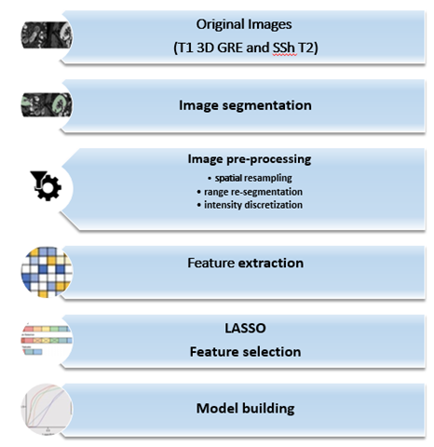
Supplementary figure 1. Radiomic pipeline followed in our study.

