Supplementary information
Ordered versus non-ordered mesoporous CeO₂-based systems for the direct synthesis of dimethyl carbonate from CO₂
Nicoletta Rusta^{1,2 #}, Fausto Secci^{1,2 #}, Valentina Mameli^{1,2}, Carla Cannas^{1,2} *
¹ Department of Chemical and Geological Sciences, University of Cagliari, S.S. 554 bivio per Sestu, 09042 Monserrato (CA), Italy
² Consorzio Interuniversitario Nazionale per la Scienza e Tecnologia dei Materiali (INSTM), Via Giuseppe Giusti 9, 50121 Firenze (FI), Italy
# Equal contribution
* Corresponding author: ccannas@unica.it

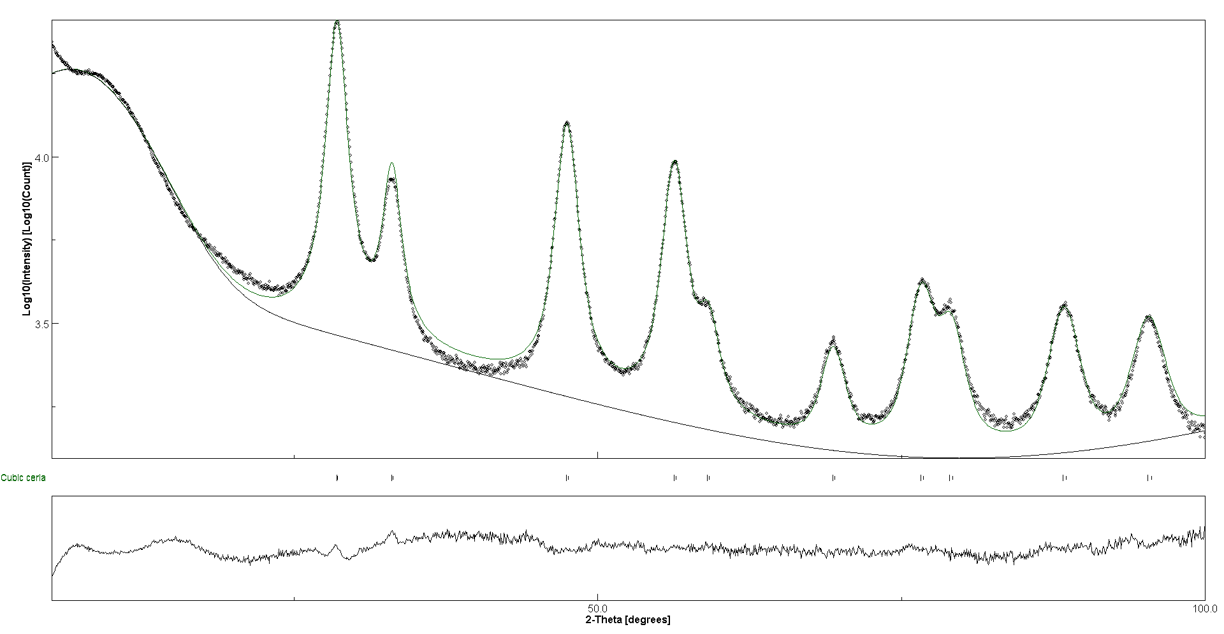
Figure S1 Rietveld refinement of CeO₂_Meso.
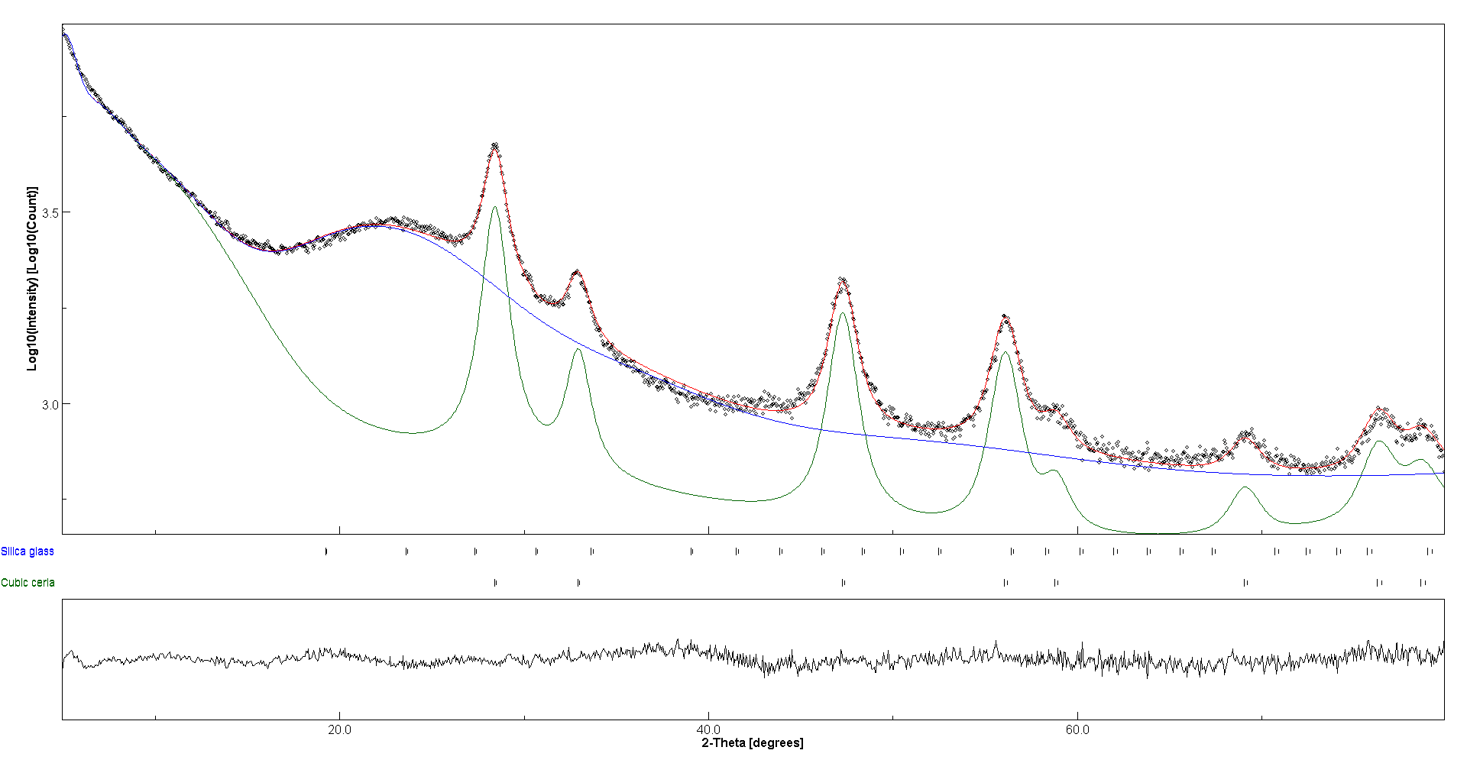
Figure S2 Rietveld refinement of CeO₂@SBA-15_TS.

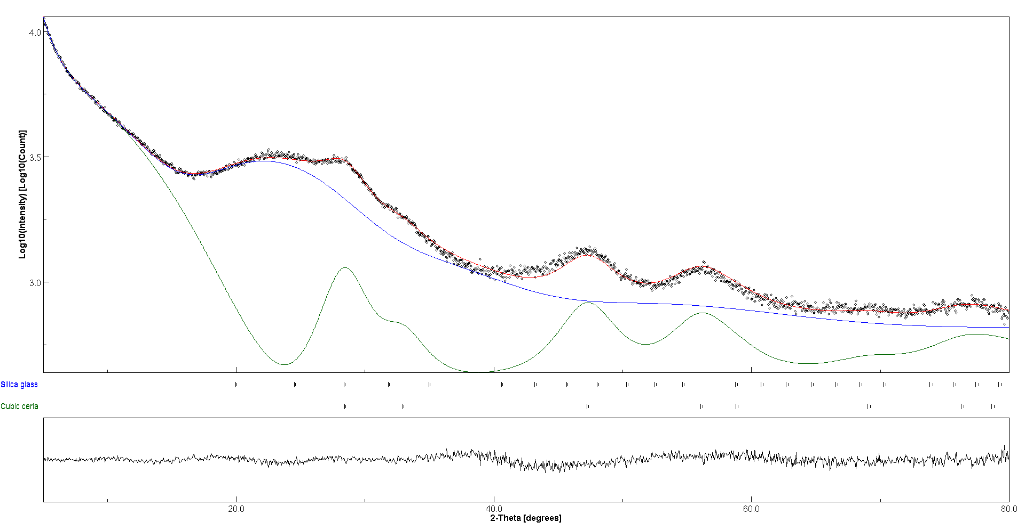
Figure S3 Rietveld refinement of CeO₂@SBA-15_SC.

Table S1 EDX quantitative analysis for CeO₂@SBA15_TS.
Spot | Element | Wt% | Wt% Sigma | Atomic %
Spot 1 | Ce | 7.75 | 0.52 | 1.13
 | Si | 33.82 | 0.45 | 24.51
 | O | 58.43 | 0.54 | 74.36
Spot 2 | Ce | 9.18 | 0.22 | 1.42
 | Si | 41.41 | 0.24 | 31.86
 | O | 49.41 | 0.26 | 66.73
Spot 3 | Ce | 8.71 | 0.23 | 1.33
 | Si | 40.99 | 0.26 | 31.28
 | O | 50.30 | 0.28 | 67.39
Spot 4 | Ce | 8.79 | 0.23 | 1.35
 | Si | 42.09 | 0.26 | 32.35
 | O | 49.12 | 0.28 | 66.29
Spot 5 | Ce | 9.89 | 0.31 | 1.55
 | Si | 42.43 | 0.33 | 33.12
 | O | 47.68 | 0.36 | 65.34

Table S2 EDX quantitative analysis for CeO₂@SBA15_SC.
Spot | Element | Wt% | Wt% Sigma | Atomic %
Spot 1 | Ce | 3.49 | 0.06 | 0.55
 | Si | 56.45 | 0.09 | 44.28
 | O | 40.06 | 0.09 | 55.17
Spot 2 | Ce | 2.56 | 0.12 | 0.38
 | Si | 48.04 | 0.18 | 35.52
 | O | 49.39 | 0.18 | 64.10
Spot 3 | Ce | 7.01 | 0.43 | 0.99
 | Si | 30.79 | 0.42 | 21.78
 | O | 62.20 | 0.50 | 77.23
Spot 4 | Ce | 12.78 | 0.30 | 1.98
 | Si | 35.06 | 0.28 | 27.14
 | O | 52.16 | 0.32 | 70.88
Spot 5 | Ce | 15.95 | 0.09 | 2.61
 | Si | 37.32 | 0.09 | 30.45
 | O | 46.73 | 0.10 | 66.94
Spot 6 | Ce | 3.13 | 0.34 | 0.43
 | Si | 31.99 | 0.30 | 21.83
 | O | 64.88 | 0.37 | 77.74
Spot 7 | Ce | 5.27 | 0.21 | 0.78
 | Si | 41.62 | 0.30 | 30.62
 | O | 53.11 | 0.31 | 68.60
Spot 8 | Ce | 6.34 | 0.26 | 0.95
 | Si | 42.99 | 0.33 | 32.27
 | O | 50.68 | 0.35 | 66.78
Spot 9 | Ce | 14.58 | 0.24 | 2.36
 | Si | 38.13 | 0.24 | 30.73
 | O | 47.29 | 0.27 | 66.91
Spot 10 | Ce | 15.87 | 0.25 | 2.64
 | Si | 40.31 | 0.24 | 33.47
 | O | 43.82 | 0.27 | 63.89
Spot 11 | Ce | 7.57 | 0.20 | 1.14
 | Si | 40.44 | 0.25 | 30.36
 | O | 51.99 | 0.27 | 68.50
Spot 12 | Ce | 14.15 | 0.19 | 2.29
 | Si | 39.17 | 0.19 | 31.60
 | O | 46.68 | 0.21 | 66.11
Spot 13 | Ce | 11.27 | 0.20 | 1.74
 | Si | 37.46 | 0.21 | 28.88
 | O | 51.27 | 0.24 | 69.38

