Latent Bacterial Cells Residing Inside Macrophages Can Be Spotted With pH-sensitive Fluorescent FRET Probe in Poly-meric Micellar Formulation
Igor D. Zlotnikov ¹, Alexander A. Ezhov ², Natalya G. Belogurova ¹ and Elena V. Kudryashova ^{1,}*
¹ Faculty of Chemistry, Lomonosov Moscow State University, Leninskie Gory, 1/3, 119991 Moscow, Russia; zlotnikovid@my.msu.ru, nbelog@mail.ru (N.G.B.)
² Faculty of Physics, Lomonosov Moscow State University, Leninskie Gory, 1/2, 119991 Moscow, Russia;
alexander-ezhov@yandex.ru (A.A.E.)
* Correspondence: helena_koudriachova@hotmail.com (E.V.K.)

Figure S1. Synthesis scheme of the pH-sensitive fluorophore NBD-spd-R6G. The products are a mixture of isomers (because spermidine is not symmetrical).
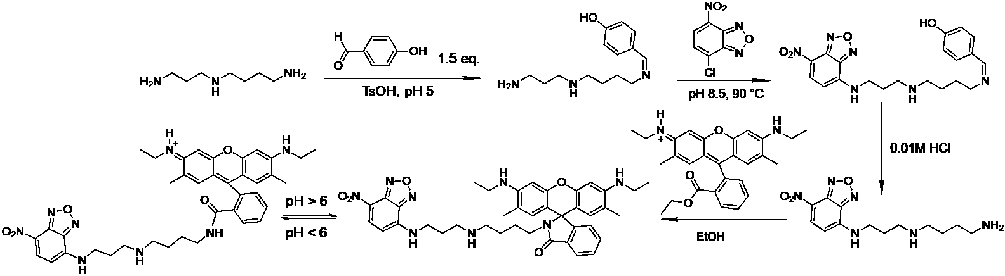

Figure S2. FTIR spectra of initial compounds, intermediate substances, and product of synthesis of pH-sensitive fluorophore R6G-spd-NBD: (a) stage 1, (b) stage 2, (c) stage 3, (d) stage 4. Aqueous solutions. T = 22 °C.
(a)
(b)
(c)
(d)

Figure S3. ¹H NMR spectra of NBD-spd. T = 22 °C. DMSO-d₆, 500 MHz.
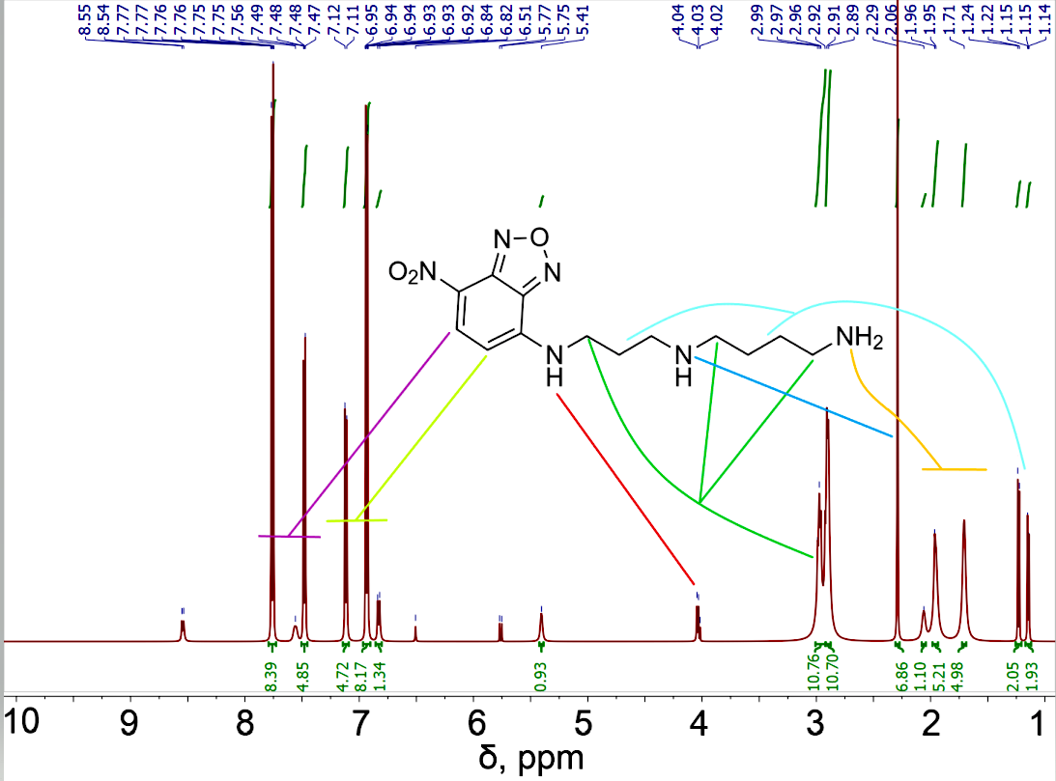

Figure 6. Confocal laser scanning microscopy images of HEK293T normal cells labeled with R6G or R6G-spd-NBD (1 µg/mL for all markers). λexci = 488 nm, λemi = 510–560 nm (green), λemi = 560–800 nm (red). The green and red channels are shown, as well as a brightfield and merge. The scale segment is 60 µm. “Micelles” means Chit5-LA polymeric micelles. Cmic = 0.1 mg/mL.
