Supplementary figures and tables

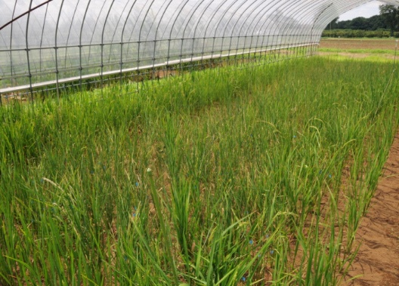
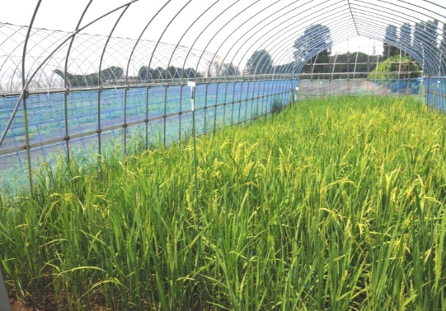
(a)
(b)

Fig. S1. Experimental upland fields used for (a) control and (b) drought treatments of the Otomemochi × Yumenohatamochi population at Nishitokyo, Japan.

Fig. S2. Maximum and minimum daily air temperature and daily rainfall. Timing of transplanting, drought imposition, rewatering, and periods of 50% flowering for genotypes in control and drought treatments are indicated.

Table S1. Summary of phenotyping experiments with the Otomemochi × Yumenohatamochi population (OY).
Experiment | Experiment 1 (2011) | Experiment 2 (2012)
Number of lines | 97 recombinant inbred lines (RILs)
Experimental design | 11 × 11 Latin square
Replications | 3
Dates of sowing / transplanting | 28 April / 23 May | 24 April / 25 May
Plant density | 20 cm × 20 cm hill space (1 plant per hill)
Fertilizer management | Basal (13 May): 6 g/m² N, 8 g/m² P₂O₅, 9 g/m² K₂O, Ca₂O₄Si Supplementary*: 2 g/m² N
Drought period | 5 July – 3 September (68–128 DAS**) (60 days; very severe) | 19 July – 2 September (79–124 DAS**) (45 days; severe)
Flowering period (control / drought) | 31 July – 24 August /  1 August – 25 September | 23 July – 20 August /  28 July – 23 August
Last harvest date (control / drought | 27 September / 22 October | 4 October / 4 November
*3 July 2011 (Experiment 1) and 5 July 2012 (Experiment 2); ** days after sowing

Table S2. Putative QTLs for drought response index (DRI) and production traits for the Otomemochi × Yumenohatamochi (OY) population. Experiment 1: 22 main-effect QTLs (control, 6; drought, 16). Experiment 2: 16 QTLs (control, 4; drought 12). Combined analysis: 12 QTLs (control, 4; drought, 8).
Experiment | Chr no. | Trait | Marker interval ª | Position ^{b} | LOD ^{c} | R^{2 d} | A ^{e}
Experiment 1 | 1 | Total dry weight D | RM8147–RM6039 | 50.8 | 2.6 | 10.4 | 2.14
 | 2 | DRI | RM3703–RM6911 | 37.4 | 5.9 | 19.9 | 2.24
 |  | Grain dry weight after rewatering D | RM3703–RM6911 | 37.4 | 5.7 | 19.2 | 0.47
 |  | Grain dry weight D | RM3703–RM6911 | 37.4 | 5.8 | 19.3 | 0.39
 |  | Harvest index D | RM3703–RM6379 | 37.4 | 2.8 | 8.5 | 0.01
 |  | Leaf rolling D | RM6933–RM3857 | 120.7 | 3.6 | 14.6 | −0.88
 |  | Plant height C | RM6911–RM6933 | 97.8 | 2.6 | 24.1 | −4.00
 | 3 | 50% flowering C | ~RM4853 | 0.0 | 3.1 | 10.6 | −2.14
 |  | Grain dry weight before rewatering D | RM1332–RM3029 | 25.0 | 5.4 | 18.2 | 0.25
 |  | Harvest index D | RM1332–RM3029 | 21.0 | 3.5 | 22.2 | 0.02
 |  | Harvest index D | RM3029–RM3872 | 34.0 | 3.3 | 11.1 | 0.02
 |  | Plant height reduction D | RM1332–RM3872 | 25.0 | 2.8 | 8.2 | −2.37
 | 4 | Flowering delay D | RM3288–RM5503 | 91.6 | 2.7 | 18.8 | 4.99
 | 5 | Grain dry weight C | ~RM2010–RM4501 | 8.5 | 3.0 | 35.5 | −3.52
 |  | Harvest index D | RM4501–RM3476 | 96.5 | 3.2 | 11.5 | −0.02
 |  | Plant height C | ~RM2010 | 1.5 | 4.5 | 20.9 | −3.77
 |  | Plant height reduction D | ~RM2010 | 1.5 | 8.6 | 35.9 | −4.74
 | 6 | Root dry weight C | RM2615–RM7023 | 46.0 | 2.5 | 11.8 | −0.39
 | 7 | Plant height D | ~RM5711 | 10.5 | 3.3 | 14.0 | 2.32
 |  | Total dry weight D | RM1353–RM6767 | 50.8 | 2.7 | 10.6 | 2.15
 | 11 | 50% flowering C | RM536–RM206 | 68.6 | 2.9 | 9.4 | −1.98
 | 12 | Leaf rolling D | ~RM247 | 8.0 | 4.0 | 46.4 | 1.65
Experiment 2 | 1 | Harvest index D | RM5919–RM1297 | 111.6 | 2.8 | 9.2 | −0.03
 |  | Leaf rolling D | RM3475–RM6696 | 117.1 | 3.9 | 11.8 | 0.48
 | 2 | Leaf rolling D | RM6379–RM3857 | 122.7 | 2.9 | 12.0 | −0.48
 | 3 | 50% flowering C | ~RM4853 | 1.5 | 3.4 | 14.5 | −2.44
 |  | Grain dry weight D | RM1332–RM3029 | 24.5 | 2.8 | 9.8 | 1.09
 |  | Plant height C | RM6676–RM3525 | 97.1 | 2.5 | 12.7 | 3.41
 | 4 | Leaf rolling D | RM1388–RM5503 | 91.1 | 3.7 | 18.7 | −0.59
 | 5 | 50% flowering D | ~RM2010–RM4501 | 10.0 | 3.4 | 36.1 | −4.01
 | 6 | DRI | RM8120–RM7023 | 31.0 | 3.6 | 12.4 | −0.90
 |  | Grain dry weight D | RM8120–RM7023 | 31.0 | 3.7 | 12.2 | −1.16
 |  | Grain dry weight D | RM6734–RM5509 | 105.8 | 2.5 | 8.3 | 0.96
 |  | Harvest index D | RM6734–RM5814 | 105.8 | 2.5 | 8.3 | 0.03
 | 7 | Plant height reduction D | RM5508–RM1362 | 104.8 | 2.6 | 9.9 | 4.24
 | 10 | Grain dry weight C | RM216–RM467 | 34.3 | 3.7 | 16.7 | 2.42
 |  | Total dry weight C | RM216–RM467 | 35.3 | 3.9 | 14.8 | 4.82
 | 11 | Plant height D | RM287–RM209 | 68.6 | 4.5 | 16.3 | −4.38
Experiments 1 and 2 (combined) | 2 | DRI | RM3703–RM6379 | 40.4 | 5.1 | 26.3 | 1.42
Experiments 1 and 2 (combined) |  | DRI | RM6733–RM3850 | 151.5 | 3.3 | 10.3 | −0.87
 |  | Leaf rolling D | RM6379–RM6933 | 119.2 | 6.5 | 22.2 | −0.67
 | 3 | 50% flowering C | ~RM4853 | 1.0 | 3.3 | 12.8 | −2.25
 |  | 50% flowering D | ~RM4853 | 0.0 | 2.7 | 8.8 | −2.53
 |  | Grain dry weight D | RM1332–RM3029 | 24.5 | 3.8 | 13.3 | 0.67
 |  | Harvest index D | RM1332–RM3029 | 25.0 | 4.1 | 13.0 | 0.02
 | 5 | 50% flowering C | ~RM2010–RM4501 | 16.5 | 3.6 | 40.7 | −3.89
 |  | 50% flowering D | ~RM2010 | 1.0 | 2.5 | 9.6 | −2.62
 | 6 | Grain dry weight D | RM8120–RM7023 | 31.0 | 2.6 | 8.5 | −0.52
 | 7 | Grain dry weight C | RM5508–RM1362 | 103.8 | 2.5 | 10.4 | 1.62
 | 11 | 50% flowering C | RM536–RM206 | 68.6 | 3.2 | 10.3 | −1.96
D: QTL found under drought.
C: QTL found in the control.
~: chromosome short arm tip.
ª Markers flanking the region of 1-LOD confidence interval.
^{b} Position of LOD peak in centimorgans from the short arm of the chromosome.
^{c} Peak LOD score obtained from composite interval mapping.
^{d} Percentage of phenotypic variance explained by the given QTL.
^{e} Positive (negative) value indicates a positive (negative) effect of Yumenohatamochi (Otomemochi) allele on the trait.

