**Supplementary Material**

Single-Crystal Structure Analysis of Dicarboxamides: Impact of Heteroatoms on Hydrogen Bonding of Carboxamide Groups

Abdulrahman Mohabbat 1, Jasmin Salama 1, Philipp Seiffert 1 and Christoph Janiak 1,*

1 *Institut für Anorganische Chemie und Strukturchemie, Heinrich-Heine-Universität 40204 Düsseldorf, Germany*

*\* Correspondence: janiak@uni-duesseldorf.de*

Emails: abdulrahman.mohabbat@uni-duesseldorf.de, jasmin.salama@uni-duesseldorf.de, philipp.seiffert@uni-duesseldorf.de, janiak@uni-duesseldorf.de

Content

S1 Chemicals used 2

S2 Preparation of the dicarboxamides 2

S3 NMR spectra of the dicarboxamides 3

S4 IR spectra of the dicarboxamides 6

S5 Mass spectra of the dicarboxamides 7

S6 PXRD of the dicarboxamides 9

S7 2D Hirshfeld plots of the dicarboxamides 11

References 19

# S1 Chemicals used

**Table S1**. Overview of chemicals used.

|  |  |  |  |  |
| --- | --- | --- | --- | --- |
| Chemical | | Purity [%] | Supplier | |
| 2,5-furandicarboxylic acid | | 97 | Sigma-Aldrich | |
| 3,5-pyridinedicarboxylic acid | | >98,0 | TCL | |
| 2,5-thiophenedicarboxylic acid | | 99,23 | BLD Pharmatech Ldt. | |
| Ammonia solution 25% | | 25 | Merck | |
| Deionized ultrapure water | | - | Milipore | |
| Dimethyl sulfoxide-d6 | | 99,9 | Sigma-Aldrich | |
| Ethanol | | ≥99,9 | ChemSolute | |
| Methanol | | ≥99,9 | | | Sigma-Aldrich | |
| N,N-Dimethylformamide | | 99,5 | Fisher Chemical | |
| n-Hexane | | 97 | VWR Chemicals | |
| Thionyl chloride | | 99,7 | Acros Organics | |

# S2 Preparation of the dicarboxamides

For the synthesis of the dicarboxamides, 10 mmol of the corresponding dicarboxylic acid and 25 mL of thionyl chloride were placed in a 100 mL flask and connected to a reflux condenser. The specific amounts of each dicarboxylic acid used are listed in Table S2 . A few drops of DMF were added as a catalyst, and the mixture was heated to reflux at 90 °C overnight. The resulting solution was cooled to room temperature, and the excess thionyl chloride was removed. The remaining residue was washed three times with 15 mL of hexane and then dried under vacuum. This intermediate was then transferred to a 100 mL flask, and 5 mL of aqueous ammonia (25%) was added dropwise while stirring in an ice bath. The reaction mixture was stirred in the ice bath for one hour. After drying, the product was washed three times with 15 mL of water and ethanol, and then dried again to obtain the final product [1].

**Table S2.** Amount of dicarboxylic acids used for the synthesis and yield of obtained dicarboxamides.

|  |  |  |
| --- | --- | --- |
| Dicarboxylic acid | Amount [g]/[mmol] | Yield of dicarboxamides [%] |
| 2,5-thiophenedicarboxylic acid | 1.72 / 10 | 75 |
| 2,5-furandicarboxylic acid | 1.56 / 10 | 62 |
| 3,5-pyridinedicarboxylic acid | 1.67 / 10 | 60 |

# S3 NMR spectra of the dicarboxamides

Ein Bild, das Text, Diagramm, Entwurf, Zeichnung enthält.

**Figure S1**. 1H-NMR spectrum (600 MHz, DMSO-d6) of 3,5-pyridinedicarboxamide, PDC.

Ein Bild, das Text, Reihe, Screenshot, Diagramm enthält.

**Figure S2.** 13C-NMR spectrum (75 MHz, DMSO-d6) of 3,5-pyridinedicarboxamide, PDC.

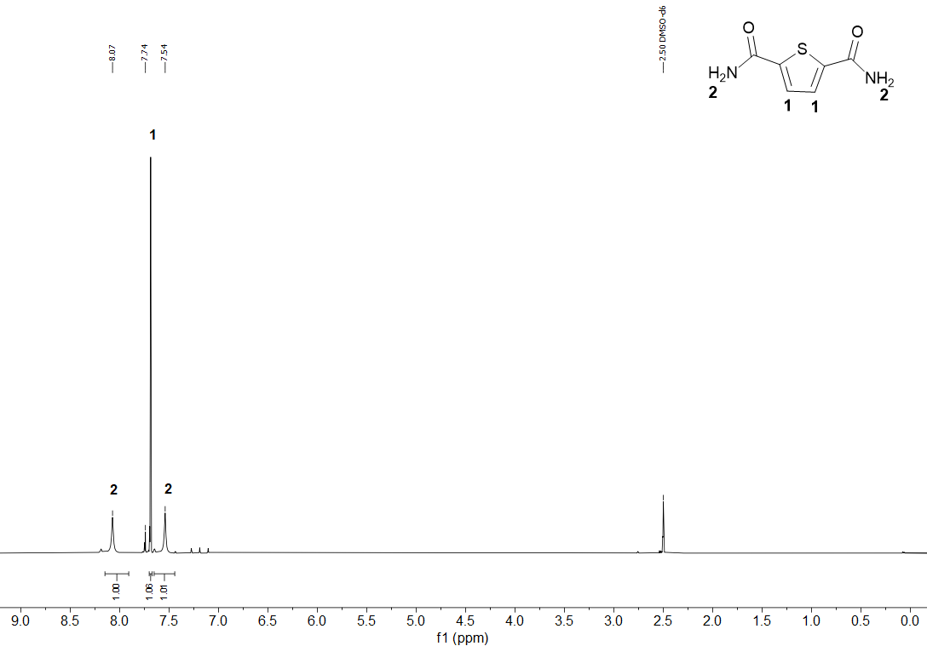

**Figure S3**. 1H-NMR spectrum (600 MHz, DMSO-d6) of 2,5-thiophenedicarboxamide.TDC.

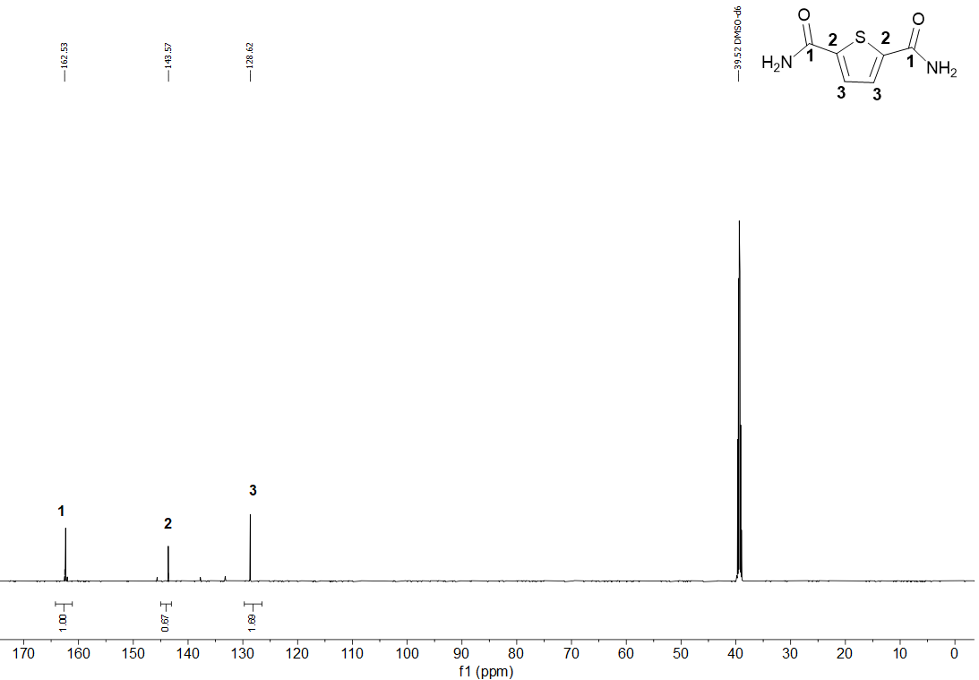

**Figure S4.** 13C-NMR spectrum (75 MHz, DMSO-d6) of 2,5-thiophenedicarboxamide, TDC.

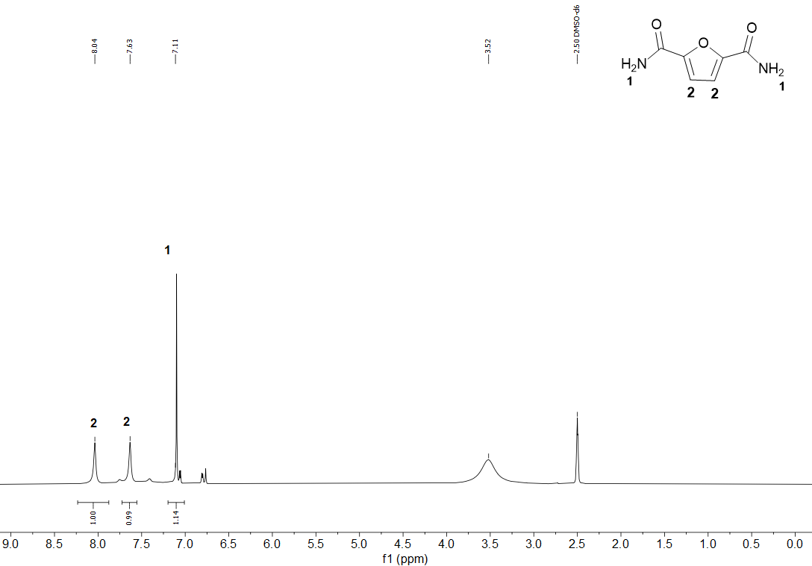

**Figure S5**. 1H-NMR spectrum (600 MHz, DMSO-d6) of 2,5-furandicarboxamide, FDC.

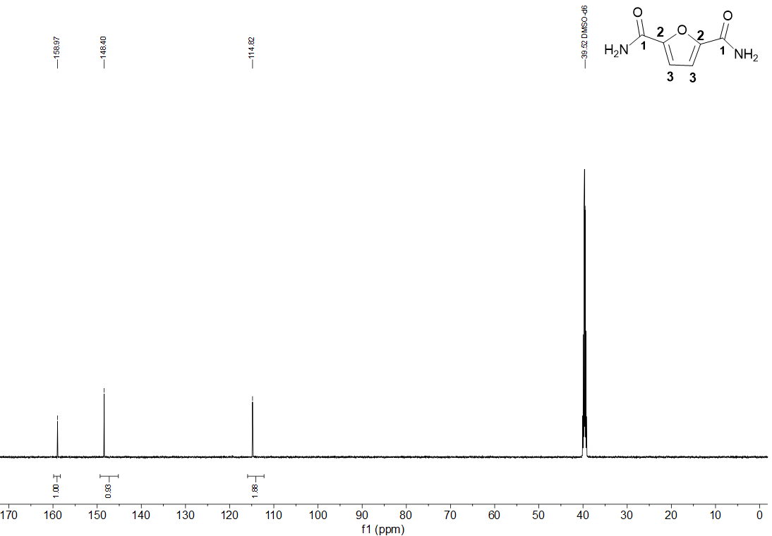

**Figure S6.** 13C-NMR spectrum (75 MHz, DMSO-d6) of 2,5-furandicarboxamide, FDC.

# S4 IR spectra of the dicarboxamides

Ein Bild, das Text, Diagramm, Schrift, Reihe enthält.

**Figure S7.** IR spectrum of 3,5-pyridinedicarboxamide, PDC (attenuated total reflection, ATR).

Ein Bild, das Text, Entwurf, Zeichnung enthält.

**Figure S8.** IR spectrum of 2,5-thiophenedicarboxamide, TDC (attenuated total reflection, ATR).

**Ein Bild, das Text, Diagramm, Schrift, Reihe enthält.
**

**Figure S9.** IR spectrum of 2,5-furandicarboxamide, FDC-subl and FDC-solv (attenuated total reflection, ATR).

# S5 Mass spectra of the dicarboxamides

Ein Bild, das Text, Diagramm, Reihe, Schrift enthält.

**Figure S10.** EI mass spectrum for 3,5-pyridinedicarboxamide, PDC.

Ein Bild, das Text, Diagramm, Reihe, technische Zeichnung enthält.

**Figure S11.** EI mass spectrum for 2,5-thiophenedicarboxamide, TDC.

Ein Bild, das Text, Diagramm, Reihe, Schrift enthält.

**Figure S12.** EI mass spectrum for 2,5-furandicarboxamide, FDC.

# S6 PXRD of the dicarboxamides

Ein Bild, das Text, Diagramm, Schrift, Screenshot enthält.

**Figure S13.** Simulated and experimental powder X-ray diffraction patterns of 3,5-pyridinedicarboxamide, PDC.

Ein Bild, das Text, Diagramm, Schrift, Reihe enthält.

**Figure S14.** Simulated and experimental powder X-ray diffraction patterns of 2,5-thiophenedicarboxamide, TDC.

**Ein Bild, das Text, Diagramm, Reihe, Schrift enthält.
**

**Figure S15.** Simulated and experimental powder X-ray diffraction patterns of 2,5-furandicarboxamide for the FDC-subl structure.

# S7 2D Hirshfeld plots of the dicarboxamides

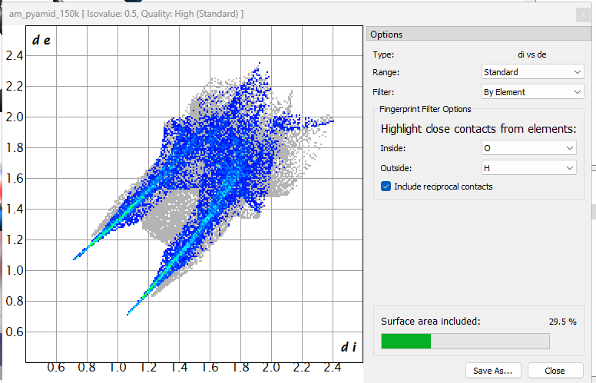

**Figure S16.** Contribution of O⋯H contacts in the Hirshfeld 2D plot of 3,5-pyridinedicarboxamide, PDC.

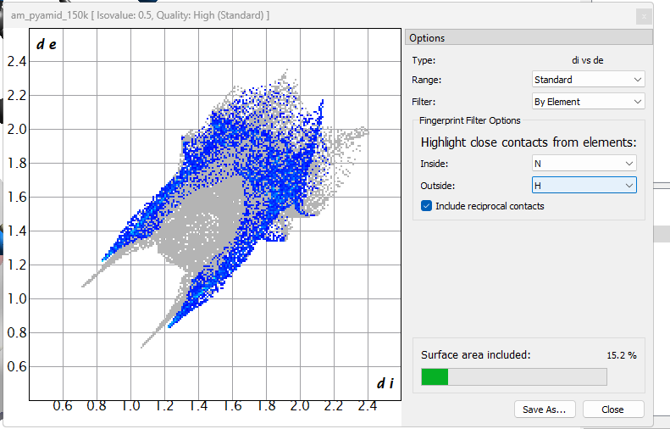

**Figure S17.** Contribution of N⋯H contacts in the Hirshfeld 2D plot of 3,5-pyridinedicarboxamide, PDC.

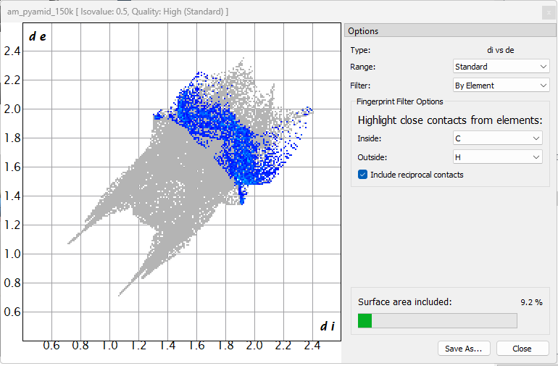

**Figure S18.** Contribution of C⋯H contacts in the Hirshfeld 2D plot of 3,5-pyridinedicarboxamide, PDC.

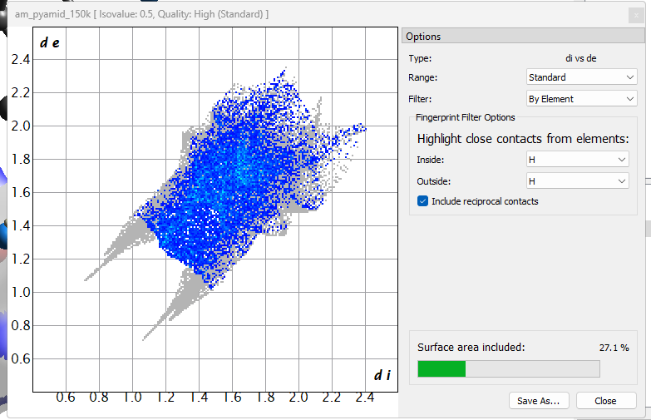

**Figure S19.** Contribution of H⋯H contacts in the Hirshfeld 2D plot of 3,5-pyridinedicarboxamide, PDC.

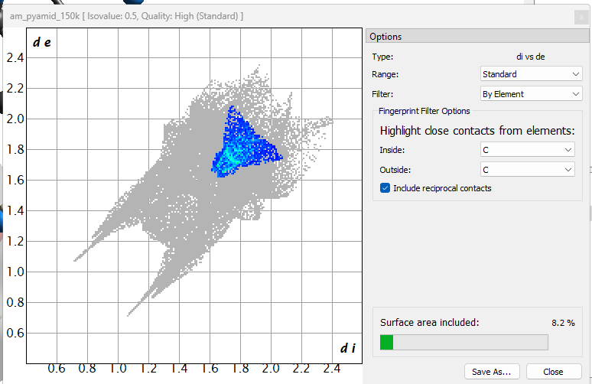

**Figure S20.** Contribution of C⋯C contacts in the Hirshfeld 2D plot of 3,5-pyridinedicarboxamide, PDC.

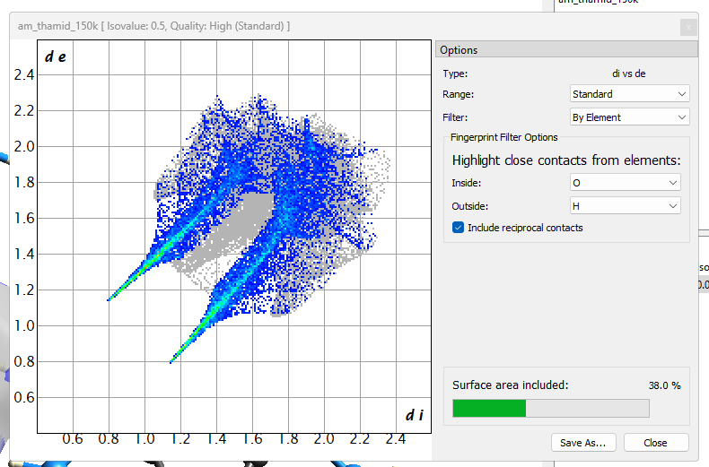

**Figure S21.** Contribution of O⋯H contacts in the Hirshfeld 2D plot of 2,5-thiophenedicarboxamide, TDC.

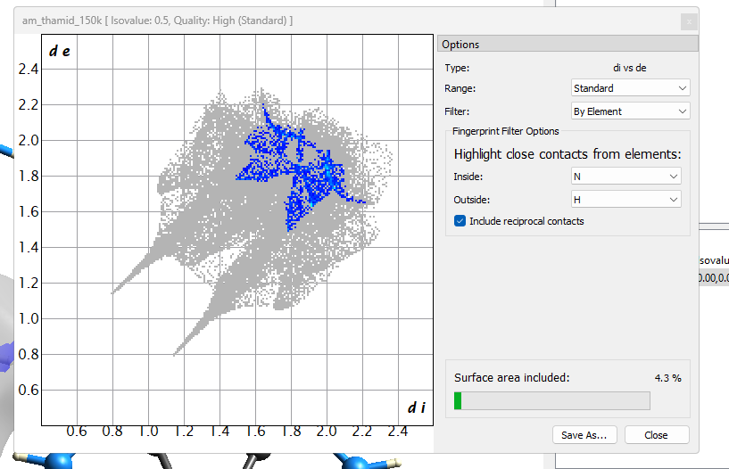

**Figure S22.** Contribution of N⋯H contacts in the Hirshfeld 2D plot of 2,5-thiophenedicarboxamide, TDC.

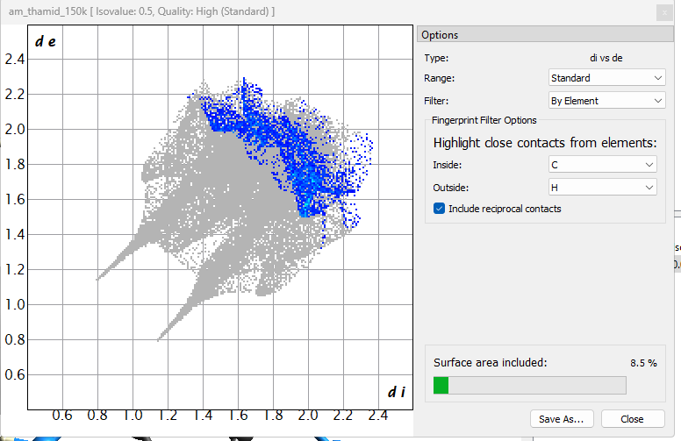

**Figure S23.** Contribution of C⋯H contacts in the Hirshfeld 2D plot of 2,5-thiophenedicarboxamide, TDC.

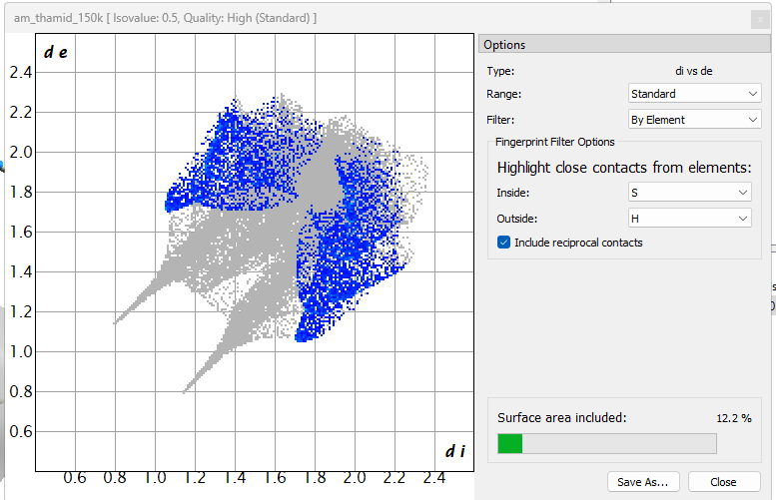

**Figure S24.** Contribution of S⋯H contacts in the Hirshfeld 2D plot of 2,5-thiophenedicarboxamide, TDC.

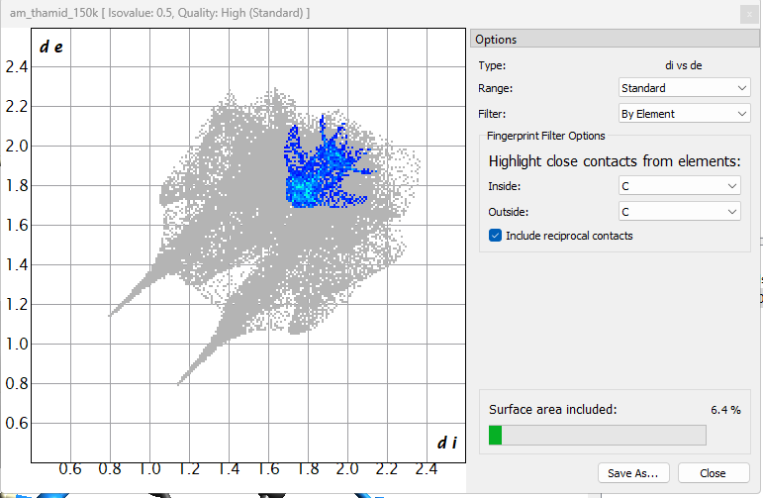

**Figure S25.** Contribution of C⋯C contacts in the Hirshfeld 2D plot of 2,5-thiophenedicarboxamide, TDC.

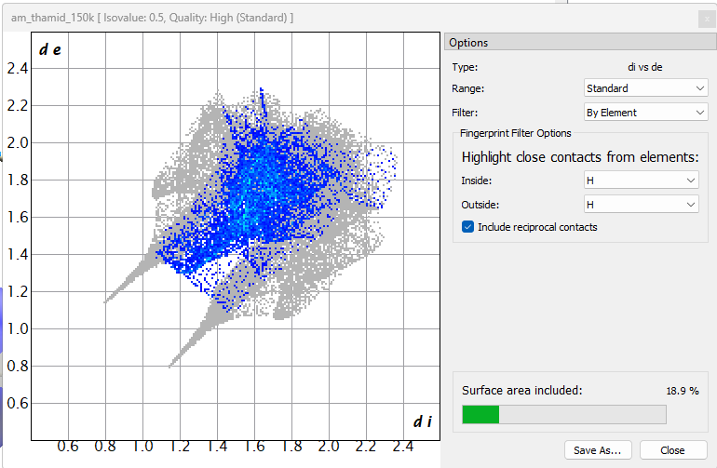

**Figure S26.** Contribution of H⋯H contacts in the Hirshfeld 2D plot of 2,5-thiophenedicarboxamide, TDC.

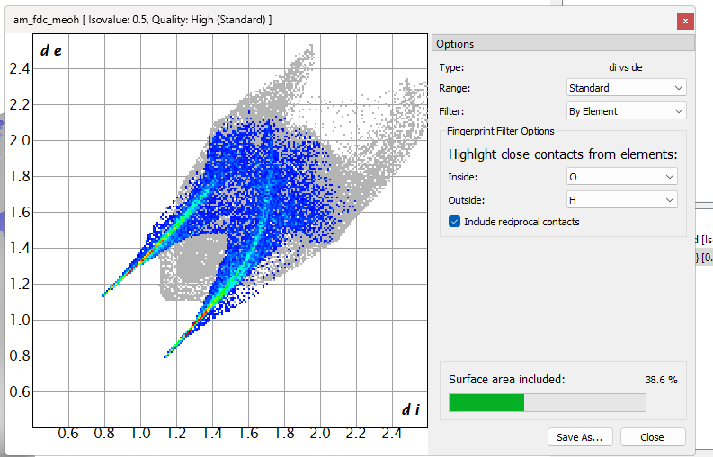

**Figure S27.** Contribution of O⋯H contacts in the Hirshfeld 2D plot of 2,5-furandicarboxamide for the FDC-solv structure.

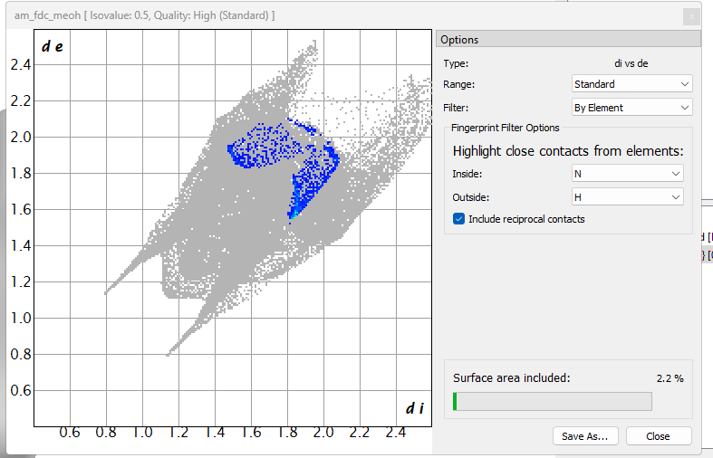

**Figure S28.** Contribution of N⋯H contacts in the Hirshfeld 2D plot of 2,5-furandicarboxamide for the FDC-solv structure.

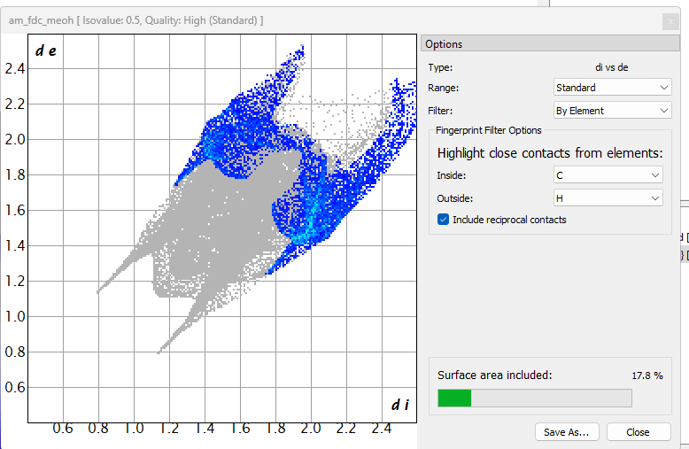

**Figure S29.** Contribution of C⋯H contacts in the Hirshfeld 2D plot of 2,5-furandicarboxamide for the FDC-solv structure.

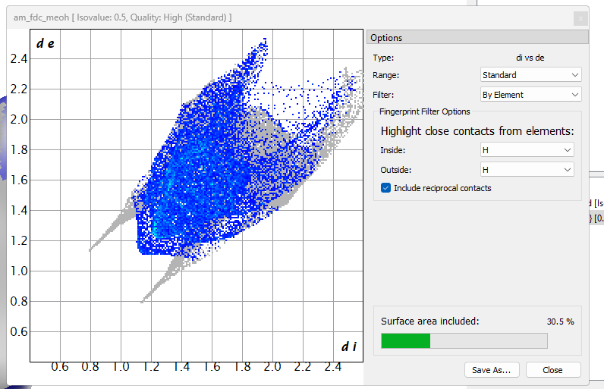

**Figure S30.** Contribution of H⋯H contacts in the Hirshfeld 2D plot of 2,5-furandicarboxamide for the FDC-solv structure.

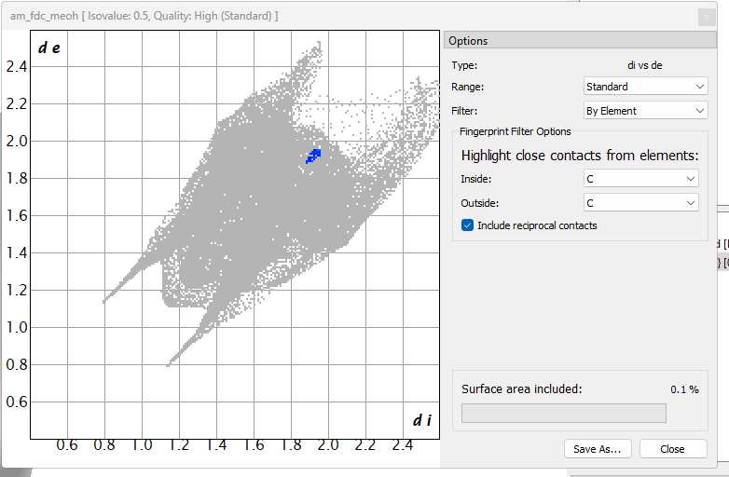

**Figure S31.** Contribution of C⋯C contacts in the Hirshfeld 2D plot of 2,5-furandicarboxamide for the FDC-solv structure.

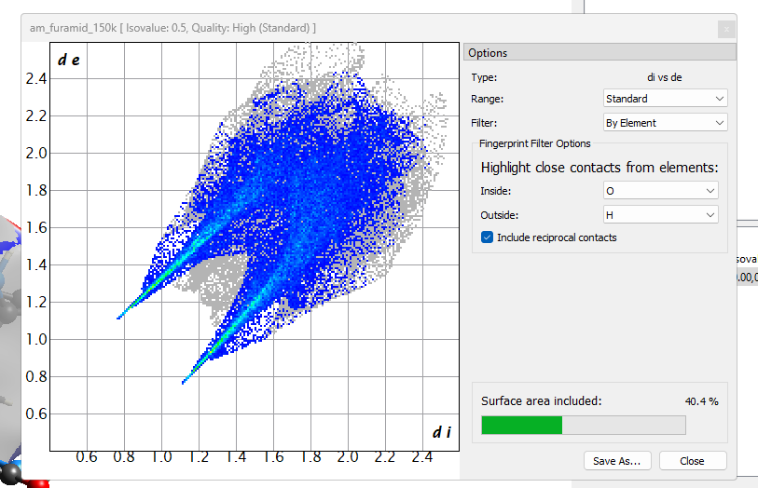

**Figure S32.** Contribution of O⋯H contacts in the Hirshfeld 2D plot of 2,5-furandicarboxamide for the FDC-subl structure.

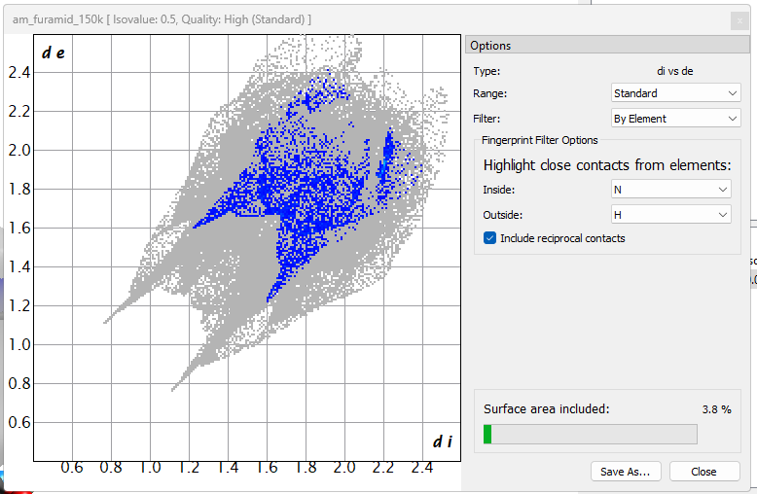

**Figure S33.** Contribution of N⋯H contacts in the Hirshfeld 2D plot of 2,5-furandicarboxamide for the FDC-subl structure.

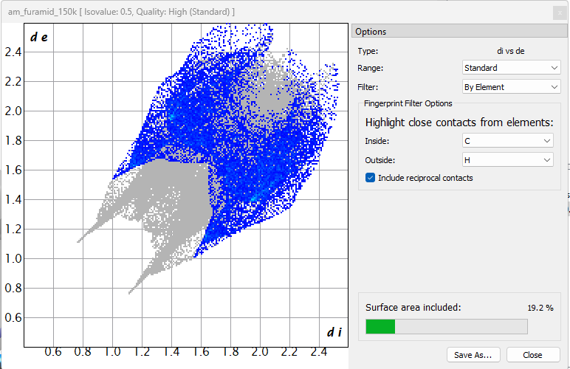

**Figure S34.** Contribution of C⋯H contacts in the Hirshfeld 2D plot of 2,5-furandicarboxamide for the FDC-subl structure.

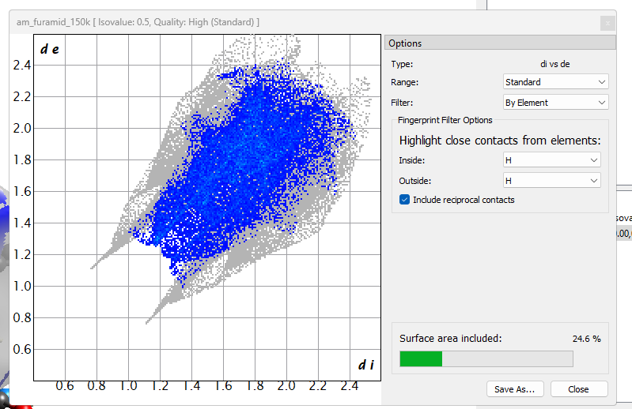

**Figure S35.** Contribution of H⋯H contacts in the Hirshfeld 2D plot of 2,5-furandicarboxamide for the FDC-subl structure.

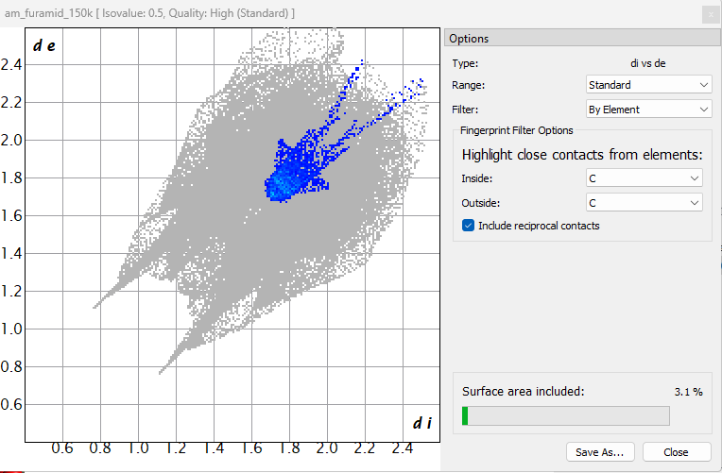

**Figure S36.** Contribution of C⋯C contacts in the Hirshfeld 2D plot of 2,5-furandicarboxamide for the FDC-subl structure.

References

1. Wu, Y.Y.; Meng, M.; Wang, G.Y.; Feng, P.; Liu, C.Y. Optically probing the localized to delocalized transition in Mo2–Mo2 mixed-valence systems. *Chem. Commun*. **2017**, *53*, 3030–3033**.** <https://doi.org/10.1039/C7CC00119C>