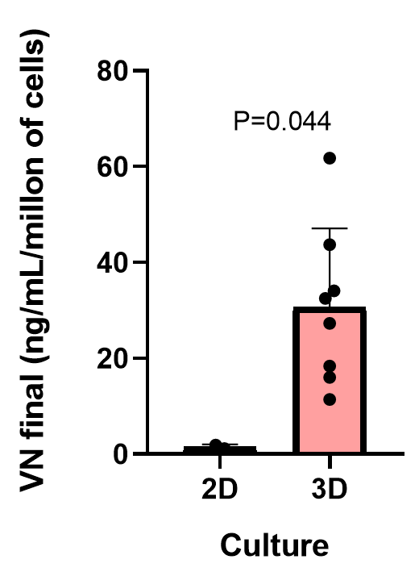**Supplementary Materials**

**Figure S1.** Comparison of vitronectin (VN) levels secreted to culture media of 2D and 3D cultures by Ewing sarcoma cell lines (p – value= 0.044).

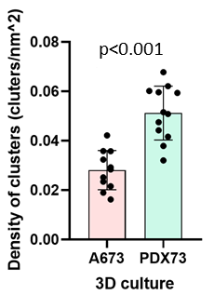

**Figure S2.** Cluster density in 3D cultures of Ewing sarcoma cell lines (p – value<0.0001).

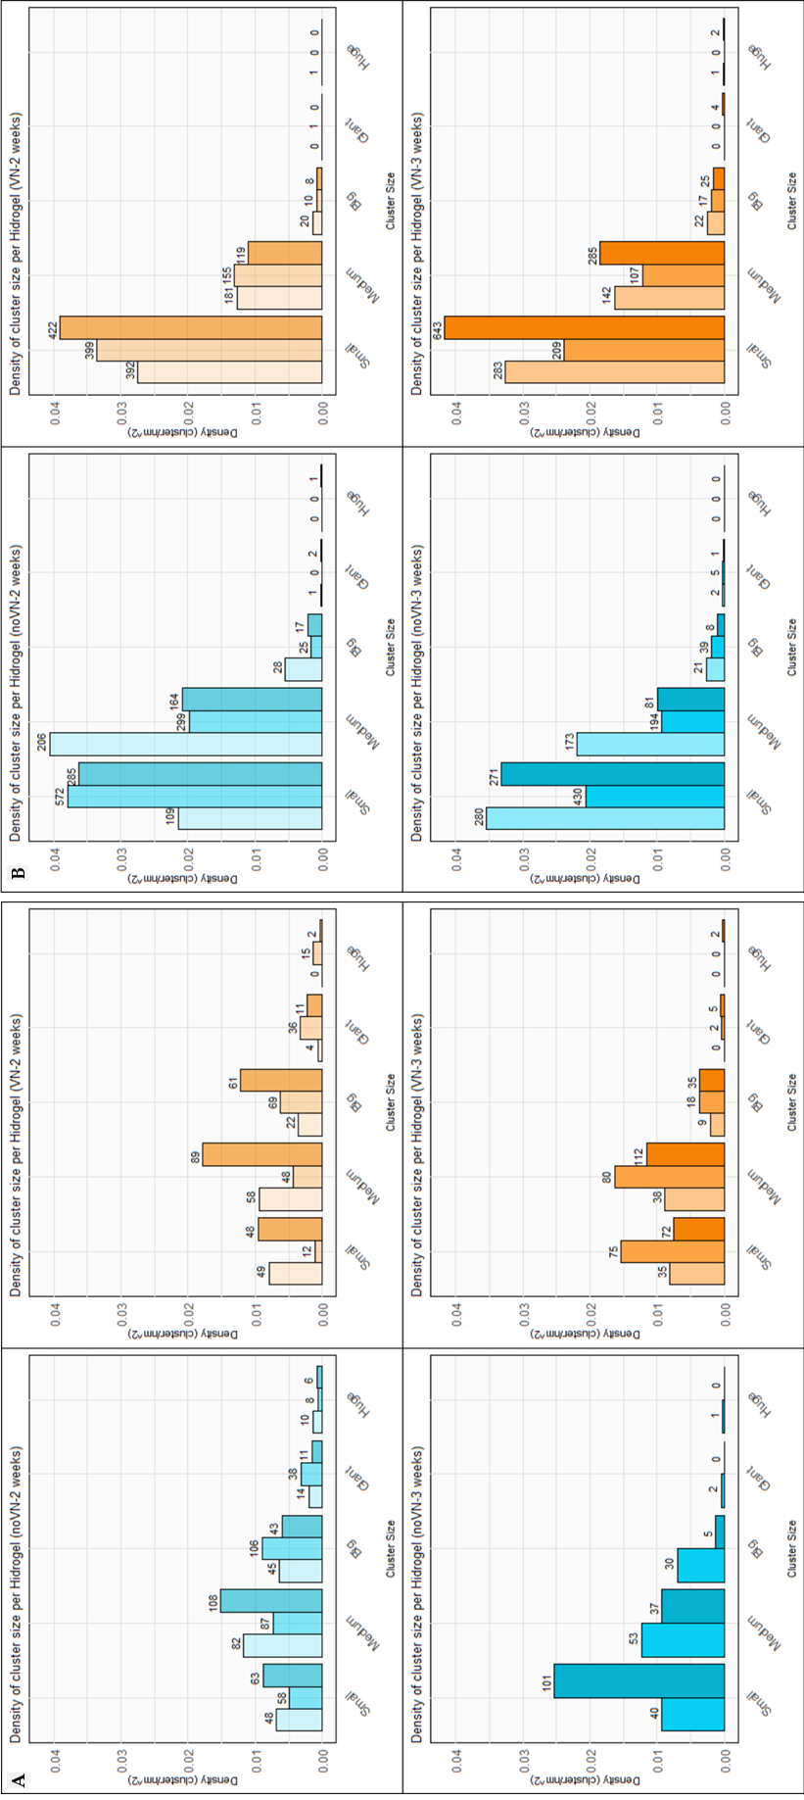**Figure S3.** Cluster density (clusters/nm²) in each hydrogel replicate divided by size (cell count inside), composition and culture time. (**A**) A673 and (**B**) PDX73 cell line. Boxes in cyan represent no added VN in the scaffold (noVN), boxes in orange represent added VN in the scaffold (VN), a light color of both represents culture for 2 weeks (2w) and dark color of both represent culture for 3 weeks (3w). The number of clusters is at the top of each bar.

**Table S1.** Information obtained per hydrogel replicate.

|  |  |  |  |  |  |  |  |
| --- | --- | --- | --- | --- | --- | --- | --- |
| **Line** | **Hydrogel** | **Scaffold**  **composition** | **Time of**  **culture** | **Hydrogel**  **Size (cm2)** | **Number of**  **clusters** | **Number**  **of cells** | **Cluster median**  **area (µm2)** |
| **A673** | HG1 | noVN | 2 weeks | 7.014 | 199 | 11573 | 1239.5 |
| HG2 | noVN | 2 weeks | 11.81 | 297 | 15896 | 2606.7 |
| HG3 | noVN | 2 weeks | 7.14 | 231 | 10552 | 1358.7 |
| HG1 | VN | 2 weeks | 6.16 | 133 | 3664 | 936.31 |
| HG2 | VN | 2 weeks | 11.08 | 180 | 15336 | 3464.65 |
| HG3 | VN | 2 weeks | 5.003 | 211 | 8292 | 1385.7 |
| HG1 | noVN | 3 weeks | ------ | ------ | ------- | ------ |
| HG2 | noVN | 3 weeks | 4.31 | 126 | 4115 | 1030.2 |
| HG3 | noVN | 3 weeks | 3.99 | 143 | 1960 | 408.22 |
| HG1 | VN | 3 weeks | 4.32 | 82 | 1945 | 925.085 |
| HG2 | VN | 3 weeks | 4.89 | 175 | 3944 | 813.43 |
| HG3 | VN | 3 weeks | 9.65 | 226 | 6470 | 1133.9 |
| **PDX73** | HG1 | noVN | 2 weeks | 5.08 | 344 | 7156 | 898.8 |
| HG2 | noVN | 2 weeks | 15.09 | 896 | 11686 | 514.25 |
| HG3 | noVN | 2 weeks | 7.86 | 469 | 7686 | 595.43 |
| HG1 | VN | 2 weeks | 14.27 | 594 | 7688 | 579.75 |
| HG2 | VN | 2 weeks | 11.89 | 565 | 6948 | 437.12 |
| HG3 | VN | 2 weeks | 10.80 | 549 | 5689 | 339.06 |
| HG1 | noVN | 3 weeks | 7.91 | 476 | 6450 | 457.49 |
| HG2 | noVN | 3 weeks | 20.85 | 668 | 10013 | 547.55 |
| HG3 | noVN | 3 weeks | 8.16 | 361 | 4434 | 432.88 |
| HG1 | VN | 3 weeks | 8.69 | 448 | 6739 | 440.54 |
| HG2 | VN | 3 weeks | 8.77 | 333 | 5103 | 509.06 |
| HG3 | VN | 3 weeks | 15.45 | 959 | 11888 | 488.44 |

**Table S2.** **Area** of Clusters vs. time and composition of hydrogels cultured with **A673** cell line

|  |  |  |  |  |  |
| --- | --- | --- | --- | --- | --- |
|  | **Interaction** | | | | |
|  | **Statistical Data** | **VN – 2w** vs.  **noVN - 2w** | **VN – 3w** vs.  **noVN – 3w** | **noVN - 2w** vs.  **noVN – 3w** | **VN – 2w** vs.  **VN – 3w** |
| **Small** | N sample | 109-169 | 182-141 | 169-141 | 109-182 |
| p-value | ns | <0.0001**** | ns | 0.0010*** |
| **Medium** | N sample | 195 -277 | 230-90 | 277-90 | 195-230 |
| p-value | ns | 0.0451** | 0.0017 | ns |
| **Big** | N sample | 152-194 | 62-35 | 194-35 | 152-62 |
| p-value | ns | ns | ns | 0.0051 |
| **Giant** | N sample | 51-63 | 7-2 | 63-2 | 51-7 |
| p-value | ns | 0.0215 | ns | ns |
| **Huge** | N sample | 17-24 | 2-1 | 24-1 | 17-2 |
| p-value | ns | ns | ns | ns |

**ns:** not significant

**Table S3. Area** of Clusters vs. time and composition of hydrogels cultured with **PDX73** cell line

|  |  |  |  |  |  |
| --- | --- | --- | --- | --- | --- |
|  | **Interaction** | | | | |
|  | **Statistical Data** | **VN – 2w** vs.  **noVN - 2w** | **VN – 3w** vs.  **noVN – 3w** | **noVN - 2w** vs.  **noVN – 3w** | **VN – 2w** vs.  **VN – 3w** |
| **Small** | N sample | 1213-966 | 1135-981 | 966-981 | 1213-1135 |
| p-value | ns | ns | 0.0008 | ns |
| **Medium** | N sample | 455-669 | 534-448 | 669-448 | 455-534 |
| p-value | * | ns | ns | ns |
| **Big** | N sample | 38-70 | 64-68 | 70-68 | 38-64 |
| p-value | ns | ns | ns | ns |
| **Giant** | N sample | 1-3 | 4-8 | 3-8 | 1-4 |
| p-value | ns | ns | ns | ns |
| **Huge** | N sample | Insufficient | Insufficient | Insufficient | Insufficient |
| p-value |  |  |  |  |

**ns:** not significant

**Table S4.** **Circularity** of Clusters vs. time and composition of hydrogels cultured with **A673** cell line

|  |  |  |  |  |  |
| --- | --- | --- | --- | --- | --- |
|  | **Interaction** | | | | |
|  | **Statistical Data** | **VN – 2w** vs.  **noVN - 2w** | **VN – 3w** vs.  **noVN – 3w** | **noVN - 2w** vs.  **noVN – 3w** | **VN – 2w** vs.  **VN – 3w** |
| **Small** | N sample | 75-109 | 164-130 | 109-130 | 75-164 |
| p-value | <0.0001 | <0.0001 | ns | ns |
| **Medium** | N sample | 137-172 | 200-77 | 172-77 | 137-200 |
| p-value | ns | <0.0001**** | <0.0009*** | ns |
| **Big** | N sample | 133-164 | 54-28 | 164-28 | 133-54 |
| p-value | ns | ns | ns | ns |
| **Giant** | N sample | 41-47 | 6-1 | 47-1 | 41-6 |
| p-value | ns | ns | ns | ns |
| **Huge** | N sample | Insufficient | Insufficient | Insufficient | Insufficient |
| p-value |  |  |  |  |

**ns:** notsignificant

**Table S5.** **Circularity** of Clusters vs. size of clusters of **A673** cell line

|  |  |  |  |  |  |
| --- | --- | --- | --- | --- | --- |
|  | **Interaction** | | | | |
|  | **Statistical Data** | **noVN - 2w** | **VN – 2w** | **noVN – 3w** | **VN – 3w** |
| Small - Medium | N sample | 109-172 | 75-137 | 130-77 | 164-200 |
| p-value | <0.0001**** | ns | ns | ns |
| Small - Big | N sample | 109-164 | 75-133 | 130-28 | 164-54 |
| p-value | <0.0001**** | ns | 0.0013** | ns |
| Small - Giant | N sample | 109-47 | 75-41 | 130-1 | 164-6 |
| p-value | <0.0001**** | ns | ns | ns |
| Small - Huge | N sample | 109-16 | 75-17 | Insufficient | Insufficient |
| p-value | 0.0005*** | ns |  |  |
| Medium - Big | N sample | 172-164 | 137-133 | 77-28 | 200-54 |
| p-value | ns | ns | 0.0038** | ns |
| Medium - Giant | N sample | 172-47 | 137-41 | 77-1 | 200-6 |
| p-value | 0.0271* | ns | ns | ns |
| Medium - Huge | N sample | 172-16 | 137-17 | Insufficient | Insufficient |
| p-value | ns | ns |  |  |
| Big –  Giant | N sample | 164-47 | 133-41 | 28-1 | 54-6 |
| p-value | ns | ns | ns | ns |
| Big –  Huge | N sample | 164-16 | 133-17 | Insufficient | Insufficient |
| p-value | ns | ns |  |  |
| Giant - Huge | N sample | 47-16 | 41-17 | Insufficient | Insufficient |
| p-value | ns | ns |  |  |

**ns:** not significant

**Table S6.** **Circularity** of Clusters vs. time and composition of hydrogels cultured with **PDX73** cell line

|  |  |  |  |  |  |
| --- | --- | --- | --- | --- | --- |
|  | **Interaction** | | | | |
|  | **Statistical Data** | **VN – 2w** vs.  **noVN - 2w** | **VN – 3w** vs.  **noVN – 3w** | **noVN - 2w** vs.  **noVN – 3w** | **VN – 2w** vs.  **VN – 3w** |
| **Small** | N sample | 1157-927 | 1110-945 | 927-945 | 1157-1110 |
| p-value | <0.0001**** | ns | ns | 0.0002 |
| **Medium** | N sample | 434-634 | 513-420 | 634-420 | 434-513 |
| p-value | ns | 0.0112 | <0.0001**** | <0.0001**** |
| **Big** | N sample | 36-62 | 54-47 | 62-47 | 36-54 |
| p-value | ns | ns | 0.0079 | 0.0111 |
| **Giant** | N sample | 1-2 | 3-5 | 2-5 | 1-3 |
| p-value | ns | 0.0154** | ns | ns |
| **Huge** | N sample | Insufficient | Insufficient | Insufficient | Insufficient |
| p-value |  |  |  |  |

**ns:** not significant

**Table S7.** **Circularity** of clusters vs. size of clusters of **PDX73** cell line

|  |  |  |  |  |  |
| --- | --- | --- | --- | --- | --- |
|  | **Interaction** | | | | |
|  | **Statistical Data** | **noVN - 2w** | **VN – 2w** | **noVN – 3w** | **VN – 3w** |
| Small - Medium | N sample | 927-634 | 1157-434 | 945-420 | 1110-513 |
| p-value | <0.0001**** | ns | <0.0001**** | ns |
| Small - Big | N sample | 927-62 | 1157-36 | 945-47 | 1110-54 |
| p-value | ns | ns | 0.0002*** | <0.0001**** |
| Small - Giant | N sample | 927-2 | 1157-1 | 945-5 | 1110-3 |
| p-value | ns | ns | ns | 0.0221* |
| Small - Huge | N sample | 927-1 | 1157-1 | Insufficient | 1110-1 |
| p-value | ns | ns |  | ns |
| Medium - Big | N sample | 634-62 | 434-36 | 420-47 | 513-54 |
| p-value | ns | ns | ns | 0.0005*** |
| Medium - Giant | N sample | 634-2 | 434-1 | 420-5 | 513-3 |
| p-value | ns | ns | ns | 0.0411* |
| Medium - Huge | N sample | 634-1 | 434-1 | Insufficient | 513-1 |
| p-value | ns | ns |  | ns |
| Big –  Giant | N sample | 62-2 | 36-1 | 47-5 | 54-3 |
| p-value | ns | ns | ns | ns |
| Big –  Huge | N sample | 62-1 | 36-1 | Insufficient | 54-1 |
| p-value | ns | ns |  | ns |
| Giant - Huge | N sample | 2-1 | 1-1 | Insufficient | 3-1 |
| p-value | ns | ns |  | ns |

**ns:** not significant

**Supplementary materials. Appendix A: Digital microscopic analyses of 3D models**

QuPhatTH, and its extension StarDist, was used for all digital analyses [67]. For digital analyses of 3D models, a semi-automatic method was developed to detect HG area, clusters and cells in the scanned H&E-stained slides.

The first step consisted of encircling the entire HG perimeter using a script based on the auto-threshold segmentation method. For HG detection with H&E staining, we used the Huang auto-threshold method by blue channel, with a minimum detection area of 90,000 µm2 (Figure S4A). The previous tool was adapted to detect clusters using the Otsu auto-threshold method by hematoxylin channel with a minimum area of 500 µm2 (Figure 4A), and a pretrained StarDist model for nucleus segmentation based on brightfield (i.e., hematoxylin, available in https://github.com), adjusted for details such as nucleus area and mean hematoxylin intensity (Figure 8B), was used to distinguish and count the cells within each cluster.

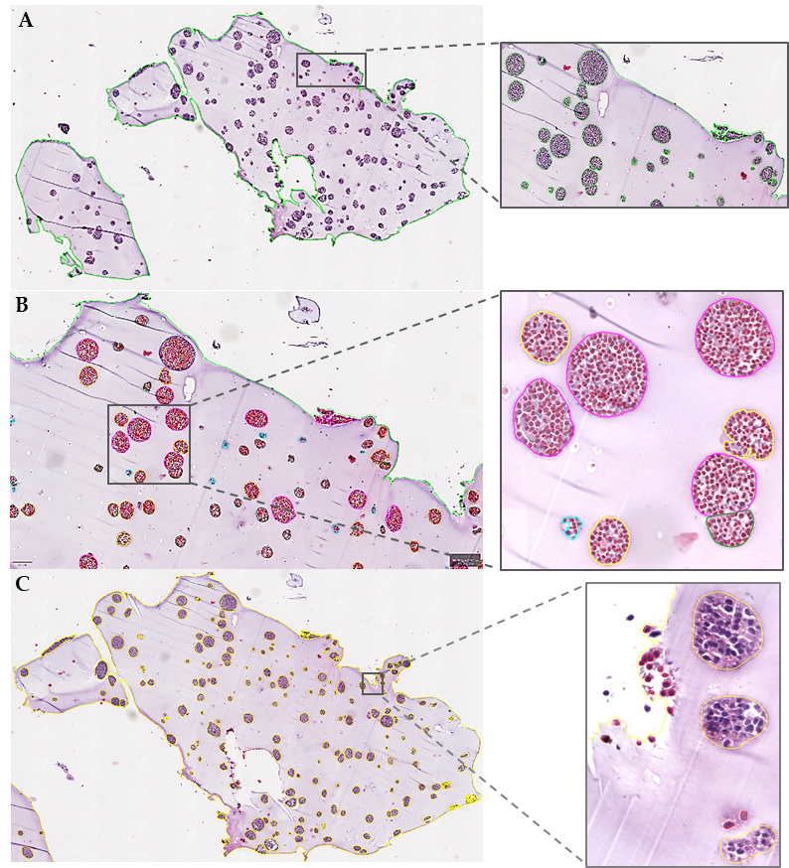

**Figure S4. Digital detection of hydrogel (HG) clusters and cells**. (**A**) Example of an image of an HG after perimeter detection (green line) and cluster detection (green circles). (**B**) Cluster and cell detection: Example of an HG with clusters circulated in different colors according to the consensual cell number (Table 1) and cell detection in each cluster (red). (**C**) Out-of-cluster cell detection. The yellow borders represent the clusters. The red circles represent cells detected in the HG not belonging to any cluster.

We used quartile analysis of the cell count in each cluster of the two cell lines studied and consensus was reached for size classification (Table 1). Next, a new script was adapted to classify clusters by cell number/size which was then validated by experts.

The last step was to detect single cells present in each HG not forming part of any cluster, and to combine them with the total number of detections inside clusters per HG obtained from the previous step (Figure S4C).