Supplementary

Spatiotemporal characteristics of ammonia concentration and their abundancy in Korea

**Table S1.** Population density by region in 2020.

|  |  |  |  |
| --- | --- | --- | --- |
| Region | Type | Population density (persons/km2) | |
| Entire | - | 516 |
| SE | Urban | 15,839 |
| DJ | Urban | 2,758 |
| GJ | Urban | 2,948 |
| BI | Remote | 112 |
| JI | Remote | 363 |
| US | Industry | 1,069 |

**Table S2.** Performance of main parameters on selected instrument.

|  |  |
| --- | --- |
| Parameter | Performance |
| Measurement range | 0 ~ 500 ppb. Optional expanded range 0 ~ 50 ppm |
| Measurement Interval | 1 sec over guaranteed range |
| Lower Detection Limit | 0.03 ppb |
| Sample temperature | -10 to 45 ℃ |
| Sample flow rate | > 1.5 slm at 760 torr |

Source: <http://www.picarro.com> [8]

**Table S3.** NOx concentration by region in 2020.

|  |  |  |  |
| --- | --- | --- | --- |
| Region | Type | NOx (ppb) | |
| Entire | - | 15.3 |
| SE | Urban | 23.3 |
| DJ | Urban | 26.0 |
| GJ | Urban | 14.2 |
| BI | Remote | 4.6 |
| JI | Remote | 3.4 |
| US | Industry | 16.6 |

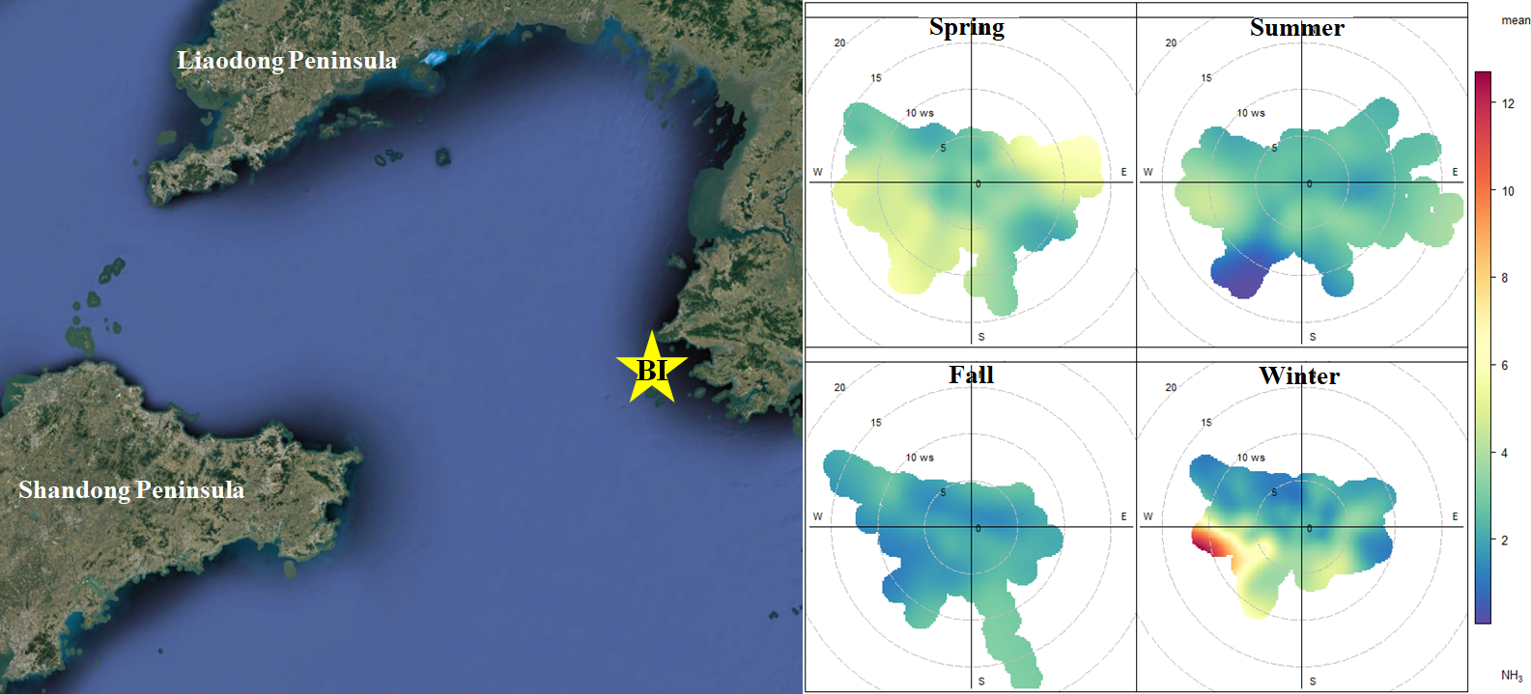

**Figure S1.** Location of BI and Seasonal polar plot.

**Measurement method of HNO3 and data Verification**

The production process of HNO3 in the atmosphere largely consists of the NO-NO2 photochemical cycle and the oxidation process of NO2. During the day, photochemical equilibrium between NO and NO2 is achieved in minutes, and NO2 is oxidized to HNO3 through a photochemical reaction with OH radicals. At night, NO2 undergoes an oxidation process with O3 and is mainly converted into nitrogen oxides of N2O5 and NO3, ultimately producing HNO3 [1-3].

NO + O3 → NO2 + O2

NO2 + hv → NO + O3

NO2 + OH + M → HNO3 + M

NO2 + O3 → NO3 + O2

NO3 + NO2 + M → N2O5 + M

N2O5 + H2O → 2HNO3

But it isn't easy to predict and measure the HNO3 concentration because it has a rapid reaction from production by oxidation of NO2. HNO3 is currently being measured with expensive equipment based on mass spectrometry, but it is challenging to utilize universally because of the cost. Denuder, another measurement method, has limitations in identifying the chemical properties and real-time changes of HNO3 because it requires long-time collection. Therefore, in research project, semi-continuous monitoring equipment for HNO3 was developed to supplement the above problems [4-7]. HNO3 has a very high-water solubility (Henry's Law Constant @25 °C: 2.1*105 (mol L-1 atm-1)). Therefore, HNO3 in the air was absorbed into 18 MΩ DI water (Deionized Water), and NO3- eluted in the solution was analyzed using ion chromatography. The HNO3 measurement system consists of an HNO3 collection part using DI water, a vacuum pump that can transport atmospheric air and samples, a peristaltic pump, and a syringe pump. The air introduced from the external atmosphere through the vacuum pump passes through the mixing coil at 2 L min-1 and is mixed with DI water injected at a flow rate of 0.5 mL min-1, so that HNO3, which is highly water-soluble in the air, is captured in DI water. DI water containing HNO3 is collected in a 10mL glass tube for 20 minutes through a peristaltic pump. The 10 mL sample collected over 20 minutes is injected into the anion concentration column (DIONEX TAC-ULP1) every 20 minutes by the sequence of the syringe pump. The anion concentration column serves to lower the detection limit by concentrating the anions that can be analyzed by ion chromatography, making it possible to measure trace amounts of HNO3 in the air. The syringe of the syringe pump used to move samples is operated to prevent contamination between samples through a sufficient cleaning process with DI water. To verify the HNO3 measurement results, we compared them with two other HNO3 measurement methods, the denuder method and PTR-MS (Proton Transfer Reaction Mass Spectrometry), and found that the slope and correlation with each method were high (Figure S2).

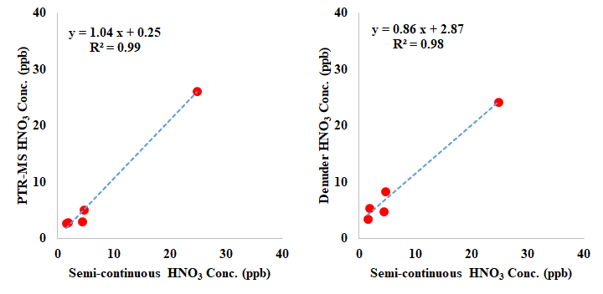

**Figure S2.** Comparison of correlations between measurement methods.

# References

1. Cheng, B.; Wang-Li, L. Responses of secondary inorganic PM2.5 to precursor gases in an ammonia abundant area in North Carolina. Aerosol Air Qual. Res. 2019, 19(5), 1126-1138. <https://doi.org/10.4209/aaqr.2018.10.0384>.
2. Huey, L. G.; Dunlea, E. J.; Lovejoy, E. R.; Hanson, D. R.; Norton, R. B.; Fehsenfeld, F. C.; Howard, C. J. Fast time response measurements of HNO3 in air with a chemical ionization mass spectrometer. J. Geophys. Res. Atmos. 1998, 103(D3), 3355-3360. <https://doi.org/10.1029/97jd02214>.
3. Liakakou, E.; Fourtziou, L.; Paraskevopoulou, D.; Speyer, O.; Lianou, M.; Grivas, G.; Myriokefalitakis, S.; Mihalopoulos, N. High-Resolution Measurements of SO2, HNO3 and HCl at the Urban Environment of Athens, Greece: Levels, Variability and Gas to Particle Partitioning. Atmosphere 2022, 13(2), 218. <https://doi.org/10.3390/atmos13020218>.
4. Hwang, J.; Kim, K., Park, T.; Kang, S.; Ban, J.; Song, J.; Park, I.; Lee, T. Development of Semi-continuous Monitoring Techniques for Atmospheric HNO3. AGU Fall Meeting, Chicago, USA, 16/12/2022.
5. Hwang, J.; Kim, K.; Park, T.; Kang, S.; Ban, J.; Song, J.; Park, I.; Lee, T. Development of Semi-continuous Monitoring Techniques for Atmospheric HNO3. J. Korean Soc. Atmos. Environ. 2023, 39(2), 265-277. <https://doi.org/10.5572/kosae.2023.39.2.265>.
6. Park, S. S.; Lee, M. H.; Lee, T. H.; Lee, J. Y.; Jung, C. H.; Yu, G. H.; Son, S. C.; Ju, S. R.; Park, T. U.; Sung, B. C.; Park, G. T.; Park, T. H.; Kang, S. W.; Ban, J. H.; Kim, K. H.; Choi, S. Y.; Park, M. H.; Lee, A. R.; Gil, J. S.; Kang, S. G. Investigation on the formation processes of secondary inorganic species in Seoul and Gwangju1 - Focusing on sulfate, nitrate, and ammonium; National Institute of Environmental Research (NIER): Incheon, Korea, 2021.
7. Lee, T. H.; Lee, M. H.; Park, S. S.; Lee, J. Y.; Jung, C. H.; Park, G. T.; Park, T. H.; Yu, G. H.; Kim, J. Y.; Kim, N. G.; Lee, H. M.; Lee, Y. H.; Kang, S. W.; Kim, K. H.; Ban, J. H.; Choi, S. Y.; Song, J. I.; Son, S. C.; Park, T. U.; Gil, J. S. Investigation on the formation processes of secondary inorganic species in Seoul and Gwangju2 - Focusing on sulfate, nitrate, and ammonium; National Institute of Environmental Research (NIER): Incheon, Korea, 2022.
8. Picarro, USA. <https://www.picarro.com> (17/8/2023).