Supplementary material
Fungal Methane Production Under High Hydrostatic Pressure in Deep Subseafloor Sediments

Mengshi Zhaoª, Dongxu Li ª, Jie Liu^{b}, Jiasong Fang^{bc}*, Changhong Liu ^{a,}*
ªState Key Laboratory of Pharmaceutical Biotechnology, Nanjing University, Nanjing 210023, China
^{b}Shanghai Engineering Research Center of Hadal Science and Technology, College of Marine Sciences, Shanghai Ocean University, Shanghai 201306, PR China
^{c}Laboratory for Marine Biology and Biotechnology, Qingdao National Laboratory for Marine Science and Technology, Qingdao 266237, China
∗Correspondence:
Jiasong Fang
jsfang@shou.edu.cn
Changhong Liu
chliu@nju.edu.cn

Table S1. Transcriptome quality control analysis
Sample_ID | Raw_reads | Raw_bases | Clean_reads | Clean_Bases | Q20% | Q30%
d1_01M1 | 61225688 | 9245078888 | 59924560 | 8923556763 | 98.59 | 95.67
d1_01M2 | 57660352 | 8706713152 | 57093920 | 8492669667 | 98.63 | 95.76
d1_01M3 | 78692462 | 11882561762 | 77966734 | 11574682555 | 98.72 | 96.03
d1_15M1 | 58292626 | 8802186526 | 57372462 | 8546726611 | 98.41 | 95.32
d1_15M2 | 57596182 | 8697023482 | 57148878 | 8523100243 | 98.38 | 95.23
d1_15M3 | 65583050 | 9903040550 | 64891218 | 9628476854 | 98.4 | 95.33
d1_35M1 | 62930370 | 9502485870 | 62248622 | 9273294662 | 98.38 | 95.28
d1_35M2 | 50448150 | 7617670650 | 49998534 | 7475352356 | 98.3 | 95.02
d1_35M3 | 49151190 | 7421829690 | 48754856 | 7270718571 | 98.46 | 95.42
d3_01M1 | 50533726 | 7630592626 | 48120520 | 7154045635 | 98.48 | 95.36
d3_01M2 | 57806778 | 8728823478 | 55059002 | 8197060519 | 98.6 | 95.7
d3_01M3 | 57385564 | 8665220164 | 56966126 | 8507516649 | 98.71 | 95.98
d3_15M1 | 61646368 | 9308601568 | 61022202 | 9085820646 | 98.47 | 95.54
d3_15M2 | 65798042 | 9935504342 | 65238428 | 9738132671 | 98.39 | 95.29
d3_15M3 | 56952974 | 8599899074 | 56250886 | 8366846120 | 98.46 | 95.49
d3_35M1 | 61443184 | 9277920784 | 60730442 | 9069017317 | 98.4 | 95.34
d3_35M2 | 47487154 | 7170560254 | 46292670 | 6938107353 | 98.36 | 95.23
d3_35M3 | 47088886 | 7110421786 | 46439164 | 6913881206 | 98.39 | 95.33
d5_01M1 | 57971786 | 8753739686 | 57444428 | 8573357523 | 98.74 | 96.03
d5_01M2 | 46008078 | 6947219778 | 45531714 | 6851055859 | 98.58 | 95.59
d5_01M3 | 52839130 | 7978708630 | 52454630 | 7886413231 | 98.78 | 96.16
d5_15M1 | 61865750 | 9341728250 | 61253746 | 9122127602 | 98.42 | 95.33
d5_15M2 | 50901704 | 7686157304 | 50333004 | 7484406434 | 98.51 | 95.6
d5_15M3 | 49558750 | 7483371250 | 49052310 | 7267314405 | 98.51 | 95.66
d5_35M1 | 44510344 | 6721061944 | 43941122 | 6551168123 | 98.5 | 95.58
d5_35M2 | 43622492 | 6586996292 | 43113272 | 6448029277 | 98.56 | 95.7
d5_35M3 | 49276522 | 7440754822 | 48618848 | 7253078402 | 98.52 | 95.66

Note: d1_01, d3_01, d5_01 respectively represent strains grown at 0.1MPa for one, three and five days ; d1_15, d3_15, d5_15 respectively represent strains grown at 15 MPa for one, three and five days;d1_35, d3_35, d5_35 respectively represent strains grown at 35 MPa for one, three and five days;Q20: The percentage of bases in clean reads with a Phred value >20; Q30: The percentage of bases in clean reads with a Phred value >30.

Table S2. qRT-PCR primers

Primer ID | Sequence (5'-3')
mct1-F | ATTCCTGGGATATTGCATGG
mct1-R | GTCGAATATGCGAGTTAGCTC
mct2-F | CTCCGGGACCAGAGACAGTT
mct2-R | AGCCAGGGGTGATGTTCTTG
dh1-F | GAATCTCGCCGCTACCAACT
dh1-R | GACGAGAACGCTGATCCAGTA
dh2-F | GTTGGCCGGACTCAACACTA
dh2-R | GTTCACCAACAAGCGCACAT
dh3-F | TCACTCCCCAGCCCAACC
dh3-R | GCTTGTCCGTCTCGCCG
dh4-F | GGCGGCACCAAATCGAATAC
dh4-R | TTGTACCAGTTGAGCGGACC
dh5-F | TTCCAGAAGGGCGGTCTGA
dh5-R | GGCTTCGTGACTTTGAGGGT
ms-F | CATCCCCAGCGGTGATTTCT
ms-R | GGCCCATCGCAAAGTAGACA
act-F | GTCCGCCCTCGAGAAGAGTTA
act-R | TTGTACGTCGTCTCGTGGATA

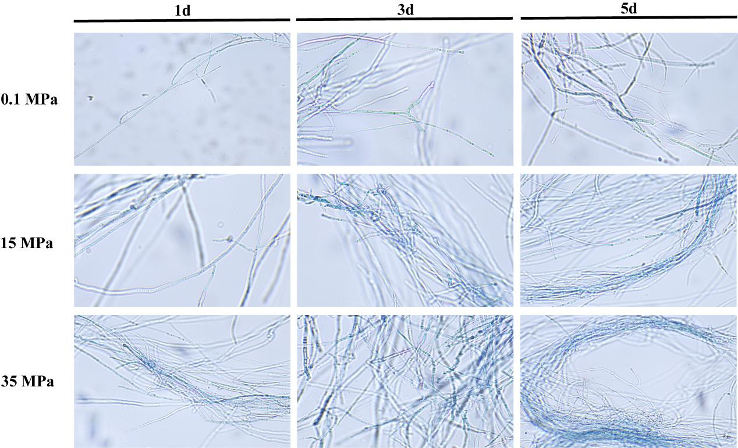
Figure S1. S. commune 20R-7-F01 cell activity under high hydrostatic pressure

Table S3. Intracellular O²⁻ and OH· levels of S. commune 20R-7-F01 under different stress conditions
 | O²⁻ ( μmol/g ) |  |  | OH· ( μmol/g )
 | 0.1MPa | 15MPa | 35MPa | 0.1MPa | 15MPa | 35MPa
1d | 0.21 ± 0.01 | 0.24 ± 0.02 | 0.34 ± 0.03 | 0.13±0.01 | 0.19±0.02 | 0.13±0.01
3d | 0.33 ± 0.05 | 0.26 ± 0.01 | 0.37 ± 0.01 | 0.16±0.02 | 0.16±0.03 | 0.14±0.03
5d | 0.25 ± 0.01 | 0.31 ± 0.01 | 0.35 ± 0.02 | 0.17±0.03 | 0.21±0.02 | 0.25±0.04

Table S4. Intracellular ROS levels of S. commune 20R-7-F01 under different stress conditions
 | CdCl₂ |  |  | H₂O₂
 | 0.75mM | 1.5mM | 3mM | 0.75mM | 1.5mM | 3mM
1d | 1.13 ± 0.21 | 2.31 ± 0.52 | 2.92 ± 0.55 | 1.81 ± 0.31 | 2.54 ± 0.46 | 3.17 ± 0.65
3d | 2.23 ± 0.18 | 4.78 ± 0.27 | 5.42 ± 0.46 | 2.74 ± 0.25 | 5.23 ± 0.60 | 7.12 ± 0.33
5d | 3.99 ± 0.16 | 6.82 ± 0.37 | 8.15 ± 0.32 | 4.95 ± 0.45 | 8.65 ± 0.61 | 10.29 ± 0.47

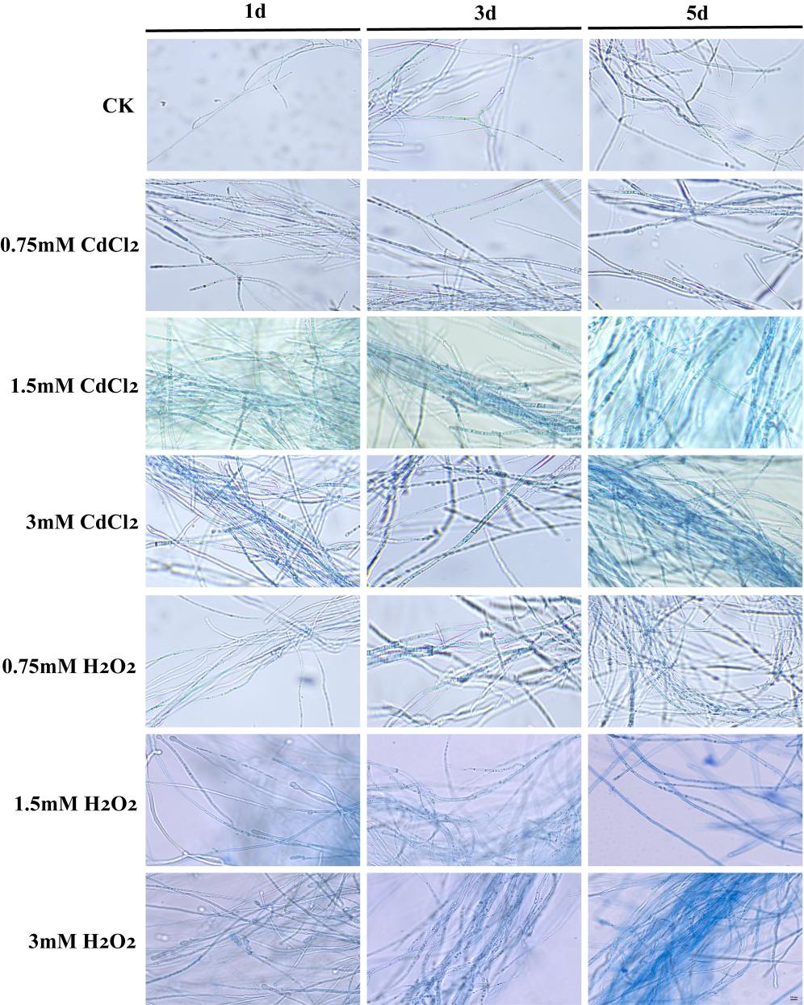
Figure S2. S. commune 20R-7-F01 cell activity under different stress conditions

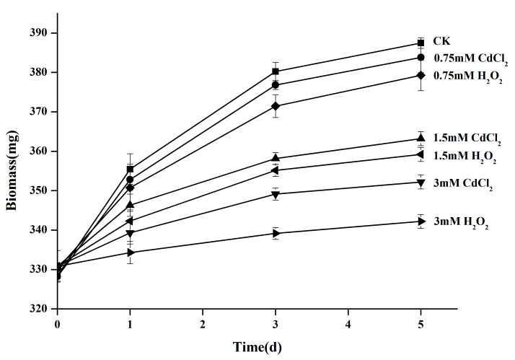
Figure S3. Alterations in the biomass of S. commune 20R-7-F01 under varying stress conditions.

