Supplementary Figures

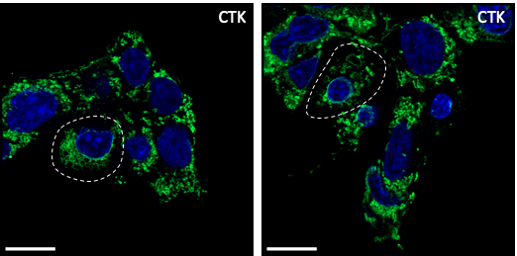

Fig. S1 Airyscan imaging of OSER structures. Representative images of the OSER structures of ER in INS1-E cells treated with cytokines (Il-1β and IFN-γ) for 24h. Scale bar indicates 10 µm.

