Supplementary Materials
Simulink Model
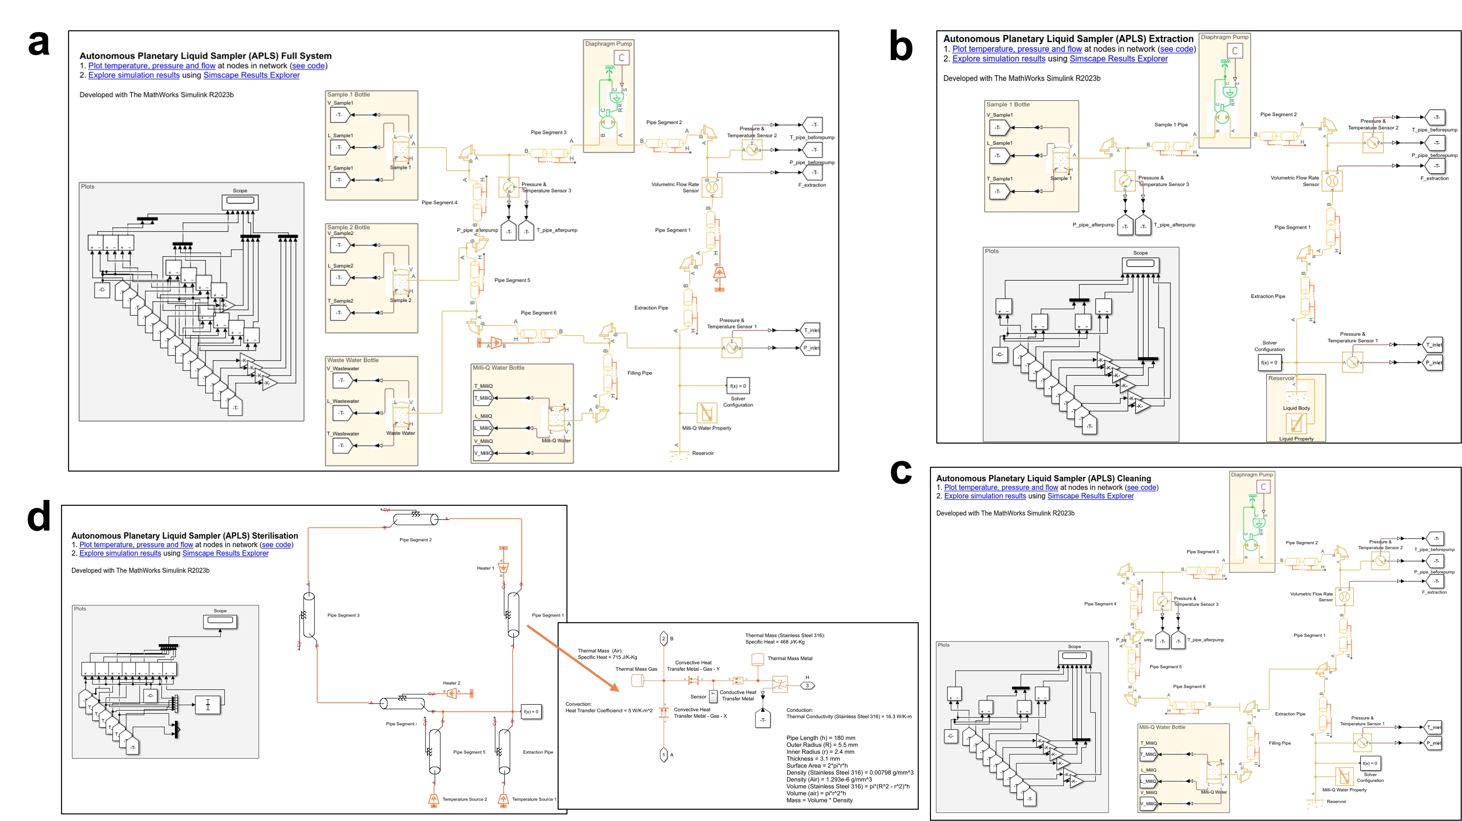 Figure S1. APLS Simulink models of the (a) full system, (b) extraction, (c) cleaning, and (d) sterilisation with thermal circuit of the pipe at inset

Comparison of extraction procedure between experiment and simulation
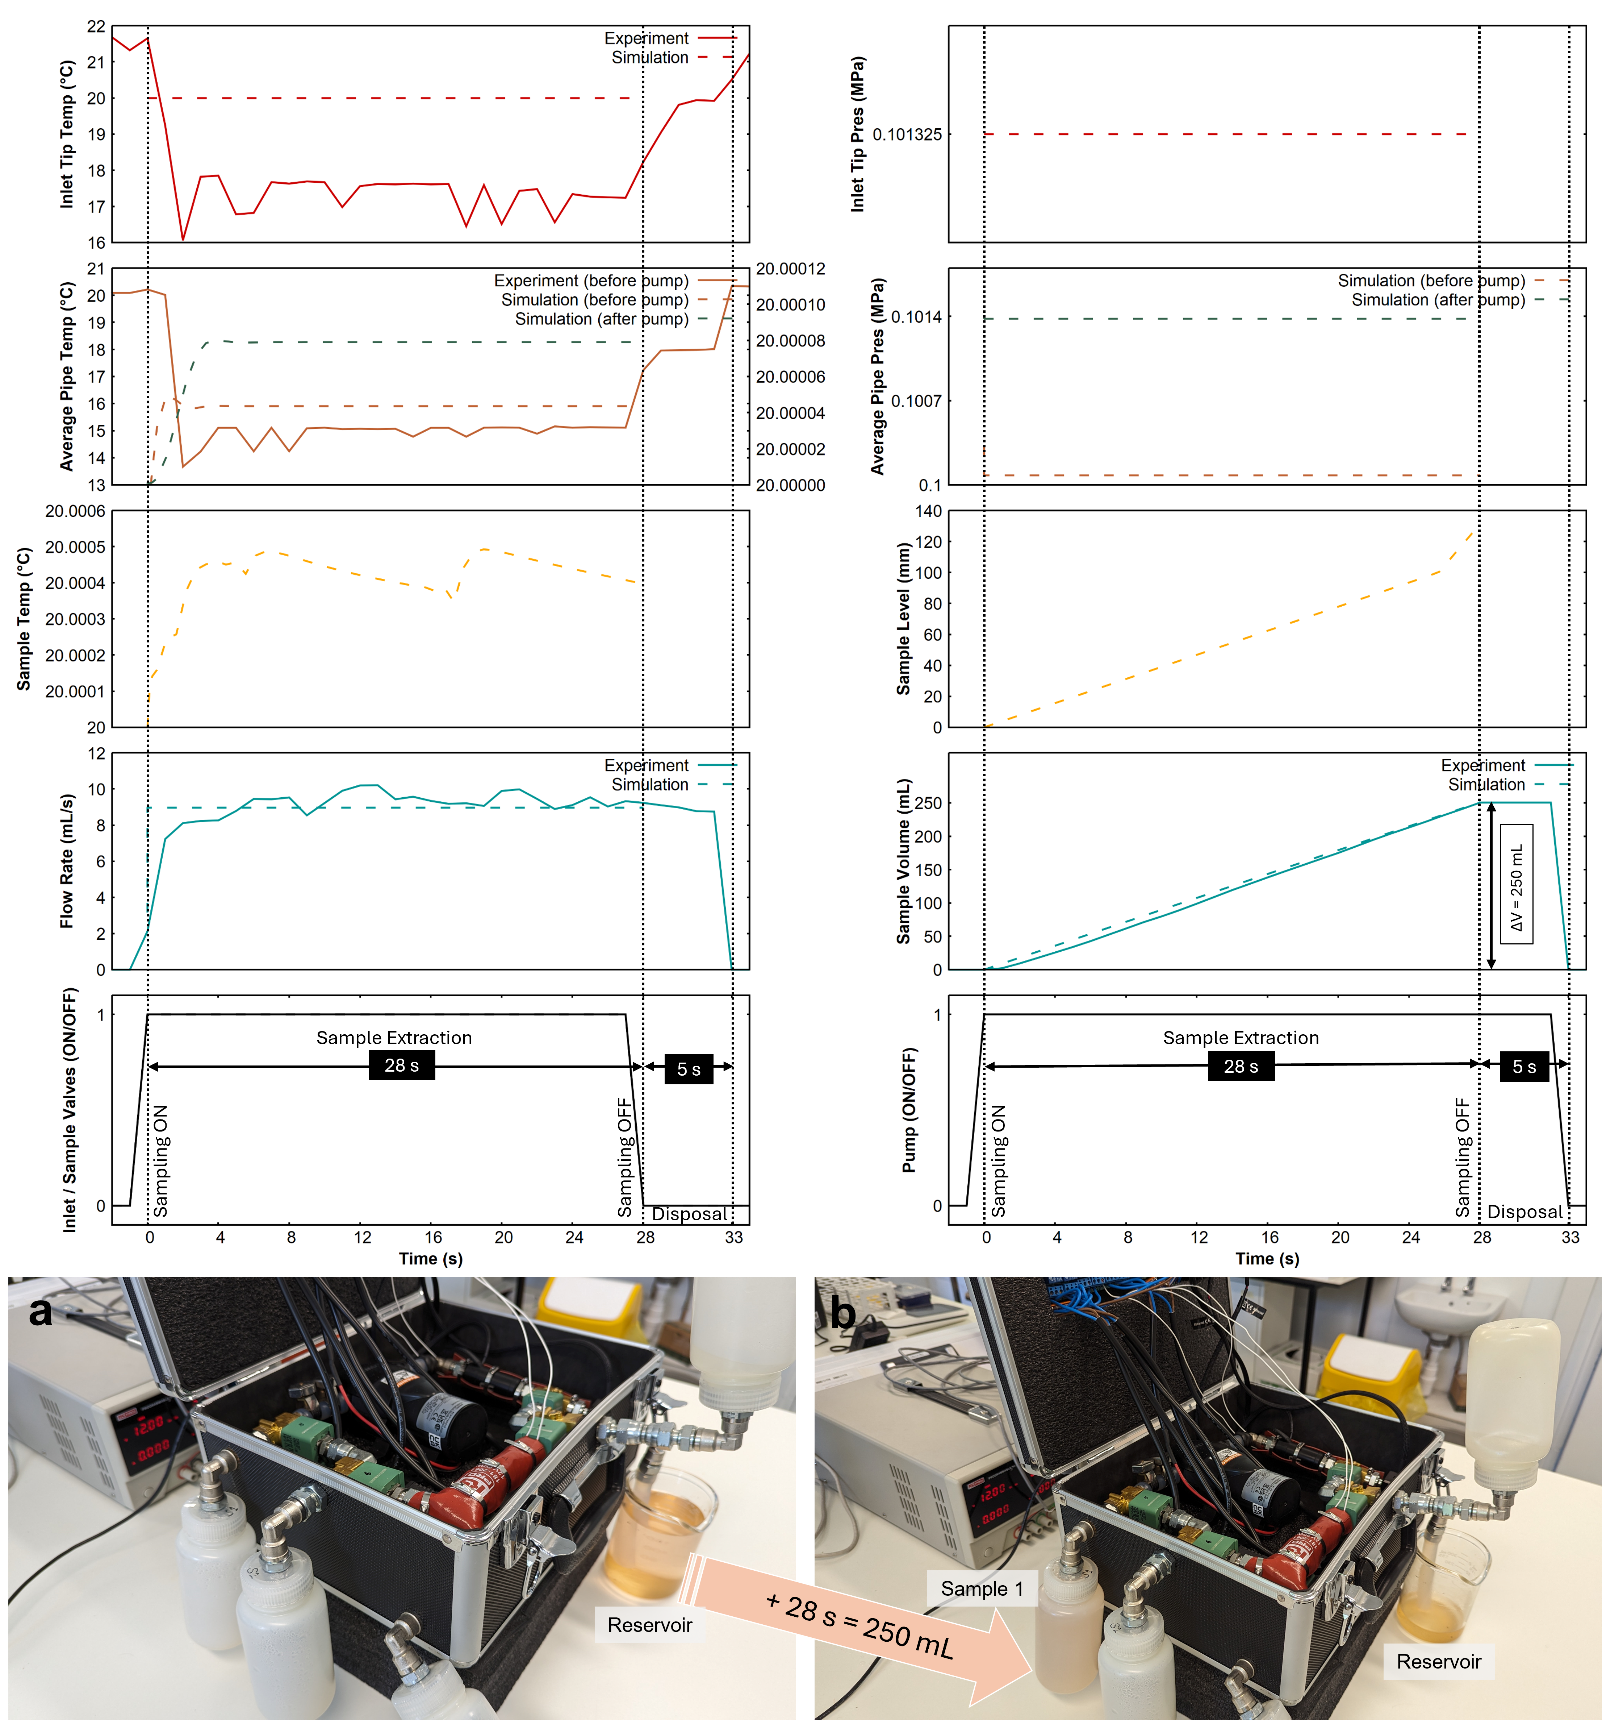 Figure S2. Sample extraction of 250 mL at 8.946 mL/s water at ambient laboratory conditions. Plots of inlet tip temperature, average pipe temperature, flow rate, volume and statuses of inlet and sample valves, pump are shown. The experimental results are shown as solid lines and simulation as dashed lines (measurements are in right y-axis for some subplots). The model predicted a maximum flow rate of 8.958 mL/s to achieve an extraction volume of 250.8 mL in 28 s at ambient laboratory conditions with 20 °C liquid temperature. (a) Before sample extraction from the reservoir glass beaker, (b) after sample 1 extracted in 28 s.
Figure S2 also shows the extraction performance of the APLS as predicted by the model. The pump was tuned to match the liquid output as that of the prototype and yielded a maximum flow rate of 8.958 mL/s. The model assumes stable flow rates, so for most of the extraction time, the flow rate was the same. Just at the start of the pump operation, the system experienced a backflow which is nominal if the system pressure is higher than the liquid body pressure. But this can be arrested by using a check valve depending on the desirable direction of flow.
Comparison of cleaning procedure between experiment and simulation
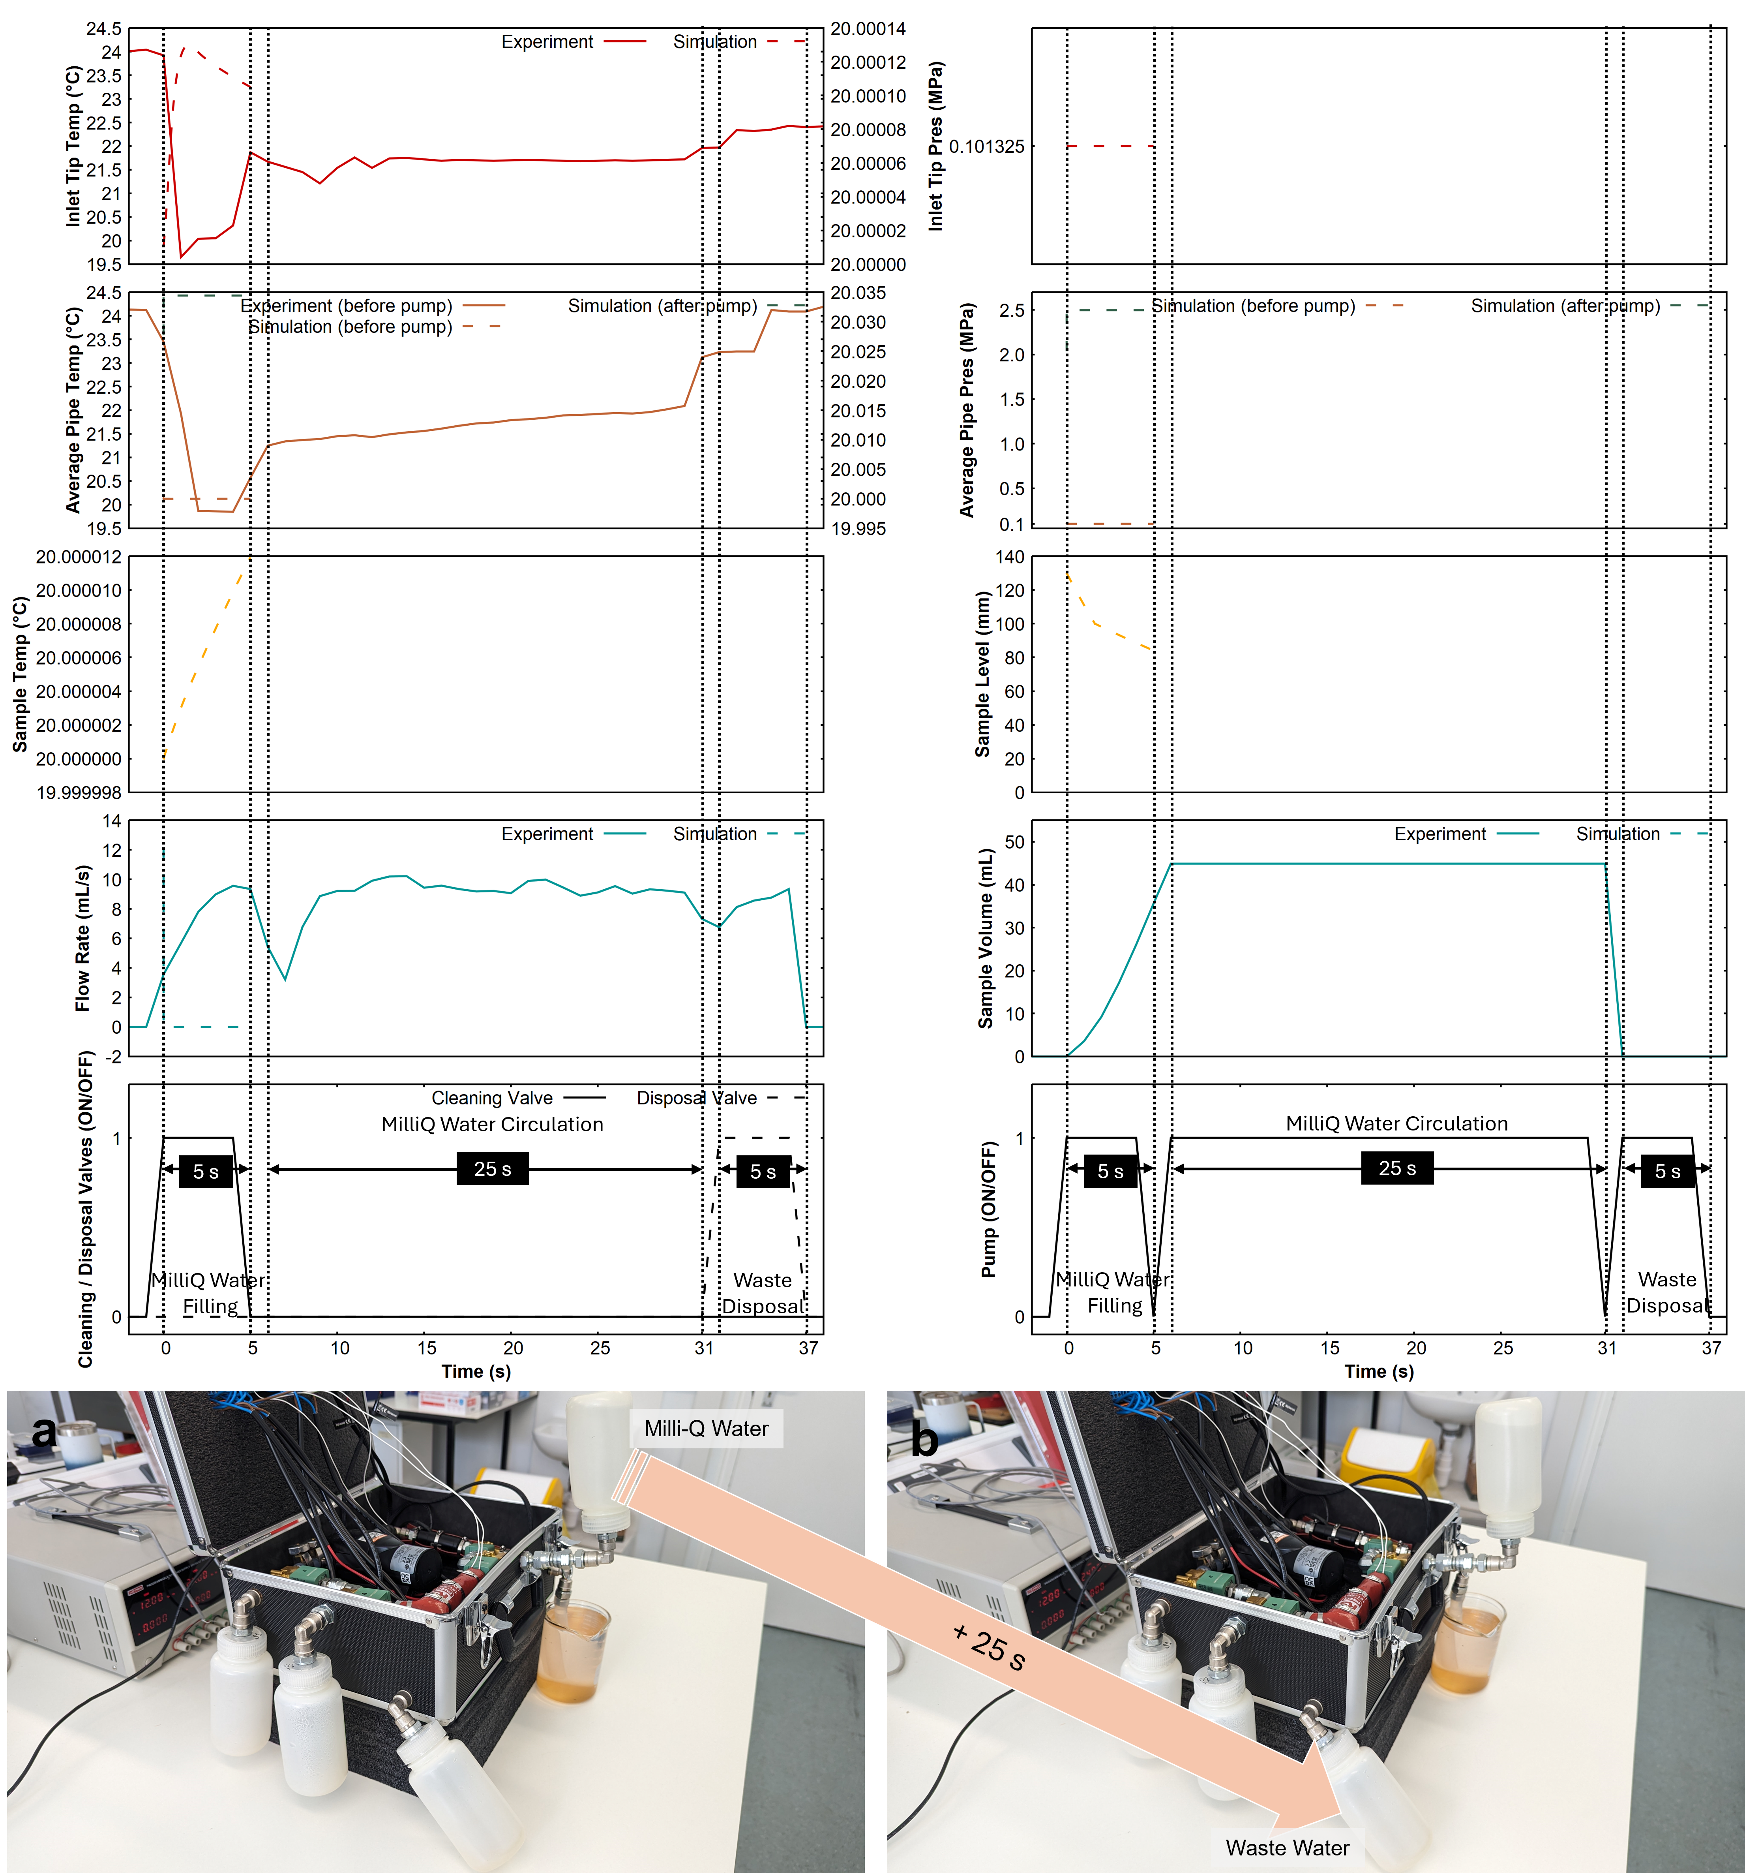 Figure S3. Cleaning procedure with MilliQ water at ambient laboratory conditions with 20 °C liquid temperature. Plots of inlet tip temperature and pressure, average pipe temperature and pressure (before and after pump), flow rate, MilliQ Water temperature, liquid level, and volume are shown. About 44.73 mL MilliQ water was extracted into the system (5 s pump operation) and circulated for 25 s for cleaning and disposed into the wastewater bottle. The model predicts 56.59 mL MilliQ water was extracted into the system during the 5 s pump operation. The experimental results are shown as solid lines and simulation as dashed lines (measurements are in right y-axis for some subplots).
Figure S3 also shows the cleaning liquid filling performance of the APLS as predicted by the model. For the given pump flow rate (8.958 mL/s), the model predicts that 56.59 mL of MilliQ water would be filled in the system, if the pump was run for 5 s. This is still within the safe limits since the total internal volume of the pipes is 65.814 mL. Note that, the initial burst in the flow rate is due to the elevation difference of the MilliQ water bottle which was set to be at 13 cm higher than the pump to allow gravity assisted feed.
Comparison of sterilisation procedure between experiment and simulation
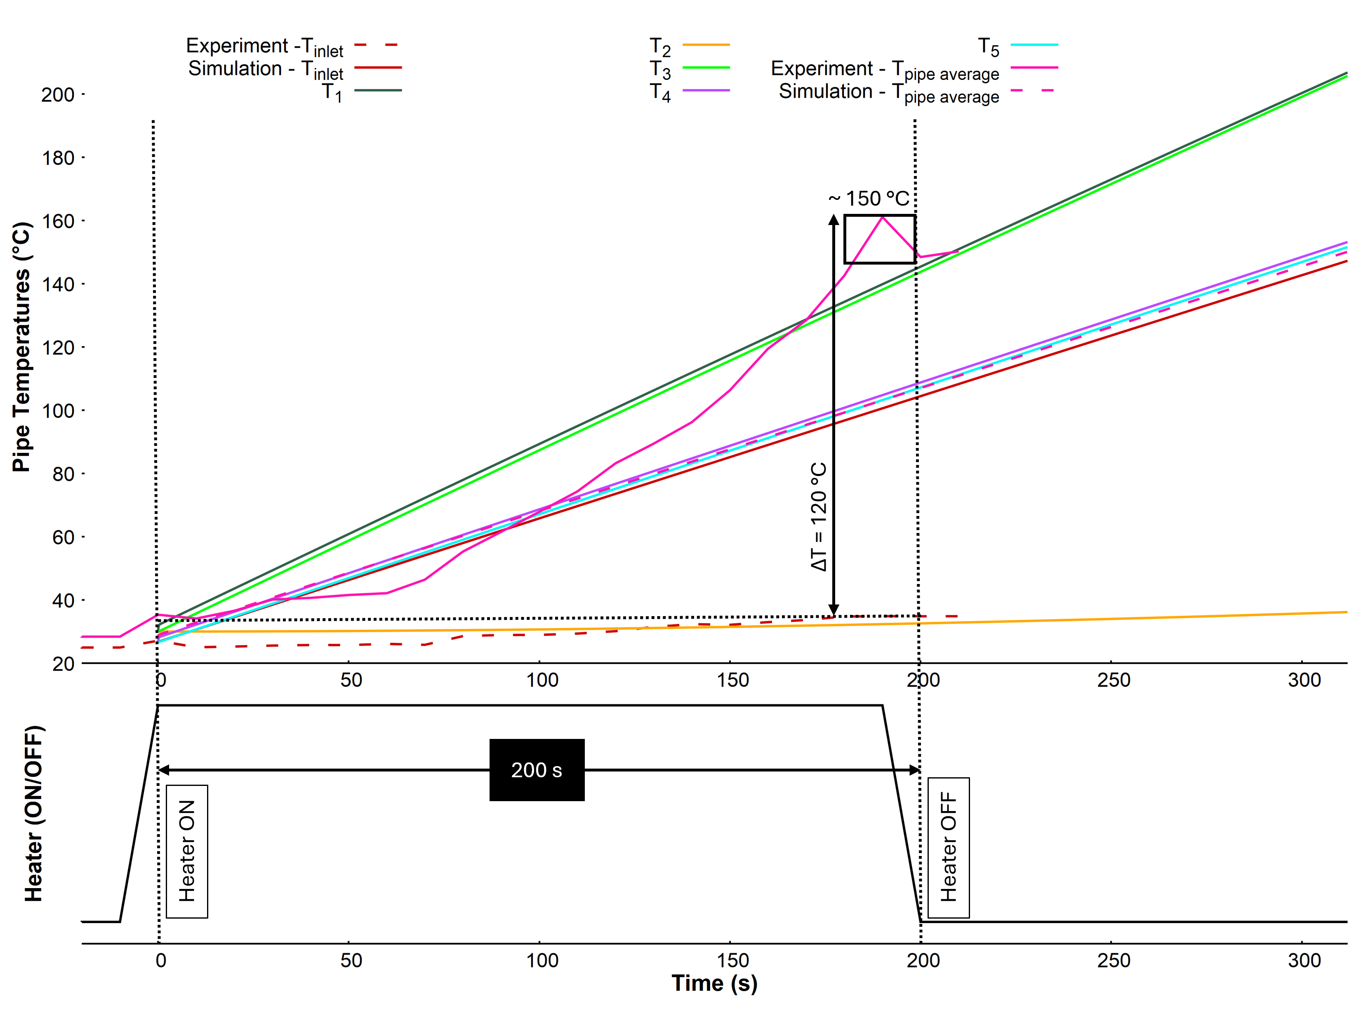 Figure S4. Inlet tip temperature (T_{inlet}), average pipe temperature (T_{pipe average}) during the 200 s heating cycle demonstrating a steady increase in the average pipe temperature to ~150 °C in ambient laboratory conditions (ΔT = ~120 °C). Model predicted inlet tip temperature, temperatures of pipe segments 1, 2, 3, 4, 5 (T₁, T₂, T₃, T₄, T₅) and the average pipe temperature are also shown. The model predicted a 312 s heating demonstrating a steady increase in the average pipe temperature to 150.1 °C in ambient laboratory conditions (ΔT = ~120 °C). The experimental results are shown as solid lines and simulation as dashed lines.
Figure S4 also shows the main difference in the performance of the model in comparison to the prototype. Since the current prototype does not have inbuilt temperature sensors at various parts of the pipe, achieving a reliable average temperature was difficult. But the model results show the thermal discrepancies throughout the system to help devise a method to achieve the average temperature that must comply with the ECSS standards for DHMR procedure. Typically, the temperatures of the parts closest to the heat source was higher than the rest of the system. Also, the material properties of different parts of the pipes influenced the heat distribution. Due to this, the model overinterpreted the thermal distribution of the system that resulted in 312 s for achieving an average temperature of 150.1 °C in comparison to 200 s with the prototype.
Electronics Circuit Schematic
The schematic for electronics circuit and subsequent data push request to InfluxDB Cloud data bucket and visualisation using Grafana is shown in Figure S5. The connection between the relay terminals to the pump/valves/heater can be done as shown. Except the pump (Relay 3) and the heater mats (Relay 4) which operate with a 12 V DC source, all the valves are connected to the 24 V DC source (Relays 2, 5, 6, 7 and 8). The digital outputs from ESP32S3 are used to send the HIGH/LOW signal to the 8-Channel Relay module and the analog outputs from the 10 K NTC Thermistor (T) and the Hall effect flow sensor (F) are connected as analog inputs. The ESP32S3 does the job of connecting to the WiFi and pushing the data into the desired InfluxDB Cloud data bucket. Note that the data bucket and access token must be created beforehand. Once the data is in the bucket, they can be verified using the inbuilt “SQL Synx” option. Post this, a visualisation dashboard can be created in Grafana by selecting the specified data bucket as the data source.
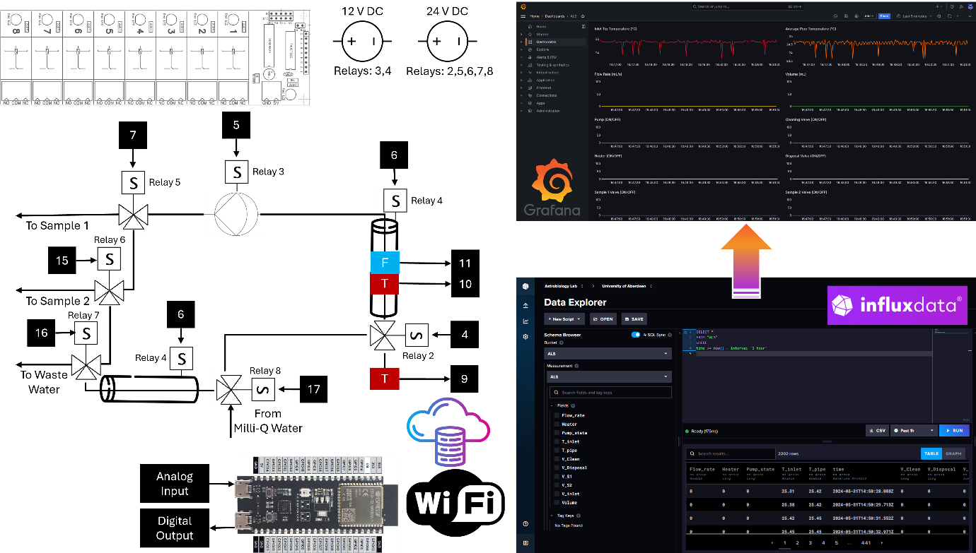
Figure S5. Electronics Circuit Schematic of the APLS proof-of-concept prototype
Source Code
All the source code for uploading to the ESP32S3 developed board and Simulink model and results can be found at https://github.com/miracleisraelnazarious/APLS.
Grafana Plot Query
The below script in Figure S6 was used to visualise the data from the InfluxDB Cloud data bucket named “ALS”. Note that, this script must be used individually for each visualisation window by changing the “VARIABLE_NAME” to be displayed. The user can choose to aggregate the data points in the field mentioned “XXX” with a time parameter. E.g., 1s (second), 1m (minute), 1h (hour), 1d (day), etc.
from(bucket: "ALS") // ── Source
|> range(start: -1h) // ── Filter on time
|> filter(fn: (r) => r._field == "VARIABLE_NAME") // ── Filter on variable
// |> aggregateWindow(every: “XXX”, fn: mean) // ── Averaged values
Figure S6. Sample Grafana plot query

