Complete Genome Sequence of the Butirosin-producing Bacillus vitellinus NBRC 13296 and its reclassification to Paenibacillus chitinolyticus
Kyung-A Hyun, Seung-Young Kim, Kyung-Hwan Boo, Won-Jae Chi and Chang-Gu Hyun
* Correspondence: wjchi76@korea.kr and cghyun@jejunu.ac.kr; Tel.: +82-64-754-3900

Supplementary Materials
Table S1. Comparison of 16S rRNA genes in B. vitellinus NBRC 13296 and Type strains of the genus Paenibacillus 1
Table S2. Putative gene clusters coding for secondary metabolites in B. vitellinus NBRC 13296 derived using BAGEL 4.0. 3
Table S3. Putative genetic organization of contig1.0.AOI_02 derived using BAGEL 4.0. and BLASTP packages 4
Table S4. Putative gene clusters coding for secondary metabolites in B. vitellinus NBRC 13296 derived using PRISM 4.4.5. 5
Table S5. Genetic organization and sequence homology of butirosin BGCs derived from B. vitellinus NBRC 13296 and N. circulans ATCC 21558 6
Figure S1. Maximum-likelihood phylogenetic tree based on the complete 16S rRNA gene sequence, extracted from the assembled genome 8
Figure S2. Distribution of secondary metabolite gene clusters (1–18) in B. vitellinus NBRC 13296 as predicted by the antiSMASH package 9
Figure S3. Genetic organization of BGC region 15 as predicted by the antiSMASH package 10

Table S1. Comparison of 16S rRNA genes in B. vitellinus NBRC 13296 and Type strains of the genus Paenibacillus.
Accession | Description | Total Score | Query Cover | Per. Ident
NR_040854.1 | P. chitinolyticus HSCC 596 16S ribosomal RNA | 2717 | 95% | 99.66%
NR_043219.1 | P. gansuensis B518 16S ribosomal RNA | 2435 | 97% | 95.71%
NR_173496.1 | P. lutrae N10 16S ribosomal RNA | 2431 | 97% | 95.60%
NR_029071.1 | P. favisporus GMP01 16S ribosomal RNA | 2422 | 99% | 94.96%
NR_148738.1 | P. yonginensis DCY84 16S ribosomal RNA | 2410 | 100% | 94.68%
NR_117730.2 | P. polymyxa DSM 36 16S ribosomal RNA | 2401 | 99% | 94.71%
NR_043166.1 | P. rhizosphaerae CECAP06 16S ribosomal RNA | 2399 | 99% | 94.71%
NR_178528.1 | P. swuensis DY6 16S ribosomal RNA | 2388 | 95% | 95.52%
NR_136854.1 | P. wulumuqiensis Y24 16S ribosomal RNA | 2370 | 97% | 94.97%
NR_029109.1 | P. xylanilyticus XIL14 16S ribosomal RNA | 2366 | 99% | 94.32%
NR_114621.1 | P. turicensis MOL722 16S ribosomal RNA | 2364 | 99% | 94.28%
NR_117012.1 | P. uliginis N3/975 16S ribosomal RNA | 2364 | 97% | 94.90%
NR_117742.1 | P. peoriae KCTC 3763 16S ribosomal RNA | 2362 | 99% | 94.38%
NR_148890.1 | P. bovis BD3526 16S ribosomal RNA | 2361 | 100% | 94.09%
NR_040890.1 | P. apiarius DSM 5581 16S ribosomal RNA | 2361 | 98% | 94.48%
NR_116789.1 | P. tianmuensis B27 16S ribosomal RNA | 2357 | 99% | 94.32%
NR_122065.1 | P. sabinae T27 16S ribosomal RNA | 2353 | 99% | 94.10%
NR_180160.1 | P. nuruki TI45-13ar 16S ribosomal RNA | 2350 | 100% | 93.97%
NR_165675.1 | P. lutimineralis MBLB1234 16S ribosomal RNA | 2348 | 100% | 93.98%
NR_133806.1 | P. relictisesami KB0549 16S ribosomal RNA | 2348 | 97% | 94.66%
NR_040892.1 | P. validus JCM 9077 16S ribosomal RNA | 2346 | 96% | 95.00%
NR_178645.1 | P. enshidis RP-207 16S ribosomal RNA | 2344 | 99% | 94.07%
NR_115664.1 | P. aquaticus GPTSA 19 16S ribosomal RNA | 2344 | 95% | 95.24%
NR_041929.1 | P. mendelii C/2 16S ribosomal RNA | 2344 | 99% | 94.12%
NR_025391.1 | P. azoreducens CM1 16S ribosomal RNA | 2344 | 96% | 94.87%
NR_112054.1 | P. ehimensis IFO 15659 16S ribosomal RNA | 2338 | 97% | 94.47%
NR_181067.1 | P. rhizovicinus 14171R-81 16S ribosomal RNA | 2337 | 100% | 93.91%
NR_180424.1 | P. protaetiae FW100M-2 16S ribosomal RNA | 2337 | 100% | 93.83%
NR_118573.1 | P. lentus CMG1240 16S ribosomal RNA | 2337 | 99% | 94.00%
NR_042189.1 | P. cineris LMG 18439 16S ribosomal RNA | 2337 | 96% | 94.63%
NR_132304.1 | P. profundus Sl 79 16S ribosomal RNA | 2337 | 97% | 94.50%
NR_179441.1 | P. phocaensis mt24 16S ribosomal RNA | 2333 | 97% | 94.36%
NR_028817.1 | P. naphthalenovorans PR-N1 16S ribosomal RNA | 2333 | 99% | 93.95%
NR_178252.1 | P. lemnae L7-75 16S ribosomal RNA | 2331 | 96% | 94.57%
NR_040884.1 | P. illinoisensis JCM 9907 16S ribosomal RNA | 2331 | 96% | 94.62%
NR_042009.1 | P. jamilae CECT 5266 16S ribosomal RNA | 2329 | 98% | 93.91%
NR_025024.1 | P. chinjuensis WN9 16S ribosomal RNA | 2329 | 97% | 94.78%
NR_134783.2 | P. nicotianae YIM h-19 16S ribosomal RNA | 2326 | 99% | 93.87%
NR_040886.1 | P. macerans IAM 12467 16S ribosomal RNA | 2324 | 96% | 94.51%
NR_025299.1 | P. borealis KK19 16S ribosomal RNA | 2324 | 98% | 93.91%
NR_137363.1 | P. physcomitrellae XB 16S ribosomal RNA | 2322 | 97% | 94.29%
NR_169361.1 | P. dakarensis FF9 16S ribosomal RNA | 2320 | 97% | 94.29%
NR_147741.1 | P. terreus D33 16S ribosomal RNA | 2320 | 97% | 94.28%
NR_151978.1 | P. aceti L14 16S ribosomal RNA | 2316 | 97% | 94.27%
NR_145625.1 | P. yunnanensis YN2 16S ribosomal RNA | 2316 | 99% | 93.87%
NR_040885.1 | P. chibensis JCM 9905 16S ribosomal RNA | 2316 | 96% | 94.23%
NR_179515.1 | P. tuaregi Marseille-P2472 16S ribosomal RNA | 2314 | 97% | 94.09%
NR_144710.1 | P. antibioticophila GD11 16S ribosomal RNA | 2314 | 97% | 94.39%
NR_179433.1 | P. rubinfantis MT18 16S ribosomal RNA | 2313 | 97% | 94.22%
NR_112162.1 | P. campinasensis JCM 11200 16S ribosomal RNA | 2313 | 96% | 94.37%
NR_041380.1 | P. anaericanus Gsoil 1638 16S ribosomal RNA | 2313 | 96% | 94.60%

Table S2. Putative gene clusters coding for secondary metabolites in B. vitellinus NBRC 13296 derived using BAGEL 4.0.
AOI | Class | Start | End
Contig1.0.AOI_01 | LAPs | 333668 | 354376
Contig1.0.AOI_02 | Sactipeptides | 5883692 | 5903692

Table S3. Putative genetic organization of contig1.0.AOI_02 derived using BAGEL 4.0. and BLASTP packages.
ORFs | Putative Functions of contig1.0.AOI_02
5332 | Carbon-nitrogen hydrolase family protein
5333 | Class I SAM-dependent methyltransferase
5334 | MerR family transcriptional regulator
5335 | MFS transporter
5336 | UDP-glucose--hexose-1-phosphate uridylyltransferase
5337 | UDP-glucose 4-epimerase GalE
5338 | Galactokinase
5339 | AraC family transcriptional regulator
5340 | Prolipoprotein diacylglyceryl transferase
5341 | Radical SAM protein
5342 | Hypothetical protein
5343 | Hypothetical protein
5344 | Hypothetical protein
5345 | ABC transporter permease
5346 | ABC transporter permease
5347 | ABC transporter ATP-binding protein
5348 | BMP family ABC transporter substrate-binding protein
5349 | Threonine ammonia-lyase IlvA

Table S4. Putative gene clusters coding for secondary metabolites in B. vitellinus NBRC 13296 derived using PRISM 4.4.5.
Region | Type
Cluster 1 | Nonribosomal peptide
Cluster 2 | Unknown thiotemplated cluster type
Cluster 3 | Polyketide/nonribosomal peptide
Cluster 4 | Polyketide/nonribosomal peptide
Cluster 5 | Polyketide/nonribosomal peptide
Cluster 6 | Phosphonate
Cluster 7 | 2-Deoxy-streptamine derived aminoglycoside
Cluster 8 | Nonribosomal peptide
Cluster 9 | Nonribosomal peptide
Cluster 10 | Polyketide
Cluster 11 | Nonribosomal peptide

Table S5. Genetic organization and sequence homology of butirosin BGCs derived from B. vitellinus NBRC 13296 and N. circulans ATCC 21558.
B. vitellinus NBRC 13296 | Amino acids | Putative Function | N. circulans  ATCC 21558  Identity/Similarity (%)
ORF 3151 | 421 | RNA polymerase sigma factor | 88.73%/92.72%
ORF 3152 | 144 | YciI family protein | 90.97%/93.75%
ORF 3153 (BtrZ) | 279 | Alpha/beta hydrolase | 81.36%/89.25%
ORF 3154 (BtrY) | 422 | MFS transporter | 83.45%/90.54%
ORF 3155 (BtrX) | 673 | ABC transporter ATP-binding protein/permease | 87.24%/94.36%
ORF 3156 (BtrW) | 582 | ABC transporter transmembrane domain-containing protein | 85.67%/93.52%
ORF 3157 (BtrQ) | 504 | GMC family oxidoreductase | 92.87%/98.22%
ORF 3158 (BtrV) | 82 | 4-(gamma-L-glutamylamino)butanoyl-ACP monooxygenase  DUF6137 domain-containing protein | 80.23%/88.37%
ORF 3159 (BtrP) | 213 | 5''-Phosphoribostamycin phosphatase  Histidine phosphatase family protein | 82.16%/89.67%
ORF 3160 (BtrO) | 338 | 4-(gamma-L-glutamylamino)butanoyl-[BtrI acyl-carrier protein] monooxygenase  LLM class flavin-dependent oxidoreductase | 86.73%/91.74%
ORF 3161 (BtrK) | 428 | L-glutamyl-[BtrI acyl-carrier protein] decarboxylase  Type III PLP-dependent enzyme | 82.94%/92.06%
ORF 3162 (BtrJ) | 419 | [Butirosin acyl-carrier protein]--L-glutamate ligase  ATP-grasp domain-containing protein | 75.53%/85.75%
ORF 3163 (BtrI) | 87 | Acyl carrier protein | 87.36%/94.25%
ORF 3164 (BtrH) | 302 | Ribostamycin:4-(gamma-L-glutamylamino)-(S)-2-hydroxybutanoyl-[BtrI acyl-carrier protein] 4-(gamma-L-glutamylamino)-(S)-2-hydroxybutanoate transferase  BtrH N-terminal domain-containing protein | 74.03%/83.44%
ORF 3165 (BtrG) | 139 | Gamma-L-glutamyl-butirosin B gamma-glutamyl cyclotransferase  Branched-chain alpha-keto acid dehydrogenase | 76.60%/84.40%
ORF 3166 (BtrF) | 232 | Xylostasin dehydrogenase  SDR family oxidoreductase | 81.20%/89.74%
ORF 3167 (BtrE) | 349 | Ribostamycin dehydrogenase  Zinc-binding alcohol dehydrogenase | 92.29%/95.71%
ORF 3168 (BtrD) | 275 | 2'-N-acetylparomamine deacetylase  PIG-L family deacetylase | 77.70%/85.97%
ORF 3169 (btrC) | 368 | 2-deoxy-scyllo-inosose synthase | 90.54%/96.49%
ORF 3170 (BtrB) | 432 | Neamine transaminase  Aminotransferase class III-fold pyridoxal phosphate-dependent enzyme | 85.88%/94.68%
ORF 3171 (BtrA) | 1224 | Hypothetical protein | 77.80%/87.09%
ORF 3172 (BtrL) | 604 | Phosphoribostamycin synthase  Neamine phosphoribosyltransferase | 67.81%/82.19%
ORF 3173 (BtrM) | 412 | 2-Deoxystreptamine N-acetyl-D-glucosaminyltransferase  Glycosyltransferase family 4 protein | 91.75%/95.87%
ORF 3174 (BtrN) | 250 | S-adenosyl-L-methionine-dependent 2-deoxy-scyllo-inosamine dehydrogenase  SPASM domain-containing protein | 92.80%/98.00%
ORF 3175 (BtrS) | 418 | L-glutamine:2-deoxy-scyllo-inosose aminotransferase  DegT/DnrJ/EryC1/StrS family aminotransferase | 86.84%/94.26%
ORF 3176 (BtrT) | 56 | Hypothetical protein
ORF 3177 (BtrR2) | 353 | Suppressor of fused domain protein | 81.87%/89.80%
ORF 3178 (BtrU) | 205 | NAD(P)H-dependent oxidoreductase | 81.46%/87.32%
ORF 3179 (BtrR1) | 217 | TetR/AcrR family transcriptional regulaton | 84.02%/92.24%
ORF 3180 (BtrT2) | 334 | Iron-hydroxamate ABC transporter substrate-binding protein
ORF 3181 (BtrT3) | 181 | DUF6022 family protein | 78.69%/89.62%
ORF 3182 (BtrT4) | 188 | NADAR family protein | 82.45%/90.43%
ORF 3183 (BtrT5) | 296 | NUDIX hydrolase
ORF 3184 (BtrT6) | 194 | YdeI/OmpD-associated family protein
ORF 3185 (BtrT7) | 188 | UbiX family flavin prenyltransferase
ORF 3186 | 497 | UbiD family decarboxylase

Figure S1
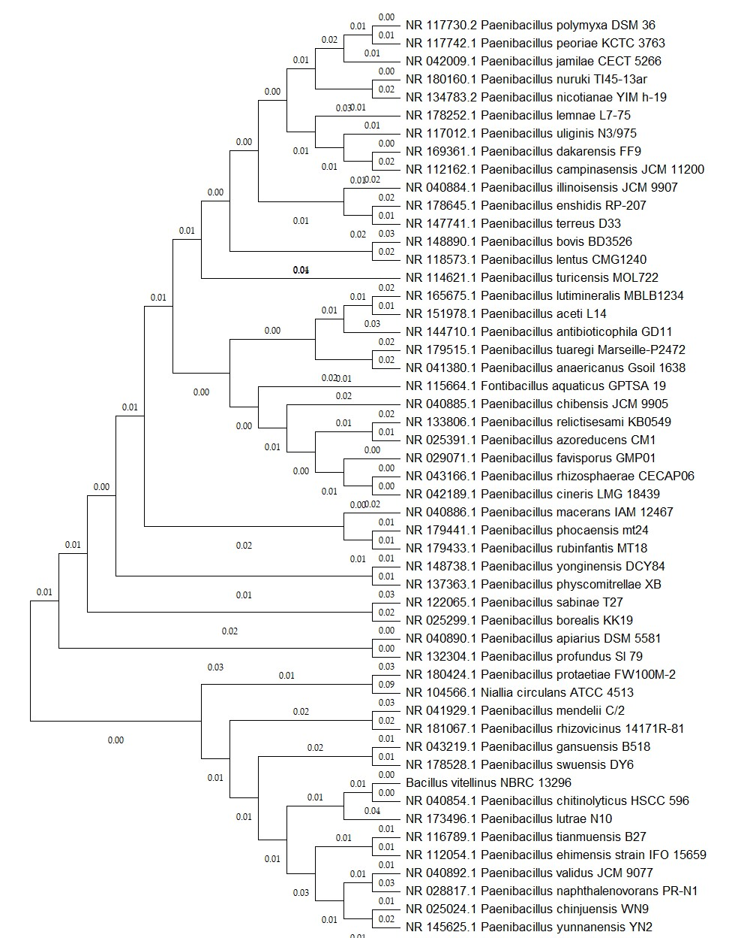
Figure S1. Phylogenetic tree constructed using Maximum-likelihood methods based on the complete 16S rRNA gene sequence, extracted from the assembled genome. The relationship among closely related species of Type cultures from the genus Paenibacillus are illustrated. The percentage of replicate trees in which the associated taxa clustered together in the bootstrap test (1000 replicates) is shown next to the branches in decimal form. The analysis, performed using MEGA 11, demonstrates Paenibacillus chitinolyticus KCCM 41400^{T} as the closest neighbor.

Figure S2.

Figure S2. Distribution of secondary metabolite gene clusters (1–18) in B. vitellinus NBRC 13296, as predicted by the antiSMASH package. Details of the predicted BGCs (1–18) are provided in Table 1.

Figure S3.
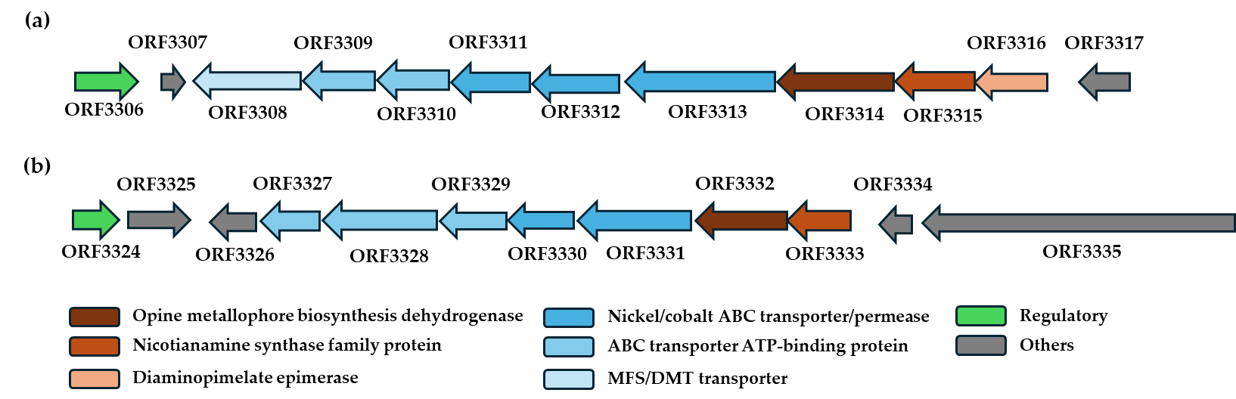

Figure S3. Genetic organization of BGC region 15 as predicted by the antiSMASH package. Region 15 contains two-copies (a and b) of an opine-like metallophore gene cluster, consisting of opine metallophore biosynthesis dehydrogenase, nicotianamine synthase family protein, and a nickel/cobalt ABC transporter substrate-binding protein/permease.

