**Statistical validation developed for a new quantitative spectrophotometric analysis method of sodium valproate in tablets**

**SODIUM VALPROATE – VISIBLE SPECTRUM**

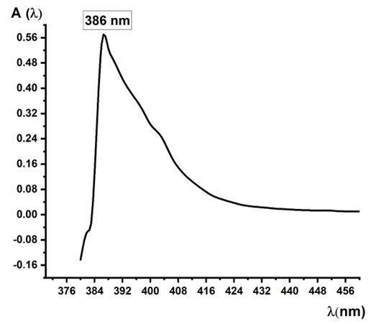

**RAW SPECTRUM VALUES OBTAINED FOR THE FIRST PRESENTED METHOD:**

***Absorption spectrum*** was plotted in the Visible range (Fig. 2) for a Sodium Valproate standard solution with concentration CS = 1.44 μg /mL = 0.000144 g %. It was established that the maximum absorption of the bright light Yellow monoazo dye quatitatively obtained from Sodium Valproate was assigned to the wavelenght λ = 386 nm corresponding to absorbance A = 0.540. According to the relationship (1) **a = A / CS** = 0.540 / 0.000144 = 3750. ***Specific absorbance*** of the pure standard sodium valproate solution, whose absorption spectrum was plotted (Fig. 2), had the **value a = 3750** = specific absorbance calculated for the concentration of target standard solution CS = 1.44 μg /ml = 0.000144 g % = 1.44.10-4 g %. ***Molar absorbtivity*** was calculated according to Bouguer Lambert-Beer law, as follows**: ε = A / CM** **(2),** where CM = represented concentration of standard solution of sodium valproate expressed in Moles / L assigmed to **CS = 1.44 μg /mL** for which was plotted the absorption spectrum, and A = the average absorbance corresponding to the absorption maximum was the same = 0.540. Target standard solution concentration was trandformed into g/L (g/1000 mL): **CS** = 1.44 μg /mL = 0.000144 g % = **0.00144 g/L = 1.44 .10-3 g/L** Wavelength corresponding to the absorption maximum of monoazo dye was ƛ = 386 nm corresponding to A = 0.540. Molecular formula of the bright light Yellow monoazo dye quantitatively formed was: **C18H21N2O2Na**. Molecular mass of this bright light yellow dye obtained was M = 216 + 21 + 28 + 32 + 23 = 320 g/mol. So, the molecular mass of the light yellow monoazo dye obtained was **M = 320 g/mol**. Then **CS**  = 1.44 μg /mL = 0.000144 g % = **1.44 .10-4 g % =**  **0.00144 g/L = 1.44 .10-3 g/L** Then, standard solution concentration of Sodium Valproate was converted from **g/L to Mole/L: CM = molar concentration** directly assigned to **CS = 1.44 .10-3 g**/L Sodium Valproate standard solutionIt was known the molar mass of bright light Yellow monoazo dye obtained was **M = 320 g/mol. So, CM = (1.44 .10-3 ) / 320 expressed in Moles/L. Thus, CM = 4.5. 10-6 Moles / L was** final molar concentration of standard Sodium Valproate solution corresponding to the initial analyzed solution **CS = 1.44 .10-3 g**/L = **1.44 .10-4 g% = 1,44 μg/mL** Sodium Valproate, for which the absorption spectrum was plotted**.** From formula (2) it was concluded**: ε = A / CM =** 0.540 / 4.5.10-6 = 0.540 / 0.0000045 = **120000.00**. Molar extinction coefficient "ε" (molar absorptivity) had a proper value**: ε = 120000.00** corresponding to **CM = 4.5. 10-6 Moles / L** standard solution . It was registered also a good specific absorbance **a = 3750;** bothmolar extinction coefficient and specific absorbance were assigned to the initial studied standard solution **CS = 1.44 .10-3 g**/L = **1.44 .10-4 g% = 1,44 μg/mL,** that has contained the bright light Yellow monoazxo dye quatitatively obtained from Sodium Valproate. This initial standard solution of Sodium Valproate for which the Spectrum has been plotted also had a molar concentration **CM = 4.5. 10-6 Moles / L.**

380 -0.157

382 -0.053

383 -0.028

384 0.001

**386 0.540 Maximum Values A = f (λ).**

388 0.29

392 0.11

395 0.137

390 0.426

400 0.126

403 0.149

406 0.134

409 0.136

412 0.105

415 0.08

418 0.059

421 0.047

424 0.037

427 0.029

430 0.025

433 0.022

436 0.019

439 0.017

442 0.015

445 0.014

448 0.013

451 0.013

454 0.011

457 0.01

460 0.01

A Second Method essayed (was not described in the main manuscript):

380 0.092

382 0.153

383 0.288

384 0.488

386 0.49

388 0.51

390 0.489

393 0.487

**396 0.554 Maximum Values A = f (λ).**

399 0.496

403 0.449

406 0.465

409 0.436

412 0.425

415 0.408

418 0.429

421 0.437

424 0.397

427 0.389

430 0.325

433 0.322

436 0.219

439 0.217

442 0.215

445 0.214

448 0.213

451 0.173

454 0.171

457 0.161

460 0.161

463 0.159

466 0.149

469 0.179

472 0.181

475 0.177

478 0.177

481 0.156

484 0.157

487 0.147

490 0.148