Supplemental information

S1, Figures

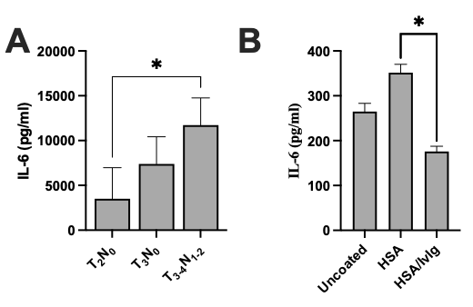

~~Figure 1. Impact of solid phase IgG on IL-6 synthesis by control PBMC. Culture wells were preincubated with medium (n=37), or coated with HSA (n=37) or HSA + IvIg (n=36).~~

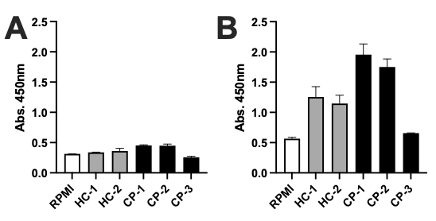

Figure 2. Generation of the IL-6IF-structure by PBMC in cultures from healthy controls and advanced cancer patients supplemented with albumin. Enhanced amount of this neo-structure was generated in cultures from cancer patients compared to healthy controls. Increasing amounts of albumin (HSA) was added to the cultures, 0.5 mg/ml (A) and 5mg/ml (B).

S1. Tables

Table 1. IL-6 inducing activity in sera (negative for IL-6) from cancer patients, cultured with PBMCs from healthy individuals. None of the control PBMC made detectable amounts of IL-6 when cultured with autologous, normal sera



~~Table 2. The effect of Protein-G-Sepharose adsorption of sera on IL-6 inducing activity. IgG and CIC depletion resulted in enhanced IL-6 production by normal PBMCs~~



Table 3. Serum concentration of auto-antibodies directed against the IL-6IF structure and the serum concentration of IL-6.



Table 4. Results from inhibition ELISA, using probe IL-6IF, stage II and III colon cancer.



**Data availability statement**

The original contribution presented in the study are included in the article / supplementary material, further inquiries can be directed to the corresponding author.