Supplemental Material

Dobner et al.
Effect of timely availability of TTR-stabilizing therapy on diagnosis, therapy, and clinical outcomes in ATTR-CM
ClinicalTrials.gov Identifier: NCT04776824

Supplemental Material

Supplementary Table 1. Associations of clinical characteristics at the time of diagnosis to the combined endpoint by Cox regression

 | Univariate associations |  | Multivariate model
 | Hazard ratio (95%CI) | p value | Hazard ratio (95%CI) | p value
Patient characteristics
Gender (female vs. male) | 2.187 (95% CI 0.667 to 7.167) | 0.20
Age [years] | 1.048 (95% CI 0.987 to 1.113) | 0.12
NHYA-class (III or IV vs. I or II) | 1.454 (95% CI 0.676 to 3.125) | 0.34
Biomarkers
Creatinine [mmol/l] | 1.011 (95% CI 1.002 to 1.020) | 0.015
eGFR [ml/min] | 0.970 (95% CI 0.950 to 0.990) | 0.004 | 0.989 (95% CI 0.963 to 1.016) | 0.42
NTproBNP [Log pg/ml] | 5.64 (95% CI 2.087 to 15.23) | 0.001 | 6.47 (95% CI 1.818 to 23.03) | 0.004
hs-Troponin T [ng/l] mean ± SD | 1.007 (95% CI 0.999 to 1.016) | 0.07
Echocardiography
LVEF [%] | 0.979 (95% CI 0.949 to 1.010) | 0.18
LV GLS [%] | 1.023 (95% CI 0.953 to 1.098) | 0.53
LV Mass Index [g/m²] | 1.000 (95% CI 0.992 to 1.007) | 0.93
RV DTI S-Wave Velocity [cm/s] | 0.945 (95% CI 0.815 to 1.096) | 0.45
TAPSE [mm] | 1.001 (95% CI 0.925 to 1.083) | 0.99
LAVi [ml/m²] | 1.012 (95% CI 0.978 to 1.048) | 0.50
Timing [months]
First presentation to diagnosis | 1.013 (95% CI 1.006 to 1.020) | <0.001 | 1.014 (95% CI 1.005 to 1.023) | 0.002
Diagnosis to therapy | 1.050 (95% CI 0.983 to 1.012) | 0.19
First presentation to therapy | 1.009 (95% CI 0.997 to 1.021) | 0.15
CU vs. IA | 1.972 (95% CI 0.998 to 3.896) | 0.051
Supplemental figure 1. Kaplan Meier estimates for all-cause mortality and time-to-first HFH since the time of diagnosis stratified by the availability of tafamidis [compassionate use (CU) vs. insurance access (IA)].
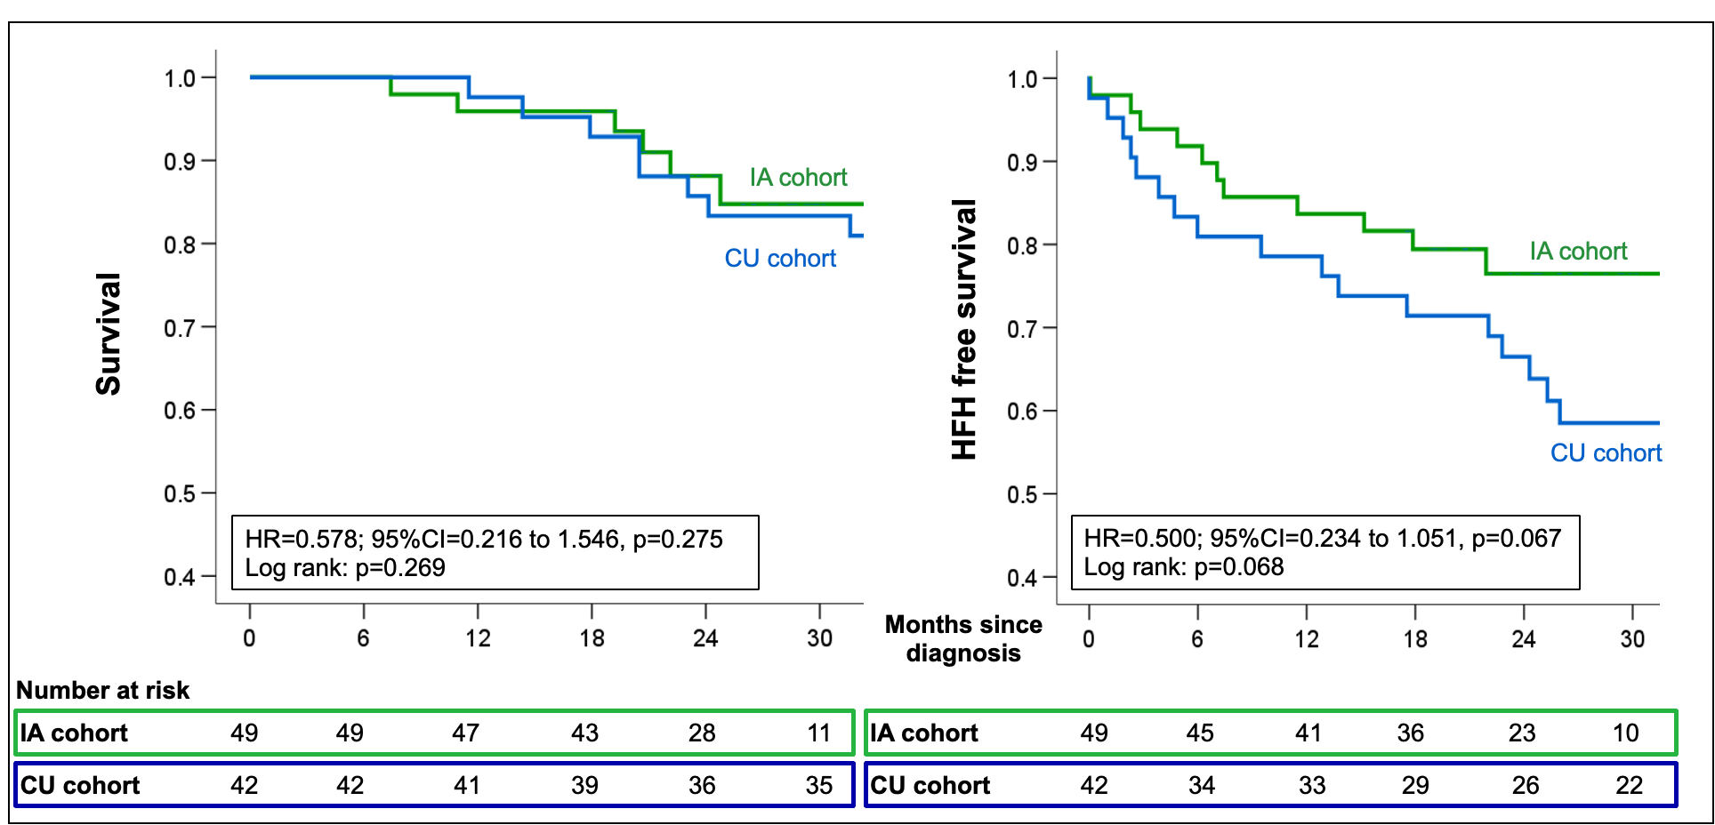

Supplemental figure 2. Kaplan Meier estimates for first MACE (A), all-cause mortality (B) and HFH (C) stratified by tafamidis therapy.

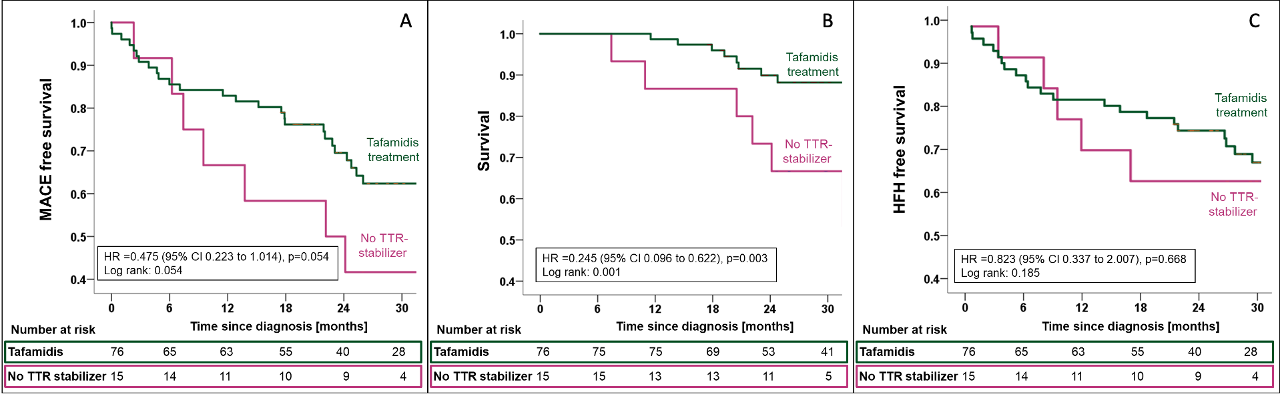

Supplemental figure 3. Kaplan Meier estimates for first MACE (A), all-cause mortality (B) and HFH (C) from the time of ATTR-CM diagnosis for patients treated with tafamidis stratified by the time from first presentation to diagnosis (<12months vs. >12 months).

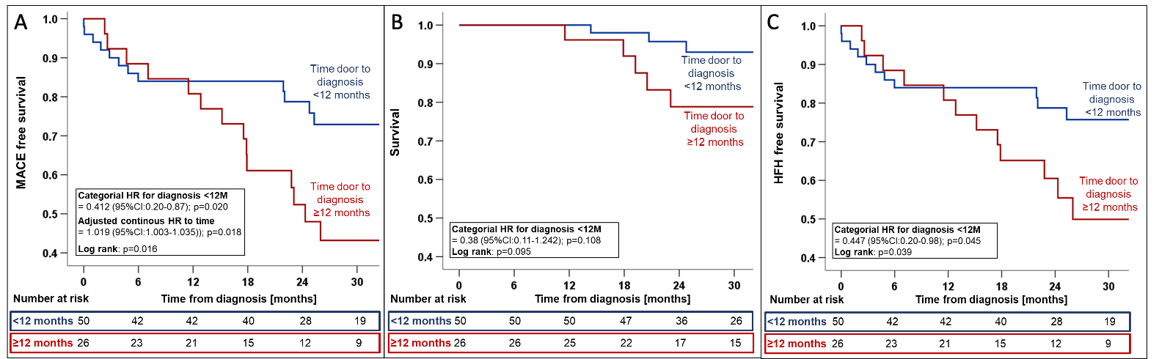

Hazard ratios were adjusted for variables with univariate association to the combined endpoint (i.e. eGFR and NT-proBNP).

Supplemental figure 4. Cumulative incidence function for repeat HFH from the time of ATTR-CM diagnosis for patients treated with tafamidis stratified by the time from first presentation to diagnosis (<12months vs. >12 months).

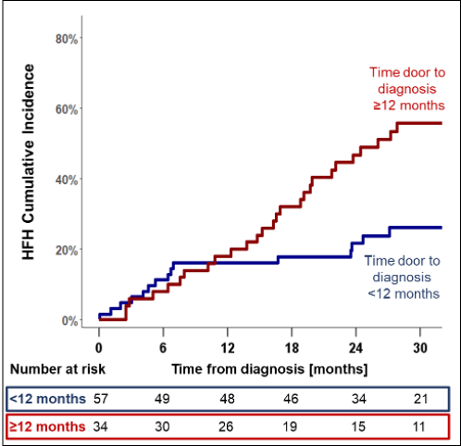
Supplemental figure 5. Kaplan Meier estimates for first MACE (A), all-cause mortality (B) and HFH (C) from the time of ATTR-CM diagnosis for patients with and without a history of or concomitant atrial fibrillation at the time of ATTR-CM diagnosis.

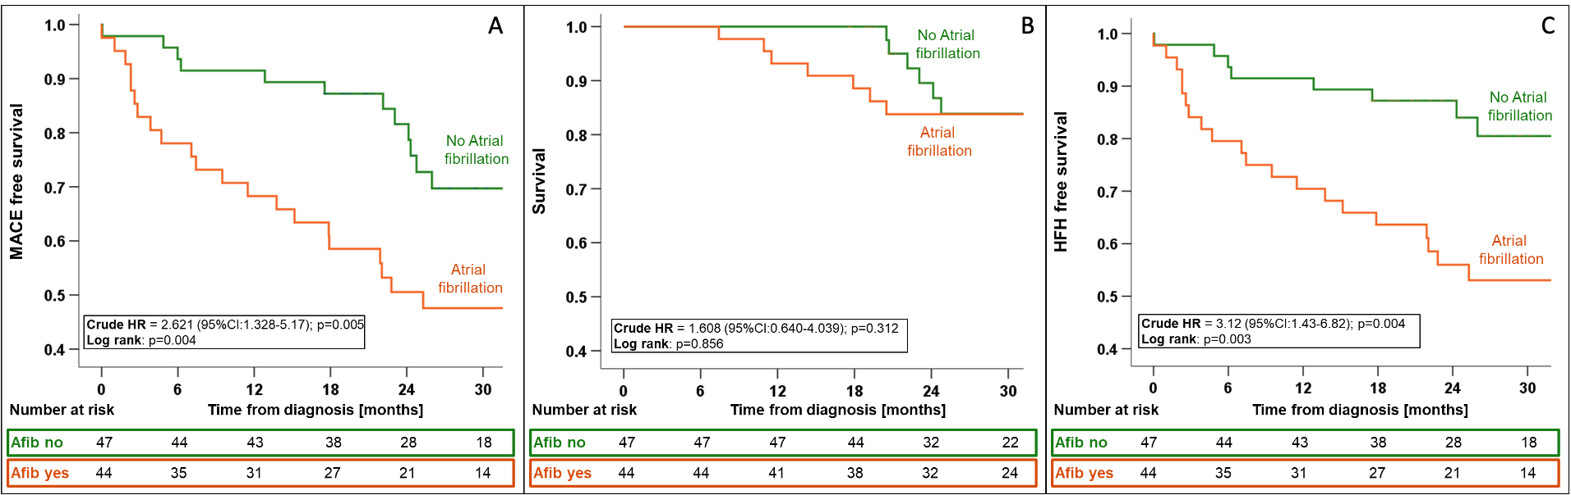

Supplemental figure 6. Cumulative incidence function for repeat HFH from the time of ATTR-CM diagnosis for patients with and without a history of or concomitant atrial fibrillation at the time of ATTR-CM diagnosis.

