Supplementary Material S1.

The original screening tool for the assessment of malnutrition in pediatrics

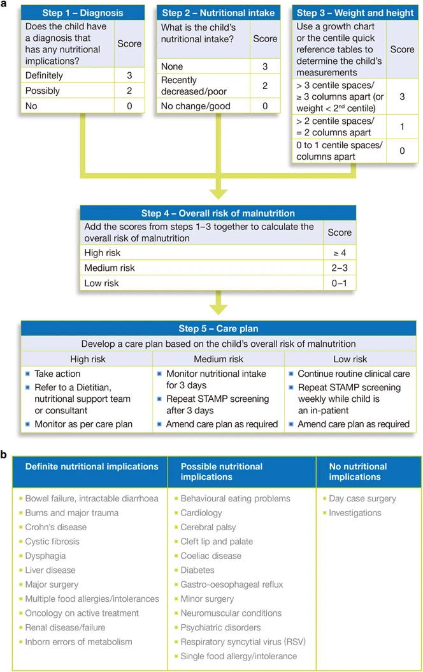

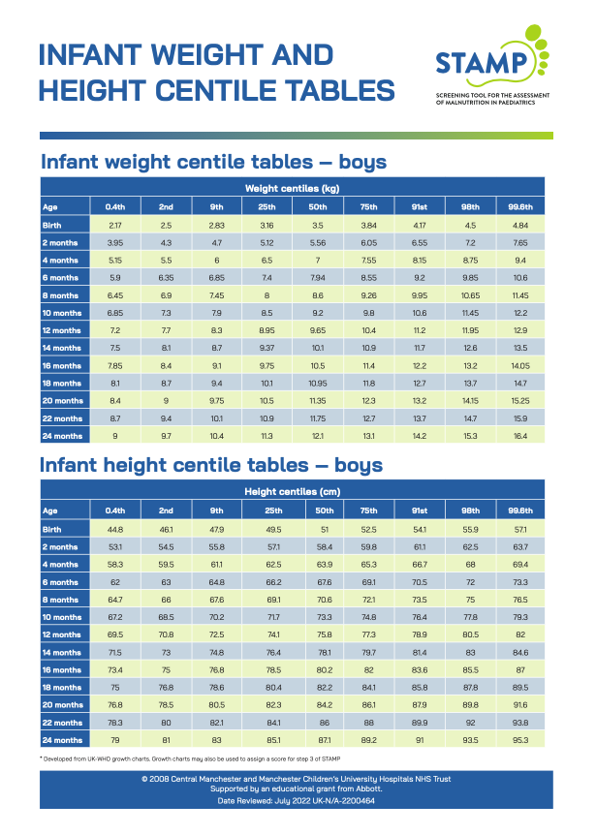

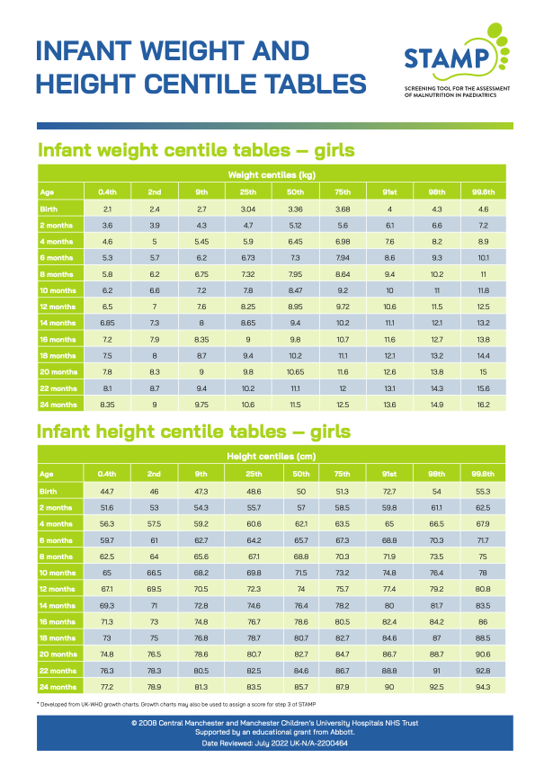

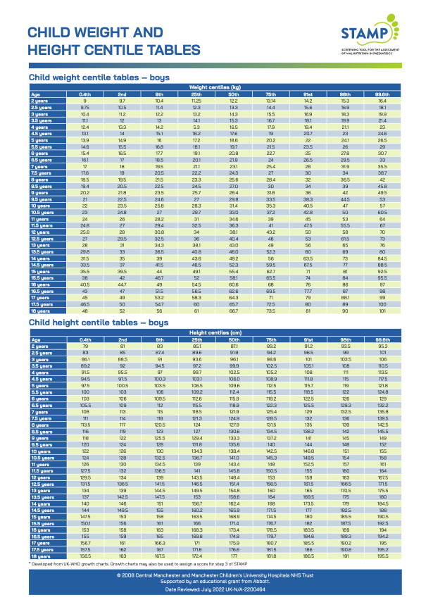

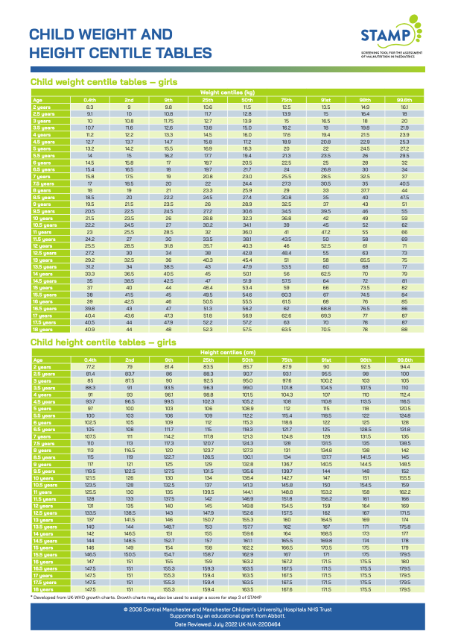

Supplementary Material S2.

A modified screening tool for the assessment of malnutrition in pediatrics

|  |  |  |  |  |
| --- | --- | --- | --- | --- |
| **Criteria** | Screening Frequency | | | |
| Week 1 | Week 2 | Week 3 | Week 4 |
| Wt = | Wt = | Wt = | Wt = |
| Ht= | Ht= | Ht= | Ht= |

|  |
| --- |
| **Step 1**  Diagnosis (check the diagnosis and circle corresponding score) |

|  |  |  |  |  |
| --- | --- | --- | --- | --- |
| * Bowel failure, intractable diarrhea * Burns and major trauma. * Crohn's disease * Cystic fibrosis * Dysphagia * Liver disease * Major surgery * Multiple food allergies/intolerances * Oncology on active treatment * Renal disease/failure * Inborn errors of metabolism * **Respiratory Infection** * **Neonatal Disorders** | **3** | **3** | **3** | **3** |
| * Behavioral eating problems * Cardiology * Cerebral palsy * Cleft lip and palate * Celiac disease * Diabetes * Gastro-oesophageal reflux * Minor surgery * Neuromuscular conditions * Psychiatric disorders * Respiratory syncytial virus (RSV) * Single food allergy/intolerance * **Pneumonia** * **Acute diarrhea** | **2** | **2** | **2** | **2** |
| * Day case surgery * Investigations | **0** | **0** | **0** | **0** |

|  |
| --- |
| **Step 2**  Nutritional intake (What is the child's nutritional intake?) |

|  |  |  |  |  |
| --- | --- | --- | --- | --- |
| * None (no nutritional intake) | 3 | 3 | 3 | 3 |
| * Recently decreased/ poor | 2 | 2 | 2 | 2 |
| * No change/good | 0 | 0 | 0 | 0 |

|  |
| --- |
| **Step 3**  Weight and height  **Use a Saudi growth chart or the centile quick reference tables to determine the child's measurements** |

|  |  |  |  |  |
| --- | --- | --- | --- | --- |
| * > 3 centiles/columns apart (or weight < 2nd centile) | 3 | 3 | 3 | 3 |
| * > 2 centiles/columns apart | 1 | 1 | 1 | 1 |
| * Similar centiles/ columns | 0 | 0 | 0 | 0 |

|  |  |  |  |  |
| --- | --- | --- | --- | --- |
| **Total scores** |  |  |  |  |
| **Data** |  |  |  |  |
| **Time** |  |  |  |  |
| **Nurse's signature** |  |  |  |  |

|  |
| --- |
| **Infant Weight and Height Centile Table (Girls)** |

|  |  |  |  |  |  |  |  |  |  |
| --- | --- | --- | --- | --- | --- | --- | --- | --- | --- |
| Weight centile (kg) | | | | | | | | | |
| Age | 3rd | 5th | 10th | 25th | 50th | 75th | 90th | 95th | 97th |
| Birth | 2.5 | 2.6 | 2.7 | 2.9 | 3.1 | 3.5 | 3.7 | 3.8 | 4.1 |
| 2 months | 3.7 | 3.9 | 4 | 4.3 | 4.8 | 5 | 5.5 | 5.7 | 6 |
| 4 months | 4.9 | 5.1 | 5.4 | 5.8 | 6.3 | 7 | 7.5 | 7.9 | 8.3 |
| 6 months | 5.7 | 5.9 | 6.1 | 6.7 | 7.3 | 8 | 8.6 | 9 | 9.3 |
| 8 months | 6.4 | 6.6 | 6.9 | 7.5 | 8.2 | 8.8 | 9.7 | 10.1 | 10.4 |
| 10 months | 6.9 | 7.1 | 7.5 | 8 | 8.7 | 9.7 | 10.5 | 11 | 11.4 |
| 12 months | 7.2 | 7.5 | 7.9 | 8.5 | 9.4 | 10.2 | 11 | 11.6 | 12 |
| 14 months | 7.5 | 7.7 | 8.2 | 8.9 | 9.7 | 10.6 | 11.5 | 12.1 | 12.5 |
| 16 months | 7.8 | 8.1 | 8.5 | 9.25 | 10.1 | 11.1 | 12 | 12.6 | 13 |
| 18 months | 8.1 | 8.4 | 8.7 | 9.5 | 10.5 | 11.5 | 12.5 | 13.1 | 13.5 |
| 20 months | 8.4 | 8.6 | 9.1 | 9.9 | 10.9 | 11.9 | 12.95 | 13.6 | 14 |
| 22 months | 8.6 | 8.9 | 9.4 | 10.2 | 11.2 | 12.25 | 13.4 | 14 | 14.5 |
| 24 months | 8.8 | 9.1 | 9.6 | 10.5 | 11.5 | 12.6 | 13.7 | 14.5 | 15 |
| Height centile (cm) | | | | | | | | | |
| Age | 3rd | 5th | 10th | 25th | 50th | 75th | 90th | 95th | 97th |
| Birth | 46 | 46.5 | 47 | 48.8 | 50 | 51.5 | 53 | 54 | 55 |
| 2 months | 51.5 | 52.5 | 53 | 55 | 57 | 58 | 60 | 61 | 62 |
| 4 months | 55.5 | 56 | 57 | 59 | 62 | 63.5 | 65 | 66 | 67 |
| 6 months | 59.8 | 60.5 | 61.5 | 63 | 66 | 67.5 | 70.5 | 71.5 | 72 |
| 8 months | 62.3 | 63 | 65 | 67 | 68.5 | 72 | 74 | 76 | 77 |
| 10 months | 65 | 66 | 67 | 68 | 72 | 74 | 77 | 78.5 | 79 |
| 12 months | 67 | 67.5 | 68 | 71 | 73 | 77 | 79 | 81 | 82 |
| 14 months | 68.5 | 70 | 71 | 73 | 76 | 78.5 | 81.5 | 82.5 | 84 |
| 16 months | 71 | 71.5 | 73 | 75.5 | 77.5 | 82 | 83 | 85 | 86 |
| 18 months | 72 | 72.5 | 74 | 77 | 80 | 82 | 85.5 | 87.5 | 88 |
| 20 months | 73 | 74 | 77 | 78.5 | 82.5 | 84.5 | 87.5 | 89 | 90 |
| 22 months | 75 | 76 | 78 | 80 | 83 | 87.5 | 91 | 92.5 | 93 |
| 24 months | 76 | 77 | 78.5 | 82 | 85 | 88 | 92 | 93 | 94 |

Source: Mohammad I. El Mouzan, Abdullah A. Al Salloum, Abdullah S. Al

Herbish, Peter J Foster, Mansour M. Qurashi, Ahmad A. Al Omar. The 2005 Growth Charts for Saudi Children and Adolescents (No. AR-20-63). King Abdulaziz City for Science and Technology 2009, Riyadh, KSA.

|  |
| --- |
| **Infant Weight and Height Centile Table (Boys)** |

|  |  |  |  |  |  |  |  |  |  |
| --- | --- | --- | --- | --- | --- | --- | --- | --- | --- |
| Weight centile (kg) | | | | | | | | | |
| Age | 3rd | 5th | 10th | 25th | 50th | 75th | 90th | 95th | 97th |
| Birth | 2.4 | 2.5 | 2.7 | 2.9 | 3.2 | 3.5 | 3.8 | 4 | 4.2 |
| 2 months | 4 | 4.1 | 4.3 | 4.8 | 5.3 | 5.9 | 6.2 | 6.8 | 7 |
| 4 months | 5.1 | 5.3 | 5.5 | 6 | 6.5 | 7.2 | 7.8 | 8.2 | 8.5 |
| 6 months | 5.9 | 6.1 | 6.5 | 7.2 | 7.7 | 8.5 | 9.3 | 9.6 | 10 |
| 8 months | 6.5 | 6.8 | 7.1 | 7.7 | 8.5 | 9.4 | 10.1 | 10.5 | 10.8 |
| 10 months | 6.9 | 7.2 | 7.6 | 8.4 | 9.2 | 10 | 10.8 | 11.4 | 11.8 |
| 12 months | 7.2 | 7.55 | 8 | 8.8 | 9.8 | 10.6 | 11.4 | 11.8 | 12.3 |
| 14 months | 7.6 | 8 | 8.4 | 9.2 | 10.2 | 11.1 | 11.9 | 12.4 | 12.8 |
| 16 months | 8 | 8.3 | 8.8 | 9.6 | 10.5 | 11.5 | 12.4 | 13 | 13.3 |
| 18 months | 8.3 | 8.6 | 9.1 | 10 | 10.9 | 11.9 | 12.9 | 13.4 | 13.8 |
| 20 months | 8.5 | 8.9 | 9.3 | 10.2 | 11.2 | 12.2 | 13.2 | 13.8 | 14.2 |
| 22 months | 8.8 | 9.1 | 9.6 | 10.5 | 11.5 | 12.6 | 13.6 | 14.3 | 14.6 |
| 24 months | 9 | 9.3 | 9.9 | 10.8 | 11.8 | 12.9 | 13.9 | 14.5 | 15 |
| 9Height centile (cm) | | | | | | | | | |
| Age | 3rd | 5th | 10th | 25th | 50th | 75th | 90th | 95th | 97th |
| Birth | 46.5 | 47.5 | 48.5 | 50.5 | 51.3 | 52 | 54 | 55.5 | 61 |
| 2 months | 52 | 52.5 | 53 | 55 | 57 | 58 | 61 | 62 | 62,5 |
| 4 months | 57 | 57.5 | 58.5 | 60.5 | 62.5 | 65 | 67 | 68 | 68.5 |
| 6 months | 60.5 | 61 | 62.5 | 64.5 | 67 | 69 | 71.5 | 72.5 | 73 |
| 8 months | 63 | 64 | 65.5 | 67.5 | 70 | 72.5 | 75 | 76 | 77 |
| 10 months | 65 | 66 | 67.5 | 70 | 72.5 | 75 | 77.5 | 78 | 79 |
| 12 months | 67.5 | 68 | 70 | 72 | 75 | 77.5 | 80 | 81.5 | 82.5 |
| 14 months | 68.5 | 70.5 | 72 | 74.5 | 77.5 | 80.5 | 82.5 | 84 | 85 |
| 16 months | 71 | 72.5 | 73.5 | 77 | 79 | 82.5 | 85 | 86 | 87.5 |
| 18 months | 73 | 74 | 75.5 | 78 | 81.5 | 83.5 | 87 | 88 | 89 |
| 20 months | 74 | 75 | 76 | 79.5 | 82.5 | 85.5 | 88 | 90 | 92 |
| 22 months | 76 | 77 | 78 | 81.5 | 84 | 87.5 | 90.5 | 92 | 93 |
| 24 months | 77 | 78 | 80 | 83 | 86 | 89 | 90 | 93.5 | 95 |

Source: Mohammad I. El Mouzan, Abdullah A. Al Salloum, Abdullah S. Al

Herbish, Peter J Foster, Mansour M. Qurashi, Ahmad A. Al Omar. The 2005 Growth Charts for Saudi Children and Adolescents (No. AR-20-63). King Abdulaziz City for Science and Technology 2009, Riyadh, KSA.

|  |
| --- |
| **Child Weight and Height Centile Table (Girls)** |

|  |  |  |  |  |  |  |  |  |  |
| --- | --- | --- | --- | --- | --- | --- | --- | --- | --- |
| Weight centile (kg) | | | | | | | | | |
| Age | 3rd | 5th | 10th | 25th | 50th | 75th | 90th | 95th | 97th |
| Birth | 2.5 | 2.6 | 2.7 | 2.9 | 3.1 | 3.5 | 3.7 | 3.8 | 4.1 |
| 2 years | 8.8 | 9.1 | 9.6 | 10.5 | 11.5 | 12.6 | 13.7 | 14.5 | 15 |
| 2.5 years | 9.5 | 9.8 | 10.4 | 11.3 | 12.4 | 13.6 | 14.8 | 15.6 | 16.3 |
| 3years | 10 | 10.4 | 11 | 11.9 | 13.2 | 14.6 | 16 | 16.7 | 17.5 |
| 3.5 years | 10.5 | 10.9 | 11.5 | 12.6 | 14 | 15.5 | 17 | 18 | 18.5 |
| 4 years | 11 | 11.5 | 12.2 | 13.3 | 14.8 | 16.5 | 18.1 | 19.1 | 19.8 |
| 4.5 years | 11.5 | 12 | 12.8 | 14.1 | 15.6 | 17.5 | 19.2 | 20.4 | 21.2 |
| 5 years | 12.2 | 12.6 | 13.4 | 14.8 | 16.7 | 18.6 | 20.6 | 21.8 | 22.8 |
| 5.5 years | 13 | 13.5 | 14 | 15 | 17 | 18 | 21 | 22.5 | 24 |
| 6 years | 13.5 | 14 | 15 | 16.5 | 18.5 | 21 | 23 | 25 | 26 |
| 6.5 years | 14 | 14.5 | 16 | 17.5 | 20 | 22.5 | 25 | 27 | 28 |
| 7 years | 14.5 | 15.3 | 16.2 | 18.5 | 21 | 24 | 27 | 28.5 | 30 |
| 7.5 years | 15 | 16 | 17 | 19.5 | 22 | 22.5 | 28.5 | 31 | 32.5 |
| 8 years | 16 | 17 | 18 | 20.5 | 23.5 | 27 | 30.5 | 33 | 35 |
| 8.5 years | 17 | 17.5 | 19 | 22.5 | 25 | 29 | 33 | 36 | 38 |
| 9 years | 17.5 | 18.5 | 20 | 23 | 26.5 | 31 | 32.5 | 38 | 40 |
| 9.5 years | 18.5 | 19.5 | 21 | 24 | 28 | 33 | 38 | 41 | 43.5 |
| 10 years | 19.5 | 20.5 | 22 | 26 | 30 | 35.5 | 41 | 44.5 | 47 |
| 10.5 years | 21 | 22 | 24 | 28 | 32.5 | 38 | 44 | 48 | 51 |
| 11 years | 22 | 25 | 25.5 | 29.5 | 35 | 40.5 | 47 | 51.5 | 55 |
| 11.5 years | 23.5 | 25 | 27 | 31.5 | 37 | 43.5 | 50.5 | 55.5 | 59 |
| 12 years | 25 | 26 | 29 | 33 | 39 | 46 | 53.5 | 58.5 | 62 |
| 12.5 years | 26.5 | 28 | 31 | 35.5 | 42 | 49 | 57 | 62 | 65.5 |
| 13 years | 28 | 29.5 | 32 | 37 | 44 | 51.5 | 60 | 65 | 69 |
| 13.5 years | 29.5 | 31 | 34 | 39 | 46 | 54 | 62 | 68 | 72 |
| 14 years | 31 | 32.5 | 35.5 | 41 | 48 | 56 | 64 | 70 | 74 |

|  |  |  |  |  |  |  |  |  |  |
| --- | --- | --- | --- | --- | --- | --- | --- | --- | --- |
| Height centile (cm) | | | | | | | | | |
| Age | 3rd | 5th | 10th | 25th | 50th | 75th | 90th | 95th | 97th |
| Birth | 46 | 46.5 | 47 | 48.8 | 50 | 51.5 | 53 | 54 | 55 |
| 2 years | 76 | 77 | 78.5 | 82 | 85 | 88 | 92 | 93 | 94 |
| 2.5 years | 80 | 81 | 83 | 86.5 | 90 | 93 | 96 | 98 | 99 |
| 3years | 83 | 84.5 | 86 | 90 | 93 | 97 | 100 | 102.5 | 103 |
| 3.5 years | 87 | 88 | 90 | 93 | 97 | 100.5 | 103 | 105.5 | 106 |
| 4 years | 90 | 91 | 93 | 96 | 100 | 103 | 107 | 108 | 110 |
| 4.5 years | 93 | 94 | 96 | 98.5 | 103 | 107 | 110.5 | 112.5 | 113 |
| 5 years | 96 | 97.5 | 99 | 102.5 | 107 | 110 | 113 | 116 | 117 |
| 5.5 years | 99 | 101 | 102.5 | 106 | 110 | 113 | 117 | 119 | 120 |
| 6 years | 103 | 104 | 106 | 109 | 113 | 117 | 121 | 122 | 123.5 |
| 6.5 years | 105 | 106 | 108 | 112.5 | 115.5 | 120 | 123 | 125.5 | 127 |
| 7 years | 106.5 | 109 | 111 | 115 | 119 | 122.5 | 126 | 129 | 130.5 |
| 7.5 years | 110 | 112.5 | 114 | 117.5 | 122 | 126 | 129.5 | 132 | 133.5 |
| 8 years | 112.5 | 113 | 116 | 120 | 123 | 127.5 | 132 | 134.5 | 135.5 |
| 8.5 years | 114.5 | 116 | 118 | 122.5 | 126 | 131 | 135 | 136 | 137 |
| 9 years | 116 | 118 | 121 | 125 | 129 | 133 | 137 | 139.5 | 141 |
| 9.5 years | 120 | 121 | 123 | 127 | 132 | 136 | 140 | 142 | 143 |
| 10 years | 122 | 123 | 126 | 130 | 134 | 138 | 142 | 145 | 146 |
| 10.5 years | 124 | 126 | 128 | 132 | 137 | 141.5 | 145.5 | 148 | 150 |
| 11 years | 126.5 | 129 | 132 | 135 | 140 | 145 | 149 | 152 | 153 |
| 11.5 years | 130 | 132 | 134 | 138 | 143 | 147.5 | 152 | 155 | 156 |
| 12 years | 132.5 | 134 | 137 | 141 | 145.5 | 150 | 154 | 157.5 | 159 |
| 12.5 years | 135 | 136.5 | 139.5 | 142.5 | 148 | 152.5 | 157 | 159 | 161 |
| 13 years | 137.5 | 139.5 | 142 | 145.5 | 150.5 | 155 | 159.5 | 161 | 162 |
| 13.5 years | 140 | 141 | 144 | 147.5 | 152 | 156 | 160 | 162.5 | 164.5 |
| 14 years | 141 | 142.5 | 145 | 149 | 153 | 157.5 | 161 | 163 | 165 |

Source: Mohammad I. El Mouzan, Abdullah A. Al Salloum, Abdullah S. AlHerbish, Peter J Foster, Mansour M. Qurashi, Ahmad A. Al Omar. The 2005 Growth Charts for Saudi Children and Adolescents (No. AR-20-63). King Abdulaziz City for Science and Technology 2009, Riyadh, K

|  |
| --- |
| **Child Weight and Height Centile Table (Boys)** |

|  |  |  |  |  |  |  |  |  |  |
| --- | --- | --- | --- | --- | --- | --- | --- | --- | --- |
| Weight centile (kg) | | | | | | | | | |
| Age | 3rd | 5th | 10th | 25th | 50th | 75th | 90th | 95th | 97th |
| Birth | 2.4 | 2.5 | 2.7 | 2.9 | 3.2 | 3.5 | 3.8 | 4 | 4.2 |
| 2 years | 9 | 9.3 | 9.9 | 10.8 | 11.8 | 12.9 | 13.9 | 14.5 | 15 |
| 2.5 years | 9.7 | 10.1 | 10.6 | 11.6 | 12.7 | 13.8 | 15.1 | 15.8 | 16.4 |
| 3years | 10.5 | 10.8 | 11.4 | 12.4 | 13.6 | 15 | 16.3 | 17.1 | 17.6 |
| 3.5 years | 11.1 | 11.5 | 12.1 | 13.2 | 14.5 | 16 | 17.5 | 18.4 | 19 |
| 4 years | 11.6 | 12.1 | 12.7 | 13.9 | 15.4 | 16.9 | 18.6 | 19.5 | 20.2 |
| 4.5 years | 12.2 | 12.6 | 13.3 | 14.6 | 16.2 | 17.9 | 19.6 | 20.7 | 21.5 |
| 5 years | 12.6 | 13.2 | 13.8 | 15.3 | 17 | 18.8 | 20.8 | 22 | 22.8 |
| 5.5 years | 13 | 14 | 14.5 | 16 | 18 | 20 | 22 | 23.5 | 24.5 |
| 6 years | 14 | 14.5 | 15 | 17 | 19 | 21 | 23.5 | 25 | 26 |
| 6.5 years | 14.5 | 15 | 16 | 17.5 | 20 | 22.5 | 25 | 26.5 | 28 |
| 7 years | 15 | 15.5 | 16.5 | 18.5 | 21 | 24 | 26.5 | 28.5 | 29.5 |
| 7.5 years | 15.5 | 16.5 | 17.5 | 19.5 | 22 | 25 | 28 | 30.5 | 32 |
| 8 years | 16 | 17 | 18 | 21 | 23.5 | 27 | 30 | 33 | 34 |
| 8.5 years | 17 | 18 | 19 | 22 | 25 | 29 | 32.5 | 35 | 37 |
| 9 years | 17.8 | 18.8 | 20 | 23 | 26.5 | 31 | 35 | 38 | 39.3 |
| 9.5 years | 18.4 | 19.4 | 21 | 24 | 28 | 33 | 37.5 | 40.5 | 43 |
| 10 years | 19 | 20.4 | 22 | 25.4 | 30 | 35 | 40 | 44 | 46 |
| 10.5 years | 20 | 21 | 23 | 27 | 31.5 | 37 | 43 | 47 | 49.5 |
| 11 years | 21 | 22 | 24 | 28 | 33 | 39.5 | 46 | 50 | 53 |
| 11.5 years | 22 | 23 | 25.5 | 29.5 | 35 | 42 | 49 | 54 | 57 |
| 12 years | 23 | 24.5 | 27 | 31.5 | 37.5 | 45 | 52 | 57.5 | 61 |
| 12.5 years | 24.5 | 26 | 28 | 33 | 39.5 | 47.5 | 55.5 | 61 | 65 |
| 13 years | 25.5 | 27.5 | 30 | 34 | 42 | 50 | 59 | 65 | 69 |
| 13.5 years | 27.5 | 29 | 31.5 | 37 | 44 | 53 | 62 | 68.5 | 73 |
| 14 years | 29 | 30.5 | 33.5 | 39 | 47 | 56 | 65 | 72 | 76.5 |
| Weight centile (kg) | | | | | | | | | |
| Age | 3rd | 5th | 10th | 25th | 50th | 75th | 90th | 95th | 97th |
| Birth | 46.5 | 47 | 47.5 | 48.5 | 51.3 | 52 | 54 | 55.5 | 61 |
| 2 years | 77 | 78 | 80 | 83 | 86 | 89 | 90 | 93.5 | 95 |
| 2.5 years | 81 | 82.5 | 84 | 87 | 90 | 93.5 | 97 | 98.5 | 100 |
| 3years | 84.5 | 86 | 88 | 91 | 94 | 97.5 | 101 | 103 | 104 |
| 3.5 years | 88 | 89 | 91.5 | 94 | 98 | 102 | 105 | 106 | 107 |
| 4 years | 91 | 92.5 | 94.5 | 98 | 102 | 105.5 | 108 | 111 | 112 |
| 4.5 years | 94 | 96 | 97.5 | 101 | 105 | 108 | 112 | 113.5 | 115.5 |
| 5 years | 97 | 98 | 101 | 104.5 | 107 | 112 | 115 | 117 | 119 |
| 5.5 years | 100 | 101 | 103 | 107 | 110 | 115 | 118 | 120 | 122 |
| 6 years | 102.4 | 103 | 106 | 109.5 | 113 | 116 | 121 | 123 | 125 |
| 6.5 years | 105 | 107 | 108 | 112.5 | 116 | 120 | 124 | 126 | 127.5 |
| 7 years | 107.5 | 109 | 111 | 115 | 118 | 123 | 126 | 128 | 130 |
| 7.5 years | 110 | 112 | 114 | 118 | 122 | 126 | 130 | 132 | 133 |
| 8 years | 133 | 114 | 116 | 120 | 123 | 127 | 133 | 134 | 136 |
| 8.5 years | 116 | 117 | 119 | 123 | 127 | 131 | 135 | 137 | 139 |
| 9 years | 118 | 119 | 122 | 125 | 129 | 133 | 137 | 140 | 142 |
| 9.5 years | 120 | 122 | 124 | 127 | 132 | 136 | 140 | 143.5 | 145 |
| 10 years | 122 | 123 | 126 | 129 | 134 | 138 | 142.5 | 145 | 147 |
| 10.5 years | 124 | 125.5 | 127.5 | 132 | 136 | 140 | 145 | 147.5 | 150 |
| 11 years | 126 | 127.5 | 130 | 133.5 | 137.5 | 143 | 147 | 151 | 152.5 |
| 11.5 years | 128 | 130 | 132 | 136 | 141 | 146 | 151 | 154 | 155 |
| 12 years | 131 | 132 | 135 | 138 | 144 | 149 | 153 | 157 | 159 |
| 12.5 years | 134 | 135 | 137 | 142 | 147 | 152 | 157 | 160 | 162 |
| 13 years | 135 | 137 | 140 | 145 | 150 | 155 | 160 | 163 | 165 |
| 13.5 years | 137.5 | 138 | 142.5 | 157.5 | 152.5 | 157.5 | 162.5 | 166 | 168 |
| 14 years | 140 | 142.5 | 145 | 150 | 155 | 161 | 166 | 169 | 171 |

Source: Mohammad I. El Mouzan, Abdullah A. Al Salloum, Abdullah S. AlHerbish, Peter J Foster, Mansour M. Qurashi, Ahmad A. Al Omar. The 2005 Growth Charts for Saudi Children and Adolescents (No. AR-20-63). King Abdulaziz City for Science and Technology 2009, Riyadh, KSA.

Supplementary Material S3.

Nutrition Status of the Patients Based on Anthropometric Measurements

|  |  |  |
| --- | --- | --- |
| Variables |  | |
| Weight for height z score (WHO/CDC) * (age <59 months) | | N=155 |
| Severe malnutrition | | 16 (10.3%) |
| Moderate malnutrition | | 7 (4.5%) |
| Mild malnutrition | | 25 (16.1%) |
| Normal | | 65 (41.9%) |
| Overweight | | 16 (10.3%) |
| Obese | | 14 (9%) |
| Very obese | | 12 (7.7%) |
| Weight for height z score (Saudi)* (age <59 months) | | N=155 |
| Severe malnutrition | | 11 (7.15%) |
| Moderate malnutrition | | 5 (3.2%) |
| Mild malnutrition | | 20 (12.9%) |
| Normal | | 47 (30.3%) |
| Overweight | | 38 (24.5%) |
| Obese | | 23 (14.8%) |
| Very obese | | 11 (7.15%) |
| BMI for age z score (CDC) (age > 59 months) * | | N=152 |
| Severe malnutrition | | 15 (9.9%) |
| Moderate malnutrition | | 16 (10.5%) |
| Mild malnutrition | | 12 (7.9%) |
| Normal | | 73 (48.0%) |
| Overweight | | 22 (14.5%) |
| Obese | | 12 (7.9%) |
| Very obese | | 2 (1.3%) |
| BMI for age z score (Saudi) (age > 59 months) * | | N=152 |
| Severe malnutrition | | 8 (5.3%) |
| Moderate malnutrition | | 8 (5.3%) |
| Mild malnutrition | | 23 (15.1%) |
| Normal | | 36 (23.7%) |
| Overweight | | 45 (29.6%) |
| Obese | | 24 (15.7%) |
| Very obese | | 8 (5.3%) |
| Weight for height z score (WHO/CDC) * | | N=155 |
| Malnutrition | | 48 (31%) |
| Absence of malnutrition | | 107 (69%) |
| Weight for height z score (Saudi) * | | N=155 |
| Malnutrition | | 36 (23.2%) |
| Absence of malnutrition | | 119 (76.8%) |
| BMI for age z score (CDC) * | | N=152 |
| Malnutrition | | 43 (28.3%) |
| Absence of malnutrition | | 109 (71.7%) |
| BMI for age z score (Saudi) * | | N=152 |
| Malnutrition | | 39 (25.7%) |
| Absence of malnutrition | | 113 (74.3%) |