Supplementary Material

Table S1. Descriptive Statistics of Continuous Variables 2
Table S2. Descriptive Statistics of Sociodemographic Categorical Variables 3
Table S3. Descriptive Statistics of ASD-Related Categorical Variables 5
Table S4. Descriptive Statistics of Peri- and Postnatal Categorical Variables 6
Table S5. Comparison of Continuous Variables by Functionality of Child with ASD 9
Table S6. Group Descriptives of Continuous Variables by Functionality of Child with ASD 10
Table S7. Collinearity Statistics of Binominal Logistic Regression 11
Figure S1. The visualization of the Chi-square test results for the Current Family Residence 12
Figure S2. Cut-Off Plot of the Binominal Logistic Regression Prediction Model 13
Figure S3. ROC Curve of the Binominal Logistic Regression Prediction Model 14

Table S1. Descriptive Statistics of Continuous Variables
Variable | N | M | Mdn | SD | Min | Max
Mother's Age | 517 | 40.2 | 40 | 5.42 | 21 | 63
Father's Age | 517 | 43.3 | 43 | 6.19 | 24 | 70
Age of Child with ASD | 517 | 6.89 | 6 | 3.94 | 1 | 28
Age at ASD Diagnosis | 517 | 3.47 | 3 | 2.29 | 0 | 24
Pre-pregnancy Weight (kg) | 517 | 67.2 | 63 | 33.4 | 34 | 761
Mother's Age at Conception | 517 | 32.9 | 33 | 4.95 | 17.0 | 65.0
Weight at End of Pregnancy | 517 | 80.4 | 78 | 29.1 | 49.0 | 651
Height at End of Pregnancy (cm) | 517 | 164 | 165 | 16.1 | 1.52 | 188
Father's Age at Conception | 517 | 36.0 | 36 | 5.61 | 20.0 | 65.0
Gestational Age at Birth (weeks) | 504 | 37.9 | 38 | 2.74 | 9.00 | 42.0
Duration of Labor (hours) | 517 | 4.88 | 2 | 6.14 | 0 | 48
Duration of Labor (minutes) | 517 | 293 | 120 | 368 | 0 | 2880
Birth Weight of Child (grams) | 513 | 3089 | 3150 | 744 | 2.90 | 4850
Note: M = Mean, Mdn = Median, SD = Standard Deviation, Min = Minimum, Max = Maximum.

Table S2. Descriptive Statistics of Sociodemographic Categorical Variables
Variable |  | Counts |  | % of Total |  | Cumulative %
Family Type
Two parents living together in the same house |  | 466 |  | 90.1 % |  | 90.1 %
Two parents living separately |  | 26 |  | 5.0 % |  | 95.2 %
Adoptive/foster parents |  | 1 |  | 0.2 % |  | 95.4 %
Single-parent family (only one parent) |  | 24 |  | 4.6% |  | 100.0%
Mother's Educational level
Secondary education (Middle School - High School) |  | 131 |  | 25.3 % |  | 25.3 %
PhD holder |  | 13 |  | 2.5 % |  | 27.9 %
Master's degree holder |  | 147 |  | 28.4 % |  | 56.3 %
Primary education (Elementary School) |  | 1 |  | 0.2 % |  | 56.5 %
Tertiary education (University education) |  | 225 |  | 43.5 % |  | 100.0%
Father's Educational level
Secondary education (Middle School - High School) |  | 246 |  | 47.6 % |  | 47.6 %
PhD holder |  | 12 |  | 2.3 % |  | 49.9 %
Master's degree holder |  | 69 |  | 13.3 % |  | 63.2 %
Primary education (Elementary School) |  | 9 |  | 1.7 % |  | 65.0 %
Tertiary education (University education) |  | 181 |  | 35.0% |  | 100.0%
Annual Family Income
€10,001-20,000 |  | 196 |  | 38.1% |  | 38.1%
€20,001-40,000 |  | 217 |  | 42.1% |  | 80.2%
€40,001-60,000 |  | 35 |  | 6.8% |  | 87.0%
Below €10,000 |  | 44 |  | 8.5% |  | 95.5%
Above €60,000 |  | 23 |  | 4.5% |  | 100.0%
Current Family Residence
Thessaly |  | 63 |  | 12.2 % |  | 12.2 %
North Aegean |  | 15 |  | 2.9 % |  | 15.1 %
Attica |  | 189 |  | 36.6 % |  | 51.7 %
Central Macedonia |  | 69 |  | 13.4 % |  | 65.1 %
Crete |  | 26 |  | 5.0 % |  | 70.2 %
Eastern Macedonia and Thrace |  | 27 |  | 5.2 % |  | 75.4 %
South Aegean |  | 15 |  | 2.9 % |  | 78.3 %
Western Greece |  | 34 |  | 6.6 % |  | 84.9 %
Ionian Islands |  | 10 |  | 1.9 % |  | 86.8 %
Western Macedonia |  | 8 |  | 1.6 % |  | 88.4 %
Peloponnese |  | 26 |  | 5.0 % |  | 93.4 %
Central Greece |  | 21 |  | 4.1 % |  | 97.5 %
Epirus |  | 13 |  | 2.5% |  | 100.0%

Table S3. Descriptive Statistics of ASD-Related Categorical Variables
Variable |  | Counts |  | % of Total |  | Cumulative %
Functionality of Child with ASD
Low/Moderate |  | 195 |  | 37.7 % |  | 37.7 %
High |  | 322 |  | 62.3% |  | 100.0%
Gender of Child with ASD
Boy |  | 419 |  | 81.0% |  | 81.0%
Girl |  | 98 |  | 19.0% |  | 100.0%
Birth Order of Child with ASD
1st child |  | 348 |  | 67.3 % |  | 67.3 %
2nd child |  | 137 |  | 26.5 % |  | 93.8 %
3rd child |  | 27 |  | 5.2 % |  | 99.0 %
4th child |  | 2 |  | 0.4 % |  | 99.4 %
5th child |  | 2 |  | 0.4 % |  | 99.8 %
Other |  | 1 |  | 0.2% |  | 100.0%
Other Children with Neurodevelopmental Difficulties or Autism
No |  | 462 |  | 89.4 % |  | 89.4 %
Yes |  | 55 |  | 10.6 % |  | 100.0%
Mother's Family History with Autism, Developmental Disorders, Epileptic Seizures, Depression, or Anxiety Disorder
No |  | 350 |  | 67.7 % |  | 67.7 %
Yes |  | 167 |  | 32.3% |  | 100.0%
Father's Family History with Autism, Developmental Disorders, Epileptic Seizures, Depression, or Anxiety Disorder
No |  | 315 |  | 60.9 % |  | 60.9 %
Yes |  | 202 |  | 39.1% |  | 100.0%

Table S4. Descriptive Statistics of Peri- and Postnatal Categorical Variables
 |  | Counts |  | % of Total |  | Cumulative %
Contact with Chemicals/Pesticides
No |  | 486 |  | 94.0% |  | 94.0%
Yes |  | 31 |  | 6.0% |  | 100.0%
Exposure to loud noise daily
No |  | 445 |  | 86.1% |  | 86.1%
Yes |  | 72 |  | 13.9% |  | 100.0%
Living near a Public Power Corporation (PPC) substation
No |  | 480 |  | 92.8% |  | 92.8%
Yes |  | 37 |  | 7.2% |  | 100.0%
Smoke during pregnancy
No |  | 446 |  | 86.3% |  | 86.3%
Yes |  | 71 |  | 19.0% |  | 100.0%
Gestational Diabetes
No |  | 420 |  | 81.2% |  | 81.2%
Yes |  | 97 |  | 18.8% |  | 100.0%
Hyperemesis (severe vomiting)
No |  | 449 |  | 86.8% |  | 86.8%
Yes |  | 68 |  | 13.2% |  | 100.0%
Viral or Bacterial Infection
No |  | 453 |  | 87.6% |  | 87.6%
Yes |  | 64 |  | 12.4% |  | 100.0%
Viral or Bacterial Infection during the pregnancy of the child with ASD
No |  | 445 |  | 86.1 % |  | 86.1 %
Don't remember |  | 1 |  | 0.2% |  | 86.3%
Yes |  | 71 |  | 13.7 % |  | 100.0 %
High Blood Pressure
No |  | 476 |  | 92.1% |  | 92.1%
Yes |  | 41 |  | 7.9% |  | 100.0%
Preeclampsia/Eclampsia
No |  | 497 |  | 96.1% |  | 96.1%
Yes |  | 20 |  | 3.9% |  | 100.0%
Vaginal Bleeding
No |  | 409 |  | 79.1% |  | 79.1%
Yes |  | 108 |  | 20.9% |  | 100.0%
Vaginal bleeding during the pregnancy of the child with ASD (trimester)
1st trimester |  | 83 |  | 16.1% |  | 16.1%
2nd trimester |  | 19 |  | 3.7% |  | 19.7%
3rd trimester |  | 19 |  | 3.7% |  | 23.4%
No |  | 396 |  | 76.6% |  | 100.0%
Normal Delivery
No |  | 325 |  | 62.9% |  | 62.9%
Yes |  | 192 |  | 37.1% |  | 100.0%
Vaginal Delivery with Vacuum Extraction
No |  | 486 |  | 94.0% |  | 94.0%
Yes |  | 31 |  | 6.0% |  | 100.0%
Cesarean Section
No |  | 192 |  | 37.1% |  | 37.1%
Yes |  | 325 |  | 62.9% |  | 100.0%
Labor Induced with Medication
No |  | 322 |  | 62.3% |  | 62.3%
Don't know |  | 49 |  | 9.5% |  | 71.8%
Yes |  | 146 |  | 28.2% |  | 100.0%
Other Medications During Labor
No |  | 213 |  | 41.2% |  | 41.2%
Don't know |  | 276 |  | 53.4% |  | 94.6%
Yes |  | 28 |  | 5.4% |  | 100.0%
Baby Cried Immediately After Birth
No |  | 49 |  | 9.5% |  | 9.5%
Don't remember |  | 44 |  | 8.5% |  | 18.0%
Yes |  | 424 |  | 82.0% |  | 100.0%
Newborn Developed Infection After Birth
No |  | 479 |  | 92.6% |  | 92.6%
Yes |  | 38 |  | 7.4% |  | 100.0%
Exclusively Breastfed
No |  | 293 |  | 56.7% |  | 56.7%
Yes |  | 224 |  | 43.3% |  | 100.0%
Mixed Feeding of Newborn (Breastfeeding and Formula)
No |  | 274 |  | 53.0% |  | 53.0%
Yes |  | 243 |  | 47.0% |  | 100.0%
Exclusive Formula Feeding
No |  | 400 |  | 77.4 % |  | 77.4 %
Yes |  | 117 |  | 22.6% |  | 100.0%

Table S5. Comparison of Continuous Variables by Functionality of Child with ASD
 |  |  |  | Statistic |  | df |  | p
Mother's Age |  | Student's t |  | 2.214 |  | 515 |  | 0.027
Father's Age |  | Student's t |  | 1.279 |  | 515 |  | 0.202
Age of Child with ASD |  | Student's t |  | 0.127 |  | 515 |  | 0.899
Age at ASD Diagnosis |  | Student's t |  | -5.431 |  | 515 |  | < .001
Pre-pregnancy Weight (kg) |  | Student's t |  | -0.955 |  | 515 |  | 0.340
Mother's Age at Conception |  | Student's t |  | 2.443 |  | 515 |  | 0.015
Weight at End of Pregnancy (kg) |  | Student's t |  | -1.114 |  | 515 |  | 0.266
Height at End of Pregnancy (cm) |  | Student's t |  | 0.712 |  | 507 |  | 0.477
Father's Age at Conception |  | Student's t |  | 1.748 |  | 512 |  | 0.081
Gestational Age at Birth (weeks) |  | Student's t |  | -1.855 |  | 502 |  | 0.064
Duration of Labor (hours) |  | Student's t |  | -1.227 |  | 515 |  | 0.220
Duration of Labor (minutes) |  | Student's t |  | -1.227 |  | 515 |  | 0.220
Birth Weight of Child (grams) |  | Student's t |  | 0.177 |  | 511 |  | 0.860
Note. H μ Functionality of Child with ASD = Low/Moderate ≠ μ Functionality of Child with ASD = High

Table S6. Group Descriptives of Continuous Variables by Functionality of Child with ASD

 |  | Group |  | N |  | Mean |  | Median |  | SD |  | SE
Mother's Age |  | Low/Moderate |  | 195 |  | 40.86 |  | 41.00 |  | 5.38 |  | 0.385
 |  | High |  | 322 |  | 39.78 |  | 40.00 |  | 5.41 |  | 0.302
Father's Age |  | Low/Moderate |  | 195 |  | 43.78 |  | 44.00 |  | 5.38 |  | 0.385
 |  | High |  | 322 |  | 43.06 |  | 42.00 |  | 6.62 |  | 0.369
Age of Child with ASD |  | Low/Moderate |  | 195 |  | 6.92 |  | 6.00 |  | 4.05 |  | 0.290
 |  | High |  | 322 |  | 6.87 |  | 6.00 |  | 3.87 |  | 0.216
Age at ASD Diagnosis |  | Low/Moderate |  | 195 |  | 2.78 |  | 3.00 |  | 1.46 |  | 0.105
 |  | High |  | 322 |  | 3.89 |  | 3.00 |  | 2.59 |  | 0.144
Pre-pregnancy Weight (kg) |  | Low/Moderate |  | 195 |  | 65.39 |  | 62.00 |  | 12.54 |  | 0.898
 |  | High |  | 322 |  | 68.29 |  | 63.00 |  | 41.14 |  | 2.293
Mother's Age at Conception |  | Low/Moderate |  | 195 |  | 33.63 |  | 33.00 |  | 5.05 |  | 0.362
 |  | High |  | 322 |  | 32.53 |  | 32.00 |  | 4.86 |  | 0.271
Weight at End of Pregnancy (kg) |  | Low/Moderate |  | 195 |  | 78.53 |  | 77.00 |  | 13.36 |  | 0.957
 |  | High |  | 322 |  | 81.48 |  | 78.00 |  | 35.37 |  | 1.971
Height at End of Pregnancy (cm) |  | Low/Moderate |  | 190 |  | 164.89 |  | 165.00 |  | 13.28 |  | 0.964
 |  | High |  | 319 |  | 163.84 |  | 165.00 |  | 17.54 |  | 0.982
Father's Age at Conception |  | Low/Moderate |  | 194 |  | 36.56 |  | 37.00 |  | 5.17 |  | 0.371
 |  | High |  | 320 |  | 35.67 |  | 35.00 |  | 5.85 |  | 0.327
Gestational Age at Birth (weeks) |  | Low/Moderate |  | 190 |  | 37.61 |  | 38.00 |  | 3.15 |  | 0.229
 |  | High |  | 314 |  | 38.08 |  | 38.00 |  | 2.44 |  | 0.138
Duration of Labor (hours) |  | Low/Moderate |  | 195 |  | 4.46 |  | 2.00 |  | 6.51 |  | 0.466
 |  | High |  | 322 |  | 5.14 |  | 3.00 |  | 5.90 |  | 0.329
Duration of Labor (minutes) |  | Low/Moderate |  | 195 |  | 267.38 |  | 120.00 |  | 390.47 |  | 27.962
 |  | High |  | 322 |  | 308.39 |  | 180.00 |  | 354.17 |  | 19.737
Birth Weight of Child (grams) |  | Low/Moderate |  | 195 |  | 3096.46 |  | 3180.00 |  | 670.59 |  | 48.022
 |  | High |  | 318 |  | 3084.49 |  | 3150.00 |  | 786.47 |  | 44.103

Table S7. Collinearity Statistics of Binominal Logistic Regression
 |  | VIF |  | Tolerance
Mother's Age |  | 1.49 |  | 0.671
Age at ASD Diagnosis |  | 1.04 |  | 0.961
Mother's Age at Conception |  | 1.45 |  | 0.692
Annual family income |  | 1.03 |  | 0.969
Birth Order of Child with ASD |  | 1.02 |  | 0.983
Mother's Family History with Autism, Developmental Disorders, Epileptic Seizures, Depression, or Anxiety Disorder |  | 1.01 |  | 0.990
Hyperemesis (severe vomiting) |  | 1.02 |  | 0.980
Viral or Bacterial Infection |  | 1.03 |  | 0.969
Vaginal Bleeding |  | 3.01 |  | 0.332
Vaginal Bleeding during the pregnancy of the child with ASD (trimester) |  | 1.46 |  | 0.685
Baby Cried Immediately After Birth |  | 1.02 |  | 0.976

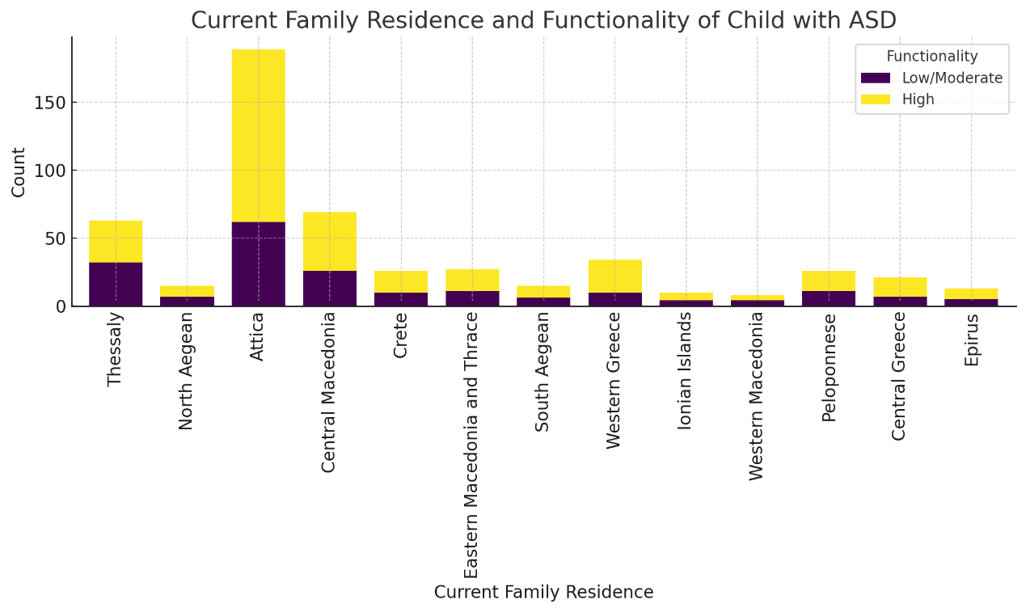

Figure S1. The visualization of the Chi-square test results for the Current Family Residence

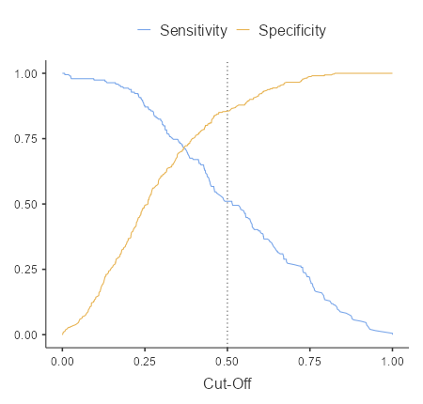

Figure S2. Cut-Off Plot of the Binominal Logistic Regression Prediction Model

Classification Table – …
 |  | Predicted
Observed |  | High |  | Low/Moderate |  | % Correct
High |  | 275 |  | 46 |  | 85.7
Low/Moderate |  | 95 |  | 99 |  | 51.0
Note. The cut-off value is set to 0.5

Predictive Measures
Accuracy |  | Specificity |  | Sensitivity |  | AUC
0.726 |  | 0.857 |  | 0.510 |  | 0.790
Note. The cut-off value is set to 0.5

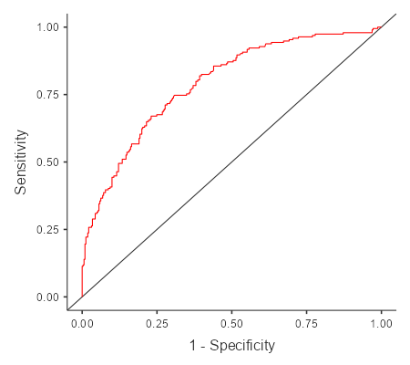

Figure S3. ROC Curve of the Binominal Logistic Regression Prediction Model

