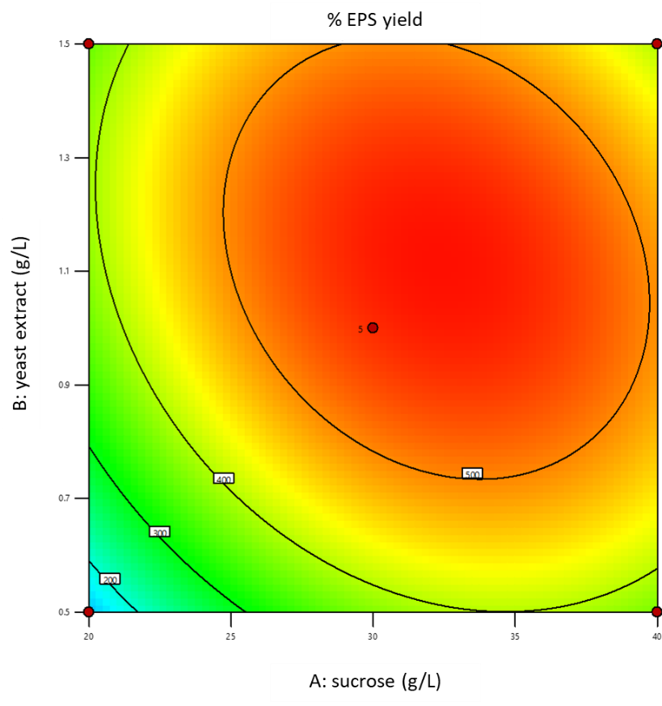

**(A)**

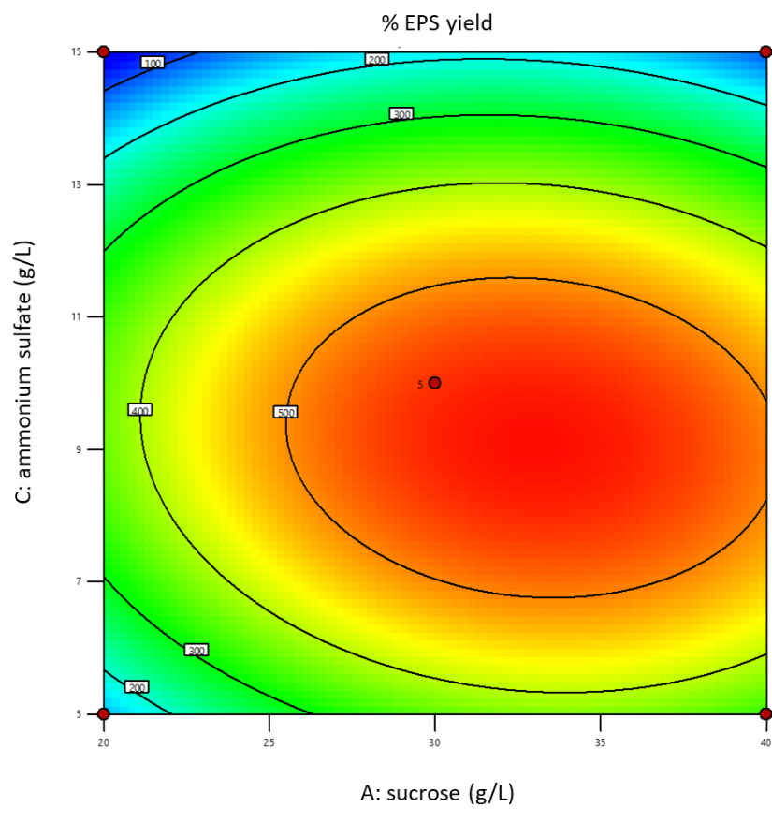

**(B)**

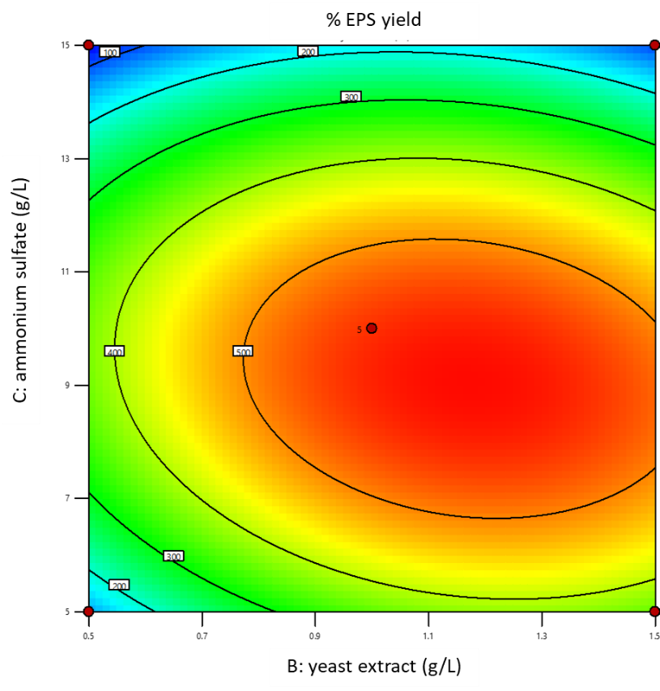

**(C)**

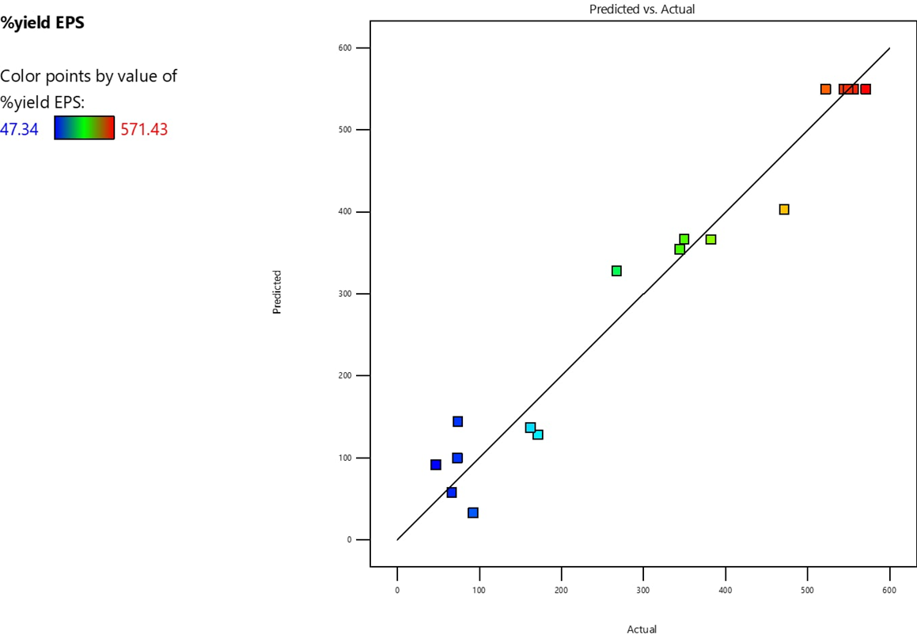

**(D)**

**Figure S1** Response surface plots of three variables in medium composition on EPS production.   
(A) Interaction of sucrose and yeast extract; (B) interaction of sucrose and ammonium sulfate; (C) interaction of yeast extract and ammonium sulfate; (D) Scatter plot of predicted value vs actual value from RSM design

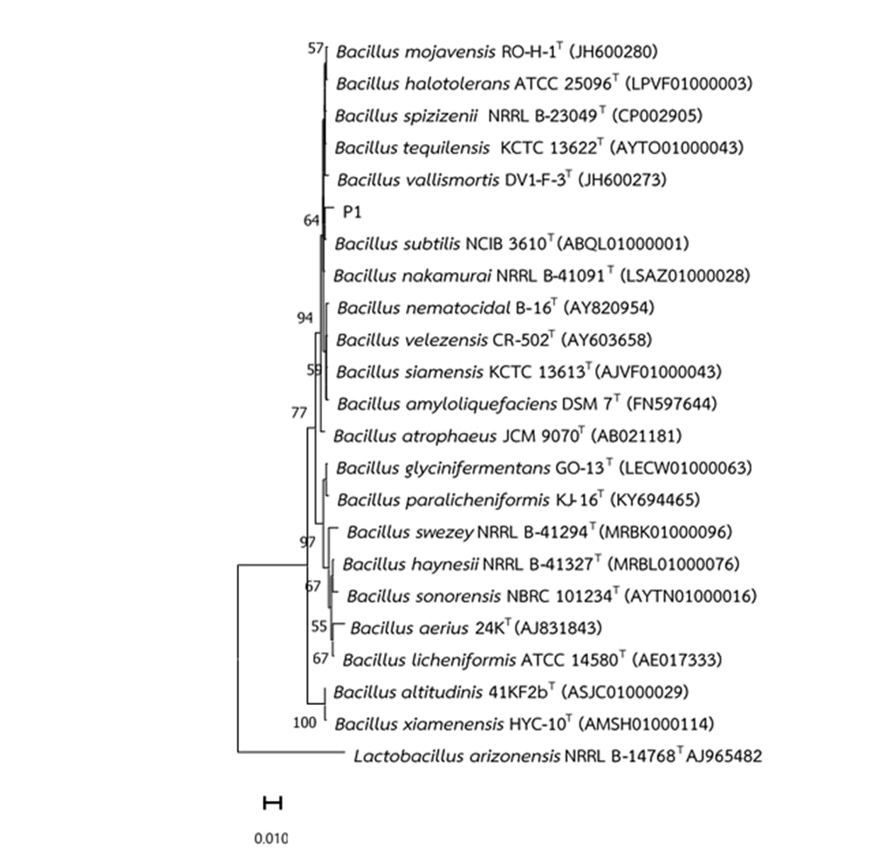

**Figure S2** Phylogenetic tree of *Bacillus* sp. P1 generated by neighbor-joining method based on the sequence of 16S rDNA gene.

**Table S1** Experimental design based on BBD and the response values of % yield EPS produced by *B. subtilis* P1

|  |  |  |  |  |
| --- | --- | --- | --- | --- |
| **Run order** | **Independent variable** | | | **Response variable** |
| **X1 : sucrose**  **(g/L)** | **X2: Yeast extract (g/L)** | **X3: (NH4)2SO4**  **(g/L)** | **% yield EPS* (%)** |
| 1 | 20 | 1 | 5 | 162.50±0.22 |
| 2 | 30 | 1 | 10 | 522.22±0.45 |
| 3 | 40 | 1 | 15 | 73.39±0.04 |
| 4 | 20 | 0.5 | 10 | 74.07±0.15 |
| 5 | 30 | 0.5 | 15 | 66.67±0.08 |
| 6 | 30 | 1.5 | 15 | 47.34±0.10 |
| 7 | 20 | 1 | 15 | 92.59±0.20 |
| 8 | 30 | 1 | 10 | 571.43±0.60 |
| 9 | 30 | 1 | 10 | 550.00±0.58 |
| 10 | 30 | 0.5 | 5 | 171.43±0.50 |
| 11 | 30 | 1 | 10 | 556.70±0.52 |
| 12 | 40 | 1 | 5 | 267.61±0.35 |
| 13 | 40 | 0.5 | 10 | 382.42±0.20 |
| 14 | 20 | 1.5 | 10 | 350.00±0.45 |
| 15 | 40 | 1.5 | 10 | 471.91±0.30 |
| 16 | 30 | 1.5 | 5 | 344.55±0.05 |
| 17 | 30 | 1 | 10 | 544.44±0.25 |

* yield EPS (%) = [the weight of EPS produced (g/L)/dry cell weight (g/L)] x100

Each experimental value represents the mean of three replicates ± SD

**Table S2** Carbohydrate substrate utilization and enzyme activity of *Bacillus* sp. P1 analyzed by API-50 CHB/API-20NE kit (bioMérieux)

|  |  |
| --- | --- |
| **Carbohydrate substrate utilization of *Bacillus* sp. P1 (API-50 CHB)** | |
| **Carbohydrates** | **Results** |
| Glycerol | + |
| Erythritol | - |
| D-Arabinose | - |
| L-Arabinose | + |
| Ribose | + |
| D-Xylose | + |
| L-Xylose | - |
| Adonithol | - |
| Methyl xyloside | - |
| Galactose | - |
| D-Glucose | + |
| D-Fructose | + |
| D-mannose | + |
| Sorbose | - |
| Rhamnose | + |
| Dulcitol | - |
| Inositol | + |
| Mannitol | + |
| Sorbitol | + |
| Methyl-D-mannoside | - |
| Methyl-D-glucoside | + |
| N-acetyl-glucosamine | - |
| Amygdalin | + |
| Arbutin | + |
| Esculine | + |
| Salicin | - |
| Cellobiose | + |
| Maltose | + |
| Lactose | - |
| Melibiose | + |
| Sucrose | + |
| Trehalose | + |
| Inulin | + |
| Melizitose | - |
| D-raffinose | + |
| Starch | + |
| Glycogen | + |
| Xylitol | - |
| Gentibiose | + |
| **Carbohydrate substrate utilization of *Bacillus* sp. P1 (API-50 CHB)** (Continued) | |
| **Carbohydrates** | **Results** |
| Turanose | + |
| Lyxose | - |
| Tagatose | - |
| D-fucose | - |
| L-fucose | - |
| D-Arabitol | - |
| L-Arabitol | - |
| Gluconate | - |
| 2,Keto-gluconate | - |
| 5,Keto-gluconate | - |

|  |  |
| --- | --- |
| **Enzyme activities of *Bacillus* sp. P1 (API-20NE)** | |
| **Reaction tested** | **Results** |
| β-galactosidase (ONPG) | + |
| arginine dihydrolase (ADH) | - |
| lysine decarboxylase (LDC) | - |
| ornithine decarboxylase (ODC) | - |
| citrate utilization (CIT) | - |
| H2S production (H2S) | - |
| urease (URE) | - |
| tryptophane deaminase (TDA) | + |
| indole production (IND) | + |
| Voges–Proskauer (VP) | + |
| gelatinase (GEL) | + |

(+) : Positive reaction refers to an ability to utilize or produce

(-) : Negative reaction refers to the inability to utilize or produce