*BioTech*

**Phytochemical composition, antioxidant, anti-*Helicobacter pylori*, and enzyme inhibitory evaluations of *Cleistocalyx operculatus* flower bud and leaf****fractions**

**Supplementary Material**

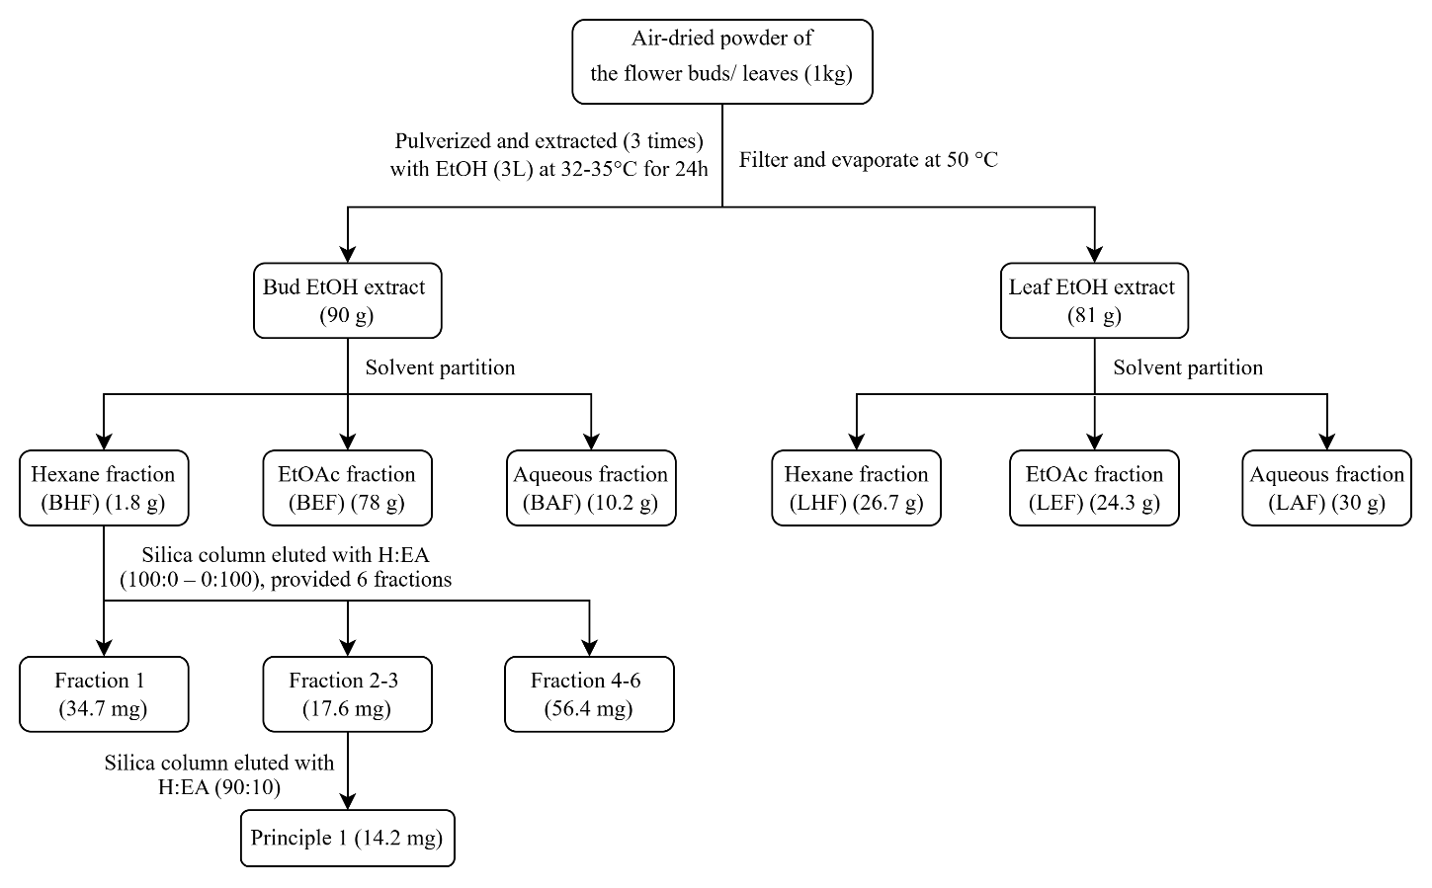

**Figure S1.** Scheme of flower bud and leaf solvent fractions partitioned by liquid-liquid fractionation from flower bud and leaf ethanolic extracts of *Cleistocalyx operculatus* and isolation of principle 1 derived from flower bud hexane fraction (BHF).

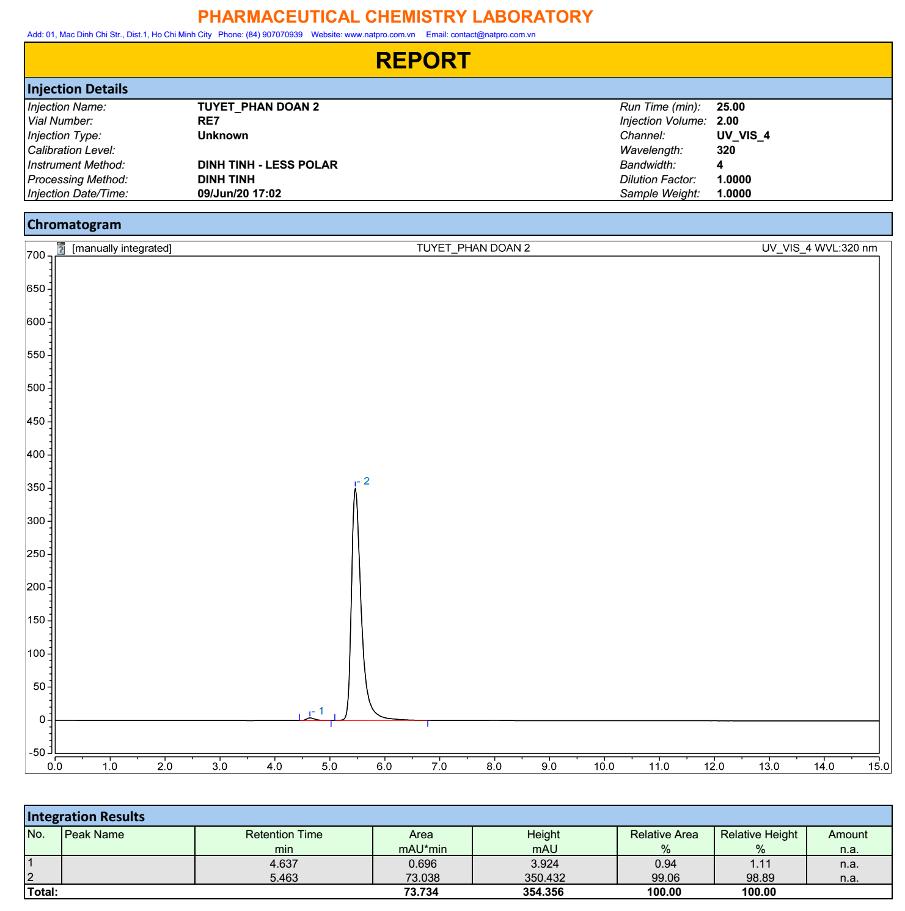

**Figure S2.** HPLC of DMC isolated from the flower bud hexane fraction (BHF)

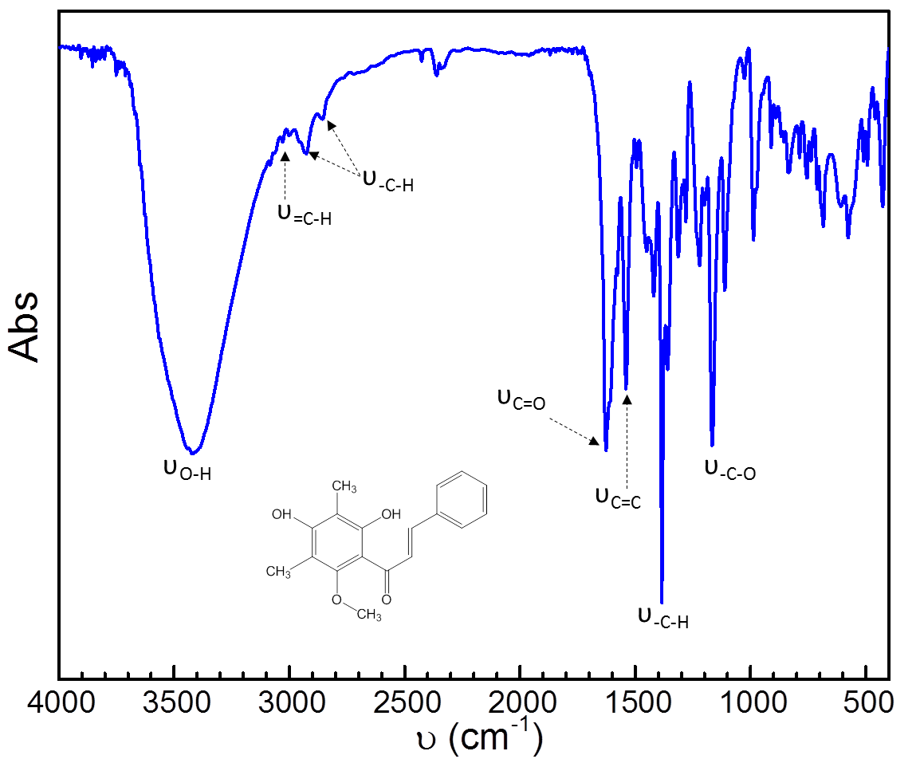

**Figure S3.** FT-IR data of DMC isolated from flower bud hexane fraction (BHF)

**Table S1**. 1H NMR, 13C-NMR, and HMBC data of DMC isolated from flower bud hexane fraction (BHF)

|  |  |  |  |
| --- | --- | --- | --- |
| Position |  | | |
| 13C | 1H | HMBC |
| (ppm) | (ppm, *J* μHz) | 1H 🡪 13C |
| 1 | 135.5 | - |  |
| 2 | 129.0 | 7.65 (dd, 7.6, 2.0) | C-*β*, 3, 4, 5 |
| 3 | 128.7 | 7.41 (m) | 1, 2 |
| 4 | 130.3 | 7.41 (m) | 2, 3, 5, 6 |
| 5 | 128.7 | 7.41 (m) | 1, 2 |
| 6 | 129.0 | 7.65 (dd, 7.6, 2.0) | C-*β*, 3, 4, 5 |
| C-*β* | 143.0 | 7.84 (d, 15.7) | 1, 2, 6, C-*α*, C=O |
| C-*α* | 126.9 | 7.99 (d, 15.7) | 1, C-*β*, C=O |
| C=O | 193.5 | - | - |
| 1' | 109.0 | - | - |
| 2' | 162.2 | - | - |
| 3' | 109.2 | - | - |
| 4' | 159.3 | - | - |
| 5' | 106.7 | - | - |
| 6' | 159.0 | - | - |
| 2’-OH | **-** | 13.2 (s) | 1', 2', 3' |
| 3’-CH3 | 8.4 | 2.16 (s) | 2', 3', 4' |
| 5’-CH3 | 7.7 | 2.14 (s) | 4', 5', 6' |
| 6’-OCH3 | 62.5 | 3.66 (s) | 6' |

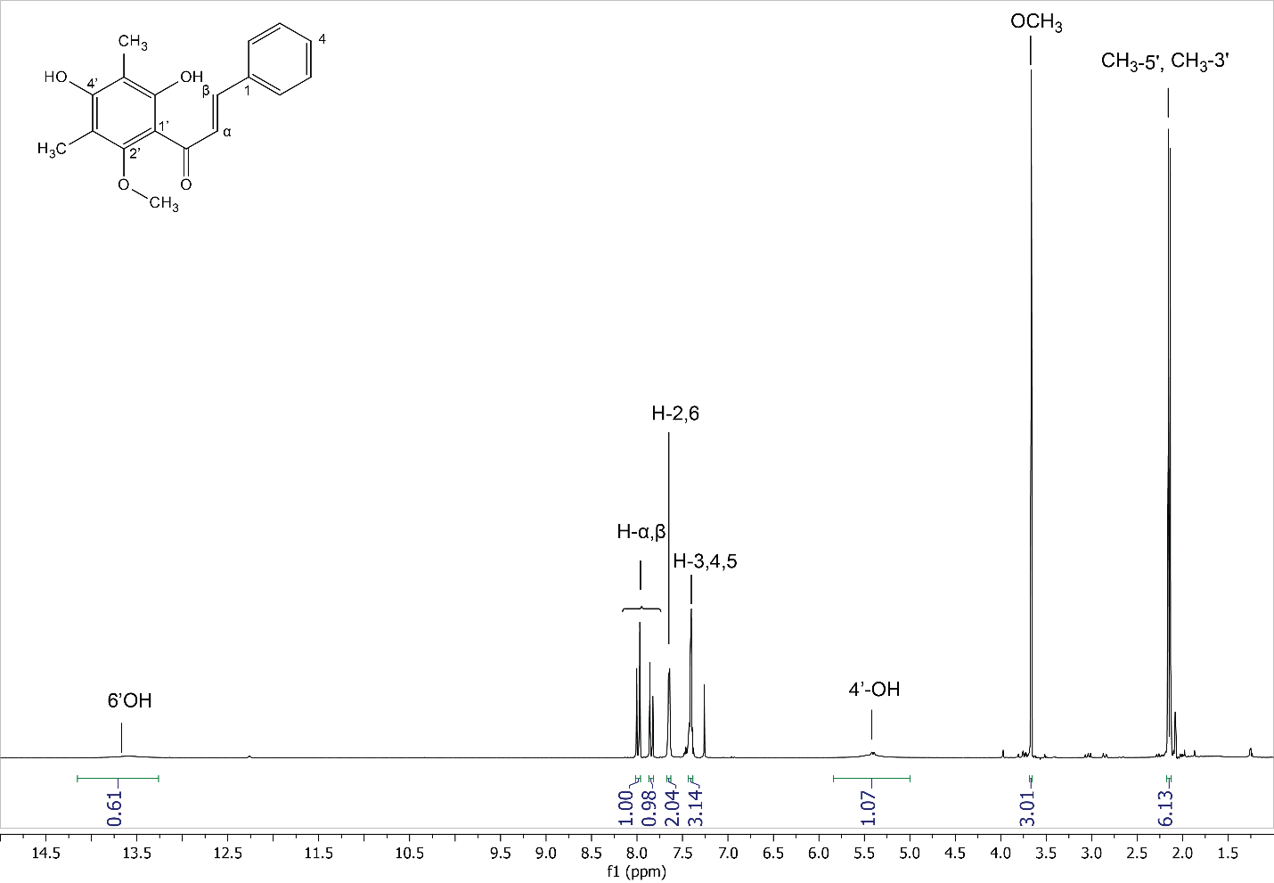

**Figure S4.** 1H-NMR data of DMC isolated from the flower bud hexane fraction (BHF)

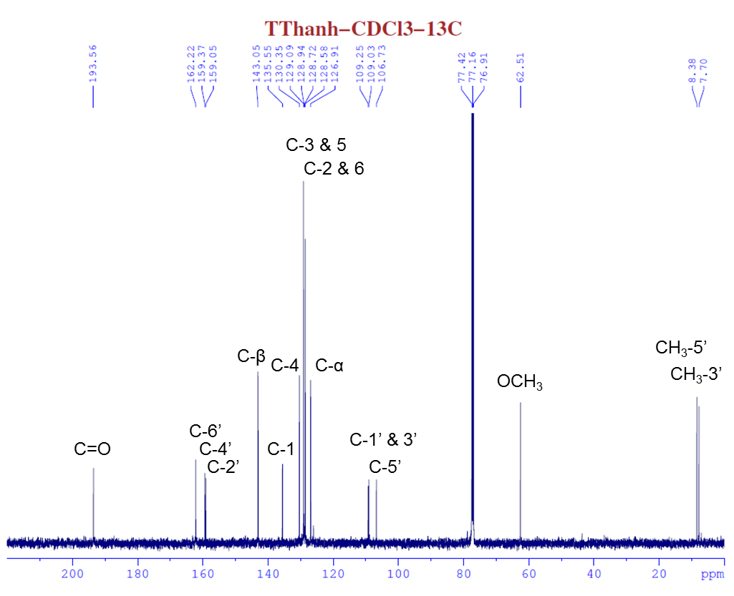

**FT-IR ν (KBr)** 3421, 2925, 1623, 1496, 1384, 1165 cm-1

**Figure S5.** 13C-NMR data of DMC isolated from flower bud hexane fraction (BHF)



**Figure S6.** 1H - 13C HMBC-correlations of DMC isolated from flower bud hexane fraction (BHF)