In Vitro Antiviral Activity of Silydianin-Rich Extract from Silybum marianum Seeds Against Four Strains of Enteroviruses: EV71, Coxsackievirus B2, Coxsackievirus A10, and Poliovirus SL-1 and Its Impact on Improving Delayed Gastric Emptying in Mice
Houda Zaher ^{1,2*,} Sanae lemrabet ², Neri Koutchala³ and Bouchaib Bencharki¹

¹Agri-Food and Health Laboratory (AFHL), Faculty of Sciences and Techniques, Hassan First University, Settat, Morocco.
zaherhouda@gmail.com; bouchaib.bencharki@uhp.ac.ma
²Virology Department, National Institute of Hygiene, Ministry of Health, Rabat, Morocco; sanae.lem@gmail.com
³Department of Computer Science and Artificial Intelligence, Technical School of Computer Engineering and Telecommunications. University of Granada, Granada, Spain; e.nerik@go.ugr.es
*Correspondence should be addressed to Houda Zaher at: zaherhouda@gmail.com

Supplementary Materials (appendix)

Figure S1. The ¹H NMR (600 MHz, DMSO-d₆) analysis of the Silybum marianum (EtOAc) fraction revealed peaks corresponding to silydianin, the major compound in the extract and the traces of minor compounds that generally characterize isosilychristine A, isosilybine B and dehydrosilydianine.

Figure S2. The ¹³C NMR (151 MHz, DMSO-d₆) analysis of the Silybum marianum (EtOAc) fraction revealed peaks corresponding to silydianin, the major compound in the extract.

Figure S3. The ¹³C DEPT analysis, this experiment differentiates between CH, CH2 and CH3 groups by variation of the selection angle parameter: the angle used is 135° angle gives all CH and CH3 in a phase opposite to CH2.

Figure S4. The ¹H NMR (600 MHz, DMSO-d₆) analysis of the n-BuOH fraction of Silybum marianum predominantly revealed peaks corresponding to sugars.

Figure S5. The ¹H NMR (600 MHz, DMSO-d₆) analysis of the (CHCl₃) fraction of Silybum marianum predominantly revealed peaks corresponding to silydianin.

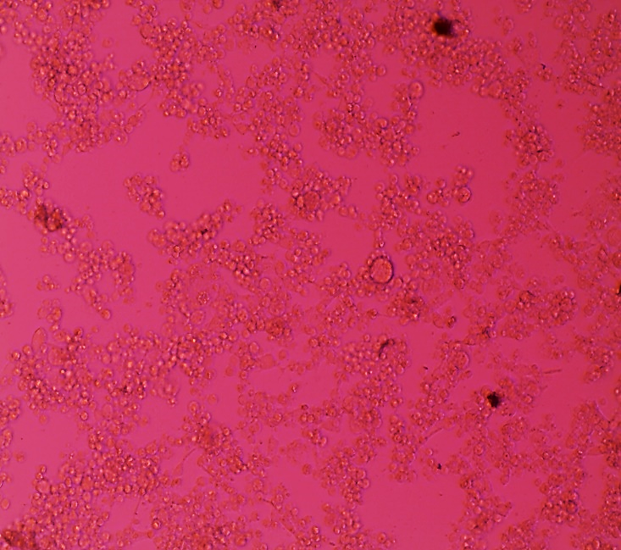
a.Virus control b. Cell control
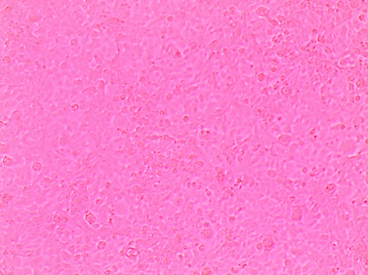

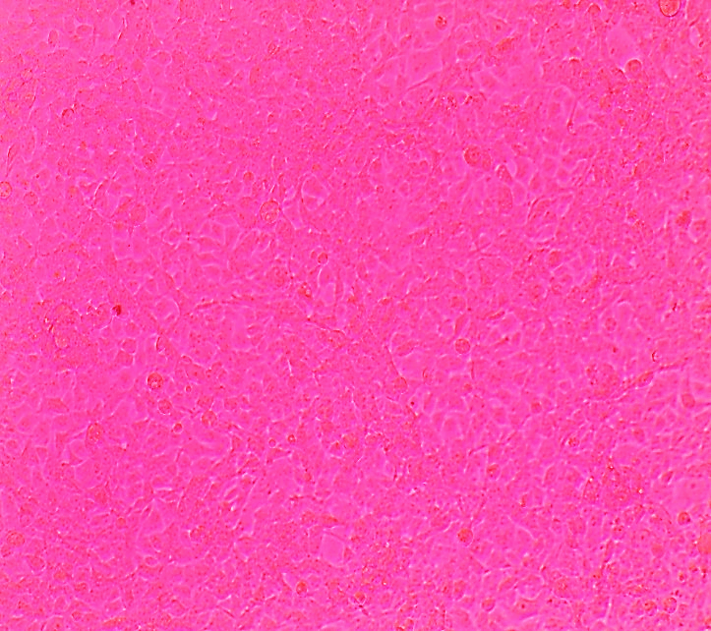
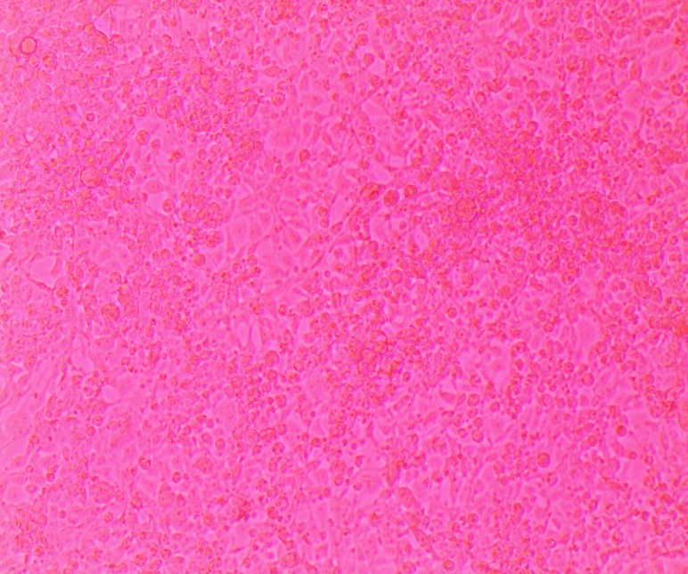
c. Treatment with 400 µg /mL d. Treatment with 200 µg /mL

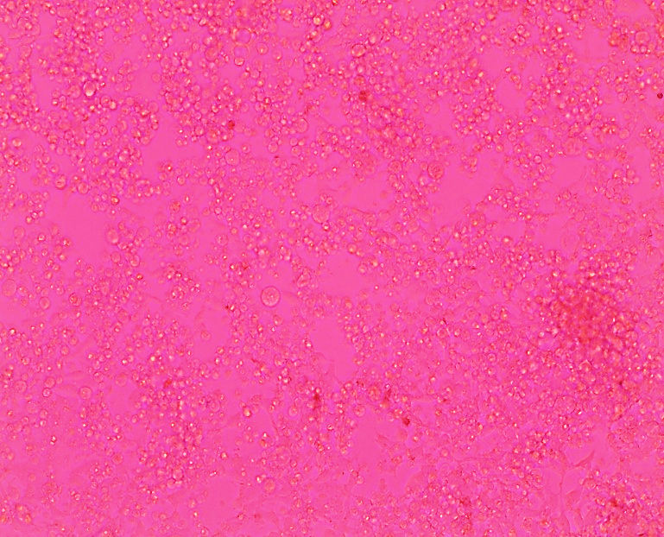
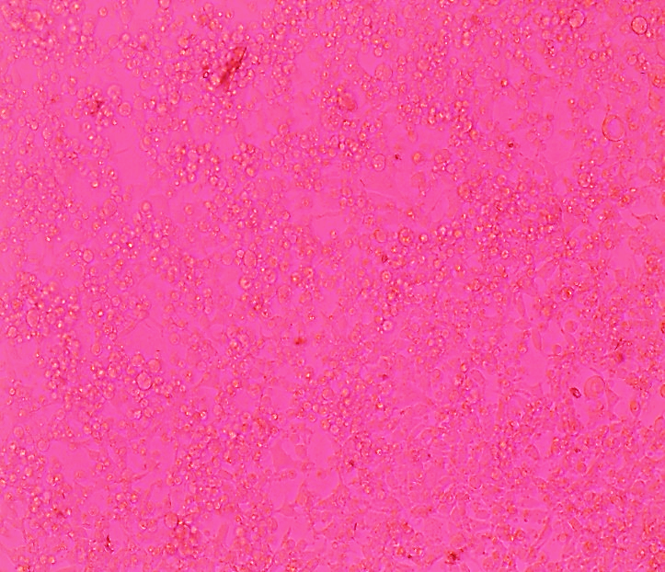
e. Treatment with 100 µg/mL f. Treatment with 50 µg /mL

Figure S6. The monolayers were microscopically examined for viral cytopathic effects (CPE) in a dose-dependent manner, focusing on cell rounding and other significant morphological changes compared to control cells after a 24 ± 2-hour incubation with the treatment concentrations, prior to performing the neutral red assay.

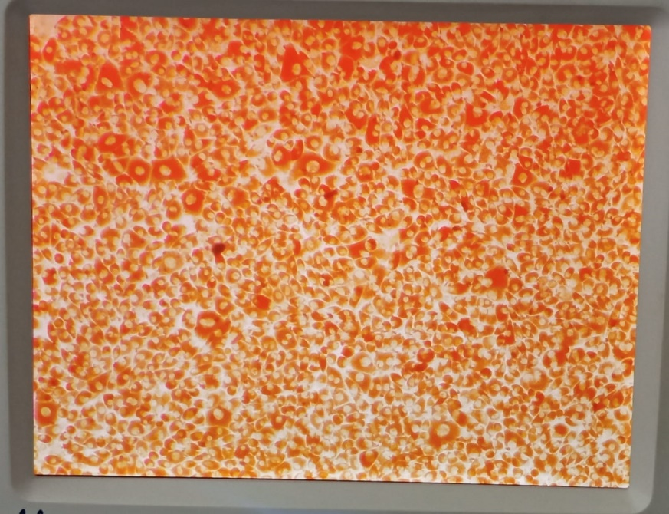
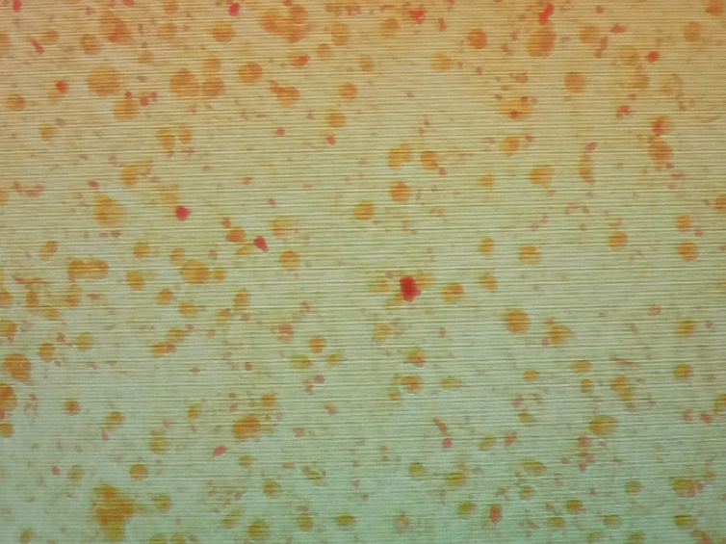
(a) (b)
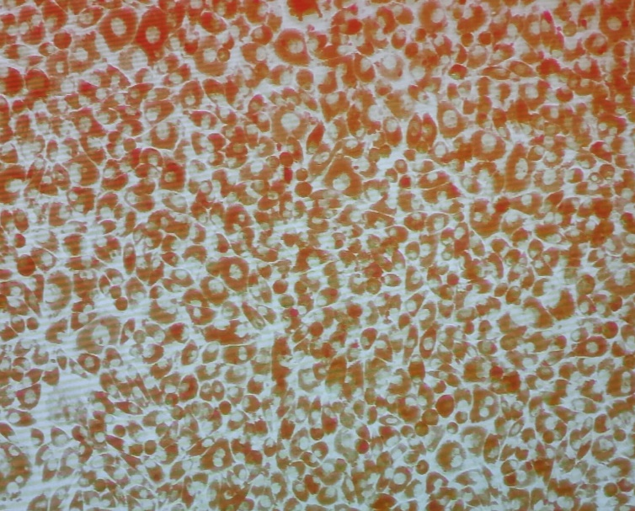
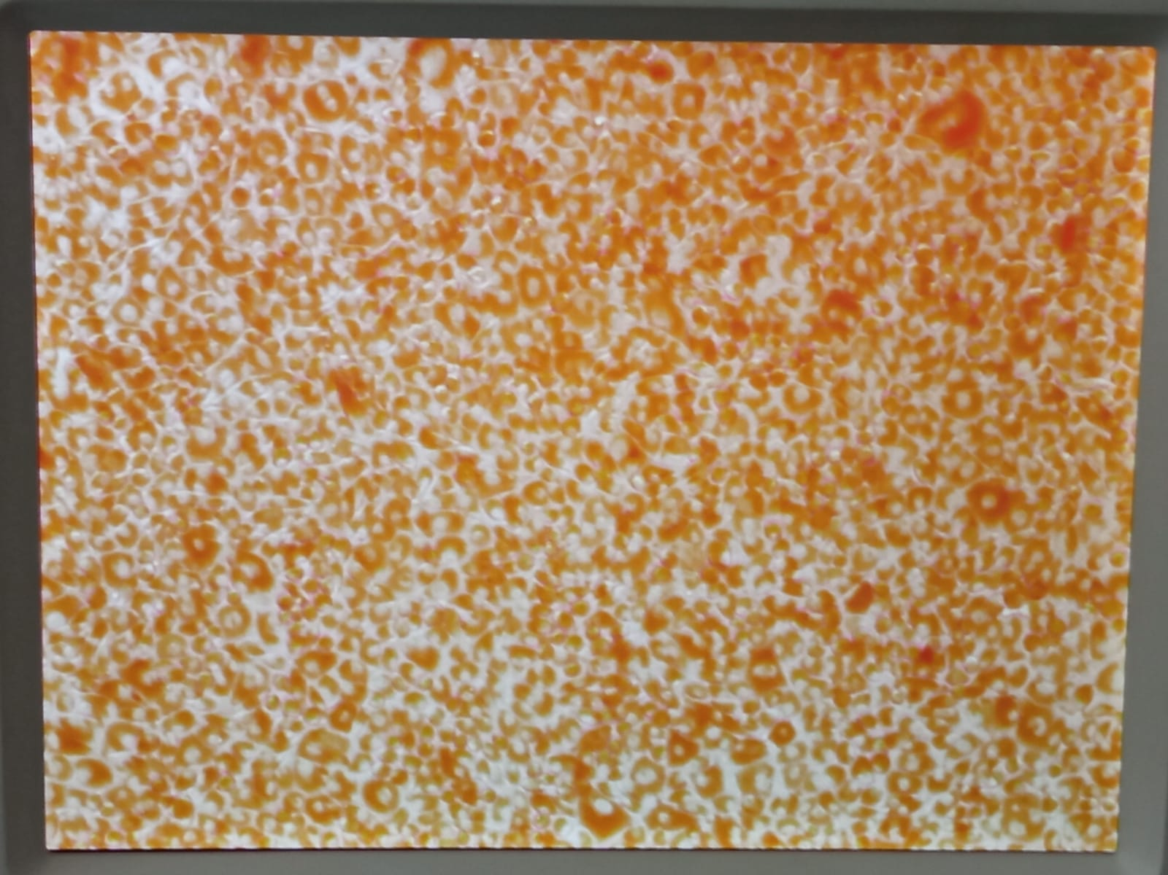
(c) (d)
(e) (f)
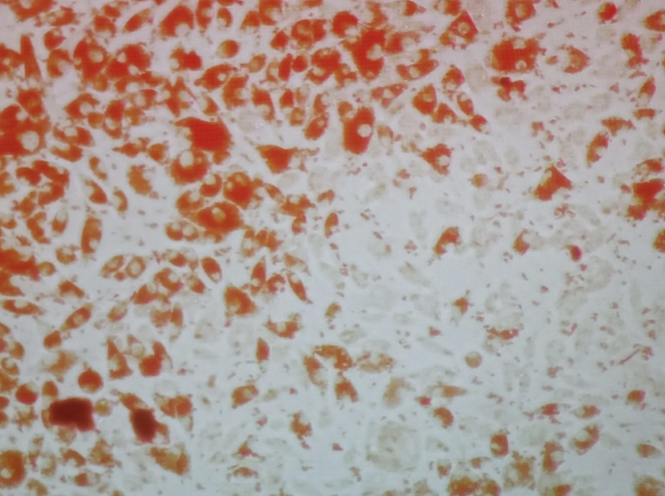
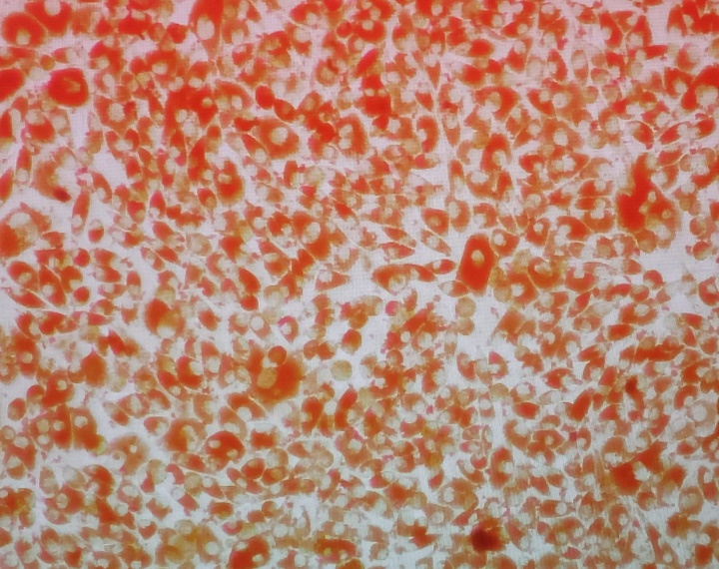
Figure S7. Cell viability stained by neutral red following the neutral red method (as detailed in the Methods section) after 24 hours of incubation with virus and treatment concentrations: (a) virus control, (b) cell control, (c) treatment with 400 µg/mL, (d) 200 µg/mL, (e) 100 µg/mL, (f) 50 µg/mL.

